DISABILITY INCLUSION IN SCHOOLS - EARLY CHILDHOOD INFORMATION PACK
This information pack can help early childhood teachers to have conversations with parents and carers of children with disability to build understanding of Disability Inclusion in schools.

Background
Disability Inclusion is the new approach to how students with disability are supported at government schools. It will help school students with disability take part in their learning on the same basis as a student without disability. Between 2021 – 2025 Disability Inclusion will deliver:
- a new funding model for schools with more investment
- a new strengths-based Disability Inclusion Profile for students with disability, supported by a new facilitator workforce
- more professional development for school staff about the best ways to support student learning.
The Disability Inclusion Profile replaces the Program for Students with Disabilities (PSD) application process. The profile process is not compulsory for any student and requires consent from the student’s parent/carer(s). It is the responsibility of the school, in partnership with the parents, student and Student Support Group, to consider and determine whether to undertake the process.
Disability Inclusion: what to expect
Disability Inclusion does not affect transition planning and supports currently in place in early childhood settings.
In line with current practice, the understanding and information that early childhood teachers have about children should continue to be shared with the school as part of all children’s transition. This includes the standard best practice of working with schools to convene Student Support Group transition / planning meetings in Term 4 for Prep students with disabilities.
Disability Inclusion Profiles are best completed after a student has been in the school setting for 10 weeks. For some children with very high needs, it may be appropriate to undertake a profile before the child commences school. Schools will work with families if this is appropriate.
Early childhood settings can support the profile process in the following ways:
- Providing high quality, strengths-based Transition Learning and Development Statements, including Section 1.2, which supports enhanced transitions for children with disability or developmental delay, and by completing other assessments such as Early ABLES.
- As per current practice, schools may ask kindergarten teachers to complete a Vineland assessment
- Kindergarten teachers may be invited to participate in a Disability Inclusion Profile meeting.
What can you do?
If the child will attend a school in an area that has begun, or will begin, to transition to Disability Inclusion from Term 1 of their first year of Prep (see next page):
☐ Continue enhanced transition processes to support students with disability, planning and working with the family, school and other early childhood professionals throughout the kinder year.
☐ Speak to parents/carers of a child with disability who are transitioning to school to build awareness of the introduction of Disability Inclusion at government schools. Provide families with the Disability Inclusion fact sheet and encourage them to speak with the prospective school about what Disability Inclusion may mean for their child.
☐ If the child is in out-of-home care, talk to their Department of Families, Fairness and Housing Case Manager or LOOKOUT Early Childhood Learning Advisor to ensure the child’s legal guardian is informed about Disability Inclusion and provided with the fact sheet.
☐ If appropriate, include an article in your newsletter by using the sample content provided.
☐ If appropriate, share a social media post on your Kindergarten Facebook page (if applicable) by using the sample content provided below.
Rollout schedule
Disability Inclusion is being implemented in a staged rollout over five years.
Year 1 areas – began transition to Disability Inclusion in 2021
- Bayside Peninsula - Frankston, Bayside, Glen Eira, Kingston, Mornington Peninsula, Port Phillip, Stonnington,
- Barwon - Colac Otway, Greater Geelong, Queenscliffe, Surf Coast,
- Loddon Campaspe – Campaspe, Central Goldfields, Greater Bendigo, Loddon, Macedon Ranges, Mount Alexander
Year 2 areas – began transition to Disability Inclusion in 2022
- Outer Eastern Melbourne – Knox, Maroondah, Yarra Ranges
- Central Highlands – Ararat, Ballarat, Golden Plains, Hepburn, Moorabool, Pyrenees
- Mallee – Buloke, Gannawarra, Mildura, Swan Hill
Year 3 areas – transition to Disability Inclusion commences in 2023
- Inner Gippsland – Bass Coast, Baw Baw, Latrobe, South Gippsland
- Ovens Murray – Alpine, Benalla, Indigo, Mansfield, Towong, Wangaratta, Wodonga
- Western Melbourne – Hobsons Bay, Maribrynong, Melbourne, Moonee Valley, Wyndham
It will also be available at Victoria’s Supported Inclusion Schools.
You can access the full rollout schedule from the Disability Inclusion: extra support for children with disability | Victorian Government (www.vic.gov.au).

Sample Newsletter article
Disability Inclusion rolling out in Victorian government schools
If you have or know someone with a child with disability starting at a government school, they may benefit from Disability Inclusion. This is the new, strengths-based approach to supporting students with disability at school and has a focus on what they can achieve, rather than what they can’t.
Your child's school will work with you to create a Disability Inclusion Profile, if required. The Profile is a written description of your child's strengths and needs at school. It will help the school give your child the support they need, as an individual and as a member of the school community.
Disability Inclusion also delivers more school funding and supports for more training and professional development for teachers and school staff.
For students, Disability Inclusion means:
- a positive focus through a strengths-based approach
- opportunity to talk about goals and educational needs
- better support through greater school-wide resources.
For families, Disability Inclusion means:
- a process that considers the strengths, aspirations and needs of their child
- more confidence that their local school can support their child, regardless of whether they have a formal diagnosis
- better access to information about their child’s learning needs and adjustments.
Disability Inclusion is being implemented in a staged rollout over five years. The Program for Students with Disabilities will continue in areas that have not yet transitioned to Disability Inclusion.

Year 1 areas – began transition to Disability Inclusion in 2021
- Bayside Peninsula - Frankston, Bayside, Glen Eira, Kingston, Mornington Peninsula, Port Phillip, Stonnington,
- Barwon - Colac Otway, Greater Geelong, Queenscliffe, Surf Coast,
- Loddon Campaspe – Campaspe, Central Goldfields, Greater Bendigo, Loddon, Macedon Ranges, Mount Alexander
Year 2 areas – began transition to Disability Inclusion in 2022
- Outer Eastern Melbourne – Knox, Maroondah, Yarra Ranges
- Central Highlands – Ararat, Ballarat, Golden Plains, Hepburn, Moorabool, Pyrenees
- Mallee – Buloke, Gannawarra, Mildura, Swan Hill
Year 3 areas – transition to Disability Inclusion commences in 2023
- Inner Gippsland – Bass Coast, Baw Baw, Latrobe, South Gippsland
- Ovens Murray – Alpine, Benalla, Indigo, Mansfield, Towong, Wangaratta, Wodonga
- Western Melbourne – Hobsons Bay, Maribrynong, Melbourne, Moonee Valley, Wyndham

It will also be available at Victoria’s Supported Inclusion Schools.
More information, including the full rollout schedule, is available at education.vic.gov.au/parents/additional-needs or from your local government school.

Facebook
Download the social media tile here
Or cut and paste this image
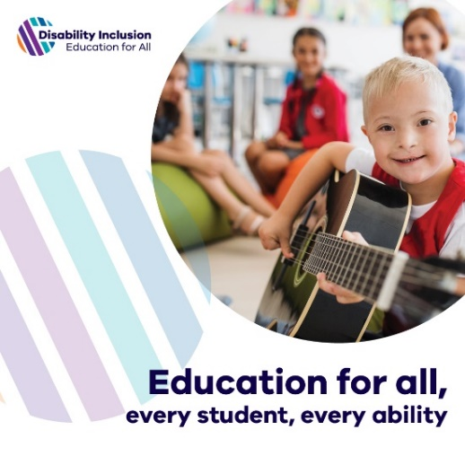
If you know someone with a child with a disability starting at a government school, they may benefit from Disability Inclusion. This approach puts the needs of the student at the heart of the school’s response – focusing on what a child can achieve, rather than what they can’t.
Parents can speak to their prospective school to find out more information.

Resources
Information for parents to learn more
Disability Inclusion: extra support for children with disability | Victorian Government (www.vic.gov.au)
Information for educators to learn more
www.education.vic.gov.au/childhood/professionals/learning/Pages/transsupport.aspx

