My Disability Inclusion Profile Meeting

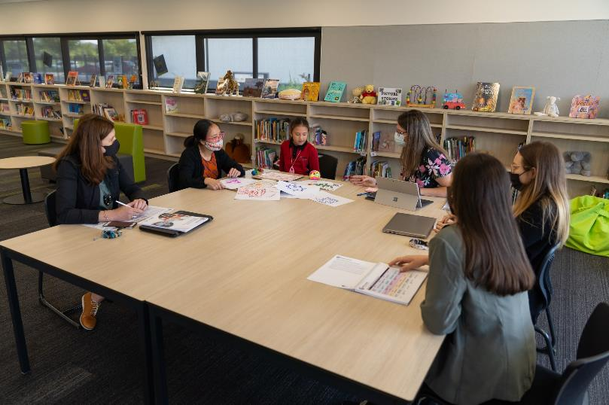

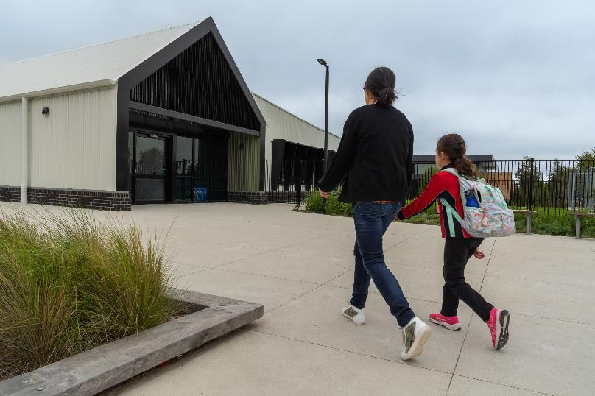

I am going to a Disability Inclusion Profile meeting. In this meeting, I will talk about school. I will talk about what l am good at and how the school can help me.

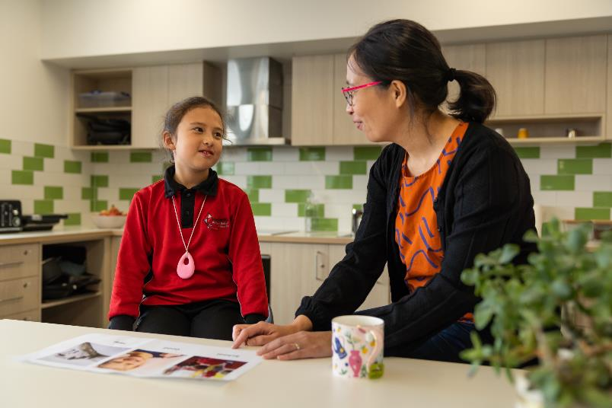

My parent or carer will talk to me before the meeting. I will tell them what I am good at and what the school could help me with. This will help me be ready for the meeting.

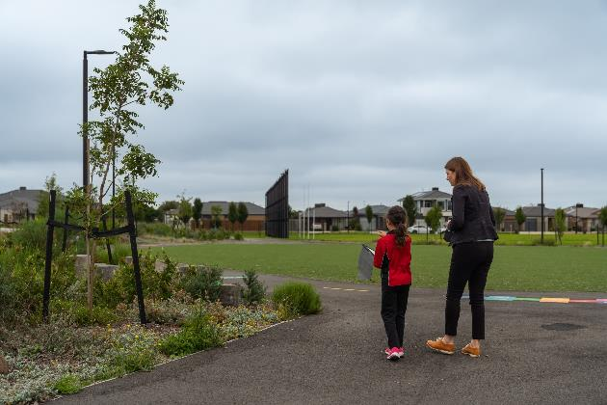
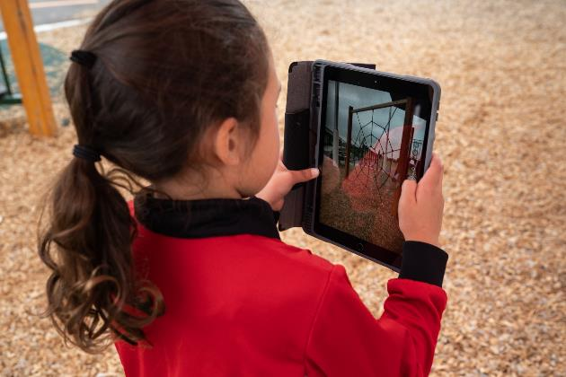

There are a few ways I can prepare for the meeting. I can use a camera to take photos of things that are important to me. I can choose to share these photos in the meeting.
I could walk around my school and tell my teacher things about school that I want to talk about.

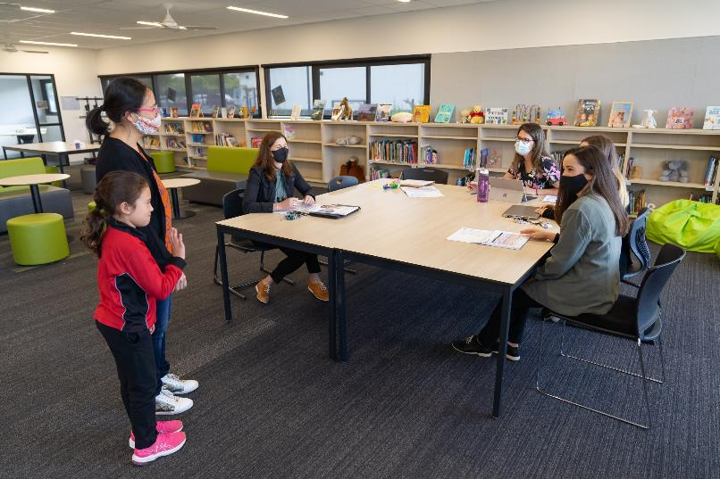

The meeting will be at school. It is my choice to go to this meeting or not. I may need to leave class to go to the meeting or it may be after school. My parent or carer will come to the meeting. One of my classroom teachers will be there. My school principal, assistant principal or another teacher will be there. Other trusted adults may be there too.

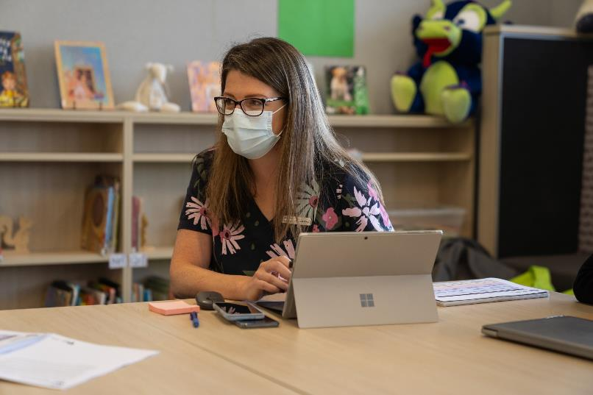

There will be a facilitator running the meeting. I will meet the facilitator at the meeting. They will ask me and my parent or carer questions in the meeting.

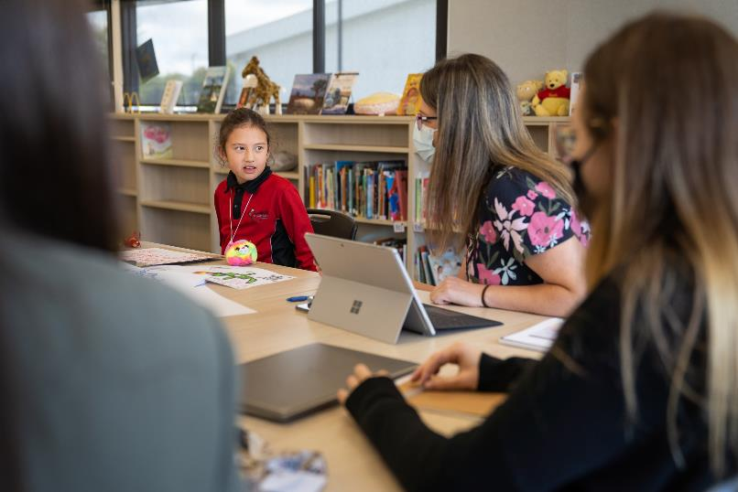

At the meeting, we will talk about me. We will talk about what helps me learn. We will talk about what I am good at. We will talk about how the school can help me.

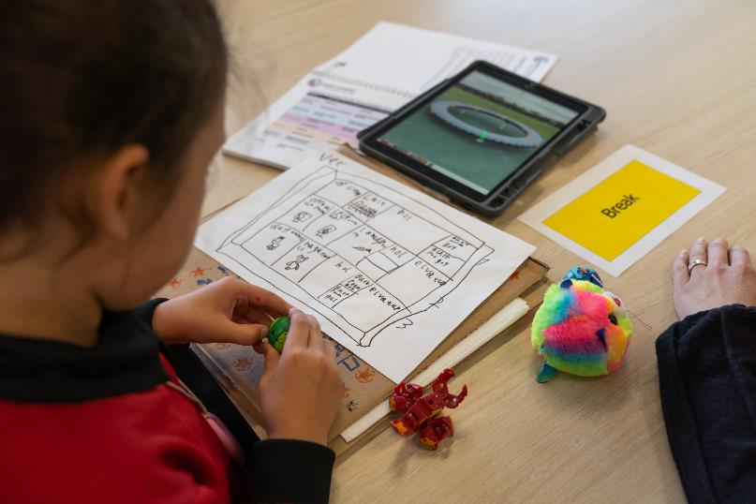

I can choose how I want to take part in the meeting. I can talk or, if I want, I can just listen. I can write, draw, or make a video for the meeting. I can also ask my parent or carer to speak for me. I can choose not to take part in the meeting or just attend the first part.

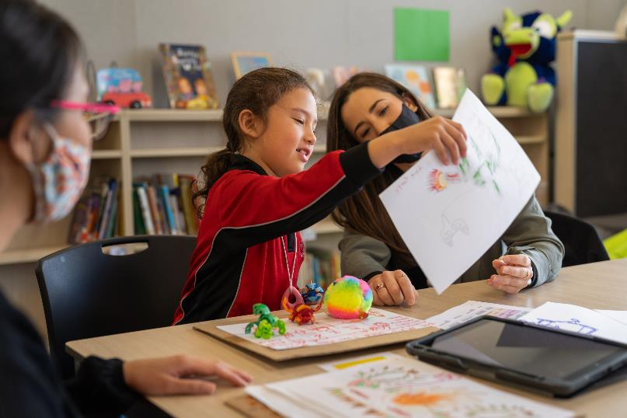

In the meeting, I will tell the adults about a big dream I have. This is called an 'aspiration.' This could be a job, an adventure, experience or something I would like to learn to do. It doesn't have to be something about school.

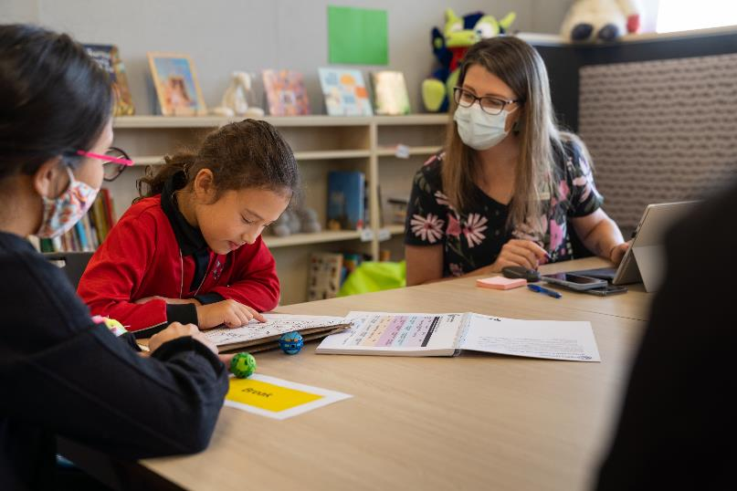

The meeting will be about what I am good at and what will help me learn. It will be a good meeting.
We will talk about how the school is helping me now and how they can help me in the future.

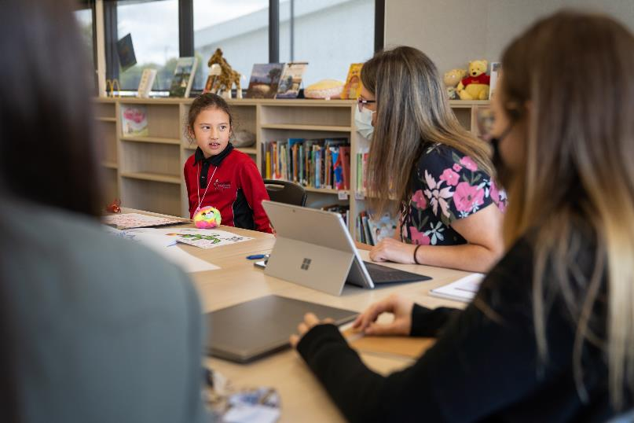

If the adults use words that I don't know, I could say “please say that again with different words". I can ask them to give me examples.

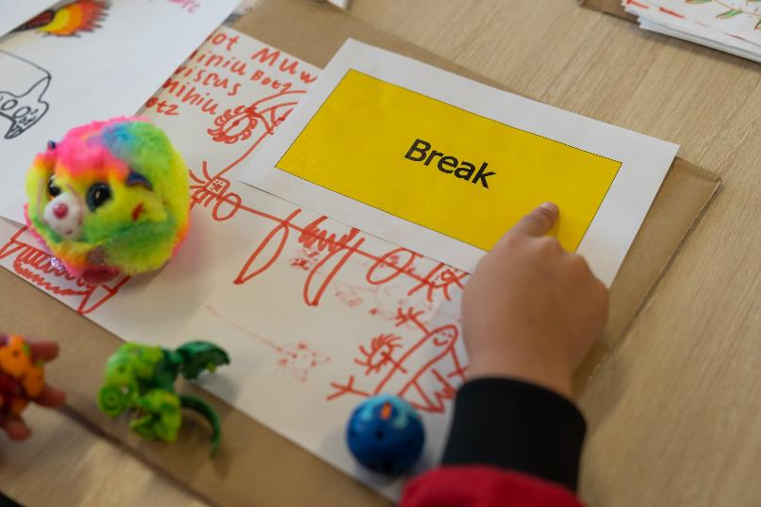

I can ask my parent, carer, or the facilitator if I want to take a break. I can also tell my parent, carer, or the facilitator if I don’t want to take part in the meeting anymore. It’s okay to change my mind about taking part.

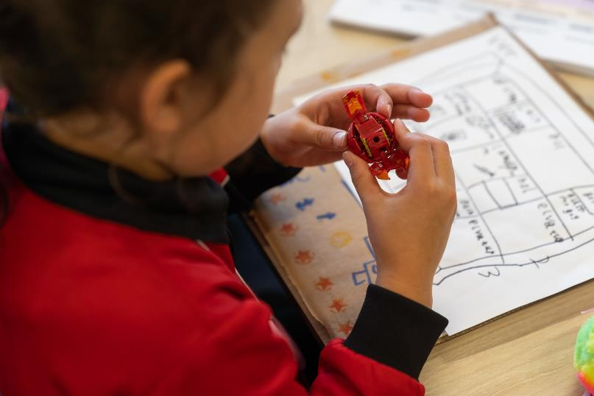

I should feel comfortable in the meeting. I can bring along fidget items. I can choose where I sit or stand.

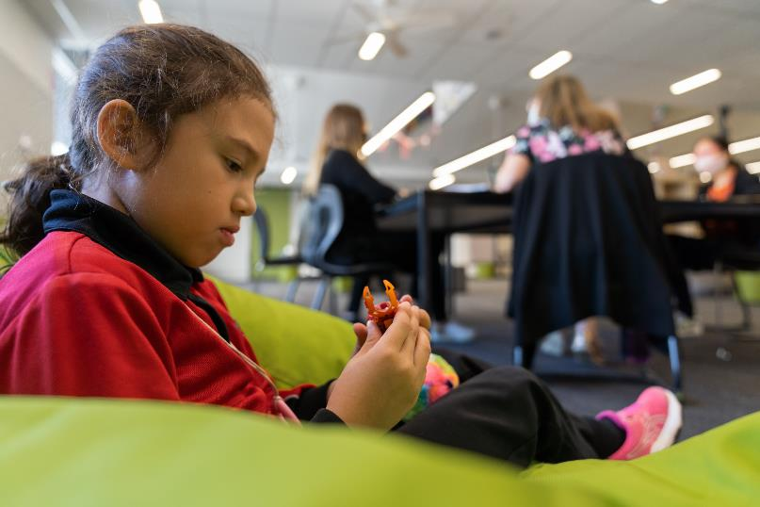

As I get older, I may be asked to go to another meeting. I can join in as much or as little as I like. I can also join the next meeting.

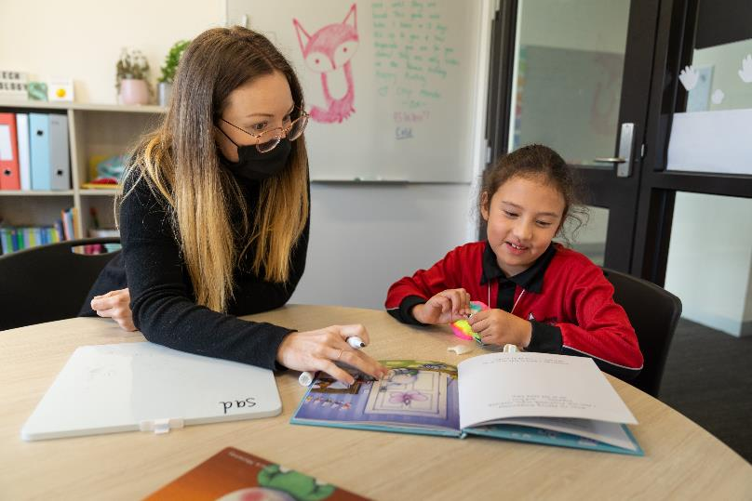

Most of the things we talked about in the meeting are already happening at school. After the meeting, the school may have some new ways to help me achieve my learning goals.
Today I got to share my ideas.
Acknowledgements

With thanks to the staff, student model and family from Keelonith Primary School.

Department of Education and Training
E: disability.inclusion@education.vic.gov.au
Disability Inclusion: extra support for children with disability | Victorian Government (www.vic.gov.au)
Amaze
Ph: 1300 308 699
E: info@autismconnect.org.au
www.amaze.org.au

