Tongan | lea faka-Tonga

Pepa Fakamatala ki he Kaumai Tisiʻapilitī (taʻemalava)
Kaumai Tisiʻapilitī - Pepa fakamatala maʻae ngaahi fāmilí
Ko e Kaumai Tisiʻapilitī (taʻemalava) ko ha founga foʻou ki hono tokoniʻi kitautolu ke tau tokoniʻi ʻa e fānau ako ko ia ʻoku nau tisiʻapilitií pea fatu ha akoʻanga ʻokú ne fakakau mai ʻo toe lahiange ʻa e kotoa ʻo ʻetau fānau akó.
Ko e ngaahi akoʻanga ko ia ʻoku nau fālute fakakātoa e fānaú ʻoku mahino ʻoku leleiange ʻa e ngaahi ola ʻoku maʻu ʻi heʻenau akó, fuʻu tokanga ange pea toe moʻui leleiange kotoa ʻa e fānau akó.
Ko e Kaumai Tisiʻapilitií ʻe tokoni ʻaupito ki he ngaahi akoʻangá ke nau toe mahinoʻi lelei ange ʻa e ngaahi fiemaʻu ʻetau fānau akó ke tokoni ki he ʻenau akó, fakafou:
- ʻi ha mōtolo fakapaʻanga tokoni foʻou mo fakatupu paʻanga
- ha ngāue tefito he ivi-mālohi ʻa ia ʻoku ui ko e Polofaile Kaumai Tisiʻapilitī ke tokoni ki hono fakaʻilongaʻi ʻa e fiemaʻu vivili ʻa e fānau akó mo e ngaahi fakalelei 'e fiemaʻú ke nau fai
- lahiange ʻa e ngaahi ako mo e fakahinohino maʻae kau faiakó mo e kaungāué fekauʻaki mo e founga lelei taha ki hono tokoniʻi ʻa e ako ʻa e tamasiʻi akó.

ʻi ha mōtolo fakapaʻanga tokoni foʻou mo fakatupu paʻanga
Ko e mōtolo fakapaʻanga tokoni foʻoú ʻokú ne tokonaki ha toe faingamālie ke fakahaofi ha paʻanga ʻe he akoʻangá ke nau lava ʻo toe tokoniʻiʻaki ʻa e fānauako tokolahi 'o e fanauako ʻo kau ai ʻa kinautolu ʻoku ʻotīsimí, faingataʻa ke ako mo ha toe ngaahi meʻa lahiange.
Ko e faingamālie fakahaofi paʻanga ko ení ʻe fakafaingamālieʻi ai ha tokoni maʻae fānauako ʻoku nau tisiʻapilitií, kau ki ai ʻa e fānauako ʻoku teʻeki ke malava ke nau kau ki ha tokoni fakataautaha mei he Polokalama maʻae Fānauako Tisiʻapilitī (PSD) ʻi he kuohilí.
ʻE lava leva ʻe he akoʻangá ke nau ngāueʻaki ʻa e foʻi paʻanga ko ení ki ha ngaahi polokalama kehekehe ʻo kau ai ʻa e:
- ngaahi ako lahiange mo ha toe teuteu fakapalofesinale maʻae kau faiakó pe kau ngāue ʻa e akoʻangá
- maʻu ha ngaahi faleʻi mei he kau mataotao ki he tisiʻapilitií
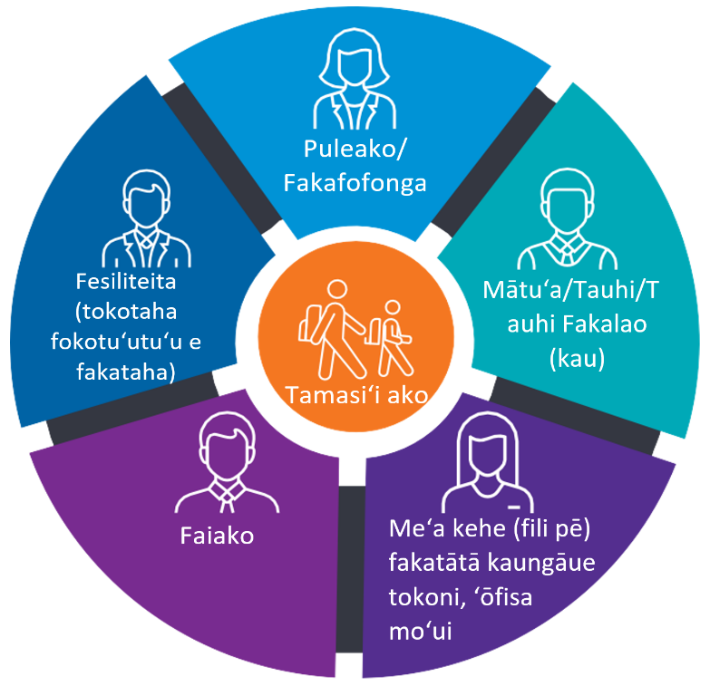
- totongiʻi mai ha kau faiako pe ha toe kau ngāue ke tokoni ki hano palani mo fakahoko ha ngaahi liliu maʻae fānauakó
- ngaahi meʻangēue pe ngaahi tokoni ke poupouʻi ʻenau akó.

Ko e Polofaile Kaumai Tisiʻapilitií
Ko e Polofaile Kaumai Tisiʻapilitī ʻe tokoni ia ki he ngaahi akoʻangá ke nau toe ʻilo lahiange ki he mālohinga ʻo hoʻo kiʻi tamá pea mo ʻenau ngaahi fiemaʻu. Te ne fakahoko hono fokotuʻutuʻu ʻo e ngaahi feituʻu ke vahevahe ki ai ʻa e paʻangá, tokoni ke palani e ako mo e ngaahi liliu ʻe fiemaʻu nai ʻe ha kiʻi tamasiʻi ako ke lava ʻo toe leleiange ʻene akó.
Ko e Polofaile Kaumai Tisiʻapilitī foʻoú te ne fetongi ʻa hono fakafehuʻi ʻo e Fiemaʻu Fakaako (Educational Needs Questionnaire) ne ngāueʻaki ko ha konga ʻo e PSD lolotongá.
ʻI he lolotonga ʻa e liliu ʻa e akoʻangá ki he founga foʻoú, ko e ngaahi fāmili ʻo e fānauako ʻoku nau kau ki he PSD ʻe kole ke nau kau mai ki ha fakataha ʻe fai ke fakakakato ʻa e Polofaile Kaumai Tisiʻapilitií.
Ko kinautolu ʻoku nau ʻiloʻi hoʻo kiʻi tamá ʻe kau mai ki he fakatahá, fakataha mo ha fesiliteita tauʻatāina kuo teuʻi ʻa ia te ne tokoni ki he ngaahi akoʻangá mo e ngaahi fāmilí ke fakakakato ʻa e polofailé.
Kapau ko hoʻo kiʻi tama ko e konga ia ʻo e PSD, ʻe fangāueʻaki leva ʻa hoʻo akoʻangá mo koe ke fakasio ʻa e faingamālie leleitahá ke fakakakato ʻa ʻenau polofailé.
ʻE ʻatā foki ʻa e polofaile ki ha kulupu tokolahi ange ʻo e fānauako ko ia ʻoku māʻolunga ʻa ʻenau ngaahi fiemaʻú.

Paʻanga tokoni ki he liliu
Ke tokoni ki he ngaahi fāmili ke nau ma'u ha loto pau'ia lolotonga ʻa e liliu ʻenau kiʻi tamá mei he Polokalama maʻae Fānau Tisiʻapilitií (PSD) ki he founga foʻoú, ʻoku foaki ai ʻe he Puleʻanga Vikatōliá ha Paʻanga Tokoni Liliu Kaumai Tisiʻapilitií 'a ia ʻe toki ʻosi ki he 2024.
Ko e Paʻanga Tokoni ki he Liliu Kaumai Tisiʻapilitī ʻokú ne fakapapauʻi ʻoku maʻu ʻe he akoʻangá ʻa e paʻanga tokoni lahi tatau maʻae lēvolo ʻa e tamasiʻi akó pe toe lahiange ke tokoniʻiʻaki ʻa e fānau akó ke liliu mei he PSD ki he Kaumai Tisiʻapilitií.
Ki ha toe fakamatala lahiange mo e founga hono ngāueʻaki ki hoʻo kiʻi tamá ʻa e Paʻanga Tokoni Liliu ki he Kaumai Tisiʻapilitií kātaki ʻo fetuʻutaki ki he puleako ʻo hoʻo akoʻangá.

Akongaue lahiange mo e ngaahi fakahinohino maʻae kau faiako mo e kaungāue ʻa e akoʻangá
Ko e Kaumai Tisiʻapilitī te ne ʻoatu ki he kau faiakó mo e kaungāue tokoni tokolahi ange ha toe mahino leleiange ki he taʻemalavá mo e founga ke fakafeangai mo kinautolu. ʻE lava ke kau heni ʻa e:
- ha kau palofesinale toko lahiange ʻi he ngaahi akoʻanga ʻoku nau mataotao ʻi he tisiʻapilitií
- fakahinohino
- ngaahi ako fakapalofesinale
- ngaahi tataki tefito 'i ha ngaahi fakamoʻoni-'osi a'usia mo e ngaahi maʻuʻanga fakamatala
- ngaahi sikolasipi.

Fakamatala lahiange
ʻAʻahi ki he www.education.vic.gov.au/disabilityinclusion ke toe maʻu ha fakamatala lahiange fekauʻaki mo e Kaumai Tisiʻapilitií.
Kapau te ke loto ke talanoa ki he ngaahi fiemaʻu ʻa hoʻo kiʻi tamá ʻi he akoʻangá, pe te ke fiemaʻu ha liliu tohi lea pe tokoni ʻi he fakatonuleá, kātaki ʻo fetuʻutaki ki he puleako ʻo hoʻo akoʻangá.

