Hakha Chin | Laiholh

Pumtlinglo Telnak kong thawngthanhmi tialnak catlap
Pumtlinglo Telnak- innchungkhar pawl caah thilsining tialnak catlap
Pumtlinglo Telnak (Disability Inclusion) cu pumtlinglo siangngakchia pawl bawmhnak lei thanchoter dingah kanmah bawmh ding le kan siangngakchia dihlak caah tamdeuh aa tel khomi sianginn sersiam dingah fuhpanh ning a thar pakhat a si.
Aa telmi sianginn pawl nih siangngakchia dihlak caah cawnnak, tonnak le thatnak ah a thadeuhmi aphichuak pawl an ngei.
Pumtlinglo Telnak nih kan siangngakchia pawl i cawn a herhmi thadeuh in hngalhnak dingah sianginn pawl kha a bawmh hna, hihi hmangin:
- tangka hrambunhnak tamdeuh he tangka kawl ningcang a thar
- siangngakchia i herhmi pawl le herhmi tawlrelnak pawl fianternak bawmh dingin Pumtlinglo Telnak Konglam tawi (Disability Inclusion Profile) tiah auhmi thazaangthawnnak hrambunh tuahtonak a thar
- siangngakchia cawnnak bawmh dingah a thabikmi lam pawl kong cachimtu pawl le sianginn riantuantu pawl caah cawnpiaknak le lamhmuhsaknak tamdeuh.

Tangka hrambunhnak tamdeuh he tangka kawl ningcang a thar
Tangka kawl ningcang a thar nih chapchihmi tangka hrambunhnak a pek i cucu sianginn pawl nih biakchawnhnak lei a chambaumi, cawnnak lei ah harnak a ngeimi pawl le adangdang pawl telhchih in siangngakchia tampi bawmh dingah a hman khawh.
Hi chapchihmi tangka hrambunhnak nih a luancia i Pumtlinglo Siangngakchia pawl caah Prokarem (Program for Students with Disabilities- PSD) hmangin pumpak bawmhnak caah phung nih a onh lomi siangngakchia pawl telhchih in, pumtlinglo siangngakchia pawl caah tamdeuh bawmhnak a pek lai.
Cawlcanghnak a phunphun caah hi bawmhnak tangka cu sianginn nih a hman khawh hihi telhchih in:
- cachimtu pawl le sianginn riantuantu pawl caah a tamdeuhmi cawnpiaknak le thiamnak lei thanchonak
- pumtlinlonak kongah thiamsang ruahnak cheuhmi ngahnak
- timhtuahmi bawmh ding le siangngakchia pawl caah thlennak pawl pek dingah cachimtu pawl asilole adang riantuantu hlaannak
- cawnnak bawmh dingah thilri le thilri hmuh khawhnak a hrampi pawl.

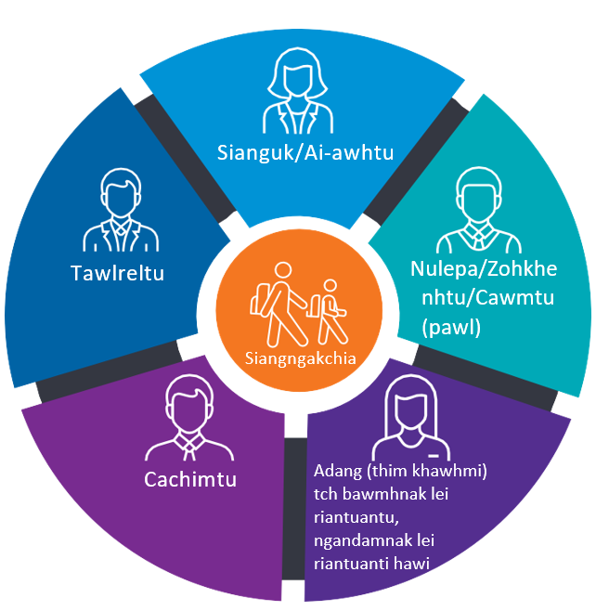
Pumtlinglo Telnak Konglam tawi
Pumtlinglo Telnak Konglam tawi nih na fa i a thazaangthawnnak pawl le a herhmi pawl tamdeuh hmuh khawh dingah sianginn pawl kha a bawmh lai. Cu nih cun pumpak bawmhnak phawtzammi pawl kong theihternak a tuah lai, siangngakchia cawnnak caah le siangngakchia pakhat nih a thadeuhmi cawnnak a herh khawh menmi thlennak pakhat khat caah timhtuahmi a bawmh lai.
Pumtlinglo Telnak Konglam tawi a thar tuahto mi nih Fimcawnnak lei Aherhmi pawl Biahalnak pawl hmanmi kha atu lio PSD phunkhat bantukin a ai-rolh lai.
Sianginn pawl cu fuhpanh thar ah thialkamnak a si bantukin, PSD ah aa telmi siangngakchia pawl i innchungkhar pawl cu Pumtlinglo Telnak Konglam tawi tling tein lum dingah meting kai dingin fial an si lai.
Na fa kong a hngalmi minung kha meeting ah an itel lai, konglam tawi tling tein phitnak ah sianginn pawl le innchungkhar pawl a bawm dingmi amah tein a dirmi, cawnnak a ngeimi riantuanpiaktu he.
Na fa cu PSD ah aa tel ahcun, an konglam tawi tling tein phih dingah aa rem bik caan kawl dingah nangmah he na sianginn cu rian a tuanti lai.
Bawmhnak a herh bakmi siangngakchia tamdeuh phu caah konglam tawi cu hmuh khawh a si fawn.

Thialkaamnak lei tangka bawmhnak
Pumtlinglo Siangngakchia pawl caah Prokarem (PSD) in fuhpanhnak a thar ah nan fa thialkaamnak pawl dirhmun ah fianfainak tamdeuh innchungkhar pawl peknak bawmh dingah, Victoria Acozah nih 2024 tiang Pumtlinglo Telnak lei Thialkaamnak Tangka bawmhnak cu a pek lai.
Pumtlinglo Telnak lei Thialkaamnak Tangka bawmhnak nih PSD in Pumtlinglo Telnak ah siangngakchia i thialkaamnak kha bawmh dingah siangngakchia level ningin tangka bawmhnak tangka zat he aa khatmi asilole tamdeuh sianginn pawl nih an hmuhnak ding kha a fehter.
Thawngthanhmi tamdeuh hmuhnak caah le na fa i a dirhmun pawl ah Pumtlinglo Telnak lei Thialkaamnak Tangka bawmhnak hman ningcang kongkau ah zaangfahnak in nan sianginn sianguk kha pehtlaihnak tuah.

Cachimtu pawl le sianginn riantuantu pawl caah tamdeuh cawnnak le lamhruainak
Cachimtu pawl le riantuantu pawl kha Pumtlinglo Telnak nih pumtlinnak kong thadeuh in hngalhnak le leh ning thadeuh in tuah ding kha a bawmh hna lai. Hi ah hin hi pawl hmuh khawhnak aa tel kho:
- pumtlinlonak kongkau ah thiamsang a simi sianginn pawl i a thiammi pawl tamdeuh
- lamhruainak
- thiamnak lei cawnpiaknak
- thilcang cungah hrambunh lamhmuhsaknak le thilri a hrampi hmuh khawhnak pawl
- cacawnnak caah pekmi tangka pawl.

Thawngthanhmi tamdeuh
Pumtlinglo Telnak kongkau tamdeuh hmuhkhawhnak dingah www.education.vic.gov.au/disabilityinclusion ah zoh.
Sianginn i na fa a herhmi pawl kong chimchawnh na duh ahcun, asilole calehnak asilole holhlehnak lei bawmhnak na herh ahcun, zaangfahnak nan sianginn sianguk kha pehtlaihnak tuah.

