Sample school risk register

School: Red Dot Primary School

Supervising teachers/staff: John Doe

Program/Excursion: Red Dot Primary School, 1 Redding Road, Redville

Year Level (if relevant):

Dates: 1 April 2016

Location(s): 1 Redding Road, Redville

Risk Title & Description | Risk Causes & Consequences | Existing Controls | Current Risk Assessment – with existing controls |  |  |  | Treatment | Target Risk Assessment – after treatments
Define the risk event including a risk title and a short description  What can go wrong? | Describe the risk event cause/s and consequence/s.  What would cause it to go wrong? (causes)  What are the impacts if it does go wrong? (consequences) | Describe any existing policy, procedure, practice or device that acts to minimise the risk  What is in place now that reduces the likelihood of this risk occurring or its impact if it did occur? | Effectiveness of existing controls  How effective are the current controls we have in place?  (choose one) | Current Risk Consequence  How big would the impact of this risk be if it occurred?  (choose one) | Current Risk Likelihood  How likely is this risk to occur?  (choose one) | Current Risk Rating  What is the current risk level based on the risk rating matrix? | Describe the actions to be undertaken for those risks requiring further treatments.  What will be done? Who is accountable? When will it happen? | Target Risk Consequence  (choose one) | Target Risk Likelihood  (choose one) | Target Risk Rating  What is the target risk level based on the risk rating matrix?
Risk Title  Student Learning  Risk short description  There is the risk that the school will not improve student outcomes in literacy and numeracy. | Causes  - Lack of professional development opportunities for staff  - High absentee rates  - Inadequate or obsolete ICT hardware / software / networks  - Administrative burden (regulatory, social and legal compliance) 'red tape'  - Ability to recruit, train and retain appropriately skilled teachers  - Insufficient funding to support strategic objectives (SRP internal funding does not achieve target)  - Lack of leadership at local levels  - Failure to engage students in curriculum  - Ongoing organisational renewal may impact service delivery  - Lack of casual relief teachers  - Strategic targets and priorities not realistic  Consequences  - Failure to achieve targeted NAPLAN results  - Falling VELS achievement levels (or no improvement)  - Reputation damage to the school, the Department and the Government  - Criticism from school community  - Decreasing enrolments (further impacting funding and creating cyclic issues)  - Low staff morale  - High staff turnover | - School Strategic Plan, Annual Implementation Plan, curriculum review and ongoing development  - Review and standardise pedagogical practices  - BASTOW Institute of Educational Leadership Courses to raise leadership skills and abilities within the school  - Ongoing tracking of student performance against AusVELS targets  - Active Teacher Professional Leave program for professional development  - Strengthen classroom practices across the school through strategic use of the most skilled staff  - Use the implementation of the AusVELS as an opportunity to review curriculum and teaching and learning practices  - Promotion of school as a desirable place to work  - Scarce human, facility and finance resources applied in the most effective manner  - Ongoing involvement by school community  - Student resource package (SRP) funding  - Framework for ICT in schools (eduSTAR) - sponsored by ITD Central Office | Needs improvement | Major | Possible | High | - Develop tailored strategies for individual students including specific educational outcomes targets for students  - Evaluation of school performance data and research to identify needs and implement best practice education strategies  - Continue to develop and implement literacy strategies  - Continue to build teacher capacity in the use of learning technologies  - Provide ongoing professional learning for all staff to ensure a base level of understanding of literacy and numeracy  - Induct new teachers and provide professional learning (ADITL)  - Work with SEILs to review, improve and implement strategies to improve student learning  - Develop a school ICT strategy / implementation plan  - Monitor and review this risk as a regular agenda item at School Council meetings | Moderate | Possible | Medium
Risk Title  Student engagement and wellbeing  Risk short description  There is the risk that student engagement and wellbeing fails to improve their connectedness to the school, their peers and the broader community. | Causes  - Lack of professional development opportunities for staff  - Ability to recruit, train and retain appropriately skilled teachers  - Insufficient funding to support strategic objectives (SRP internal funding does not achieve target)  - Lack of leadership at local levels  - Failure to engage students in curriculum and other school activities  Consequences  - Best outcomes for students not achieved  - Students do not reach competent numeracy and literacy levels  - Reputation damage to the school, the Department and the Government  - Criticism from school community  - Decreasing enrolments (further impacting funding and creating cyclic issues) | - School Strategic Plan, Annual Implementation Plan, curriculum review and ongoing development  - Active Teacher Professional Leave program for professional development  - Review student wellbeing arrangements to ensure each student is ‘known and valued’ by a significant adult at school.  - Provide ongoing PD for staff identified as the ‘significant teachers,’ to support them in their pastoral responsibilities  - Promote and publicise excellence in debating, sport, drama, competitions etc. through the school newsletter and assemblies  - Regular school leadership team meetings to monitor and review progress  - See wellbeing and safety - within school grounds risk, wellbeing and safety - outside school grounds risk and emergency response risk | Needs improvement | Major | Possible | High | - Broaden range of strategies which give students the opportunity to lead students and contribute to the cultural life of the school, such as; sport, music, drama, debating, public speaking, student council etc.  - Continue to work towards the personalising of learning for all students  - Explore ways to strengthen home-school partnerships and thus increase parental involvement  - Update and review school website to ensure it reflects best aspects of the school  - Teaching planners include: response to relevant local, national and international current affairs and events  - Develop a strategy for enhancing communication and the quality of information for parents  - Work with SEILs to develop and implement strategies to improve student engagement and wellbeing  - Monitor and review this risk as a regular agenda item at School Council meetings | Major | Unlikely | Medium
Risk Title  Student pathways and transitions  Risk short description  There is the risk that the school does not improve transitions into, through and out of school. | Causes  - Administrative burden (regulatory, social and legal compliance) 'red tape'  - Local stakeholders not effectively engaged  - Pathways and transitions not understood by parents  - Ineffective communication strategies  - Ability to recruit, train and retain appropriately skilled teachers  - Budget / resource constraints  - Lack of leadership at local levels  - Failure to engage students in curriculum  - Failure to maintain pathways and transitions through the education system  Consequences  - Disadvantaged youth leave school system  - Best outcomes for students not achieved  - Students do not reach competent numeracy and literacy levels | - School Strategic Plan, Annual Implementation Plan, curriculum review and ongoing development  - Engagement in the political agenda through evidence based policy discussions  - Departmental research and projects undertaken to identify and implement best practice education strategies through school review process  - Promotion of school as a desirable place to work  - Scarce human, facility and finance resources applied in the most effective manner  - Ongoing involvement by school community  - Recognition there is a limit to the pool of staff due to geographical isolation (in some cases)  - Recognition there will be different educational outcomes and level of schooling among students | Needs improvement | Major | Possible | High | - Develop a financial plan to supplement existing strategies to widen pathways and transitions opportunities  - Review and analyse the demographics of all student exit data to determine that student destination is a meaningful pathway or level of school accountability for exit  - Continue to develop knowledge and skills of those who counsel students in making course and pathways choices  - Continued development, implementation and evaluation of school programs  - Continue to develop meaningful relationships with feeder kindergartens/schools  - Work with SEILs to develop and implement strategies to provide better pathways across the school system and vocational education  - Monitor and review this risk as a regular agenda item at School Council meetings | Major | Unlikely | Medium
Risk Title  Small school  Risk short description  There is a risk that small schools will not be able to provide their students education choices that meet their learning needs, aspirations and interests.  (A small school is defined as a school with an enrolment of 100 or less students)  Small school opportunity  Small schools can create highly personalised learning environments with teachers better able to connect with their students (smaller class sizes contribute to that). | Causes  - Failure to attract, retain, develop and engage suitable workforce (teachers and support staff)  - Lack of capacity and expertise of principals and leaders to lead school improvement and understanding of lifelong learning model in autonomous environment  - Lack of aspiration to principal class roles due to perceived workload and duality of principal / teacher role in smaller schools  - Smaller schools can only offer a limited curriculum (hard to attract music, maths & science teachers to remote rural areas - see cause 1  - Size of school determines financial support (SRP)  - Lack of professional development opportunities for staff  - Lack of Departmental / regional support  - Lack of quality facilities and equipment  Consequences  - Failure to achieve improved learning outcomes  - Failure to demonstrate sustained improvement in student engagement and wellbeing  - Fail to improve pathways and transitions  - Failure to support disadvantaged youth  - Poor student attendance  - Reputation damage to the Department | - School Strategic Plan, Annual Implementation Plan, curriculum review and ongoing development  - Need for a systematic response (Network and cluster mechanisms)  - Peer networks across Regions for individual positions  - Targeted programs - e.g. disengaged youth, Wannik, etc.  - Principal Reference Group is a forum for communication of the Department's new directions and resources to support school improvement  - PDP processes and professional development  - TVLC, Strategic Plan, priority projects and action plans (see below and within Treatments to be implemented)  - Implement Learning Places  - Parenting Strategy  - School improvement networks | Needs improvement | Major | Possible | High | - Develop and implement engagement plan with local community  - Continue implementation of National Quality Framework  - Develop better pathways between school and vocational education  - Support more productive partnerships, through youth engagement  - Support more productive partnerships, through school partnerships  - Develop and implement Workforce Development Plan  - Build on the existing social and academic relationships with feeder kindergartens/schools  - Work with SEILs to develop and implement enrolment strategies  - Monitor and review this risk as a regular agenda item at School Council meetings | Major | Unlikely | Medium
Risk Title  Succession planning  Risk short description  There is the risk of a lack of succession planning for key staff. | Causes  - High staff turnover  - Lack of budget  - Lack of planning  - Lack of leadership at local levels  - Lack of opportunity for key staff (small school)  - Geographically isolated school  Consequences  - Low staff morale  - Decreasing enrolments  - Failure to achieve targeted (school / state / national) numeracy and literacy levels  - Reputation damage for the school, the Department and the Government | - Workforce planning strategies  - BASTOW Institute of Educational Leadership to raise leadership skills and abilities within the school  - Regular school leadership team meetings to monitor, review and provide feedback to key staff  - On the job coaching, mentoring and empowerment | Needs improvement | Moderate | Possible | Medium | - Develop job rotation / sharing strategy to allow for leading teacher developmental opportunities  - Continue to build teacher capacity in the use of learning technologies  - Key VCE teachers use relevant data to evaluate current practices and inform teaching improvements  - Develop relationships with other schools within geographical cluster to allow for relief teaching opportunities  - Monitor and review this risk as a regular agenda item at School Council meetings | Moderate | Unlikely | Medium
Risk Title  Workforce planning  Risk short description  There is the risk of the inability of the school to attract, retain and train suitable staff; including teaching staff, support staff, casual relief teachers and non-teaching staff. | Causes  - Geographically isolated school  - Lack of respect for shown by school community towards staff  - Inability to compete with private sector wages  - Budget limitations  - School / community reputation  - Lack of leadership at local levels  - Lack of suitable CRTs to enable staff professional development  - Failure to reliably forecast annual CRT resourcing needs (budget)  - Salary expectations are not met  Consequences  - Failure to achieve outcomes in school strategic plan  - Low staff morale and high turnover  - Decreasing enrolments (further impacting funding and creating cyclic issues)  - Delay or failure to implement Department priorities/policy  - Reputation damage to the school, the Department and the Government | - Use of Teachers Professional Leave program (TPL) to employ Casual Relief Teachers (CRT)  - Promotion of school as a desirable place to work e.g. market work life balance  - Ongoing dialogue with Regional Office  - Recognition there is a limit to the pool of CRT due to geographical location  - SRP funding  - Human Resources Web (HRWeb) policies and strategies  - PDP processes and professional development  - Induct new teachers and provide professional learning (ADITL) | Needs improvement | Major | Possible | High | - Develop publicity campaign to attract new teachers into the market place  - Identify Bastow Institute professional development courses to build excellence in the teaching profession  - Share resources between schools  - Continue to build teacher capacity in the use of learning technologies  - Induct new teachers and provide professional learning (ADITL)  - Monitor and review this risk as a regular agenda item at School Council meetings | Moderate | Possible | Medium
Risk Title  OH&S  Risk short description  There is a risk that staff, students or visitors on school sites (or staff, students and accompanying individuals during school sanctioned activities) suffer an injury or stress / trauma event as a result of an OH&S incident. | Causes  - Conflict/bullying/intimidating and/or threatening behaviour or harassment of staff, students or visitors and/or accompanying individuals  - Work-related stress  - Slip, trip or fall hazards  - Storage, handling and transport of materials and equipment  - Musculoskeletal injury at work  Consequences  - Inability to deliver on school goals, targets and key improvement strategies  - Potential high staff turnover  - Recruitment and re-training costs  - Staff low morale and motivation  - Increased absenteeism  - Increased workload on other staff  - Loss of corporate knowledge  - Poor public image and negative media | - WorkCover insurance  - Comply with the Department’s OHS Management System  - Clearly defined work plan  - Promote and publicise school expectations regarding school core values inclusiveness, respect, empathy, etc.  - Regular school leadership team meetings to monitor and review progress regarding OH&S management plan  - Promote the availability of the Employee Assistance Program  - Communicate the availability of online training to staff i.e. Respectful Workplaces and Workplace Bullying, OHS for employees, OHS Manual Handling, Hazard & Incident Reporting, Ergonomics.  - Provide staff with opportunities for relevant professional development and training | Needs improvement | Major | Possible | High | - Develop and implement engagement plan with local community  - Update and review school website to ensure it reflects school values, attitudes and culture regarding behaviour expectations  - Review and modify storage areas so that frequently accessed or heavy items are stored between shoulder and knee height  - Develop and implement an agreed Performance Development Plan which clearly outlines key accountabilities, activities and behaviours  - Review OHS incident data files and implement corrective measures  - Monitor and review this risk as a regular agenda item at School Council meetings | Major | Unlikely | Medium
Risk Title  Wellbeing and safety - within school grounds  Risk short description  There is the risk of injury to staff, students, contractors or visitors within school grounds / surrounds | Causes  - Failure to employ appropriate OHS principles and practices  - Lack of supervision or appropriate / adequate supervision (staff ratios)  - Recklessness / criminal act including sexual assault, drug use / abuse on school grounds e.g. prescription and illegal drugs, alcohol  - Unauthorised person(s) on school grounds e.g. drug dealer, gang member, non-custodial family member  - Student violence towards student / staff  - Staff violence towards student / staff  - Parent / visitor violence towards staff / student  - Self-harm  - Failure to use PPE  - Disregard / breach of policy and/or procedures  - Accident or misadventure e.g. infectious disease outbreak, electrocution (faulty equipment), chemical spill, gas leak etc.  - Allergic reaction arising from insect bite / sting /food product / chemical contact (anaphylaxis)  - Bullying / discrimination  - Exposure to asbestos  - Injury sustained as a result of Community use of school facility afterhours (sports injury)  - Pedestrian / traffic accident on school grounds associated with set down / pick up of students  Consequences  - Death, injury or disability  - Workers Compensation / Public Liability claim  - Cost implications (time and money for investigations / reporting / rehabilitation)  - Possible litigation  - Disruption to learning programs  - Stress event requiring professional help  - Inquest / Coroner's Inquiry  - Reputation damage to the school, the Department and the Government | - Implementation of DET OH&S Management System. See applicable elements below (no 2-11)  2. Communication and Consultation  3. OHs Policy and Planning  4. OHS Risk Management  5. Contractor Management  6. Hazard Management  7. OHS Purchasing  8. First Aid and Infection Control  9. Induction and Training  10. Document Management  11. Evaluation  - Incident and Hazard Reporting System (eduSafe)  - OHS Advisory Service for support  - WorkSafe Claims Advisory Service  - Employees Assistance Program  - Conflict Resolution Support Service | Needs improvement | Severe | Unlikely | High | - Review and management of DET's OHS Management System  - Monitor and review this risk as a regular agenda item at School Council meetings | Major | Rare | Medium
Risk Title  Wellbeing and safety - outside school grounds  Risk short description  There is the risk of injury to staff, students or contractors (or staff, students and accompanying individuals during school sanctioned activities) suffer an injury or stress / trauma event as a result of activities outside normal school surrounds, i.e. during education outdoors activity | Causes  - Failure to adequately prepare and plan  - Fail to apply principles of risk management in planning stages  - Failure to employ appropriate OHS principles and practices  - Lack of supervision or appropriate / adequate supervision (staff ratios)  - Recklessness / criminal act including sexual assault, drug use / abuse on school grounds e.g. prescription and illegal drugs, alcohol  - Pedestrian / traffic accident on school grounds associated with set down / pick up of students  - Risky nature of adventurous activity  - Failure to use PPE  - Disregard / breach of policy and/or procedures  - See overseas travel risk  - Wilful disobedience  Consequences  - Death, injury or disability  - Workers Compensation / Public Liability claim  - Cost implications (time and money for investigations / reporting / rehabilitation)  - Possible litigation  - Disruption to learning programs  - Stress event requiring professional help  - Inquest / Coroner's Inquiry  - Reputation damage to the school, the Department and the Government | - Adopt and apply DET risk management policy and procedures to identify, assess, evaluate, treat, monitor, review and report risks for the duration of the activity  - Appointment of lead teacher as decision maker and point of contact between students, teachers, principal and parents for the duration of the activity  - The lead teacher will ensure that all excursion considerations and planning and approval procedures as outlined in the School Policy and Advisory Guide are met and adhered to particularly requirements for any adventure activities  - Relevant medical information (allergies etc.) and emergency contact details obtained for each student and shared with appropriate people  - Where safety equipment is provided / required it is to be worn / used  - Activate a communication plan for emergency situations  - See excursion /camp risk assessment documentation  - See overseas travel risk assessment documentation (risk register and Overseas Travel Contingency and Emergency Response Manual) | Needs improvement | Severe | Unlikely | High | - Review and management of DET's OHS Management System  - Lead teacher upon arrival at excursion/camp to conduct briefing with responsible authority/person regarding emergency management protocols or any updates regarding local conditions prevalent at that time  - Lead teacher following briefing with responsible authority/person to brief teaching staff of any updates  - Lead teacher to conduct an end day (each day) debrief to identify any issues arising and to lead the development of treatment solutions  - Monitor and review this risk as a regular agenda item at School Council meetings | Major | Rare | Medium
Risk Title  Financial performance  Risk short description  There is the risk that school’s financial performance does not support the school strategic plan (SSP) and the annual implementation plan (AIP) | Causes  - Ineffective budget calculation (SRP)  - Over commitment of funding  - Inaccurate growth predictions (declining enrolments)  - Fund raising activities don't meet target / expectations  - Theft / loss / fraud  Consequences  - SSP and AIP goals, targets and key improvement strategies cannot be delivered  - Educational outcomes not met  - Reputation damage | - Compliance to Financial Management Act and Accountability Act 1997 and the Education and Training Reform Act 2006  - Compliance and operational audits  - Managerial / supervisor oversight, monitoring, and review of tasks - in schools by Principal and School Council  - Compliance to SPAG requirements  - Fraud and Corruption Control policy and procedures  - Adherence to DET policies and procedures | Needs improvement | Major | Possible | High | - Develop financial review strategy - suggest quarterly timeframe and School Council sign off  - Monitor and review this risk as a regular agenda item at School Council meetings | Major | Unlikely | Medium
Risk Title  Infrastructure  Risk short description  There is the risk that the school infrastructure is not adequate to provide appropriate educational outcomes or does not meet community expectations | Causes  - Loss or damage due to arson / vandalism / storm damage / natural disaster / bush fire  - Natural growth / strategic planning does not match growth / shifting population  - Inadequate maintenance increases vulnerability e.g. blocked gutters lead to storm damage  - Recklessness / criminal act  Consequences  - Loss of access to facilities until repaired / replaced  - Requirement to use sub-optimal temporary facilities  - Improved educational outcomes not achieved  - Loss of facilities without replacement (if over entitlement)  - Disruption to learning programs  - Inconvenience to every day routine  - Reputation damage for the school, the Department and the Government | - School Strategic Plan and Annual Implementation Plan  - Funding applications to Commonwealth and State Governments  - Ongoing liaison with Infrastructure and Sustainability Division - Central Office  - Ongoing liaison with local members of parliament  - Ongoing liaison with local police  - Security risk management –systems (target hardening, environmental design, electronic systems, policies, procedures) - SPAG  - Asset management system  - Ongoing liaison with Regional Office | Needs improvement | Major | Possible | High | - Secure rubbish bins  - Establish liaison with local police, fire, ambulance emergency response personal and develop positive ongoing relationship as preparation for any contact situations  - Develop funding application strategy to enhance success of infrastructure funding bids  - Monitor and review this risk as a regular agenda item at School Council meetings | Moderate | Unlikely | Medium
Risk Title  School community  Risk short description  There is the risk of decreasing support from the school community | Causes  - Failure to deliver improvement in educational outcomes  - Declining enrolments impact SRP  - Poor stakeholder management by school staff  - Lack of leadership at local levels  - Lack of community involvement / interest with school  - Failure to engage students in curriculum  - Lack of resources / budget  Consequences  - Declining enrolments impact SRP  - Important services (e.g. reading activities, canteen work etc.) reduced or discontinued  - Financial impact due to having to pay for services / loss of fund raising support  - Reputation damage for the school, the Department and the Government | - Communications strategy to inform and involve locals in school affairs  - DET Stakeholder Engagement Framework - SPAG  - Direct involvement of Regional Support Group re community involvement in school activities / programs  - Making the school an attractive and welcoming place for community volunteer work around school programs | Needs improvement | Major | Possible | High | - Develop and implement engagement plan with local community  - Develop and deliver stakeholder management training / forum for all staff  - Monitor and review this risk as a regular agenda item at School Council meetings | Moderate | Unlikely | Medium
Risk Title  Emergency response  Risk short description  There is the risk of the failure to respond to emergencies adequately / appropriately / promptly | Causes  - Inadequate Emergency Management Plan (EMP)  - Failure to undertake periodic review or implement lessons learnt from practices / incidence  - Lack of appropriately skilled / trained staff  - Failure to practice emergency responses  - Lack of leadership re emergency management at local levels (Regional Office, Principals)  Consequences  - Injuries to staff and students  - Destruction / damage of facilities  - Stress event requiring professional help  - Disruption to learning programs  - Disruption / inconvenience to every day routine  - Inquest / Coroner's Inquiry  - Reputation damage to the school, the Department and the Government | - Develop, implement, practice and review EMP (see Emergency Management - SPAG)  - Communication Plan / Strategy  - Planned and practiced evacuation and emergency training drills  - Ongoing maintenance of facilities and surrounding grounds e.g. firebreaks, gutters cleared etc.  - Ongoing liaison with regional Office | Needs improvement | Severe | Unlikely | High | - Develop Communications Plan / Strategy and activate / implement depending upon situation (Principal to decide trigger event)  - Establish liaison with local police, fire, ambulance response personal and develop positive ongoing relationship as preparation for any contact situations  - Monitor and review this risk as a regular agenda item at School Council meetings | Major | Rare | Medium
Risk Title  Information security / accessibility  Risk short description  There is the risk of unauthorised access, misuse, modification, alteration, release (leaking) of records (information) including failing to comply with privacy legislation regarding records (information) | Causes  - Inadequate information security systems / guards / classifications  - Unethical (unlawful) behaviour by staff member / contractor  - Aggrieved staff member or contractor  - Accidental release / failure to safeguard / appropriately destroy / deal with records  - Lack of accessibility and/or ease of accessibility to records (information)  Consequences  - Litigation for breach of copyright / privacy  - Potential consequences under Archives Act  - Cost involved in restoration of records  - Possible impact on student learning or student / staff well being  - Possible civil action (aggrieved party - student, teacher, parent)  - Reputation damage for the school, the Department and the Government | - Compliance to DET's ICT Security Policy - SPAG  - Compliance to DET's Information Security Policy  - Electronic records back up stored in secure drive / area  - Log in / password protocols  - Anti-virus software  - Paper records stored in secure area  - Disposal of records policy and procedures  - Records transferred to archives as much as possible  - System access controls  - Firewall and audit trails | Needs improvement | Moderate | Possible | Medium | - Develop induction pack for new staff  - Develop information security awareness campaign  - Monitor and review this risk as a regular agenda item at School Council meetings | Moderate | Unlikely | Medium
Risk Title  Overseas study experience  Risk short description  There is the risk of students failing to gain educational outcomes sought as part of an overseas study experience | Causes  - Medical emergency (localised infection, pre-existing medical condition, exotic disease, slip, trip, fall)  - Politically motivated activity (terrorism, kidnap, civil unrest, protests, strikes)  - Natural disaster (fire, flood, earthquake, storm, volcano)  - Lost staff member, student, guardian  - Poor behaviour  - Travel disruption (missed flight / connections / lost tickets)  - Criminal activity (perpetrator - victim)  Consequences  - Death, injury, hospital admission  - Student: staff ratio changes  - Full recovery not guaranteed  - Admission to hospital with no control over who (how) patient treated  - Exorbitant hospital costs  - Possible evacuation and flights home  - Stress event for all concerned  - Reputation damage for school and the Department | - See dedicated overseas travel risk register | Needs improvement | Severe | Unlikely | High | - See dedicated overseas travel risk register  - Monitor and review this risk as a regular agenda item at School Council meetings | Major | Rare | Medium
Risk Title  Fraud / corruption risk  Risk short description  There is the risk of a staff member or contractor acting dishonestly to obtain a benefit | Causes  - Opportunity combined with a lack of adequate controls  - Unethical behaviour  - Wilful non-compliance with DET policies and procedures including conflict of issues policy  - Lack of supervision  Consequences  - Loss of trust impacting ability to achieve outcomes (i.e. inability to raise funds in future)  - Financial loss: monies / asset stolen or overpayment  - Time lost to investigate alleged fraud or corruption matter  - Time lost replacing FTE /contractor  - Reputation damage for school and the Department | - Processing (recording, receipting, securing) any cash takings immediately - in schools through CASES 21 - SPAG  - Two people counting cash (concurrent or consecutive)  - Two people securing cash into safe / strongbox etc.  - Separation / segregation of duties (Procurement - requisitioner, approver and receiver)  - Monthly bank reconciliations  - Frequent / daily bankings  - Adherence to DET's Procurement and Recruitment Policy and Guidelines  - Conflict of Interest Policy  - VPS Code of Conduct  - Validation and certification of sick leave / annual leave  - Managerial / supervisor oversight, monitoring, and review of tasks  - Fraud and Corruption Control policy and procedures | Needs improvement | Major | Possible | High | - Develop financial review strategy - including review of procurement actions - monthly by Principal - then quarterly by School Council  - Monitor and review this risk as a regular agenda item at School Council meetings | Major | Unlikely | Medium
Add more rows as required. This is one way of documenting the risk management process and does not preclude other approaches. The list of risks listed here is not exhaustive and should be adapted to suit the circumstances of your school.
DET Risk Process 

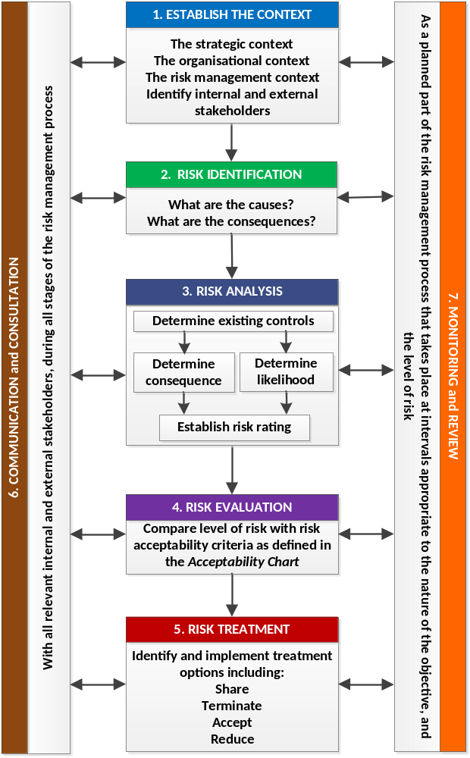

Risk can be described as anything; event, practice, process, activity, etc. that could hinder or help achievement of stated goals or objectives.
DET Risk Process
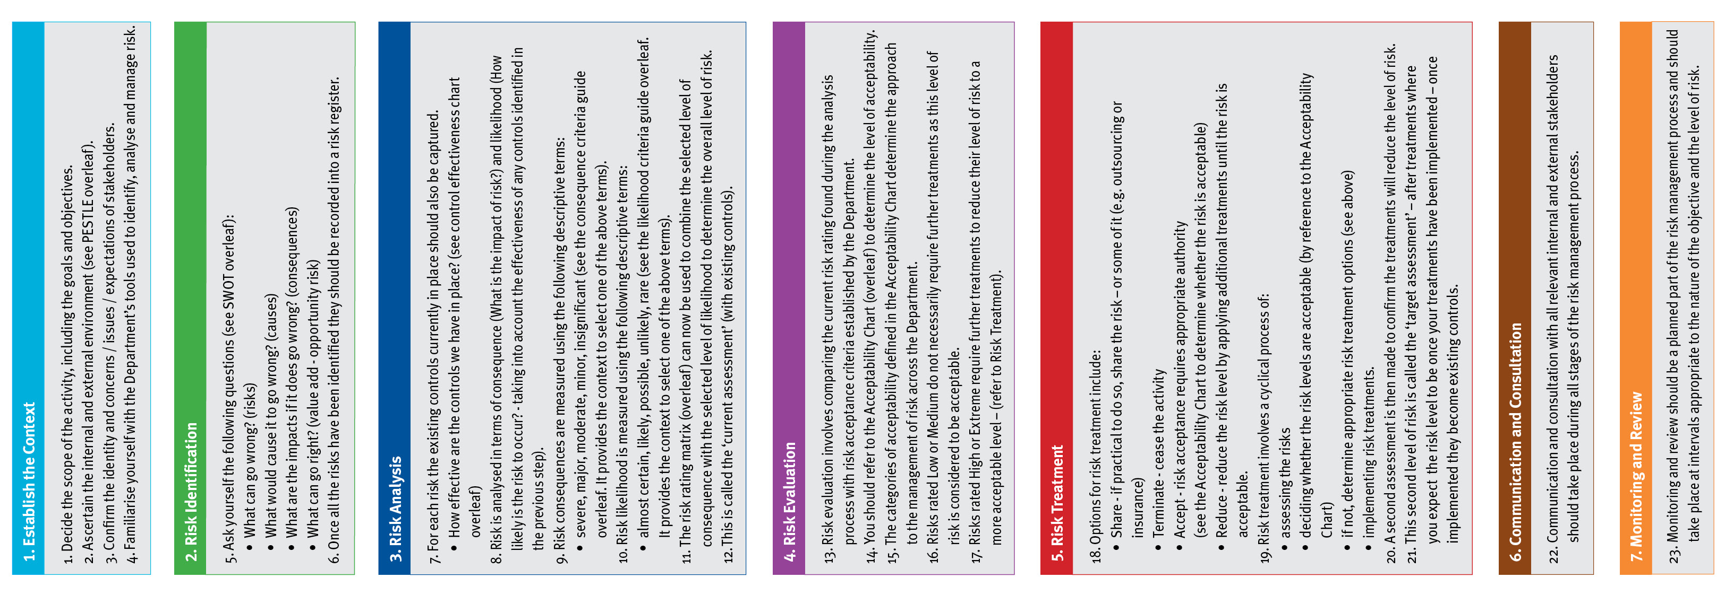
DET Risk Management Framework - Assessment Tools
Consequence Criteria: This guide provides indicative terms against which the significance of risk is evaluated.
Descriptor | Student Outcomes | Wellbeing and Safety | Finance | Reputation | Operations | Strategic
Insignificant | - Educational outcomes, engagement and wellbeing and pathways and transitions can be met with workarounds | - Minor injury requiring no first aid or peer support for stress / trauma event | - Small loss that can be absorbed | - Internal impact (no external impact) | - School operations continue with slight interruptions to normal activities | - Goals, targets and key improvement strategies can be delivered with inconsequential impacts
Minor | - Educational outcomes, engagement and wellbeing and pathways and transitions achieved but below targets | - Injury / ill health requiring first aid  - Peer support for stress / trauma event | - Loss of ‘consumable’ assets,  - < 2% deviation from budget  - Minor fraud possible | - Adverse comments local community media  - Short term stakeholder dissatisfaction / comment | - Some school operations disrupted  - Minor workarounds return school to normal operations | - Minor workaround need to be implemented to deliver the SSP goals, targets and key improvement strategies
Moderate | - Students’ overall levels of Literacy and Numeracy static  - Increasing truancy  - Partial achievement of targeted pathways and transition | - Injury / ill health requiring medical attention  - Stress / trauma event requiring professional support | - Loss of assets  - 2% - 5% deviation from budget  - External audit management letter | - External scrutiny e.g. VAGO  - Adverse state media comment  - Stakeholder relationship impacted | - Key school operations temporarily disrupted  - School leadership team meets to return school to normal operations | - Constant consultation with key stakeholders needs to be maintained to deliver the SSP goals, targets and key improvement strategies
Major | - National targeted improvements not achieved  - Partial achievement of targeted learning outcomes  - Student dissatisfaction with access to pathways / transitions | - Injury / ill health requiring hospital admission  - Stress / trauma event requiring ongoing clinical support | - Loss of significant assets  - 6% - 15% deviation from budget  - External audit qualification on accounts  - High end fraud committed | - External investigation  - Adverse comments national media  - Stakeholder relationship tenuous | - Whole of school operations disrupted  - Assistance sought from Regional Office | - Significant adjustment to resource allocation and service delivery required to deliver SSP goals, targets and key improvement strategies
Severe | - Literacy and Numeracy decline  - Student engagement and connectedness to the school and their peers is very poor  - Declining number of student options for pathways and transitions | - Fatality or permanent disability  - Stress / trauma event requiring extensive clinical support for multiple individuals | - Loss of key assets  - >15 % deviation from budget  - Systemic and high value fraud | - Commission of inquiry  - National front page headlines  - Stakeholder relationship irretrievably damaged | - Normal school operations cease  - School evacuated  - Regional Office notified | - SSP goals, targets and key improvement strategies cannot be delivered  - Changes need to be made to the SSP
Likelihood Criteria: This guide provides the indicative terms against which the probability of a risk event occurrence is evaluated.
Descriptor | Description | Indicative % | Indicative Frequency | Note:  - The Likelihood Criteria refers to the likelihood of the consequence descriptor you have selected i.e. the likelihood of a ‘major’ consequence.  - The Indicative Frequency may not be relevant when assessing risks related to repeated activities, or when objectives are to be delivered over discrete periods of time. It should not be the sole basis for assessment.
Almost Certain | Expected to occur | >95% | Multiple times in the next year
Likely | Probably will occur (no surprise) | 66-95% | At least once in the next year
Possible | May occur at some stage | 26-65% | Once in the next 3 years
Unlikely | Would be surprising if it occurred | 5-25% | Once in the next 5 years
Rare | May never occur | <5% | Once in the next 10 years
DET’s Control Effectiveness: Indicates the self-assessment of control effectiveness.
Controls Effectiveness Rating and Criteria
Ineffective | - The design of controls overall, is ineffective in addressing key causes and/or consequences.  - Documentation and/or communication of the controls does not exist (e.g. policies, procedures, etc.).  - The controls are not in operation or have not yet been implemented.
Needs Improvement | - The design of controls only partially addresses key causes and/or consequences.  - Documentation and/or communication of the controls (e.g. policies, procedures, etc.) are incomplete, unclear or inconsistent.  - The controls are not operating consistently and/or effectively and have not been implemented in full.
Acceptable | - The design of controls is largely adequate and effective in addressing key causes and/or consequences.  - The controls (e.g. policies, procedures, etc.) have been formally documented but not proactively communicated to relevant stakeholders.  - The controls are largely operating in a satisfactory manner and are providing some level of assurance.
Effective | - The design of controls is adequate and effective in addressing the key causes and/or consequences.  - The controls (e.g. policies, procedures, etc.) have been formally documented and proactively communicated to relevant stakeholders.  - The controls overall, are operating effectively so as to manage the risk.
DET’s Risk Rating Matrix: Used to combine consequence with likelihood to determine the overall level of risk.
Risk Rating Matrix |  | Consequence
 |  | Insignificant | Minor | Moderate | Major | Severe
Likelihood | Almost Certain | Medium | High | Extreme | Extreme | Extreme
Likelihood | Likely | Medium | Medium | High | Extreme | Extreme
Likelihood | Possible | Low | Medium | Medium | High | Extreme
Likelihood | Unlikely | Low | Low | Medium | Medium | High
Likelihood | Rare | Low | Low | Low | Medium | Medium

DET’s Acceptability Chart: Used to decide whether the risk is acceptable, based on the rating calculated.
Extreme = Unacceptable  (must have Principal / School Council / Regional Office oversight) | Immediately consider whether the activity associated with this risk should cease. Any decision to continue exposure to this level of risk should be made at Principal / School Council / Regional Office level, be subject to the development of detailed treatments, on-going oversight and high level review.
High = Tolerable  (with ongoing Principal Class Officer review) | Risk should be reduced by developing treatments. It should be subject to on-going review to ensure controls remain effective, and the benefits balance against the risk. Escalation of this level of risk to Principal Class Officer level should occur.
Medium = Tolerable  (with frequent risk owner review) | Exposure to the risk may continue, provided it has been appropriately assessed and has been managed to as low as reasonably practicable. It should be subject to frequent review to ensure the risk analysis remains valid and the controls effective. Treatments to reduce the risk can be considered.
Low = Acceptable  (with periodic review) | Exposure to this risk is acceptable, but is subject to periodic review to ensure it does not increase and current control effectiveness does not vary.
Find Risk Management on eduGate
School Cycle - where schools should use risk management
Utilise risk management at all stages of the school cycle, to drive decision making, establish priorities and allocate resources. Risk management should be based on the best information available. Effort expended should be proportionate to the risk and benefits should be balanced against the risk.

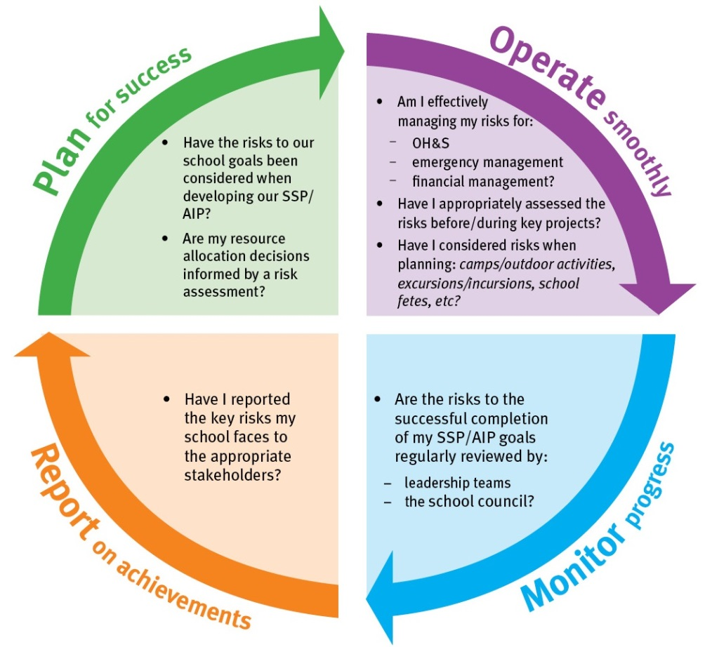

PESTLE Analysis - used to establish the context
PESTLE - (political, economic, social, technological, legal, environmental) is a useful tool to analyse the operating environment and to understand any other factors that contribute to it. It may be beneficial to involve your key stakeholders when conducting this type of analysis.

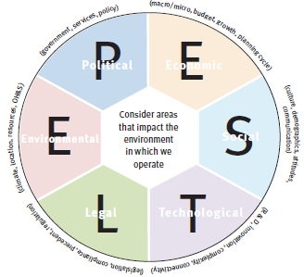

SWOT Matrix - used in risk identification
A SWOT Matrix (strengths, weaknesses, opportunities and threats) is a useful tool to analyse the environment and establish current issues and future risks. It may be beneficial to involve your key stakeholders when conducting this type of analysis.



