Sample ‘Child Safety’ risk register

School: Red Dot Primary School

Supervising teachers/staff: John Doe

Program/Excursion: ‘Child Safety’ risk register

Year Level (if relevant):

Dates: 1 August 2016

Location(s): 1 Redding Road, Redville

Risk Title & Description | Risk Causes & Consequences | Existing Controls | Current Risk Assessment – with existing controls |  |  |  | Treatment | Target Risk Assessment – after treatments
Define the risk event including a risk title and a short description  What can go wrong? | Describe the risk event cause/s and consequence/s.  What would cause it to go wrong? (causes)  What are the impacts if it does go wrong? (consequences) | Describe any existing policy, procedure, practice or device that acts to minimise the risk  What is in place now that reduces the likelihood of this risk occurring or its impact if it did occur? | Effectiveness of existing controls  How effective are the current controls we have in place?  (choose one) | Current Risk Consequence  How big would the impact of this risk be if it occurred?  (choose one) | Current Risk Likelihood  How likely is this risk to occur?  (choose one) | Current Risk Rating  What is the current risk level based on the risk rating matrix? | Describe the actions to be undertaken for those risks requiring further treatments.  What will be done? Who is accountable? When will it happen? | Target Risk Consequence  (choose one) | Target Risk Likelihood  (choose one) | Target Risk Rating  What is the target risk level based on the risk rating matrix?
Risk Title  School culture: child safety  Risk short description  There is a risk the school does not develop a culture of child safety | Causes  - Lack of an effective child safety risk management strategy  - Fail to ensure that appropriate guidance and training is provided to the individual members of the school council and school staff about child safety  - School fails to monitor who is on the premises  - Lack of reporting procedures  - Lack of understanding of roles and responsibilities in relation to child safety  Consequences  - Child safety incident occurs  - Physical or psychological injury  - Stress for all personnel involved  - Litigation / adverse court ruling  - Reputation damage | - Implement child safety risk management strategy (Child Safety Standard 6, requirement 1, page2)  - Adopt and apply risk management procedures to identify, assess, evaluate, treat, monitor, review and report child safety risks (Child Safety Standard 6, requirements 2, 3 & 4, pages 3, 4 & 5)  - Child safety policy and statement of commitment.  - Child safety code of conduct.  - Adopt practices as outlined in the VRQA Strategies to embed an organisational culture of child safety  - Utilise the practices as outlined in the DHHS Good leadership and governance in child safe organisations  - Implement human resources practices for child safe organisations  - Appointment of a child safety officer/champion for the school.  - Child safety a standard discussion item on School Leadership Team meetings and all staff meetings.  - Staff, volunteers, visitors and contractors’ induction regarding the school’s current child safety standards and practices. | Needs improvement  (example only) | Major  (example only) | Possible  (example only) | High  (example only) | - Develop and deliver training to the School Council and staff about:  - individual and collective obligations and responsibilities for managing the risk of child abuse;  - child abuse risks in the school environment; and  - the school’s current child safety standards (Child Safety Standard 6, requirement 5, page 5).  - The School Council will develop strategies to deliver appropriate education about:  - standards of behaviour for students attending the school;  - healthy and respectful relationships (including sexuality);  - resilience; and  - child abuse awareness and prevention (Ministerial Order No. 870- Child Safe Standards, Part 2, section 13 [1] & [2] – see Child Safe Standards resources (VRQA) – Empowerment and participation of children).  - Inclusion of child safety obligations in staff position descriptions.  - Develop and distribute regular school bulletins containing material related to child safety to inform the school community.  - Conduct periodic reviews of the effectiveness of the child safety risk management strategies put into practice and, if considered appropriate, revise those strategies utilising the following resources:  - Child safe standards resources (DHHS)  - Child Safe Standards resources (VRQA) | Major  (example only) | Possible  (example only) | Medium  (example only)
Risk Title  Non reporting  Risk short description  There is a risk that the school does not report child safety issues | Causes  - Lack of reporting protocols  - Staff not aware of reporting protocols  - Staff not aware of their reporting obligations  - Familiarity of relationships  - Poor child safety culture  Consequences  - Inappropriate behaviour not reported  - Child safety incident occurs/continues  - Physical or psychological injury  - Stress for all personnel involved  - Litigation / adverse court ruling  - Reputation damage | - Child safety policy and statement of commitment.  - Child safety code of conduct.  - Reporting protocols developed and implemented.  - Sample incident report readily available to all staff.  - Child safety standard discussion item on School Leadership Team meetings and all staff meetings.  - Performance management procedures | Ineffective  Needs improvement  Acceptable  Effective | Severe  Major  Moderate  Minor  Insignificant | Almost certain  Likely  Possible  Unlikely  Rare | Extreme  High  Medium  Low | - Train students and staff to detect inappropriate behaviour  - Develop and deliver training to staff, volunteers and regular contractors regarding what to do when an allegation of child abuse is made.  - Inclusion of child safety obligations in staff position descriptions. | Severe  Major  Moderate  Minor  Insignificant | Almost certain  Likely  Possible  Unlikely  Rare | Extreme  High  Medium  Low
Risk Title  Unsupervised child  Risk short description  There is the risk of a child safety incident when a child is unsupervised including during recreational or other activities | Causes  - School fails to monitor who is on the premises  - Lack of student supervision  - Lack of appropriate risk management practices in place for recreational or other activities  - Inappropriate building design  Consequences  - Child safety incident occurs  - Physical or psychological injury  - Stress for all personnel involved  - Litigation / adverse court ruling  - Reputation damage | - Implement human resources practices for child safe organisations (p.3 supervision)  - Organised ‘Yard duty’ for teachers before, during and after school  - Staff: student ratios are observed.  - Visitor and contractor sign-in process, perimeter control (SPAG – Visitors in Schools).  - Child safety standard discussion item on School Leadership Team meetings and all staff meetings.  - Adopt child safety risk management strategies as appropriate.  - Regular reminders to staff on this risk during School Leadership Team meetings and all staff meetings. | Ineffective  Needs improvement  Acceptable  Effective | Severe  Major  Moderate  Minor  Insignificant | Almost certain  Likely  Possible  Unlikely  Rare | Extreme  High  Medium  Low | - Develop and implement policy and procedures to eliminate any situation where a child may be unsupervised including during recreational or other activities  - CCTV for unsupervised areas, and ‘hot spot’ areas  - Clear windows in walls to enable visibility of occupants  - Non-lockable doors in hot spots  - Assessment of new or changed physical environments for child safety risks | Severe  Major  Moderate  Minor  Insignificant | Almost certain  Likely  Possible  Unlikely  Rare | Extreme  High  Medium  Low
Risk Title  False allegations  Risk short description  There is the risk of a false allegation of an incident of child abuse. | Causes  - Malicious complaint  - Unethical behaviour  - Discrimination  - Jealousy  Consequences  - Physical or psychological injury  - Stress for all personnel involved  - Reputation damage for school  - Reputation damage for DET | - Child safety policy and statement of commitment.  - Child safety code of conduct.  - Reporting protocols developed and implemented.  - Sample incident report readily available to all staff.  - Child safety a standard discussion item on School Leadership Team meetings.  - Employee Assistance Program .  - Manager Assist telephone advisory service  - Legal advice | Ineffective  Needs improvement  Acceptable  Effective | Severe  Major  Moderate  Minor  Insignificant | Almost certain  Likely  Possible  Unlikely  Rare | Extreme  High  Medium  Low | - Develop and deliver training to staff, volunteers and regular contractors regarding what to do when an allegation of child abuse is made. | Severe  Major  Moderate  Minor  Insignificant | Almost certain  Likely  Possible  Unlikely  Rare | Extreme  High  Medium  Low
Risk Title  Personal issues  Risk short description  There is the risk of a child safety incident occurring due to unknown personal issues of staff or students | Causes  - Natural trust of long term employees (who may have developed issues over time)  - Stress e.g. gambling, addiction, self esteem  - Mental health issues  - Domestic issues e.g. relationship break ups, domestic violence  - Peer pressure  Consequences  - Child safety incident occurs  - Physical or psychological injury  - Stress for all personnel involved  - Litigation / adverse court ruling  - Reputation damage for school  - Reputation damage for DET | - Implement human resources practices for child safe organisations  - Employ staff management practices as highlighted in the SPAG Workforce Planning  - Regular staff meetings and Principal 1:1 meetings with staff  - Employee Assistance Program  - Manager Assist telephone advisory service  - Conflict Resolution Support Service  - If required refer to SPAG Complaints, unsatisfactory performance and misconduct  - Student and young people health, wellbeing and safety  - Teacher ongoing monitoring and review of student behaviour  - School duty of care  - Adopt child safety risk management strategies as appropriate.  - Child safety standard discussion item on School Leadership Team meetings and all staff meetings. | Ineffective  Needs improvement  Acceptable  Effective | Severe  Major  Moderate  Minor  Insignificant | Almost certain  Likely  Possible  Unlikely  Rare | Extreme  High  Medium  Low | - Principal ‘Performance and professional developmental’  - Ongoing monitoring and review of staff and student work practices and behaviours for ‘warning signals’  - Inclusion of child safety obligations in staff position descriptions. | Severe  Major  Moderate  Minor  Insignificant | Almost certain  Likely  Possible  Unlikely  Rare | Extreme  High  Medium  Low
Risk Title  Online environment  Risk short description  There is the risk of a child safety incident in an online environment | Causes  - On line child safety issues via media services:  - email  - Facebook, Instagram, Twitter and other social media  - YouTube  - mobile phone SMS messages and other mobile messaging media  - telephone, Skype and other media for making voice calls  - photography and videography  - any other electronic media.  Consequences  - Psychological injury (stress / bullying)  - Stress for staff dealing with incident  - Litigation / adverse court ruling  - Reputation damage for school  - Reputation damage for DET | - School online policy and procedures.  - Use of school ‘Acceptable Use Agreement’.  - Use of an internet filter (see School internet management – SPAG).  - Adoption of Cyber Teach Toolkit  - Appropriate supervision for all online activities.  - Response protocols implemented  - Ongoing awareness of the school's online policies and procedures.  - Ongoing review of control effectiveness and improvements instigated as required. | Ineffective  Needs improvement  Acceptable  Effective | Severe  Major  Moderate  Minor  Insignificant | Almost certain  Likely  Possible  Unlikely  Rare | Extreme  High  Medium  Low | - Train students and staff to detect inappropriate behaviour  - Prepare curriculum plans that explicitly teach safe, responsible and ethical online behaviours.  - Organise for the school to take the Bully Stoppers pledge!  - Develop newsletter for parents with information and links to protect their children in the online environment e.g. Cybersmart for Parents. | Severe  Major  Moderate  Minor  Insignificant | Almost certain  Likely  Possible  Unlikely  Rare | Extreme  High  Medium  Low
Risk Title  Contractor(s) on the premises  Risk short description  There is the risk that contractors do not report to reception before commencing work on school grounds e.g. maintenance. | Causes  - School fails to monitor who is on the premises  - Lack of supervision  - Contractors not aware of school arrangements  - Lack of background checks on contractors  Consequences  - Child safety incident occurs  - Physical or psychological injury  - Stress for all personnel involved  - Litigation / adverse court ruling  - Reputation damage for school  - Reputation damage for DET | - Follow Recruitment practices for child safe organisations.  - Visitor and contractor sign-in process, perimeter control (SPAG – Visitors in Schools).  - All contractors supervised whilst on school grounds.  - Signage at school office clearly directing visitors to reception.  - Adopt child safety risk management strategies as appropriate. | Ineffective  Needs improvement  Acceptable  Effective | Severe  Major  Moderate  Minor  Insignificant | Almost certain  Likely  Possible  Unlikely  Rare | Extreme  High  Medium  Low | - Continue to raise topic in staff meetings.  - Awareness sessions for students. | Severe  Major  Moderate  Minor  Insignificant | Almost certain  Likely  Possible  Unlikely  Rare | Extreme  High  Medium  Low
Risk Title  Recruitment  Risk short description  There is a risk of recruiting an inappropriate person | Causes  - Circumvent normal employment procedures, including no background checks  - A rushed recruitment process  - Non-compliance with relevant policies and procedures including conflict of issues policy  - Unethical behaviour  Consequences  - Child safety incident occurs  - Physical or psychological injury  - Stress for all personnel involved  - Litigation / adverse court ruling  - Reputation damage for school  - Reputation damage for DET | - Follow Recruitment practices for child safe organisations  - Adopt practices as outlined in the VRQA child safety standard 4 staff selection checklist  - Follow DET Workforce Management – Schools for recruitment and appointment of staff  - Victorian Institute of Teaching registration | Ineffective  Needs improvement  Acceptable  Effective | Severe  Major  Moderate  Minor  Insignificant | Almost certain  Likely  Possible  Unlikely  Rare | Extreme  High  Medium  Low | - This level of risk is accepted (example only)
Risk Title  Excursions and camps  Risk short description  There is a risk that staff do not consider child safety matters whilst preparing for and/or whilst on excursions and camps. | Causes  - Lack of awareness of local conditions (unknown people and environments)  - School fails to monitor who is in vicinity of school camps / excursions  - Lack of supervision  - Fail to consider child safety risks  - Lack of appropriate risk management practices in place for recreational or other activities  Consequences  - Child safety incident occurs  - Physical or psychological injury  - Disruption to excursion / camp  - Stress for all personnel involved  - Litigation / adverse court ruling  - Reputation damage for school  - Reputation damage for DET | - Team Leader(s) upon arrival at commercial camp sites to conduct briefing with authorities to confirm site arrangements or any updates regarding local conditions.  - Team Leader(s) following briefing with authorities brief teaching / support staff of any updates.  - Staff and volunteers conduct area familiarity upon arrival at venue.  - Staff: student ratios are observed.  - Regular student head counts.  - Ensure at least one staff member at the camp or excursion has been trained in what to do when an allegation of child abuse is made.  - Ensure access to an incident report is readily available.  - Adopt child safety risk management strategies as appropriate.  - Appropriate school approvals for excursions/camps including risk assessment | Ineffective  Needs improvement  Acceptable  Effective | Severe  Major  Moderate  Minor  Insignificant | Almost certain  Likely  Possible  Unlikely  Rare | Extreme  High  Medium  Low | - Team Leader(s) to conduct an end day (each day) debrief to identify any issues arising and to lead the development of treatment solutions. | Severe  Major  Moderate  Minor  Insignificant | Almost certain  Likely  Possible  Unlikely  Rare | Extreme  High  Medium  Low
Risk Title  Risk short description | Causes  - xxx  Consequences  - xxx |  | Ineffective  Needs improvement  Acceptable  Effective | Severe  Major  Moderate  Minor  Insignificant | Almost certain  Likely  Possible  Unlikely  Rare | Extreme  High  Medium  Low |  | Severe  Major  Moderate  Minor  Insignificant | Almost certain  Likely  Possible  Unlikely  Rare | Extreme  High  Medium  Low
Risk Title  Risk short description | Causes  - xxx  Consequences  - xxx |  | Ineffective  Needs improvement  Acceptable  Effective | Severe  Major  Moderate  Minor  Insignificant | Almost certain  Likely  Possible  Unlikely  Rare | Extreme  High  Medium  Low |  | Severe  Major  Moderate  Minor  Insignificant | Almost certain  Likely  Possible  Unlikely  Rare | Extreme  High  Medium  Low
Add more rows as required. This is one way of documenting the risk management process and does not preclude other approaches. The list of risks listed here is not exhaustive and should be adapted to suit your school’s child safety circumstances.
DET Risk Process 

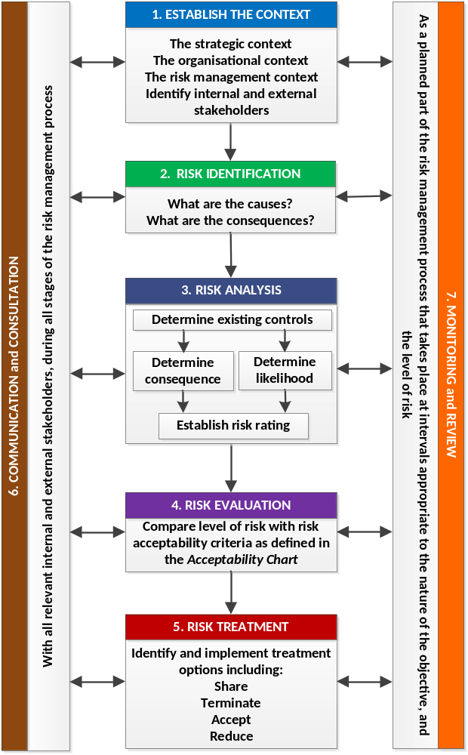

Risk can be described as anything; event, practice, process, activity, etc. that could hinder or help achievement of stated goals or objectives.
DET Risk Process
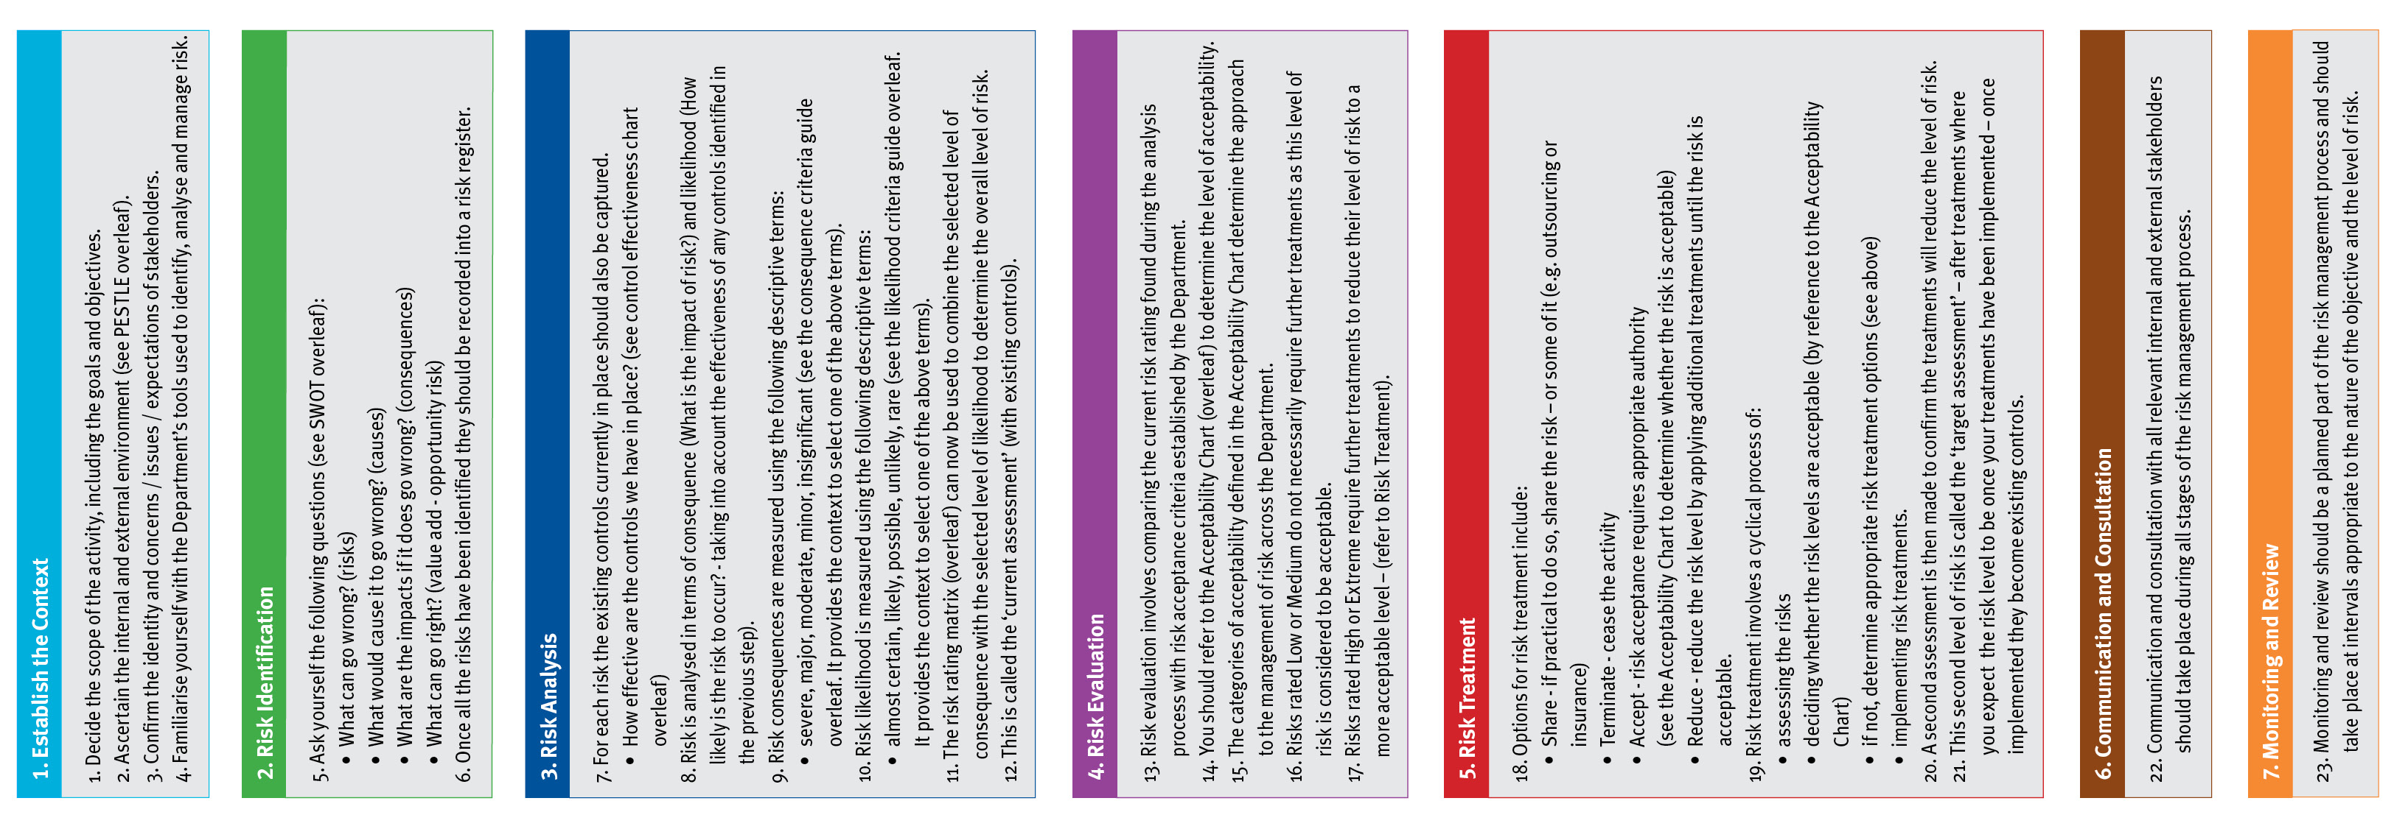
DET Risk Management Framework - Assessment Tools
Consequence Criteria: This guide provides indicative terms against which the significance of risk is evaluated.
Descriptor | Student Outcomes | Wellbeing and Safety | Finance | Reputation | Operations | Strategic
Insignificant | - Educational outcomes, engagement and wellbeing and pathways and transitions can be met with workarounds | - Minor injury requiring no first aid or peer support for stress / trauma event | - Small loss that can be absorbed | - Internal impact (no external impact) | - School operations continue with slight interruptions to normal activities | - Goals, targets and key improvement strategies can be delivered with inconsequential impacts
Minor | - Educational outcomes, engagement and wellbeing and pathways and transitions achieved but below targets | - Injury / ill health requiring first aid  - Peer support for stress / trauma event | - Loss of ‘consumable’ assets,  - < 2% deviation from budget  - Minor fraud possible | - Adverse comments local community media  - Short term stakeholder dissatisfaction / comment | - Some school operations disrupted  - Minor workarounds return school to normal operations | - Minor workaround need to be implemented to deliver the SSP goals, targets and key improvement strategies
Moderate | - Students’ overall levels of Literacy and Numeracy static  - Increasing truancy  - Partial achievement of targeted pathways and transition | - Injury / ill health requiring medical attention  - Stress / trauma event requiring professional support | - Loss of assets  - 2% - 5% deviation from budget  - External audit management letter | - External scrutiny e.g. VAGO  - Adverse state media comment  - Stakeholder relationship impacted | - Key school operations temporarily disrupted  - School leadership team meets to return school to normal operations | - Constant consultation with key stakeholders needs to be maintained to deliver the SSP goals, targets and key improvement strategies
Major | - National targeted improvements not achieved  - Partial achievement of targeted learning outcomes  - Student dissatisfaction with access to pathways / transitions | - Injury / ill health requiring hospital admission  - Stress / trauma event requiring ongoing clinical support | - Loss of significant assets  - 6% - 15% deviation from budget  - External audit qualification on accounts  - High end fraud committed | - External investigation  - Adverse comments national media  - Stakeholder relationship tenuous | - Whole of school operations disrupted  - Assistance sought from Regional Office | - Significant adjustment to resource allocation and service delivery required to deliver SSP goals, targets and key improvement strategies
Severe | - Literacy and Numeracy decline  - Student engagement and connectedness to the school and their peers is very poor  - Declining number of student options for pathways and transitions | - Fatality or permanent disability  - Stress / trauma event requiring extensive clinical support for multiple individuals | - Loss of key assets  - >15 % deviation from budget  - Systemic and high value fraud | - Commission of inquiry  - National front page headlines  - Stakeholder relationship irretrievably damaged | - Normal school operations cease  - School evacuated  - Regional Office notified | - SSP goals, targets and key improvement strategies cannot be delivered  - Changes need to be made to the SSP
Likelihood Criteria: This guide provides the indicative terms against which the probability of a risk event occurrence is evaluated.
Descriptor | Description | Indicative % | Indicative Frequency | Note:  - The Likelihood Criteria refers to the likelihood of the consequence descriptor you have selected i.e. the likelihood of a ‘major’ consequence.  - The Indicative Frequency may not be relevant when assessing risks related to repeated activities, or when objectives are to be delivered over discrete periods of time. It should not be the sole basis for assessment.
Almost Certain | Expected to occur | >95% | Multiple times in the next year
Likely | Probably will occur (no surprise) | 66-95% | At least once in the next year
Possible | May occur at some stage | 26-65% | Once in the next 3 years
Unlikely | Would be surprising if it occurred | 5-25% | Once in the next 5 years
Rare | May never occur | <5% | Once in the next 10 years
DET’s Control Effectiveness: Indicates the self-assessment of control effectiveness.
Controls Effectiveness Rating and Criteria
Ineffective | - The design of controls overall, is ineffective in addressing key causes and/or consequences.  - Documentation and/or communication of the controls does not exist (e.g. policies, procedures, etc.).  - The controls are not in operation or have not yet been implemented.
Needs Improvement | - The design of controls only partially addresses key causes and/or consequences.  - Documentation and/or communication of the controls (e.g. policies, procedures, etc.) are incomplete, unclear or inconsistent.  - The controls are not operating consistently and/or effectively and have not been implemented in full.
Acceptable | - The design of controls is largely adequate and effective in addressing key causes and/or consequences.  - The controls (e.g. policies, procedures, etc.) have been formally documented but not proactively communicated to relevant stakeholders.  - The controls are largely operating in a satisfactory manner and are providing some level of assurance.
Effective | - The design of controls is adequate and effective in addressing the key causes and/or consequences.  - The controls (e.g. policies, procedures, etc.) have been formally documented and proactively communicated to relevant stakeholders.  - The controls overall, are operating effectively so as to manage the risk.
DET’s Risk Rating Matrix: Used to combine consequence with likelihood to determine the overall level of risk.
Risk Rating Matrix |  | Consequence
 |  | Insignificant | Minor | Moderate | Major | Severe
Likelihood | Almost Certain | Medium | High | Extreme | Extreme | Extreme
Likelihood | Likely | Medium | Medium | High | Extreme | Extreme
Likelihood | Possible | Low | Medium | Medium | High | Extreme
Likelihood | Unlikely | Low | Low | Medium | Medium | High
Likelihood | Rare | Low | Low | Low | Medium | Medium

DET’s Acceptability Chart: Used to decide whether the risk is acceptable, based on the rating calculated.
Extreme = Unacceptable  (must have Principal / School Council / Regional Office oversight) | Immediately consider whether the activity associated with this risk should cease. Any decision to continue exposure to this level of risk should be made at Principal / School Council / Regional Office level, be subject to the development of detailed treatments, on-going oversight and high level review.
High = Tolerable  (with ongoing Principal Class Officer review) | Risk should be reduced by developing treatments. It should be subject to on-going review to ensure controls remain effective, and the benefits balance against the risk. Escalation of this level of risk to Principal Class Officer level should occur.
Medium = Tolerable  (with frequent risk owner review) | Exposure to the risk may continue, provided it has been appropriately assessed and has been managed to as low as reasonably practicable. It should be subject to frequent review to ensure the risk analysis remains valid and the controls effective. Treatments to reduce the risk can be considered.
Low = Acceptable  (with periodic review) | Exposure to this risk is acceptable, but is subject to periodic review to ensure it does not increase and current control effectiveness does not vary.
Find Risk Management on eduGate

School Cycle - where schools should use risk management
Utilise risk management at all stages of the school cycle, to drive decision making, establish priorities and allocate resources. Risk management should be based on the best information available. Effort expended should be proportionate to the risk and benefits should be balanced against the risk.

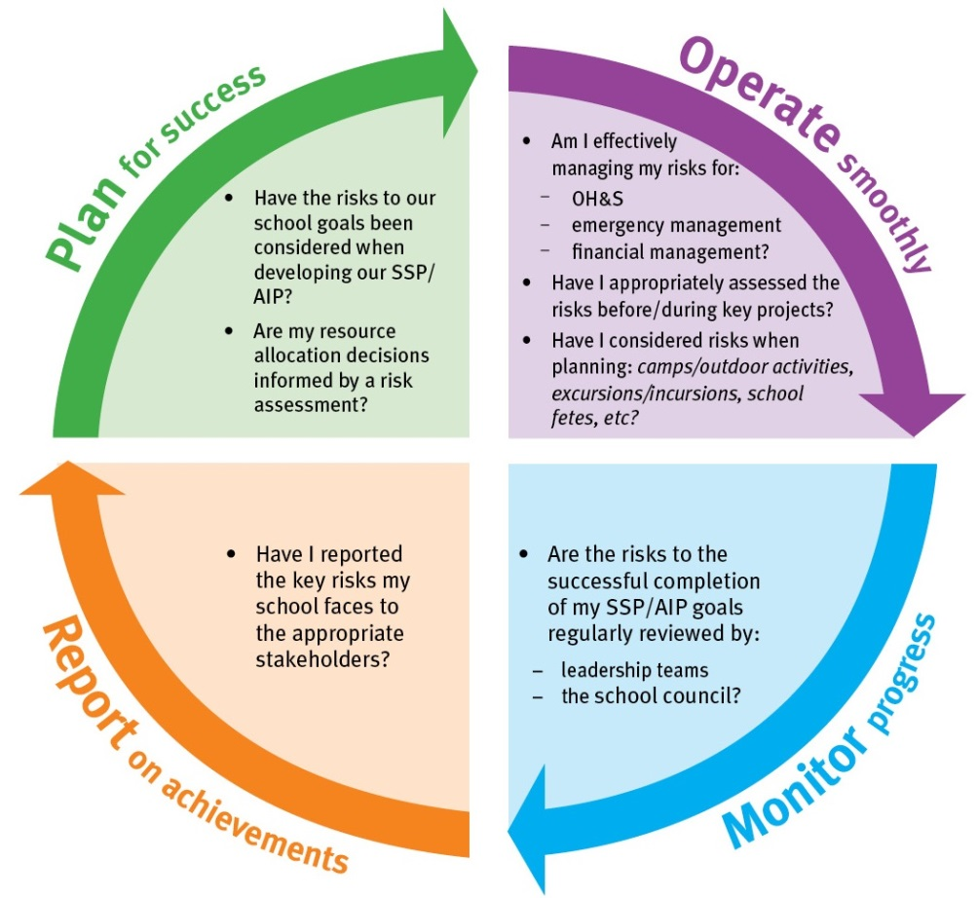

PESTLE Analysis - used to establish the context
PESTLE - (political, economic, social, technological, legal, environmental) is a useful tool to analyse the operating environment and to understand any other factors that contribute to it. It may be beneficial to involve your key stakeholders when conducting this type of analysis.

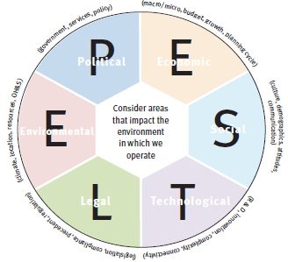

SWOT Matrix - used in risk identification
A SWOT Matrix (strengths, weaknesses, opportunities and threats) is a useful tool to analyse the environment and establish current issues and future risks. It may be beneficial to involve your key stakeholders when conducting this type of analysis.



