The Victorian Department of Education and Training (DET) and your school are using online learning services to support learning and teaching.

Information pack for parents
What is ClickView?

ClickView is an educational video platform that all Victorian government secondary and P-12 schools can access as part of the DET Secondary School Software Suite. Through ClickView students have online access to thousands of educational programs, movies and TV shows to support the school’s curriculum and students’ learning. This means that students can easily access videos for classroom tasks, assignments or research, in a safe environment.

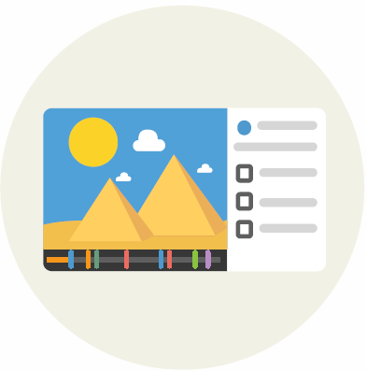
| High-quality resources for learning
ClickView provides a library of video content explicitly aligned to the Victorian Curriculum. Students
and teachers can confidently access high-quality video resources that have been purpose-made in Melbourne, or educationally curated from a selection of pay-TV or free-to-air programs.

| Safe and age-appropriate
ClickView resources feature Australian content classifications to help ensure students are
accessing age-appropriate materials.

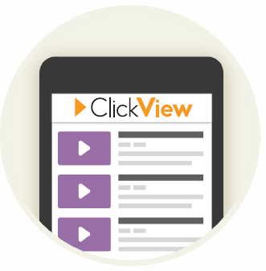
| Engaging and interactive
Teachers can find, edit and share relevant educational videos with students, including interactive
learning tasks, through which teachers can monitor each student's understanding. Students can upload and share their work with teachers and other students to demonstrate their learning.

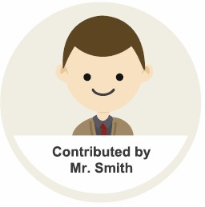
| Access videos from home on any device
Teaching staff can share clips with students to view at home so they can use class time for quality
discussions, higher-order thinking and problem-solving.
ClickView can be conveniently accessed on laptop, desktop, tablet or mobile devices.

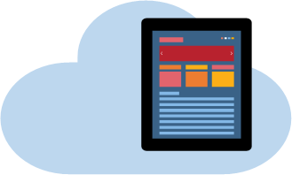

For more details on ClickView visit:

https:// www.clickview.com. au /privacy-policy/

Student eduPass log-in credentials are used for secure access to ClickView. Students' name, year level and school name are collected for learning and teaching, technical support and platform security purposes.

Your school's Acceptable Use Policy will guide appropriate use of the service.

If you have concerns about the use of ClickView or are considering opting out, please contact your school to get more information about the system and the protection in place. While we can make alternative local arrangements for your child/ren it is preferable for all students to have equal access to online educational tools.

