Conveyance Allowance

Manual Claims Workbook School User Guide Version 4.0



**Published by the**

**Department of Education & Training, Melbourne  
May 2015.**

**© State of Victoria (Department of Education & Training) 2015.**

**The copyright in this document is owned by the   
State of Victoria (Department of Education & Training),**

**or in the case of some materials, by third parties   
(third party materials). No part may be reproduced by any process  
except in accordance with the provisions of the Copyright Act 1968  
the National Education Access Licence for Schools (NEALS)   
(see below) or with permission.**

**NEALS is an educational institution situated in Australia which is  
not conducted for profit, or a body responsible for administering  
such an institution may copy and communicate the materials, other   
than third party materials, for the educational purposes of the   
institution.**

**Authorised by the Department of Education & Training,   
2 Treasury Place, East Melbourne, Victoria, 3002.  
ISBN [to be inserted if required]   
this document is also available on the internet at**at <http://www.education.vic.gov.au/school/principals/finance/Pages/transportscas.aspx>

**Contents**

1 About Conveyance Allowance 5

2 Introduction 6

2.1 Purpose 6

3 Manage Students, Applications and Claims 7

3.1 Workbook 7

3.2 Save 12

4 Claim Submission Closing Dates 13

5 Troubleshooting 14

6 Help 15

6.1 Microsoft Excel 2010 15

6.2 For Information Regarding Conveyance Allowance 15

6.3 Student Conveyance Allowance System (SCAS) 15

6.4 Contacting the SCAS Helpdesk in the Family Payment Unit 15

Glossary 16

# 

# About Conveyance Allowance

The **Conveyance Allowance Program (CAP)** is a form of financial assistance for parents, guardians or carers to transport children to and from school predominantly in rural and regional Victoria.

CAP applies to both government and non-government schools including all special settings based on the eligibility criteria outlined in the Conveyance Allowance Policy found at: <http://www.education.vic.gov.au/school/principals/finance/Pages/conveyance.aspx>

Allowances are available for public transport, private car and private bus.

# Introduction

This guide is produced by the Family Payments Unit (FPU) of the Department of Education & Training (DET) of Victoria.

The Family Payments Unit (FPU) is responsible for the management of the Student Conveyance Allowance Program (CAP) through the use of the **Student Conveyance Allowance System** (**SCAS**) and for **\***selected schools, in addition to SCAS, the use of the manual Microsoft Excel **Conveyance Allowance School Claim** **workbook**.

**\***An explanation of selected schools is defined in the **Glossary** section of this document.

## Purpose

The purpose of this guide is to assist schools with the manual Microsoft Excel Conveyance Allowance School Claim **workbook** in conjunction with SCAS to process conveyance allowance claims.

The Microsoft Excel Conveyance Allowance School Claim is now referred as the **workbook** in this document (unless stated otherwise).

### Student ‘Conveyance Allowance Application’ Form

Completed conveyance application forms must be submitted to the student’s school for input into the manual **workbook** in accordance with the ‘Conveyance Allowance Policy’, in particular, the Section for Administration by Schools.

Schools need to request a completed conveyance application form signed by the parent, guardian or carer prior to creating an application for conveyance allowance in the following circumstances:

* Students applying for the allowance for the first time at this school;
* Existing conveyance allowance claimants who have a change of circumstances affecting eligibility. For example are:
* Moving residence;
* Changing their mode of transport;
* Changing schools/campuses.

However if schools are satisfied that existing conveyance allowance claimants have no changes of circumstance then there is no need for annual ‘Student Conveyance Allowance Application’ forms to be submitted to the school.

Current ‘Student conveyance application forms’ can be found at: <http://www.education.vic.gov.au/school/principals/finance/Pages/conveyance.aspx>

‘Student Conveyance Allowance Application’ forms are to be retained by the school for audit and accountability purposes.

# Manage Students, Applications and Claims

SCAS normally manages all aspects of conveyance allowance Applications or Claims however for selected schools; SCAS cannot be used to fully support the conveyance allowance claim process.

In this case, SCAS and the **workbook** are used together to process conveyance allowance.

Schools manually enter data into the **workbook** based on the returned ‘Student conveyance application forms’ from parents, guardians or carers and submit the **workbook** by email to the FPU at [conveyance@edumail.vic.gov.au](mailto:conveyance@edumail.vic.gov.au)

The FPU will check the **workbook**,and if approved, will process a SCAS **Adhoc Payment** that is used for school payment and also historical and auditing purposes.

Selected schools have the ability to **View** their **Adhoc Payment**s through the SCAS school web portal.

This includes opening the respective Excel **workbook** that contains Applications and Claim details.

Editing or submitting of Applications or Claims by selected schools through SCAS is **NOT** supported.

## Workbook

The **workbook** has been designed to assist schools with the manual entry of student Applications by the use of drop down lists and specific fields that automatically calculate and populate the **Summary** or **Students Details** worksheets.

Any data entry errors will be displayed with a background and **MUST** be corrected by the school before submitting any claim to the FPU. The error needs to be corrected in the **Student Details** worksheet.

The **workbook** contains the **Summary**, **Student Details** and **User Guide** worksheets that are located at the bottom of the **workbook** similar to the display below.



Worksheets used by selected schools to process conveyance allowance Applications / Claims

### Summary Worksheet - Entering Data

Schools should fill in all the yellow fields in the **Summary** worksheet.

Any data entry errors will be displayed with background and **MUST** be corrected by the school before submitting any claim to the FPU. The error needs to be corrected in the **Student Details** worksheet.

The following yellow fields will automatically populate when using the drop down lists and highlighting the appropriate selection:

* **SCHOOL YEAR;**
* **TERMS;**
* **SCHOOL NUMBER:**
  + That will, in turn, automatically populate the following fields:
    - **SCHOOL NAME**;
    - **ADDRESS**;
    - **POSTCODE**;
    - **TELEPHONE NO**;
    - **FAX NO** (optional information).

The **ENROLMENT** field will automatically populate with the total number of students claiming conveyance allowance after entering data in **Student Details** worksheet.

The following yellow fields need manual data entry:

* **CAMPUS** – Specify the campus number:
  + For **NON Victorian** schools, always enter the digit, 1;
* **FORM COMPLETED BY** – The person at the school who can be contacted if there are any queries;
* **CONTACT PH** – The person’s contact number at the school if there are any queries;
* **PRINCIPAL’S SIGNATURE** - The principal’s name;
* **DATE** - Date of claim or amended claim;
* **COMMENTS** – This is an optional free text field and usually has information about the claim the FPU needs to know.

MC900292594[1] Notes about the **Summary** worksheet.

* When making adjustments to a prior claim, schools should select the **Amended** option for the relevant term by using the drop down list in the **TERM** field:
  + This option should be used in cases where students have left the school after a prior claim has been submitted;
  + To add additional student Applications mid-term / semester or to correct errors, schools should change the details to be entered in **Student Details** worksheet. Refer to section **3.1.2 Student Details Worksheet – Entering Data** of this document for details.
* Schools need to inform the FPU by email [conveyance@edumail.vic.gov.au](mailto:conveyance@edumail.vic.gov.au) for changes of school address, campus, etc.
  + - 1. **Automatic Populating Fields**

The **MODE OF TRAVEL**, **NUMBER OF STUDENTS** and **CLAIM** fields will automatically be populated when the relevant data is entered in the **Student Details** worksheet.

Refer to section **3.1.2 Student Details Worksheet – Entering Data** in this document for details.

Refer to the **Summary Worksheet Overview** below for more information.

* + - 1. **Summary Worksheet Overview**

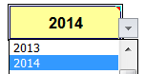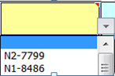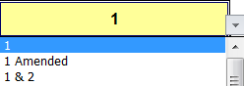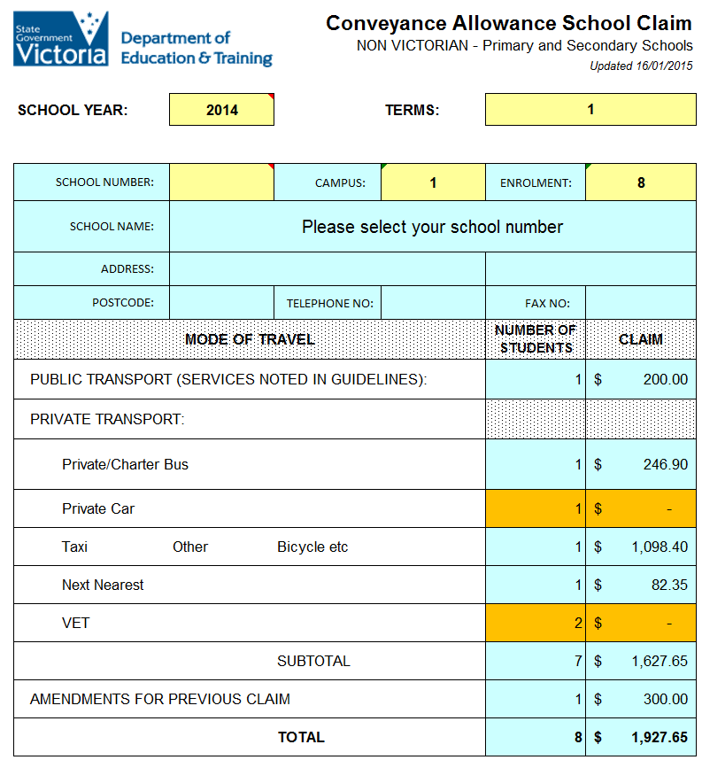

Select from drop down list **TERMS**, the period of the claim

Total number of students in the claim

Select from drop down **list** **SCHOOL YEAR**

Any cells with orange background are errors that **MUST** be corrected by schools in the **Student Details** worksheet.

Select from drop down list the **SCHOOL NUMBER**.

The **SCHOOL NAME**, **ADDRESS**, **POSTCODE**, **TELEPHONE NO** and (optionally) **FAX NO** should be automatically populated

Contact person at the school

**CONTACT PH** for the person at the school

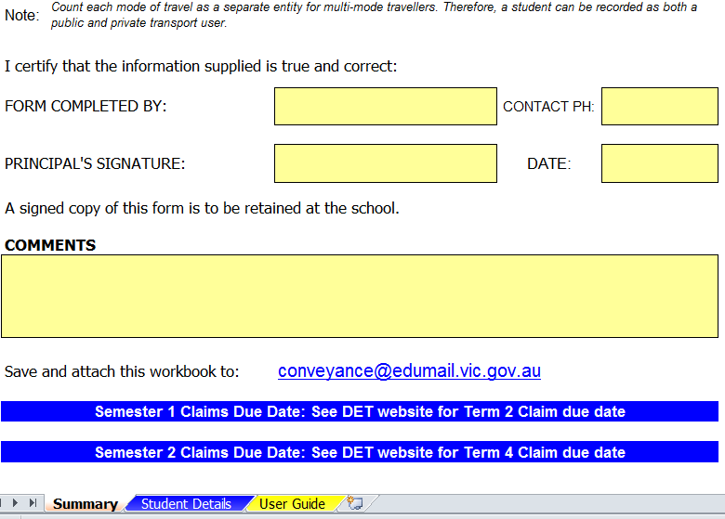

Claim **DATE** submitted to the FPU

**PRINCIPAL’S** name

Optional, additional information the FPU needs to know regarding the claim

Send the completed worksheet to the FPU with this email address

The **Summary** worksheet is selected

### Student Details Worksheet – Entering Data

Select the **Student Details** worksheet at the bottom of the **workbook** screen.

Schools should fill in the yellow fields in the **Student Details** worksheet.

Data entry should be based by the Student ‘Conveyance Allowance Application’ form that has been provided by parents, guardians or carers to schools.

Any data entry errors will be displayed with background and **MUST** be corrected by the school before submitting your claim to the FPU.

In order for a claim to be accepted the following student details need to be entered:

* **Student Name and ID:**
  + **Student ID;**
    - A unique **Student ID** is accepted.
  + **Surname**;
    - If this field is blank then **NO** amount value will populated in the **Estimated Amount Payable ($)** field and **NOT** added in the **Summary** worksheet.
  + **Given** **Name**;
* **Residential Address:**
  + **House Number**;
  + **Street Name**;
  + **Town**;
  + **Post Code**;
* **D.o.B & Y/L**:
  + **Date of Birth**;
  + **Year Level**;
* **Transport Details:** 
  + **Transport Mode Code**:
    - ‘**C**’ for **Private Car**;
    - ‘**B**’ for **Private Bus**;
    - ‘**P**’ for **Public Transport**;
    - ‘**T**’ for **Taxi**;
    - ‘**O**’ for **Other**;
    - ‘**N**’ for **Next Nearest**;
    - ‘**V**’ for **VET:**
    - ‘**A**’ for **Amended Claim**:
      * This is used for an amendment to a previous claim;
      * Manually enter the adjustment amount in the **Public Transport & Amendments** field;
        + Positive or negative amounts are supported.
      * ‘**A**’ automatically populates the **Summary** worksheet, **AMENDMENTS FOR PREVIOUS CLAIM**, **NUMBER OF STUDENTS** and **CLAIM** amount.
  + **Km;** - enter the distance in Kilometres:
    - No entry required for **Transport Mode Code** ‘**A**’**.**
  + **Private Car, Next Nearest & VET only:** 
    - For car travellers, enter either:
      * **‘F’ for Furthermost;**
      * **‘A’ for Additional.**
    - For **VET**, enter the amount of schools days attended.
* **Allowance Details:** 
  + **Public Transport & Amendments**
    - **Private Car**, **Private Bus**, **Next Nearest**, **Taxi** and **VET** travellers, this field will automatically populate;
    - **Public Transport** and **Other** entries, the school must enter manually the dollar values:
  + **Estimated Amount Payable ($):**
    - **Private Car**, **Private Bus** and **Next Nearest** travellers, this field will automatically populate;
    - **Taxi, Other** and **Amended Claim** will populate with **FALSE**;
    - **Public Transport, VET** and **Other** will **NOT** populate;
* **Further Information:**
  + For **Public Transport:**
    - Enter the **Origin To Destination.**
  + For **Amended Claims:**
    - Enter abrief reason for adjustment.
  + Optional free text entry for all other **Transport Mode Code**s

Refer to the **Student Details Worksheet Overview** below for more information.

**3.1.2 Student Details Worksheet Overview**

Schools should fill in all the yellow fields in the **Student Details** worksheet unless otherwise stated.

Cells with blue and dotted fields cannot be changed by schools.

Enter the appropriate **Transport Mode Code** letter in this column

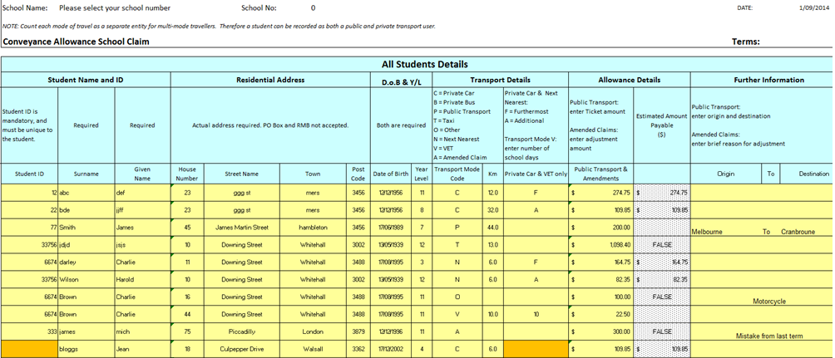

Enter **A** for **Amended**, adjustments from prior claims. Manually enter the amount into the **Public Transport & Amendments** field. **FALSE** will appear in the **Allowance Payable $** field, this is normal

Any data entry errors will display an orange background.

These **MUST** be corrected.

## Save

Once your **workbook** is completed, **Save** it and close Excel.

Schools should attach the **workbook** in an email and send it to [conveyance@edumail.vic.gov.au](mailto:conveyance@edumail.vic.gov.au) for checking and approval by the FPU.

For prompt **Adhoc Payments** ensure your **workbook** is submitted prior the **‘Term claim closing dates’** found at: <http://www.education.vic.gov.au/school/principals/finance/Pages/conveyance.aspx>

### User Guide Worksheet

This worksheet will connect you to the DET website **Conveyance Allowance Program (CAP).**

Click on the **User Guide** worksheet tab.



The screen will display:

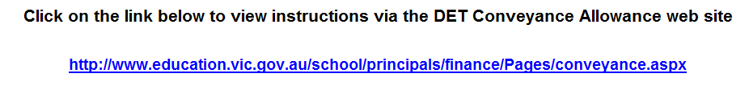

Click on the hyperlink that will connect you to the DET **Conveyance Allowance Program (CAP)** web site.

Scroll down the web page to **For Schools:** then scroll further to other hyperlinks:

* **Interstate and Teaching Unit Claim Troubleshooting Guide (docx - 1.4mb)** 
  + For **docx**, this is the Microsoft Word format and will prompt you with a **File Download** prompt to either **Open** or **Save** the file
* **Interstate and Teaching Unit Claim Troubleshooting Guide (pdf - 749kb)**
  + For **pdf**, this is an Adobe format and will immediately launch the document.

Regardless of which format is selected, the latest version of the **Conveyance Allowance Manual Claims Workbook School User Guide** is available online for schools to assist with CAP.

Schools can navigate and view the guide as desired.

For further assistance, refer to sections of this document:

* **5 Troubleshooting;**
* **6 Help.**

# Claim Submission Closing Dates

The **workbook** has been designed, where applicable, to calculate payments for two (2) Semesters for the current school year.

For prompt payment of claims please be sure your **workbook** is submitted to the FPU prior to the **Claim Submission Closing Dates** for **Term 2** and **Term 4** that can be found at: <http://www.education.vic.gov.au/school/principals/finance/Pages/conveyance.aspx>

Schools will be reimbursed by the DET, for the current school year, usually by the end of:

* **Semester 1 (Term 2)** and;
* **Semester 2 (Term 4)**.

# Troubleshooting

If you are having issues entering data into your claim, please refer to the table below:

|  |  |  |
| --- | --- | --- |
| **Issue** | **Solution** | **Worksheet Name** |
| **SCHOOL NUMBER** does **NOT** exists or the details are incorrect | The **SCHOOL NUMBER** or school details in the **workbook** has to be updated by the Family Payments Unit (FPU).  The school should fill in the **workbook** as much as possible, attach the **workbook** to an email and send to the FPU at [conveyance@edumail.vic.gov.au](mailto:conveyance@edumail.com.au) explaining the issues.  New school details must be in writing. | **Summary** |
| There is no dollar value in the totals or the word, **FALSE** appears | The incorrect **Transport Mode Code**(s) may have of been entered in the **Student Details** worksheet. | **Student Details** |
| The **Allowance Payable $** data is **NOT** correct when I enter the **Private Car** travel details | Ensure the **Code must be entered for Car Travellers** is correct.  Use the letter **F** for **Furthermost** or **A** for **Additional** must be entered when the **Transport Mode Code** is the letter **C** is used for **Private Car**.  If the **Code must be entered for Car Travellers** is blank or text other than **F** or **A** is used, the lesser dollar value will be calculated and populated. | **Student Details** |
| I need to make  changes to a claim I’ve already submitted | * If the claim has been submitted and within the same term or semester period, the school will need to re-submit the whole **workbook** again with the changes. The FPU will **NOT** accept separate **workbook** claims; * If the **workbook** claim is from a previous term or semester period, enter the letter **A** in the **Transport Mode Code** that is part of the **Student Details** worksheet. This will populate the **Allowance Payable $** field with an expected result, the word **FALSE**. Then enter the adjustment value amount manually into the **Allowance Claimed $** field. This will populate the **Summary** worksheet, **AMENDMENTS FOR PREVIOUS CLAIM** amount. | **Summary** or **Student Details** |
| Is this the most current **workbook**? | The most current **workbook**(s)can be obtained from the DET website  <http://www.education.vic.gov.au/school/principals/finance/Pages/conveyance.aspx> |  |
| Need further assistance? | Contact the FPU SCAS team directly:   * On **1800 060 970**, select **Option 1** at the voice prompts; * By email: [conveyance@edumail.vic.gov.au](mailto:conveyance@edumail.com.au) |  |

# Help

## Microsoft Excel 2010

Excel 2010 software offers online web **Help**.

**Help** is generic and is **NOT** conveyance allowance specific.

Click on the **Help**  button located usually on the right hand top of the Excel work area as shown below.

Alternatively, press the **F1** button on your keyboard to open **Help**.

Click on **Help** icon to start



Microsoft Internet Explorer should open and connect to the official Microsoft Office Excel Help web site similar to the display below.

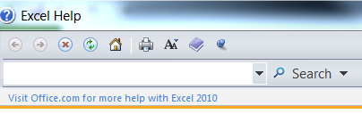

Type in your text and click on the **Search** icon or press the **Enter** key

Type in your text in the **Search** field and either:

* Press the **Enter** key or;
* Click on the **Search**  icon.

Navigate the **Help** and follow the prompts.

## For Information Regarding Conveyance Allowance

Information regarding the conveyance allowance program can be found at: <http://www.education.vic.gov.au/school/principals/finance/Pages/conveyance.aspx>

## Student Conveyance Allowance System (SCAS)

Information regarding the SCAS web based program can be found at: <http://www.education.vic.gov.au/school/principals/finance/Pages/transportscas.aspx>

## Contacting the SCAS Helpdesk in the Family Payment Unit

The SCAS Helpdesk can be contacted:

* by email: [conveyance@edumail.vic.gov.au](mailto:conveyance@edumail.vic.gov.au)
* By telephone: **1800 060 970**, **select option 1** after the voice prompt.

# Glossary

|  |  |
| --- | --- |
| Term | Definition |
| **Adhoc Payment** | Unscheduled payment, which is **NOT** part of the normal SCAS claim process. SCAS **Adhoc Payment**s may be positive or negative in value. A zero amount value is **NOT** supported. |
| **Application** | An **Application** represents a request by a parent or guardian for conveyance allowance to be paid for their child. |
| **CAP** | Conveyance Allowance Program. |
| **DET** | Department of Education & Training. |
| **FPU** | Family Payment Unit. |
| **SCAS** | Student Conveyance Allowance System. |
| **Selected Schools** | * **NON VICTORIAN Primary** and **Secondary Schools** from **SA** or **NSW** only: * Student must reside in Victoria. * **Language, Outpost** and **Teaching Unit Schools – GOVERNMENT**. |
| **Workbook** | An Excel **workbook** contains worksheets of rows and columns in which you can enter and calculate data. |
| **Worksheet** | The primary document that you use in Excel to store and work with data. Also called a spread sheet. A worksheet consists of cells that are organized into columns and rows; a worksheet is always stored in a **workbook**. |