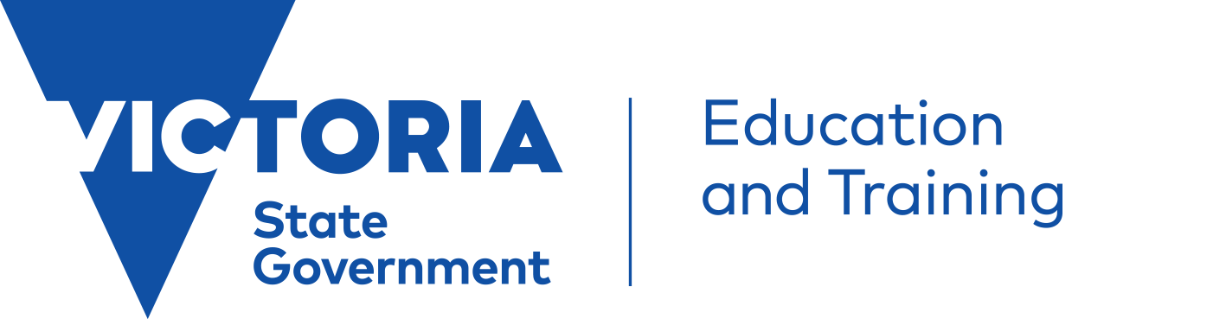 | Parent fact sheet:  Violent and dangerous student behaviours of concern
This factsheet provides information for parents and carers of children demonstrating violent and dangerous behaviours of concern.

Most children can act in ways that parents find challenging – such as breaking rules or arguing with siblings. Similar behaviours are also common in schools – students talk in class or don’t do their homework. For the most part this sort of behaviour is just a normal part of growing up.
However, sometimes these behaviours are more serious. A child may behave in a way that causes harm (or risk of harm) to themselves or to others, including fighting, making threats, throwing furniture, hitting or biting.
As a parent, dealing with violent and dangerous behaviours can be very distressing and it can be very challenging to know what to do.
These violent and dangerous behaviours are also a major challenge for schools. This is because teachers have a duty of care to protect the safety of all students and they also have the right to be safe themselves.
The best way to address these behaviours is for parents and schools to work together.

Talk with the school
If your child is demonstrating behavioural problems at school it is likely that the school will contact you to discuss this. If you are worried about your child’s behaviour you can take the first step and contact the school. You should ask to speak to your child’s teacher, year level coordinator or a wellbeing staff member.
If your child has been assessed as having a medical condition, mental health issue or disability, it’s important to pass this information on to the school.
Your child’s school may ask for your consent to speak directly with the doctor or other health professional. This can help them to get a clearer picture of your child’s needs and the best way to support them.

Behaviour support planning
A Behaviour Support Plan is a plan that can be developed specifically for your child. It will include strategies that the school, you and your child can use to prevent and respond to behaviours.
As a parent you play an important role in developing your child’s Behaviour Support Plan. If your child doesn’t already have a plan you can bring this up with the school and ask to be consulted.
If your child has a disability the plan should also outline the adjustments the school will make to enable your child to participate fully in school. Schools must make reasonable adjustments for students with disabilities as required under the Disability Standards for Education.
Understanding your child’s behaviour
In order to develop strategies that will make a real difference to your child, it’s important to understand why these behaviours are arising. Are they in response to a traumatic event, or related to a disability or mental health issue? Is there a particular student or situation that distresses your child and triggers violent behaviour?
As a parent you may already be aware of what triggers your child’s behaviours and know what
works to calm them down. Sharing this knowledge with the school is important, so that teachers can try to avoid situations that may distress your child.
Your child’s school may talk to you about undertaking a Functional Behaviour Assessment. This is a tool that can help to understand more about why a behaviour is occurring and helps develop strategies to reduce it and replace it with positive behaviours.

What to expect if there is a serious behavioural incident involving your child

If your child has been involved in a serious behavioural incident the school will contact you as soon as possible after the incident. The school will also report the incident to the Department of Education and Training (DET), and in serious cases, to emergency services.
The school will also inform you if during the incident your child was restrained by a school staff member to protect their safety or the safety of others. For more information on physical interventions ask your child’s school for a copy of the Parent Fact Sheet Student behaviours of concern – Use of physical interventions in schools, or download a copy from www.education.vic.gov.au
After the incident the school will invite you to meet to discuss appropriate actions including: developing and/or review your child’s Behaviour Support Plan; and agreeing on any additional support needed.
In some cases serious behavioural incidents may warrant suspension or expulsion from school. Schools are required to follow procedures when suspending or expelling a student. These are outlined at: http://www.education.vic.gov.au/school/parents/behaviour/Pages/discipline.aspx

Where can I go for more help in supporting my child?
If you are concerned about your child’s behaviour take the first step and contact the school to share your concerns and find out whether similar behaviours have been occurring at school. You could speak to your child’s teacher, year level coordinator or a wellbeing staff member. You can ask your child’s school about engaging Student Support Services and other appropriate professionals to help with strategies for addressing behavioural problems, and link your child to specialist services if needed.
Your GP is also a good person to speak to about your child’s behavioural issues. They can eliminate any medical causes for the behaviour. They can also make referrals to psychologists and other professionals with expertise in mental health and behavioural issues.
If your child’s behaviour is related to a disability, you may be eligible to receive support through the Department of Health and Human Services Behaviour Support Services. Contact the Disability Intake and Response Service on 1800 783 783 for more information.
If you are concerned about your child’s mental health you may also like to contact your local headspace centre by visiting http://www.headspace.org.au/headspace-centres
What can I do if I’m concerned about the school response to my child’s behaviour?
In the first instance you should always raise your concerns with the teacher involved, and following this, with the school principal. If you are unhappy with the school’s response, or would like to seek external advice about the interventions put in place by your child’s school you can contact your local DET regional office and speak to the Community Liaison Officer (CLO). The CLO can provide advice and, if needed, direct your call to another appropriate person in DET.
If after these steps you are not satisfied you may lodge a formal complaint with DET.
Contact details for your local DET regional office can be found at: http://www.education.vic.gov.au/about/contact/pages/regions.aspx

