Applying the Restraint of Students School policy May 2019, as of 31/05/2019

The aim of this presentation is to improve understanding and application of the Restraint of Students School policy in your work environment.
Underlined words are hyperlinked. All web links can also be found on page 21. ‘Where to go for additional help’ can be found on page 20.

How restraint and seclusion reduction and the Child Safe Standards align: The broader context restraint and seclusion reduction

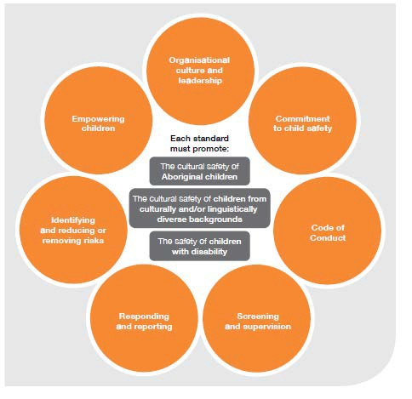Safe environments: Schools have a duty to meet the needs of children and young people and have Child Safe practices.

Reporting and legal obligations: Schools need to understand their legal obligations to report a young person who is at risk of, or is, being abused.

Critical Actions: Schools should focus on strategies to identify and reduce or remove risks, as well as strategies to promote the participation and empowerment of children and young people.

Image: How the standards and principles work together
A Guide for Creating a Child Safe Organisation, Commission for Children and Young People 2018

All teachers and principals are required under Ministerial Order 1038, Section 11.2.3, to comply with government policy, to:
- promote the general welfare of students attending the school
- comply with government policies
- observe safe working practices as to not endanger themselves or others.

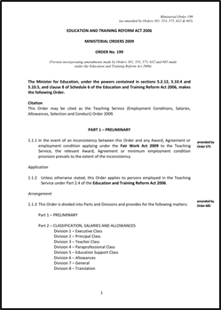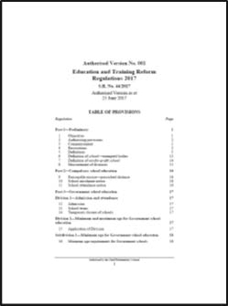

Legislative context cont.
Regulation 25 of the Education and Training Reform Regulations, 2017 provides that:
A member of staff of a Government school may take any reasonable action that is immediately required to restrain a student of the school from acts or behaviour that is dangerous to the member of staff, the student, or any other person.
Note: Regulation 25 does not apply to mechanical or chemical restraint.
The Restraint of Students School policy, Guidance, Procedures and Resources supports these obligations.

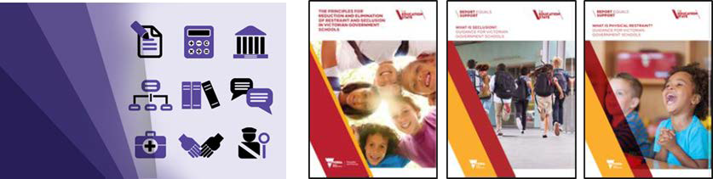

Every behaviour has a purpose: to gain or avoid something.
The environments that we move in have a large impact on our behaviour, changing an environment can influence how a student responds.
Restrictive practices - physical restraint and seclusion - are usually used to stop a person from making use of a behaviour of concern.
Physical restraint and seclusion are not behavioural interventions, they won’t change a behaviour of concern, and cannot form part of a behaviour management strategy or behaviour support plan (BSP).
Behaviour support plans should primarily focus on prevention (addressing the cause of the behaviour of concern) and skill building.

Reducing the occurrence of student behaviours of concern is more effective than merely responding to a behaviour each time it occurs.
Staff are encouraged to:
- focus on prevention and addressing the needs of the student
- be competent in de-escalation
- remove triggers when you know them
- consult with the family or carers and relevant professionals
- collect relevant data
- review and evaluate strategies, change them if they’re not working.

Restraint and seclusion is not permitted within Victorian Government Schools, except:
- in situations where the student’s behaviour poses an imminent (i.e. immediately about to occur or occurring) threat of physical harm or danger to self or others (see incident intervention) and
- where such action (i.e. to physically restrain or seclude) would be considered reasonable in all the circumstances (is needed to keep people from being physically hurt) and
- where there is no less restrictive (i.e. no other option/s available) means of responding in the circumstances.
Restraint or seclusion should be discontinued as soon as the immediate danger has passed.

Physical restraint and seclusion are emergency responses only

If it is not immediately required to protect the safety of the student or any other person, or
- to punish or discipline a student
- to make a student do what they’re told
- to stop a student from leaving (see Students Running Away From School policy)
- because a student is swearing or has verbally threatened someone
- to prevent or stop a student from damaging property (unless there is a risk of physical harm).

Physical restraint and seclusion are emergency responses only

Protective physical interventions are interventions involving physical contact that serve to block, deflect or redirect a student/s actions, or disengage from a student/s grip. For example:
- using your arm to block a student from hitting you or any other person
- breakaway techniques to disengage from the inappropriate grip or hold of a student who is causing physical harm.
In protective physical interventions students can freely move away (i.e. they are not held). Protective physical intervention must be the least invasive way available to protect those involved. Episodes of protective physical interventions must be reported.

Physical restraint is the use of physical force to for the primary purpose of behavioural control, to prevent, restrict or subdue the movement of a person’s body or part of their body.
A student is not free to move away when they are being physically restrained.
Staff must use the minimum force needed to protect against the risk of harm. Staff must only apply the physical restraint for the minimum duration required and must remove it once the imminent risk has passed. Staff should ensure the type of restraint used is consistent with a student’s individual needs and circumstances Staff must monitor the student for any indicators of distress or pain.
All episodes of physical restraint must be reported.
Any restraint which covers the student’s mouth or nose, in any way restricts breathing, takes the student to the ground into the prone (face down) or supine (face up) position, involves the hyperextension of joints, or application of pressure to the neck, chest or joints, must not be used.

Was a part of the student's body physically held preventing the student from moving their body or part of
their body?

X
No
Was a part of the student's body physically held preventing the student from moving their body or part of their body?

X
Yes

Unlikely to be Physical restraint
dent move freely away om my hold?

No
Can the stu
fr

Physical Restraint

HDE UCATIO
TATE
ORIA
tote
overnment

Education and Training

Seclusion is the solitary confinement of a student in a room or area from which their exit is prevented by a barrier or another person.
Seclusion may also include situations where a student is left alone in a room or area and reasonably believes they cannot leave that room or area even if they would physically be able to,
i.e. it is not locked.
Rooms or areas designed specifically for the purpose of seclusion or which are used solely or primarily for the purpose of seclusion are not permitted in Victorian government schools.
Seclusion does not include timeout, safe space, or chill out rooms. It also does not include or refer to situations such as supervised in-school suspensions, detentions, exam situations, situations where the student can freely exit an area or other situations which are not a response to behaviours of concern.

For reflection: Have I used seclusion?

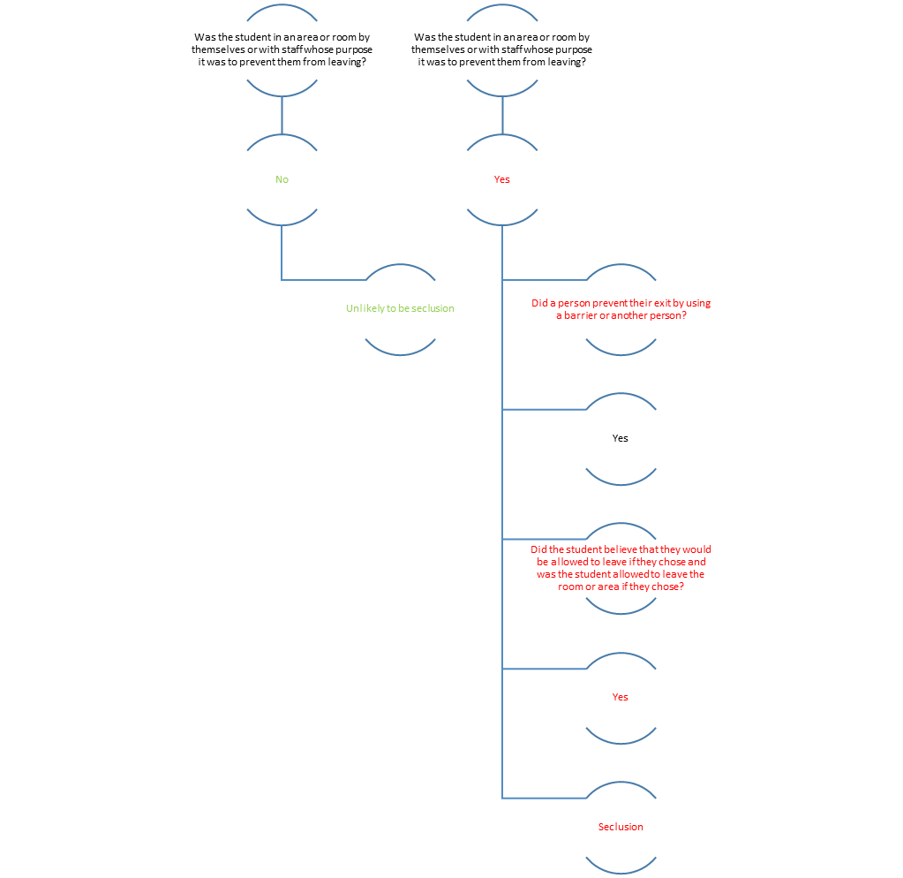

The Department is committed to early intervention and prevention through implementation of preventative framework/s such as School-wide Positive Behaviour Support (SWPBS). Early intervention and prevention are supported by:
- calm interactions with students that avoid power struggles
- reporting incidents of physical restraint and seclusion used in emergencies to elicit a regional assistance and support for the school
- using data about physical restraint and seclusion used in emergencies to inform school practices, planning and setting of improvement goals
- ensuring staff debrief immediately following an emergency in which physical restraint or seclusion have been used, acknowledging that such incidents can be stressful, with a more formal debriefing at a later date
- creating clear classroom/school behavioural expectations, prominently displayed and explicitly taught.

Preventing the use of physical restraint or seclusion cont.
Adjust classwork to meet the assessed individual learning needs of the student. This may require targeted teacher assessment for learning difficulties.
Seek additional training for staff to build capacity to meet individual learning needs (e.g. learning difficulties or ASD).
Record and interpret data on student behaviour.
Teach and reinforce functionally equivalent replacement behaviours, what to do instead of the behaviour of concern (e.g. communication skills, break taking, other self-regulation techniques).
Engage in consultation with the student, their parents or carers, and other involved professionals
e.g. caseworkers) to gain a better understanding of students’ needs and potential interventions.
Foster positive staff-student relationships.

All incidents involving restraint or seclusion must be reported. This response and recovery checklist outlines actions schools should take after an incident where physical restraint or seclusion of a student has occurred.

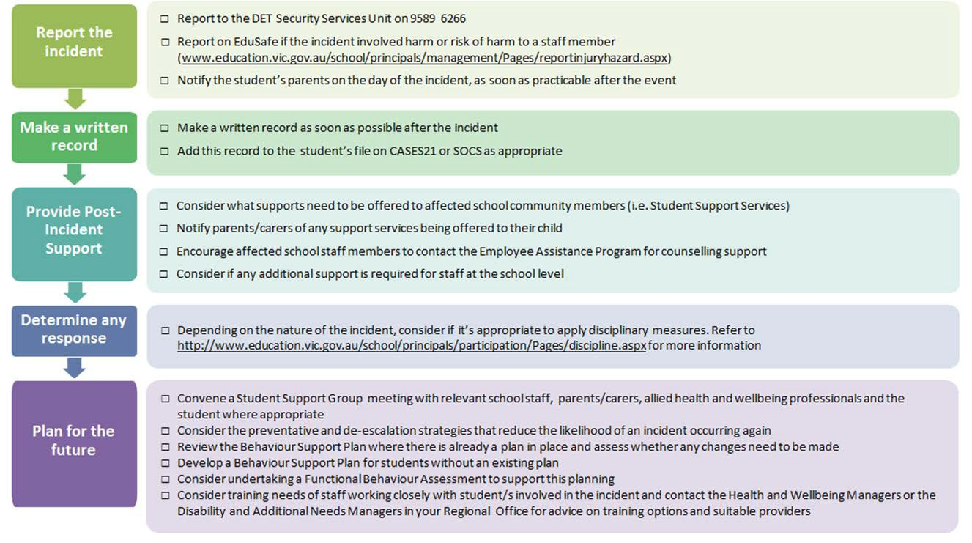

17

After an incident involving restraint or seclusion

Every instance of restraint or seclusion in schools must be reported to the Security Services Unit
{(03) 9589-6266}. Any incident involving harm or risk of physical harm to a staff member must also be reported on Edu Safe and Worksafe.

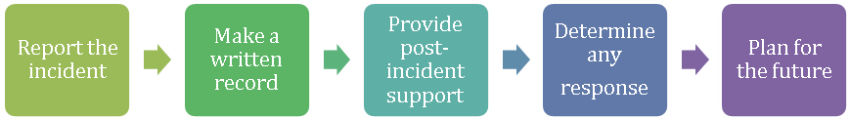

All restraint or seclusion incidents should trigger a review of the student’s behaviour support plan Focus on the future:
- What do we know now that we didn’t before?
- What do we need to find out?
- What could we have done differently?
- What do we need to do to make sure that we don’t end up restraining or secluding again?

The name of the student/s and staff member/s involved Date, time and location of the incident
What exactly happened (a brief factual account) What action/s were taken to de-escalate the situation Names of witnesses (staff and other students)
The student’s response and the outcome of the incident Any injuries or damage to property
Immediate post incident actions, such as first aid or contact with emergency services or other relevant professionals and agencies
Details of contact with the student’s parent/carer
Details of any post-incident support provided or organised, including a functional behaviour assessment.
Why physical intervention was used?

How physical restraint was used?
How long the physical restraint lasted?

Why a student was left alone in a room and unable to leave (seclusion) for a period of time?
How long the seclusion lasted?

Where to go for help

Read the Restraint of Students School policy and resources. Use available resources at the school level first.
Access the Area and Region for further support if needed.
Engaging your school’s Student Support Services (SSS) can be an important step if repeated prevention efforts have been unsuccessful in addressing behaviours of concern.
Access restraint and seclusion professional development opportunities.
Contact the Principal Practice Leader – Education via restraint.seclusion@edumail.vic.gov.au.

Restraint of Students School policy | https://www.education.vic.gov.au/school/principals/spag/governance/Pages/restraint.aspx
Child Safe Standards | https://www.education.vic.gov.au/school/principals/spag/safety/Pages/childsafestandards.aspx
Behaviour support plans | https://www.education.vic.gov.au/school/teachers/behaviour/student-behaviour/Pages/teachplans.aspx
de-escalation | https://www.education.vic.gov.au/school/teachers/behaviour/student-behaviour/Pages/inappropriate-behaviour.aspx
triggers | https://www.education.vic.gov.au/school/teachers/behaviour/student-behaviour/Pages/studentbehaviour.aspx
incident intervention | https://www.education.vic.gov.au/school/teachers/behaviour/restraint/Pages/incidentintervention.aspx
Students Running Away From School | https://www.education.vic.gov.au/school/principals/spag/safety/pages/runningaway.aspx
response and recovery checklist | https://www.education.vic.gov.au/school/teachers/behaviour/restraint/Pages/responserecovery.aspx
EduSafe | https://www.education.vic.gov.au/hrweb/safetyhw/Pages/reportinjuryhazard.aspx
WorkSafe | https://www.education.vic.gov.au/school/principals/spag/management/pages/worksafe.aspx
resources | https://www.education.vic.gov.au/school/teachers/behaviour/restraint/Pages/default.aspx
Region | https://www.education.vic.gov.au/about/contact/Pages/regions.aspx
Student Support Services | https://www.education.vic.gov.au/school/teachers/health/Pages/sss.aspx
professional development opportunities | https://www.education.vic.gov.au/school/teachers/behaviour/restraint/Pages/professionaldev.aspx

21

