**PRIMARY FAMILY** = Australian residential address and contact information (Homestay, Third Party or relative residing in Australia)

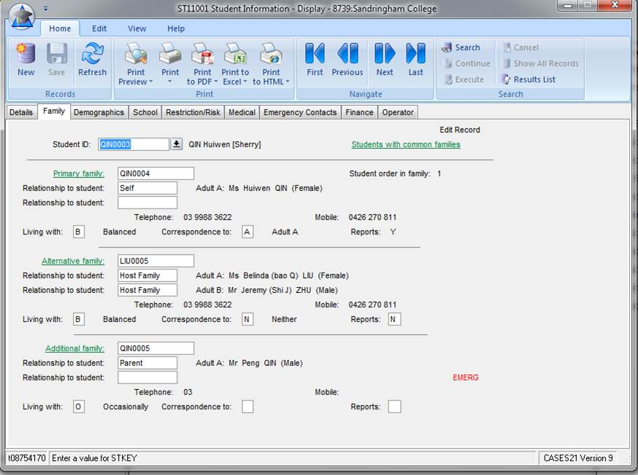

International student’s **Australian residential** address and contact information

**ALTERNATIVE FAMILY** = Parent (home country) address and contact information, including an email address



International student’s **home country** address and contact information

**ALTERNATIVE FAMILY** continued – parents email address

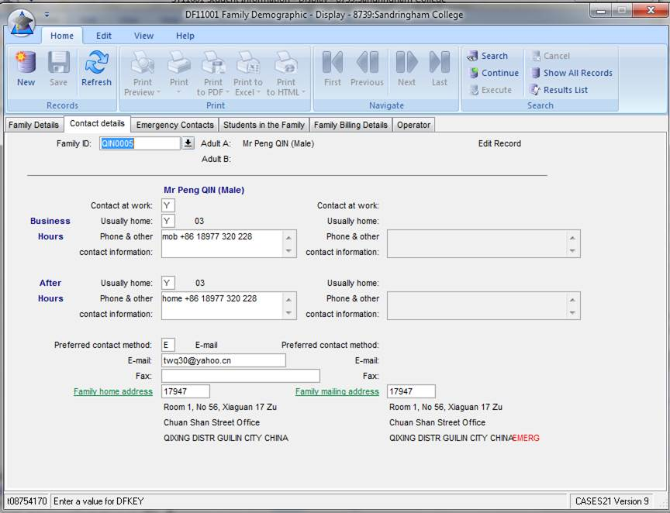

It is essential that the **parent’s email address** is entered onto CASES21. Schools should ensure it is always up-to-date.