Issue
WorkSafe Victoria is currently investigating recent incidents involving the accidental ignition of ‘Jex’ brand starting gun caps and is making arrangements for product recall through suppliers.
Factors / Risks to consider
- Chemical Safety

- Safety information/ warnings on starting gun cap packaging are not readily recognised or reliable, please see below:
The Dangerous Goods class is shown as 1.4.S, but without a clear warning or Dangerous Goods Class diamond to alert the user.
Key safety warnings are on the back of the packet, rather than front. | 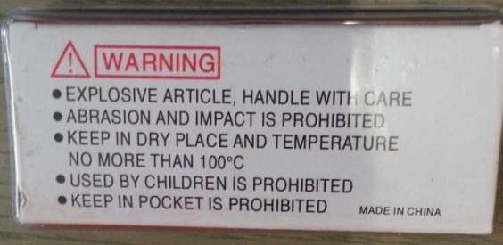

- Storage, handling and use of starting pistol caps and other devices
Starting caps are tiny detonators containing small amounts of sensitive explosive which can ignite from:
- friction, abrasion or impact;
- static electric spark;
- heat, contact with naked flame or other ignition source;
- contact with metal or sharp objects, including coins, keys, pens, fingernails, etc
Accidental explosion can cause serious burns.

Recommendations/Action required
- Isolation and removal of Jex Starting Caps in DEECD schools
Schools must take particular care with storage, handling, use and disposal of all starting caps including:
  - Do not purchase or use Jex Starting Caps at this time.
  - Schools are to immediately isolate existing stock of Jex caps in a secure locked cupboard, inaccessible to students and unauthorised persons
  - Caps must be stored in their original plastic container and clearly labelled as explosive.
  - Schools should contact their supplier immediately to (a) inform them that the school is in possession of Jex caps (b) arrange collection to a central location as per supplier’s requirements.
  - Schools should call the DEECD OHS Advisory Service for further advice Ph. 1300 074 715.
Please note that the starting gun is not part of the recall.
- Chemical Safety with other brands of starting caps.

Schools must take particular care with storage, handling, and use of starting caps and should:
- Store caps securely in clearly, rigid labelled containers as detailed above.
- Obtain a Material Safety Data Sheet and include the product in the school’s Chemical Register
- Follow manufacturer’s instructions
- Keep starting caps away from ignition triggers (as above)
- Permit only authorised and trained users to access this equipment.
- Choose an alternative starting device
In addition to chemical safety concerns hazardous noise produced by both starting pistols that use caps and alternative devices such as electronic starters can damage hearing of both users and bystanders.
Schools are therefore advised to choose alternate starting devices such as:
  - Flag, starting clap board or whistle
  - Electronic starting pistol or electronic beeper with flash
  - Portable PA with beeper
  - Air-driven horn (including rechargeable with bicycle pump)
NB: Aerosol air horns eliminate the chemical hazard from starting caps. However, compressed gases in aerosol cans can expand and explode when exposed to direct heat, such as extended periods of direct sunlight experienced during sports events. Safety instructions on the labels must be used in storage and use of portable air horns.

- Hearing protection
Hazardous noise levels are a risk for most alternative starting devices therefore, the starter must wear hearing protection with an SLC 80 rating of not less than 25 dbA. Bystanders must be kept at least 5 metres away from the starter, or also wear hearing protection.
OHS Management

The DEECD OHS Management System (OHSMS) procedures help identify and manage risks associated with the purchase of an alternative starting device.

- Use the OHS Purchasing Checklist to identify potential hazards for the product being considered. If a hazard is identified:
  - Use the Task Based Risk Management Form Appendix A to help identify the specific hazards in the task (i.e. using the starting device) and document the controls put in place.
  - Use Safe Work Procedure Template to document both (a) clear instructions and procedures for safe use and (b) persons deemed competent to use the equipment.
- Update school’s OHS Risk Register to identify hazards from starting devices and controls implemented to manage the risk.

Further information
The Department’s Occupational Health and Safety Management System provide policies and procedures for managing dangerous goods in the workplace.
For further assistance contact the OHS Advisory Service on 1300 074 715 or email safety@edumail.vic.gov.au.

Acknowledgement
Little Athletics Victoria

Disclaimer
This Alert contains information following DEECD’s inquiries into an incident at the date of this report. The information contained in this report does not necessarily reflect the final outcome of DEECD’s action with respect to this incident. DEECD does not warrant the information in this report is complete or up-to-date and does not accept any liability to any person in relation to the information in this report or as to its use.

