Pedestal Drills (Drill Press)
August 2013

Issue/Incident:
 
- An injury was sustained when a student caught their finger in the belt and pulley mechanism of a Pedestal Drill (Drill Press).

- The Drill Press remained connected to the power source while the student changed the drill speed which allowed for another student to accidentally turn on the drill press.

- A padlock used to secure the top guard was removed to reposition the belt across the pulley system, allowing access to moving parts.

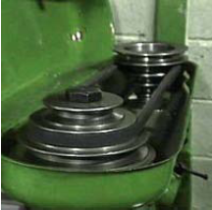
Belt and Pulley System inside drill housing

Factors/Risks to Consider:

- The Drill Press remained connected to the power source when changing the drill speed and repositioning the belt.

- A micro-switch to allow for electrical interlocking of the Pedestal Drill was not installed.

- The drill could be started or remain operational when the moving pulley and belt are exposed if the padlock is removed to open the guard.

- Students need to be supervised when the Drill Press guard is removed and have access to moving parts.

Recommendations:

Schools should implement the following controls in relation to pedestal drills:

- Conduct a risk assessment using the Plant and Equipment Risk Management Form for all Pedestal Drills in their workplace and document appropriate Safe Work Procedures.

- Display the Safe Work Procedure next to each Pedestal Drill.

- Install a micro-switch to allow for electrical interlocking of the Pedestal Drill when the housing cover is opened.

- Install a lockable isolation switch to the power supply for the Pedestal Drill.

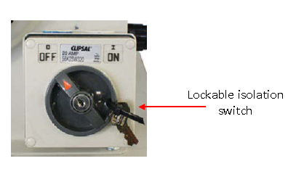
- Ensure that the isolation switch is locked in the “off” position prior to removing the guard and opening the belt and pulley housing cover. This requirement should be incorporated into the Safe Work Procedure.

- Ensure technology teachers have attended the Safe Use of Machinery for Technology Teaching course.

- Ensure students are supervised by a technology teacher when accessing the drill housing.

Further Information:

- AS4024:2006 Safety of Machinery.
- DEECD Health, Safety and WorkSafe Website.
- Contact the OHS Advisory Service on 1300 074 715 or e-mail. safety@edumail.vic.gov.au.

Disclaimer
This Alert contains information following DEECD’s inquiries into an incident at the date of this report. The information contained in this report does not necessarily reflect the final outcome of DEECD’s action with respect to this incident. DEECD does not warrant the information in this report is complete or up-to-date and does not accept any liability to any person in relation to the information in this report or as to its use.

