Stormwater Drain Pits
May 2013

Issue/Incidents:

Due to poorly maintained drain pits there have been a number of incidents including:

- Two unrelated falls into open drain pits causing bruising on arms and shoulders and broken ribs
- A Sprained ankle resulting from tripping on a piece of wood covering the end of a drain.
- A cut above left eye and grazed knees resulting from tripping and falling on a metal drainage grate.
- Twisted ankle after stepping on an open drain pit.
- Jarred elbow when supporting a student who slipped on a drain pit cover.

Factors/Risks to Consider

- The removal of drain pit covers created a falling hazard.

- Recessed, raised and damaged/broken drain pit covers created an uneven surface increasing the risk of slips, trips and falls.

- Missing paving bricks and loose grate covers created a tripping and falling hazard.

Recommendations:

- Identify all drain pits and covers on site, include these in the workplace’s OHS Risk Register and document current controls.

- Ensure that drain pits are included in the Workplace Inspection Checklist and regularly inspected for rust, cracks and damage.

- Ensure drain pit covers/grates are secured using a tight fitted bolt design as specified in the DEECD Building Quality Standards Handbook.

- Ensure raised or sunken drain pit covers are re-fitted so they sit at ground level. In the short-term, raised drain pit covers should be highlighted using high visibility paint.

- Replace rusted or damaged steel grates with ‘checkered-type’ or flat ‘steel-type’ covers (Refer to Photos 5 & 6).

- Where practicable reconfigure footpaths and walkways to avoid pedestrian traffic near or over drain pits.

- Ensure employees wear appropriate footwear particularly when on yard duty.

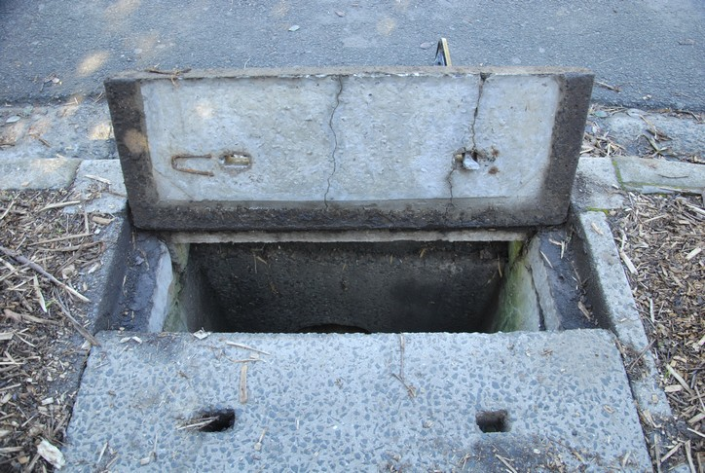 |  | 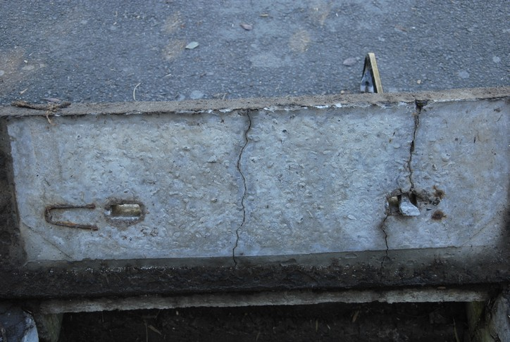
Photo 1: Unreinforced concrete cover with visible cracks from underneath |  | Photo 2: Significant cracks of unreinforced concrete cover

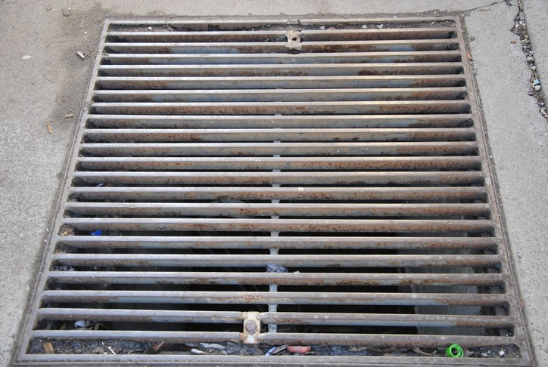 |  | 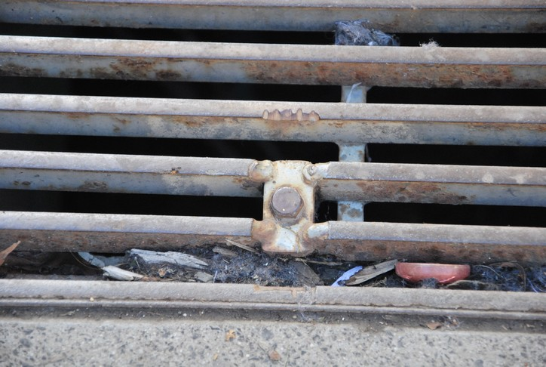
Photo 3: Secured metal grate |  | Photo 4: Bolted metal grate

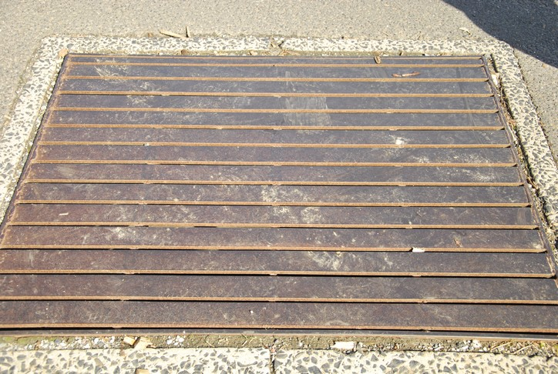 |  | 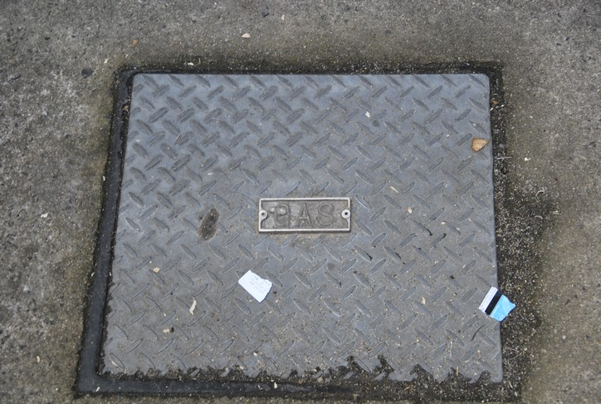
Photo 5: Flat steel-type drain pit cover |  | Photo 6: Checkered-type drain pit cover

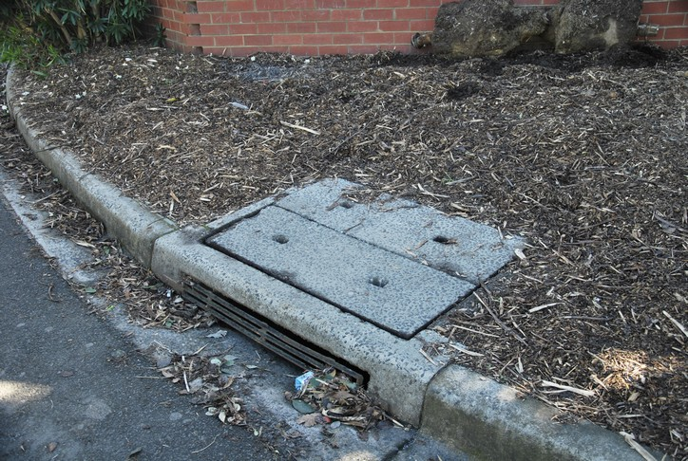 |  | 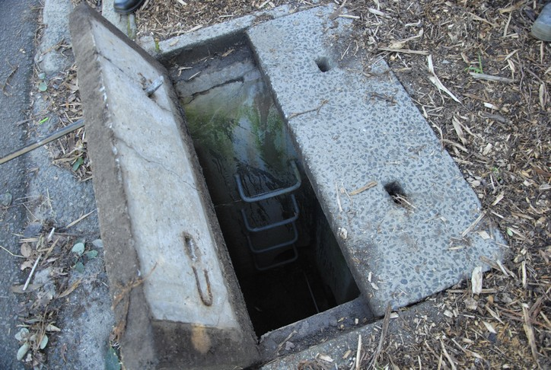
Photo 7: Typical stormwater drain pit on kerbside with concrete cover – no evidence of cracking from outside |  | Photo 8: Typical stormwater drain pit with concrete cover – no evidence of cracking from outside

Further Information:

Further information can be obtained from DEECD’s Health, Safety and WorkSafe website or by contacting the DEECD OHS Advisory Service on 1300 074 715 or email safety@edumail.vic.gov.au .

