Issue
The heads of Workplace Safety Authorities Imported Materials with Asbestos Working Group has issued an alert regarding the sale of crayons within Australia that have been found to contain trace amounts of asbestos.
Trace amounts of asbestos have been detected in some brands of children’s crayons that have been imported into Australia. The crayon products in which asbestos has been identified are as follows:
Dora the Explorer Personalized 32 pack crayons  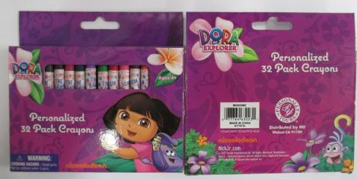 | Dora the Explorer Jumbo crayons  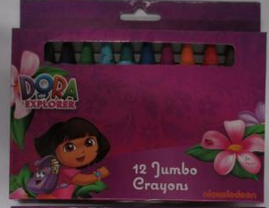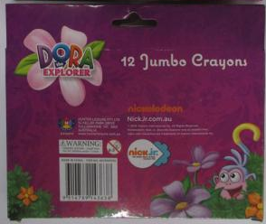
Arti Crafti 16 piece crayons  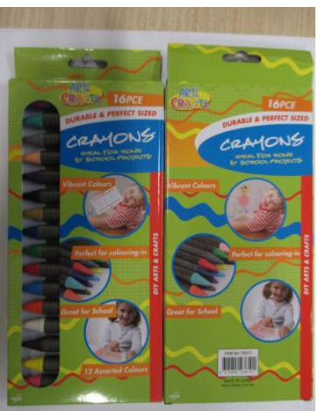 | Peppa Pig 8 wax crayons  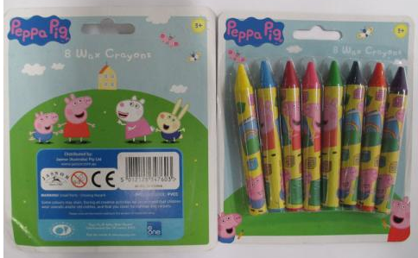
Disney ‘Frozen’ Jumbo Crayons  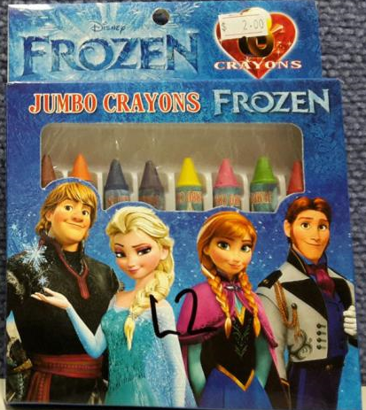 | Disney ‘Mickey Mouse and Friends’ Crayons  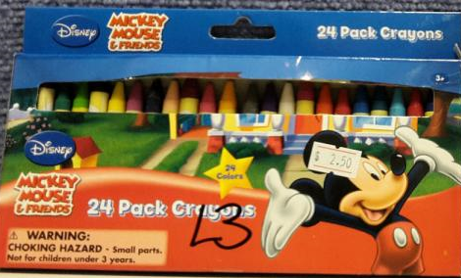

Factors / Risks to consider
The Australian Competition and Consumer Commission and Asbestos Safety and Eradication Agency does not not believe that traces of asbestos in crayons present a safety risk to consumers because the asbestos is fixed within the crayon wax, which reduces the risk of inhalation or ingestion.
Despite the low risk, the Australian Government as well as state and territory governments are taking a precautionary and coordinated approach to this issue, through the Heads of Workplace Safety Authorities Imported Materials with Asbestos Working Group.

Recommendations/Action required
- Place the crayons in a clear plastic bag (zip lock or sealed with a knot) and contact DTZ on 1300 133 468 to collect the crayons at no cost to the school or;

- Place the crayons in a clear plastic bag (zip lock or sealed with a knot) or original packaging and return to the supplier.

Further information
The DET’s Occupational Health and Safety Management System provide policies and procedures for managing hazardous building materials in the workplace.
For further assistance contact DTZ on 1300 133 468 or the OHS Advisory Service on 1300 074 715 or email safety@edumail.vic.gov.au.

Acknowledgement
Asbestos Safety and Eradication Agency
Australian Competition and Consumer Commission
WorkSafe Victoria

Disclaimer
This Alert contains information following DET’s inquiries into an incident at the date of this report. The information contained in this report does not necessarily reflect the final outcome of DET’s action with respect to this incident. DET does not warrant the information in this report is complete or up-to-date and does not accept any liability to any person in relation to the information in this report or as to its use.

