Issue
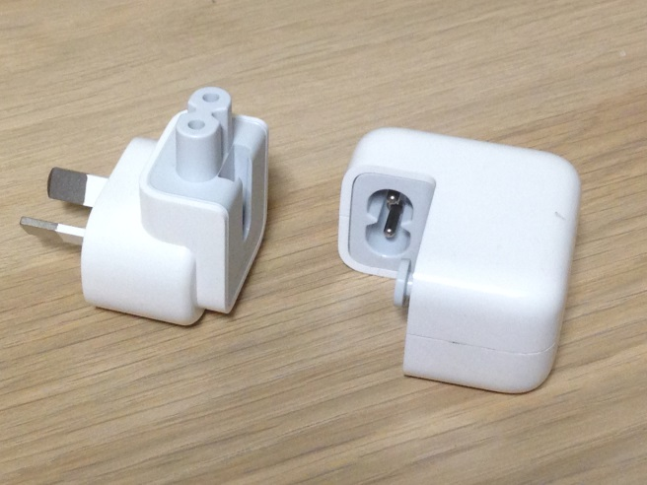
Apple has issued a recall of two-pronged AC wall plugs sold from 2003 to 2015 with Mac and certain types of iOS devices. In some cases it is possible for the plugs to break and create a risk of electric shock if touched.

Apple has advised people who may have purchased these products to identify whether the wall plug is affected by the recall. Apple will exchange affected wall plug adapters with new redesigned adapters free of charge.

Detailed information on how to identify affected wall plugs and how to arrange an exchange is provided by Apple at its website at: https://www.apple.com/au/support/ac-wallplug-adapter/

Recommendations/Action required
- All DET schools and workplaces are required to arrange for any affected adapters within the workplace to be exchanged for new redesigned adapters.
- All DET schools and workplaces should inform staff and/or students that have been issued with mac and iOS devices of the recall.
Further information
For further assistance contact the OHS Advisory Service on 1300 074 715 or email safety@edumail.vic.gov.au.

Disclaimer
This Alert contains information following DET’s inquiries into an incident at the date of this report. The information contained in this report does not necessarily reflect the final outcome of DET’s action with respect to this incident. DET does not warrant the information in this report is complete or up-to-date and does not accept any liability to any person in relation to the information in this report or as to its use.

