DOING DIVERSITY

INTERCULTURAL UNDERSTANDING IN PRIMARY AND SECONDARY SCHOOLS

FINAL REPORT 2015

Doing Diversity: Intercultural Understanding in Primary and Secondary Schools
An Australian Research Council Linkage Project
Final Report 2015

Research team:
Christine Halse, Fethi Mansouri, Julianne Moss, Yin Paradies, Joanne O’Mara, Ruth Arber, Nida Denson, Colin Arrowsmith, Naomi Priest, Claire Charles, Anne Cloonan, Brandi Fox, Catherine Hartung, Caroline Mahoney, Sarah Ohi, Georgia Ovenden, Gary Shaw, Lesley Wright.
Participating universities:
Deakin University, Western Sydney University, RMIT University and the Australian National University.
Partner Organisations:
Department of Education and Training Victoria (DET), Together for Humanity Foundation (TFH), Victorian Curriculum and Assessment Authority (VCAA), and Pukunui Technology.
Advisory Board:
Kathe Kirby (Asia Education Foundation); Padmini Sebastian and Jan Molloy (Immigration Museum); Sue Christophers, Alan McLean and Ian Burrage (Dept of Education and Training); David Howes (Victorian Curriculum and Assessment Authority); Fazal Rizvi (University of Melbourne); Zalman Kastel (Together for Humanity Foundation); Soo-Lin Quek (Centre for Multicultural Youth); Hass Dellal (Australian Multicultural Foundation).

Published by Deakin University
Copyright Deakin University 2015. This material may be reproduced for educational purposes and as otherwise allowed under local copyright legislation.
ISBN: 978-0-7300-0029-7

Acknowledgements:
Sincere thanks are due to the students, teachers and principals from the 12 schools in the study for their involvement in the Doing Diversity project. The study would not have been possible without their generous commitment of energy, thought and time.
The project would also not have been possible without the support and proactive engagement of our partner organisations, Department of Education and Training Victoria (DET), Together for Humanity Foundation (TFH), Victorian Curriculum and Assessment Authority (VCAA), and Pukunui Technology. We are grateful for their significant and invaluable contributions to the development, conduct and completion of this study.
Many people from each partner organisation contributed to the study but particular thanks must go to Gary Shaw from the International Education Division, DET, who was a full member of the research team and Mentor for one of the study schools; Connie Andreana from the International Education Division, DET, for her proactive support and valued insight into government schools and priorities in Victoria; Rabbi Zalman Kastel from TFH who provided insightful guidance about inter-faith issues and who made the TFH’s on-line professional learning modules for teachers, Difference Differently, available for use in the project and which were widely commended by teachers for their relevance and ease of use; and to David Howes and Michael Dalton from VCAA who were always responsive to our requests, provided helpful advice on ethical issues, and were invaluable critical friends on issues of research design, method and analysis. It was a pleasure working with each of you and benefiting from your expertise and support.
Finally, a sincere thanks to our Advisory Board of eminent and influential experts. It is rare to be able to gather such a distinguished group together, given their busy schedules and multitude of commitments. The fact that these experts made themselves available to advise on the study is testimony to its social and educational significance and importance to Victoria and Australia. This contribution, feedback and advice was always instructive, helpful and very much appreciated.

Contents

List of tables 5
List of figures 5
List of abbreviations 6
Synopsis of key findings 7
Executive summary 8
Introduction 16
Principals’ and teachers’ beliefs on effectively building students’ intercultural capabilities 26
School performance as indicated by the survey results 30
Intercultural capabilities in practice 37
Using school spaces to recognise diversity 41
The impact of geography 44
The intercultural capabilities in the lives of children and young people 47
Explaining differences between schools 51
References 56
Appendices 59

List of tables

Table 1: Summary of research methods ……………………………………………………………………………………… 19
Table 2: Summary of participating schools…………………………………………………………………………………… 23
Table 3: Views on the facilitators and impediments of intercultural capabilities (Year1)………….…. 25
Table 4: Illustrations of significant changes in practices ………………………………………………………….…… 27
Table 5: Views on the facilitators and impediments of intercultural capabilities (Year 2) …………… 27
Table 6: Number of eligible participants and completions at each time point ……………………………… 29
Table 7: Summary of student quiz results on a matched sample from Time 2 to Time 3 ……….……. 33

List of figures

Figure 1: Which response most closely resembles your understanding of the term ‘culture’?........ 30
Figure 2: Which response most closely resembles your understanding of the term
‘intercultural understanding’? ………………………………………………………………………..……………. 31
Figure 3: What does ‘culture’ mean to you? ………………………………………………………………………..……… 32
Figure 4: What does ‘intercultural understanding’ mean to you? ……………………………………………….. 33
Figure 5: Intercultural dimensions and actions ………………………………………………………………………………. 51

List of abbreviations

ABS Australian Bureau of Statistics
ACARA Australian Curriculum, Assessment and Reporting Authority
DET Department of Education and Training
EAL English as an Additional Language
EMA Education Maintenance Allowance
ICSEA Index of Community Socio-Educational Advantage
IC Intercultural Capacity
ICC Intercultural Capability Coordinator
LBOTE Language Background Other Than English
LOTE Language Other Than English
MCEETYA Ministerial Council on Education, Employment, Training and Youth Affairs
NAPLAN National Assessment Program – Literacy and Numeracy
SES Socio-Economic Status
TFH Together for Humanity Foundation
UNESCO United Nations Educational, Scientific and Cultural Organization
VCAA Victorian Curriculum and Assessment Authority

Synopsis of key findings
Doing Diversity: Intercultural understanding in primary and secondary schools was a three year, multi-method programme of research involving intensive work in 12 diverse profile schools in Melbourne, Victoria, that examined the facilitators and impediments to the intercultural capabilities described in the Victorian and Australian curricula for students and schools.
The study found that the most interculturally capable students attended schools that: i) have a strong, explicit and well-established culture of racial, religious and cultural equality in all areas of its operations; and ii) actively integrated the knowledge, attitudes and skills required for respectful engagement with diversity across all members of the school community, including students, teachers and parents (see Chapters 2, 7). These findings affirm earlier research about the limited efficacy of single or short-term interventions in producing substantive, intercultural change (Greco, Priest & Paradies, 2010).
So what distinguishes interculturally capable schools? The study found that the least effective schools limited intercultural education to specific subject areas. More effective schools recognised that a range of factors influence students’ intercultural knowledge, skills, attitudes and behaviours, including the values, attitudes and practices that are embedded in and perpetuated through the attitudes and behaviours of peers, parents, teachers, the media, geographic location and economic privilege/disadvantage (see Chapter 5; Charles, Mahoney, Fox & Halse, 2016; Halse, 2015). Effective schools critically and reflexively assessed the intercultural challenges specific to their schools and took action to address these by embedding intercultural policies and practices in all areas of school life, including teacher professional learning and the use of school space (see Chapters 4, 7). The most effective strategies are identified as the ‘eight key principals for building interculturally capable schools’ (see Executive Summary, Chapters 1, 3 and 4).
At the level of the individual student and teacher, the study identified key factors or dimensions of intercultural capability (see Chapters 1, 2). Because of the diversity within and across individuals and their personal histories and contexts, the study concluded that a combination of qualitative and quantitative tools are most effective for evaluating and reporting on students’ and teachers’ intercultural capabilities and for tracking changes in these over time.
A detailed analysis of individual students’ acquisition of intercultural knowledge and skills over time revealed that the most powerful and influential learning experiences occurred outside of the classroom as a result of students’ interactions with others, including family and peers (see Chapter 6). This finding reinforces the importance of a comprehensive, connected, school-wide approach to intercultural education but also underlines the imperative for schools to attend to the role of students’ outside-of-school experiences in formulating programmes and practices to equip students of all ages with the intercultural capabilities needed for a culturally diverse, global future.

Executive summary
Background

In an era of increasing ethnic, religious, linguistic and cultural diversity within nations, the capacity to interact positively with diverse cultural, ethnic and religious groups is essential for creating inclusive and cohesive multicultural societies (UNESCO, 2006, 2010, 2013). Australia is one of the most multicultural societies in the world and developing school students’ intercultural capabilities is a priority for schooling embedded in the National Education Goals for Young Australians, known as the Melbourne Declaration (MEETYA, 2008).

The Australian Curriculum (ACARA 2015) specifies ‘Intercultural Understanding’ as a key personal, interpersonal and social capability that all young people are expected to achieve through their schooling. In Victoria, ‘Intercultural Capabilities’ are a key set of personal and social knowledges and skills specified in the Victorian Curriculum (VCAA, 2015) and needed for civic participation and to thrive in life and work (DET, 2015).
The aim of the Doing Diversity study was to identify factors that facilitate and impede these intercultural capabilities in students, teachers and schools. The study was funded by an Australian Research Council in partnership with the Victorian Department of Education and Training (DET), the non-for-profit foundation Together for Humanity (TFH), the Victorian Curriculum and Assessment Authority (VCAA), and Pukunui Technology (ARCLP 120200319). Because the study was conducted in Victoria, the term ‘Intercultural Capabilities’ is used but the research findings are also relevant to jurisdictions that use comparable terms, such as ‘Intercultural Understanding’.
Research questions and design
Four questions guided the research:
- What facilitates and impedes intercultural capabilities in children and adolescents?
- What facilitates and impedes intercultural capabilities in schools?
- How can schools support the development of intercultural capabilities in schools?
- How can we know what makes a difference?

The study was conducted over three years that included two years of intensive collaborative work with six primary and six secondary schools in metropolitan Melbourne comprising a maximum variation sample in terms of geographic location, size, students’ ethnic and language backgrounds, and school Index of Community Socio-Educational Advantage (ICSEA). Each school was supported by a Mentor who provided advice and guidance, collected data and reported emergent research findings to schools. Each school also appointed a staff member as the Intercultural Capability Coordinator (ICC) to organise the school’s involvement in the study.
Multiple forms of data were collected on multiple occasions. This included an Intercultural Capabilities Quiz for students, an Intercultural Capabilities Teacher Survey, interviews with Principals and ICCs, focus groups with teachers and with students, observations of school operations, events and activities, analysis of school websites, artefacts and use of space, and annual, individual interviews with students.
.
The Doing Diversity Approach

Short-term, one-off interventions have limited and sometimes detrimental impacts on students and teachers’ diversity attitudes and behaviours (Cotton, 1993; Greco, Priest & Paradies, 2010, MacNaughton & Hughes, 2004). Thus, the Doing Diversity Approach was to focus on guiding schools through a set of research-based strategies to change school cultures re intercultural capacity (see Halse, 2013). Three elements comprised the Doing Diversity Approach.
- Building capacity: Schools were given access to a range of activities designed to move them from high, external support to self-directed, intercultural growth throughout the study. In Year 1, all principals and ICCs participated in three formal, professional learning days to build their intercultural knowledge and leadership skills; all schools were asked to complete three on-line modules on intercultural capability developed by Together for Humanity. In response to requests, mentors also provided face-to-face workshops for staff and TFH provided workshops for students in schools. The goal for Year 2 was to develop sustainable, self-directed, intercultural growth. Inter-schools networks were established and responsible for collaborating to collectively build intercultural expertise in students, teachers and schools. Each network took up this challenge in different ways that included inter-school visits by staff and students, sharing strategies and resources, and collaborative intercultural programmes. On-going support during the project was provided by a purpose-built website for sharing knowledge, information and resources.

ii) Taking responsibility: The project took the view that each school is different and, therefore, schools were required to take responsibility for building the intercultural capabilities of their students, staff and school in ways that were specific to their context and needs. Mentors provided advice and direction but each school developed an Intercultural Action Plan and presented on their progress, achievements and accomplishments at a ‘Showcase Day’ at the end of Years 1 and 2 of the project.

- Research evidence. Schools were provided with regular research evidence about the efficacy, impact and progress of their initiatives to become an interculturally capable school, and schools used this evidence to review and revise their plans and practices.

Research Findings.
The following section summarises the key findings based on the triangulation (checking and cross-checking) and synthesis of data from different sources and analyses.

The Intercultural Capabilities are a valuable framework for school practice.
In the absence of professional training, principals and teachers were uncertain about the meaning of ‘Intercultural Understanding’ in the Australian Curriculum, how it differed from ‘Multicultural Education’, and how it might be implemented in the curriculum and school practice. This finding confirms the imperative for professional learning for principals and teachers, and endorses VCAA’s use of the clearer concept of Intercultural Capabilities with a distinct scope and sequence and achievement standards in the Victorian Curriculum F-10.

Principals’ and teachers’ beliefs impact on the approach to intercultural learning in schools.
At the onset of the study, principals and teachers had firm beliefs about the factors that facilitate and impede intercultural learning among students and in schools. Many believed these factors were beyond their control and, therefore, that they could not be held responsible for the absence of intercultural capabilities among students, staff or school practices. As discussed below, these beliefs changed radically during the project as a result of participating in the Doing Diversity Approach.

The Doing Diversity Approach built staff and school knowledge and capacity.
The Doing Diversity Approach facilitated constructive improvements in principals’ and teachers’ intercultural knowledge, attitudes, beliefs and practices, demonstrating the value of a multi-pronged approached to building intercultural capacity in schools. Key facilitators of change included:

- Structured, on-going, professional learning focused on increasing knowledge and the pedagogical and leadership skills needed to implement the intercultural capabilities across all areas of schooling;
- Multiple approaches to professional learning to address the broad range of needs across different teachers and schools, including use of the TFH on-line, teacher professional learning modules, off-site professional learning days, school-based workshops for students and teachers and inter-school networks for sharing professional practice;
- Access to research evidence and academic advice to enable informed decision-making and development by schools; and
- The requirement that schools be responsible and accountable through reflexive reporting on the efficacy and progress of initiatives to build intercultural knowledge and skills.

Eight key principles for building interculturally capable schools.
Eight key principles distinguished the schools that were most successful in building the intercultural capabilities.

1. Principals make a difference: Schools with principals who were actively involved in all aspects of the Doing Diversity Approach and study, and who applied the core practices of effective leadership (Leithwood et al., 2004), had higher levels of achievement in intercultural expertise overall. These principals focused on developing people, setting school directions, and redesigning the operation of their school.

2. Research-based decision-making improves outcomes: Improvement was strongest in schools that actively engaged with the research findings, used them to evaluate existing practices, sought expert advice from the research team and included a wide range of staff in collaboratively developing action plans for improvement.
3. Strategic use of finances makes a difference: Schools that used their project funds to buy in specialist intercultural expertise had the strongest improvements in students’ and teachers’ intercultural capabilities. These actions included appointment of a part-time Multicultural Aid, appointing an Intercultural Coordinator, purchase of resources and running TFH workshops.

4. Professional learning makes a difference. Improvements were strongest in schools where staff actively participated in professional learning, particularly the TFH on-line, professional learning modules. High staff turnover limits the scale of impact on individual schools, indicating the need for continuous professional learning and support to embed the intercultural capabilities in schools.

5. Personal intercultural experiences, including travel, enhance teacher expertise. Consistent with prior research (Halse, 2015b; Halse et al., 2013), principals and teachers who had personal experience of ethnic diversity and intercultural relations inside and outside of school, including through study and travel overseas, were more alert to and engaged with building intercultural capabilities, indicating the benefits of local and overseas exchanges, networks and study tours for building staff capacity.
6. Intercultural capabilities are fostered in reflexive learning environments. There was faster, stronger progress towards becoming interculturally capable when schools regarded themselves as learning environments for all students, teachers and their community. In these schools, school leadership teams were reflexive about and eager to improve their personal intercultural knowledge and capabilities, and nurtured this approach at all levels and in all areas of school life.
7. A whole school approach is most effective in improving intercultural capabilities. Schools that adopted a multi-faceted approach across all aspects of school life showed stronger development of intercultural capabilities than schools that restricted their focus to a single discipline and/or school Grade.
8. Curriculum innovation is essential. Schools found the focus on learning to be intercultural rather than learning about ethnic and cultural diversity required fresh, innovative approaches to curriculum and school operations. Effective approaches included greater use of parent, community and ‘sister school’ relationships, collaborating with schools with different ethnic, religious and linguistic profiles; and inter-school networking to exchange intercultural ‘know-how’.

Multiple, multi-level methods should be used to assess and evaluate intercultural capabilities.
The student quiz and teacher survey indicated positive improvements in intercultural capabilities overall and were useful diagnostic tools for helping schools identify specific areas of developmental need. However, such instruments are best used with other assessment and evaluation tools that focus on the Victorian Curriculum’s achievement standards for the intercultural capabilities in Foundation to Year 10 and that attend to interculturality at the multiple levels of schools’ operations.

The need for support resources
Schools strongly endorsed the TFH on-line modules as an effective professional learning tool but also noted the relative dearth of resources specific to Intercultural Capabilities. The knowledge transfer implemented as part of this study made a start in filling this gap but schools would benefit from resources aligned to the intercultural capability scope and sequence of the curriculum, guidelines for school leaders on building interculturally capable schools, and illustrations of the application of the intercultural capabilities across all areas of school life.

Use of school spaces to acknowledge diversity and intercultural connections has a positive impact.
Visual displays in foyers, corridors, playgrounds and classrooms that honour students’ ethnicity and culture and that demonstrate a school’s local and global intercultural connections send important messages about a school’s commitment to cultural diversity, inclusion and social cohesion. There was stronger intercultural growth in schools with prominent, regularly refreshed, intercultural displays compared with those that had no or few visual displays in their public spaces.

The impact of outside-of-school factors on students’ intercultural capabilities.
Students’ intercultural capabilities are related to family background, residential postcode and relative socio-economic advantage, with higher than expected levels of intercultural capability among students in Years 5 and 7 around the south-eastern suburbs and lower than expected levels in Years 5 and 7 in the north-eastern suburbs of Melbourne. Specifically,
- Students with both parents born overseas had significantly higher levels of intercultural capability than their peers, including those with one parent born overseas or both parents born in Australia;
- There is a strong positive relationship between intercultural capabilities, NAPLAN literacy and reading scores and home postcode among Year 3 and 7 students;
- There are significantly lower levels of ‘openness to cultural diversity’ among students whose families earn less than $10,400 per annum.

Many students and, reportedly, their parents regard intercultural skills as important for a successful future career and life but this view was more common in higher ICSEA schools. However, the development of students’ intercultural capabilities is impeded when they prioritise individualism, competition and personal success and achievement over the development of empathy and compassion and this is most likely to occur in the more competitive environment of secondary school.

Data indicates that students’ intercultural capabilities develop incrementally and change as they progress through school. The curriculum is an important vehicle for building the intercultural capabilities but students’ attitudes and behaviours are also strongly shaped by experiences outside school.

Significant ‘critical moments’ or ‘turning points’ in students’ intercultural awareness and skills largely resulted either from friendships and interactions with peers, personal life experiences or knowledge acquired outside of school, including from parents and the media. This finding confirms the need for criticality in curriculum and pedagogy; a whole-school approach that affirms and reinforces the intercultural capabilities; positive school relationships with parents and community; and schools’ attention to events involving intercultural relations in wider society.

Recommendations
Based on the findings, stakeholder action is recommended in the following areas:
Focus area | Recommendation
Pre-service teacher education | Advocate that all pre-service teacher education providers address the development of the intercultural capabilities of student teachers.  Ensure that knowledge and teaching of Intercultural Capabilities is a required component of all pre-service teacher education programmes.
Building sustainable practice in school communities | Use the Doing Diversity Approach to develop guidelines for principals and school leaders on building the intercultural capabilities in their students and communities.  Strongly encourage schools to include the intercultural capabilities in their school vision and strategic plans, and to link these to teachers’ Professional Development Plans and Performance Reviews.  Strongly encourage all schools to appoint and support a school leadership role for the intercultural capabilities.  Ensure a global education focus in all schools, as highlighted in the Melbourne Declaration and curriculum, through partnerships with local community organisations, sister school partnerships, international projects with other schools, overseas tours or immersion experiences and integration of international students.
Professional learning | Include units on Intercultural Capabilities in all principal, leadership and staff induction programmes.  Develop and make available a structured programme of professional learning opportunities, using different on- and off-line modes of delivery to build capacity in the teaching profession.
Resources | Identify and encourage the use of resources and tools to support the implementation of the intercultural capabilities throughout the curriculum.  Develop and make available on-line curriculum units that address topical issues in intercultural relations that align with the Intercultural Capability Achievement Standards.  Develop and make available on-line a suite of resources for schools to use in assessing and evaluating student and school development in the intercultural capabilities.

Knowledge transfer
The study focused on two forms of knowledge transfer; additional outputs are in development.
1. Knowledge transfer to schools, the teaching profession and the education community:
- Provision of professional learning and support to principals and teachers by internationally recognised experts in school curriculum, policy and intercultural relations;
- Publication of a list of publically available resources on the project website;
- Six short videos of principals and Intercultural Capabilities Coordinators discussing the approaches they used to develop intercultural capability in their school;
- 30 ‘Intercultural Insights’ that illustrate the practice of the intercultural capabilities among students, teachers, principals, in school organisation and in school and community relations; and
- Two research forums for senior DET staff, VCAA, Catholic Education and Independent School representatives.
2. Transfer of knowledge to the international research community
Book Chapters:
Cloonan, A., O’Mara, J. & Ohi, S. (2014), Supporting intercultural engagement in literacy education, in Doecke, B., Auld, G. & Wells, M. (Eds.), Becoming a teacher of language and literacy. Port Melbourne, Vic.: Cambridge University Press, pp.83‐98.

Journal Articles (published):
Charles, C., Mahoney, C., Fox, B., Halse, C. (2014). School principals and racism: Responding to Aveling, Discourse: Studies in the Cultural Politics of Education. DOI: 10.1080/01596306.2014.985634
Halse, C. (2015) Responsibility for racism in the everyday talk of young people. Discourse: Studies in the Cultural Politics of Education. DOI: 10.1080/01596306.2015.1104848
Journal Articles (under review and forthcoming):
Charles, C. & Hartung, C. (Forthcoming) ‘Sugar and spice and all things nice’: Katy Perry, gender and cultural appropriation.
Cloonan, A, Fox, B & Ohi, S (Under review) Developing interculturality with teachers and students through autobiographical narrative exchange. Teaching Education.
Denson, N., Ovenden, G., Wright, L., Paradies, Y. & Priest, N. (Forthcoming) The Development and Validation of Intercultural Understanding (ICU) Instruments for Teachers and Students in Primary and Secondary Schools.
Halse, C., Black, R., Charles, C. & Hartung, C. (Forthcoming) Belonging and young people’s views on asylum seekers.
Halse, C., Fox, B. and O’Mara (Forthcoming) Principal and teacher perceptions of the impediments and facilitators to intercultural understanding in schools.
Halse C. Fox, B., & Mahoney C. (Forthcoming) Theorising critical moments in young people’s intercultural subjectivities.
Ohi, S., Shaw, G., O’Mara, J., Hartung, C., Arber, R. & Halse, C. (Forthcoming) What can interculturality look like in school practice?
Conference Presentations:
Charles, C., Mahoney, C., Fox, B., Halse, C. (2015) Are school principals racist? Fresh insights from an intersectional approach. Presented at Australian Association of Research in Education Conference 2015, Perth.
Fox, B. (2015) How friendship fosters interculturality in primary school kids: A longitudinal case study of four boys from culturally diverse backgrounds. Presented at European Conference of Educational Research 2015, Budapest.
Fox, B. (2015) Designing a qualitative longitudinal study with kids age 8 to 12. Presented at Consortium of Asia-Pacific Education Universities-Deakin Post-Graduate Symposium 2015, Burwood.
Halse, C., (2015) Racism and responsibility in the everyday discourse of secondary students. Presented at Australian Association of Research in Education Conference 2015, Perth.
Halse, C., Arber, R., Charles, C, Cloonan, A., Fox, B., Mahoney, C, Moss, J., Ohi, S. & O’Mara, J. (2013) Symposium: Intercultural Understanding in Primary and Secondary Schools. Presented at Australian Association for Research in Education Conference 2013, Adelaide.
Mahoney, C. (2015) Neoliberal discourses and young people’s attitudes towards addressing disadvantage. Presented at The Australian Sociological Association Conference 2015, Cairns.

Introduction
The capacity to interact positively with diverse cultural, ethnic and religious groups is of crucial social and educational importance. Accelerating transnational flows of ideas, economies, cultural practices and people have increased the ethnic, religious, linguistic and cultural diversity within nations. Thus, international agencies such as the United Nations Education, Scientific and Cultural Organisation (UNESCO) emphasise the importance of developing young people who have the intercultural knowledge and skills necessary to build interculturally skilled, inclusive and cohesive societies (UNESCO, 2006, 2013). Schools have a critical role in this agenda, as the UNESCO report on Education for Intercultural Understanding emphasises: ‘Education systems, schools and teachers are therefore responsible for strengthening the child’s cultural identity and values, while also promoting respect and understanding for the culture of others’ (UNESCO, 2010, p. 9).

Intercultural capacities are a national, social priority for Australia as a migrant nation with nearly 50 percent of its population born overseas or with a parent born overseas. Nationally, nearly 70 percent of the negative intercultural incidents experienced by young people happen in school and range from intolerance, incivility and bullying to physical violence (Mansouri & Jenkins, 2010). The national consequences are significant: extreme ethnic disparities in learning outcomes, aspirations, community connectedness and life outcomes (Arber, 2008, 2009); statistically significant increases in physical and mental health problems (Priest et al., 2012); ethnic residualisation in schools; the social and economic marginalisation of communities (Mansouri & Percival-Wood, 2008); and the perpetuation of racial discrimination that prevents social cohesion and a ‘fair go for all’ (Halse, 2015a).

Australia is one of the most multicultural societies in the world and developing school students’ intercultural capabilities is critical for student learning and wellbeing. Culturally inclusive learning environments have positive impacts on student outcomes and education practice (Arber, 2008, 2011; Gillborn, 2008); create richer, more complex social and learning environments that enhance complex thinking (Antonio et al., 2004); and better prepare young people for a global economy and society (Denson & Chang, 2009; Denson & Zhang, 2010). On the other hand, poor intercultural relations increase social exclusion and disconnection (Mansouri & Percival-Wood, 2008) and are strongly related to poor academic outcomes (Bodkin Andrews et al., 2010) and to increased mental and general health problems, including poor social and emotional wellbeing, depression, anxiety and an increase in the risk of suicide (Mansouri et al., 2009; Pachter & Coll, 2009; Paradies et al., 2015; Priest, Baxter & Hayes, 2012).

Thus, intercultural capabilities are an educational priority for Australia. The Melbourne Declaration (2008) identifies an appreciation of Australia’s social, cultural, linguistic and religious diversity and the ability to relate to and communicate across cultures as nationally agreed goals of schooling. Thus, the Australian Curriculum designates Intercultural Understanding as a key personal, interpersonal and social capability that all young people are expected to achieve through their schooling in order to be interculturally sensitive, anti-racist citizens. Specifically, the Australian Curriculum describes the ‘general capability’ of Intercultural Understanding as the knowledge and skills needed to be:

active and informed citizens with an appreciation of Australia’s social, cultural, linguistic and religious diversity, and the ability to relate to and communicate across cultures at local, regional and global levels [and to cultivate] values and dispositions such as curiosity, care, empathy, reciprocity, respect and responsibility, open-mindedness and critical awareness, and support new and positive intercultural behaviours [for] learning to live together (ACARA 2014).
In Victoria, the concept of Intercultural Understanding has been embedded in the Victorian Curriculum (VCAA, 2015) as a cross-curricula suite of ‘Intercultural Capabilities’, with a clearly outlined scope and sequence, and achievement standards for Foundation to Year 10. The knowledge and skills that comprise the Intercultural Capabilities are central to the goals of the Education State: Schools policy (DET, 2015) to build students with the necessary personal and social capabilities for civic participation and ‘to thrive in life and work’ (ibid, p.14). Because this study was located in Victoria, we use the term ‘intercultural capabilities’ throughout this report but the research findings are equally relevant to other states and territories using comparable nomenclature for the Intercultural Understanding general capability in the Australian Curriculum.

This study was developed in response to the imperative for new knowledge about the operation of, and research-based strategies for, developing intercultural capabilities in students, teachers and schools. The study was funded and supported by the Australian Research Council via a Linkage grant, in collaboration with the Victorian Department of Education and Training (DET), Together for Humanity (TFH), the Victorian Curriculum and Assessment Authority (VCAA) and Pukunui Technology.
Research questions
Four questions guided this research study:
- What facilitates and impedes Intercultural Capabilities in children and adolescents?
- What facilitates and impedes Intercultural Capabilities in schools?
- How can schools support the development of Intercultural Capabilities in schools?
- How can we know what makes a difference?

The Doing Diversity Approach

The innovative Doing Diversity Approach involved a two year, longer-term approach to create intercultural excellence from the ‘bottom-up’ by equipping teachers and schools with the skills to develop the intercultural capabilities specific to their students, staff and communities. In each school, this work was supported by an academic Mentor from Deakin University who provided advice and guidance and who collected data and reported emergent research findings and by the appointment of a staff member in each school as Intercultural Capability Coordinator (ICC) to organise intercultural initiatives and work with the research team. The approach contrasts to most previous work in education that typically adopts short term interventions imposed by external systems’ mandates.

The Doing Diversity Approach had three key components.

- Building Professional Capacity. Scaffolded professional learning activities were used to take schools, throughout the project, from high-level, external, expert support to self-directed, peer support. In Year 1, all principals and ICCs participated in three formal, professional learning days to build their intercultural knowledge and leadership skills. All school staff were asked to complete three on-line modules developed by TFH to build the intercultural capabilities. In response to school requests, Deakin Mentors also provided face-to-face workshops for staff and TFH provided workshops for students.
In Year 2, the goal was to develop sustainable, self-directed, professional growth. School networks were established and assigned responsibility for developing their own professional learning and school initiatives. Each network took up this challenge in different ways and some schools were more active participants in their network than others. Initiatives taken by different networks included inter-school visits by staff and students, sharing of action plans, exchanging of ideas, strategies and resources and the collaborative development of joint intercultural programmes and initiatives.

ii) Taking Responsibility. Each school in the project was responsible and accountable for building the intercultural capabilities of their own students, staff and school in a manner specific and relevant to their particular school needs, context, students, communities, staff profile and capacities and educational programmes and priorities. Thus, each school had to develop its unique Intercultural Action Plan for the two years of the project. A Deakin Mentor provided each school with support, advice and suggestions throughout the project, including how improvements can be developed using the evidence and emergent findings from the research. All schools presented on their annual progress and achievements at a ‘Showcase Day’ at the end of each year of their involvement in the study.

- Research evidence. Schools were provided with regular feedback on the efficacy of their Action Plan strategies and their progress in becoming an interculturally capable school. Table 1 (on page 19) details the research methods used throughout the study. All schools were provided with a quarterly report on the study, on-going feedback was provided to ICCs about emergent findings from the qualitative research, and a formal written report, as well as face-to-face feedback, was provided on the findings from the Intercultural Capabilities Quiz for students and the Intercultural Capabilities Survey for staff.

The Doing Diversity Approach was based on research evidence that:

- short-term or one-off interventions can actually increase prejudice among children and, for teachers, short-term or one-off interventions can fail to promote respect for cultural diversity, positive attitudes or behaviour or the skills to work with diverse students, even though they may improve teachers’ knowledge base (Cotton, 1993; Greco, Priest & Paradies 2010; MacNaughton & Hughes, 2007);

- intercultural capabilities include both knowledge and skills (e.g. Abdallah‐Pretceille 2006): knowledge alone is insufficient for developing intercultural capabilities (Hill, 2006; Pusch, 2004). This is reflected in the Victorian Curriculum which emphasises not only learning about cultural difference but recognising, developing, interacting in, empathising with, reflecting on and taking responsibility for intercultural relations;

- if students are to meet the achievement standards for the intercultural capabilities in the curriculum, they need principals and teachers who are interculturally capable in all areas of their practice in schools. Thus, a multi-level (student, teacher, school) approach, over an extended period, is needed to ensure effective and sustainable school change in regards to interculturality (Gorski, 2006; Leeman, 2003);

- factors outside the classroom and school, including peer relationships and broader attitudes and events in social and political life, can influence students’ attitudes and behaviours towards diversity (Halse, 2015a; 2015b). Insights into these influences on students’ lives is necessary to develop effective intercultural schooling.

Participating schools
Schools across metropolitan Melbourne from all school sectors were invited to submit expressions of interest to participate in the Doing Diversity study. The research team and DET chose 12 schools (six primary and six secondary) that offered broad representation of Melbourne’s metropolitan schools across factors of Index of Community Socio-Educational Advantage (ICSEA), enrolment numbers, geographic location and linguistic and cultural backgrounds of students (see Table 1).

Table 1: Summary of participating schools
School | Sector | No. of Students | Index of Community Socio-Educational Advantage (ICSEA) |  |  | Language Background Other Than English (LBOTE) | Post School Destinations
 |  |  | Low/  Middle | Upper Middle | High |  | University | TAFE | Employment
Ackenham Primary School | Government Prep-6 | 90 | 92% | 7% | 1% | 96% | N/A | N/A | N/A
Blackmede Primary School | Government Prep-6 | 564 | 18% | 29% | 52% | 73% | N/A | N/A | N/A
Claire Creek Primary School | Government Prep-6 | 460 | 19% | 32% | 49% | 36% | N/A | N/A | N/A
Dalmorning Primary School | Government Prep-6 | 418 | 35% | 21% | 43% | 50% | N/A | N/A | N/A
Everard Creek Primary School | Government Prep-6 | 339 | 58% | 28% | 15% | 18% | N/A | N/A | N/A
Fraser Hills Primary School | Independent Prep-6 (religious/low fee) | 600 | 48% | 33% | 19% | 74% | N/A | N/A | N/A
Grindlewake College | Government Prep-9 | 1727 | 62% | 26% | 12% | 49% | N/A | N/A | N/A
Haskell Peak College | Government 7-12 | 1363 | 67% | 24% | 8% | 41% | 56% | 26% | 3%
Jardleigh College | Government 7-12 | 1060 | 78% | 17% | 4% | 70% | 52% | 25% | 12%
Kirkswood College | Independent Prep-12 (elite/high fee) | 600+ | 7% | 17% | 76% | 21% | 90% | 3% | 3%
Leighburns College | Independent Prep-12 (religious/low fee) | 400+ | 81% | 16% | 3% | 94% | 55% | 27% | 18%
Mallore Hills College | Government 7-12 | 441 | 38% | 33% | 28% | 10% | 50% | 33% | 12%

The following section provides a brief overview of each school participating in the study.
Ackenham Primary School is a small (n=90), government school located in the inner north-western suburbs of Melbourne. Most of the school community originate from the Horn of Africa and almost all families receive an Education Maintenance Allowance (EMA). Around 16% of students have resided in Australia for less than two years. By contrast, the majority of the school’s teaching staff were born in Australia from English speaking backgrounds. The school’s expression of interest was initiated by the principal, who stated she wished the school to be involved in the project because, “it complements our work in the school and may help us scope out our future direction by connecting and networking with research partners”. During the period of involvement with the project, the school has had substantial staff turnover, including three different principals. Student enrolments are consistently low and the school experiences high student mobility.
Blackmede Primary School is a medium-size (n=564), government, primary school in the eastern suburbs of Melbourne. The school community is linguistically diverse with the most common home languages being English, Cantonese, Mandarin, Greek and Arabic. In the school’s initial expression of interest, they stated they were keen to explore further means of developing interculturality, including indigenous Australian culture, and learning about and celebrating diversity. The school also identified “some tensions” among parents and staff who were concerned that the school’s current projects’ primary focus on linking to Asia, and China in particular, meant they were “neglecting all others” and “not really promoting cultural diversity at all”. Their involvement with the project coincided with the school’s triennial review in which the school had a strong vision that incorporated intercultural capacity, including “decisions regarding how we will proceed to encourage, support and celebrate cultural diversity over the next three years, and document this explicitly in our strategic plan”.
Claire Creek Primary School is a medium-size (n=460), government, primary school situated in Melbourne’s inner north-west. Student enrolments have been steadily increasing over the last few years and the school now has an ‘enrolment ceiling’ in place. The increase is resulting in greater diversity, with evidence of at least 54 languages spoken and nearly 40% of students having a language background other than English. The school was involved in a number of initiatives relevant to intercultural capacity prior to their connection with this project. However, in their expression of interest, the school stated that sometimes their school population is “not as tolerant or accepting of other cultural groups as we would like and hope”. In 2010, the school began implementing a new strategic plan and, in 2011, appointed a new principal and they were “very keen to explore, develop and integrate a curriculum” around intercultural capacity to “further support and build teacher capacity” and “improve school culture”. They viewed the project as “our answer to a curriculum approach to encourage tolerance and acceptance of diversity and other cultures”.
Dalmorning Primary School, located in the inner, north-western suburbs of Melbourne, is a medium-size (n=418), government, primary school. In the last few years, the school’s community has changed substantially, reflecting wider trends in migration patterns, which the school sees as presenting “exciting opportunities and challenges”. The student population is increasingly diverse, culturally, linguistically and socio-economically, with 59% of students having a language background other than English. Many students have first-hand experience or maintain strong connections with other countries, including Somalia, Eritrea, Ethiopia, China, Vietnam, Italy, India and Spain. The school community also includes several Koori families. The school has taken a whole school in response to these changes, focusing on character strengths, acceptance of diversity and fostering relationships with a range of organisations to help guide the school. They realise a previous approach of ‘flags, food and festivals’ “is not sufficient for us as a community to develop a true sense of diversity and acceptance”. The school identified a “need to explore how we can best support staff, students and parents to explore the tacit and invisible aspects of culture” and, as such, viewed the project as “an exciting opportunity” for the school to “reflect on its practice”.
Everard Creek Primary School is a small (n=339), government, school in the outer eastern suburbs of Melbourne with a mix of upper middle class to low income families. While, there has been an increasing number of immigrants moving into the area, in particular Burmese refugees, the student population remains fairly culturally homogenous, with only 10% of students strongly connected to other countries (primarily, South America, India, China and the Middle East) and 18% of students from language backgrounds other than English (MySchool website, 2014 data). The principal indicates a strong commitment to intercultural capacity, through building the capacities of staff and engaging with the school community, believing the school is “well-positioned to take the next step towards becoming a leader in the community, promoting interculturality and the celebration of diversity in a [globalised] world”. Further, the school was described as poised “to redesign our school culture with a view to internationalising our curriculum and preparing our students to be interdependent global citizens”.
Fraser Hills Primary School is a medium-size (n=600), Catholic diocesan school situated south-east of Melbourne. The area is low-SES with a culturally diverse population connected to India, Sri Lanka, Sudan, Kenya, Mauritius, Vietnam, China, Philippines, Korea, the Middle East, Indonesia and the Pacific region of whom approximately 70% of the population speak English as a second language. While Catholicism remains the dominant religion among the school’s families, around 30% currently identify as non-Catholic which the school openly celebrates. The principal has been actively involved in many projects with a particular focus on engagement with Asian and Aboriginal communities. “Vitally interested” in being involved in the project, the principal considers intercultural capacity “fundamental to good citizenship” and key to the “wellbeing of the global population in an increasingly globalised and networked society”. Committed to upholding a long-term vision for intercultural capacity, the principal stated that “the social, political and economic influences on our future are changing rapidly and we owe it to our future generations to embrace the diversity of backgrounds”.
Grindlewake College is a large (n=1,727) school in a rapidly growing area in Melbourne’s outer west. Overall, the school is culturally diverse, with 68 different language groups and 53% of their total college enrolment having English as a second language. The participating campus is one of two campuses, with an enrolment of approximately 900 students from Prep to Year 9. It has engaged in a number of initiatives to help staff work with a diverse cohort of students, including employment of support staff to assist teachers in their engagement with students whose first language is not English. The school hosted various events to engage with the local community and focused on teaching about tangible aspects of culture, such as celebrations and dances. In the school’s expression of interest, they stated they wanted to be involved in order to “further understand our EAL [English as an additional language] students and how to best cater for their and their family’s needs”. This was demonstrated by the school’s leadership team who were committed to “supporting the diverse needs of our multicultural community”: the assistant principal was assigned the leadership of the EAL team of teachers and teacher aides.
Haskell Peak College is a large (n=1,363), government, secondary school located in a culturally diverse, south-eastern suburb of Melbourne referred to as a ‘dormitory suburb’, meaning people live in but work outside of the area. Approximately one third of the school’s families’ low income qualifies them for a Health Care Card and Educational Maintenance Allowance. The school community is described as a “melting pot of diverse backgrounds” with over 65 different nationalities represented among the staff and student population. However, the school’s expression of interest in the project, completed by a languages teacher, stated that issues around intercultural capacity “had a silent presence within the school”, insofar as, while the school taught German and Indonesian and had organised overseas exchanges, multicultural days and a LOTE (Languages Other Than English) club, such activities narrowed the notion of intercultural capacity to these cultures alone. Consequently, the project was seen as an opportunity to “raise the profile of intercultural awareness and get the conversation going among students and staff…[reinforcing] the importance of intercultural capability beyond specific detailed studies of Indonesian and German cultures located in the languages programme”.
Jardleigh College is a large (n=1,060), government, secondary school in the south-eastern suburbs of Melbourne with a steady increase in enrolment over several decades. The area is low-SES with high levels of unemployment and generational poverty is a concern. The school community is culturally and linguistically diverse with 50% of students speaking a language other than English at home and 54 different nationalities represented, including an increasing number of refugee students from the Horn of Africa, Sri Lanka and Afghanistan. In addition, the school has introduced an International Student Programme initially catering to students from Vietnam, China, India and Korea. Involved in several projects related to interculturality, the school has developed partnerships with a number of agencies focused on supporting students from culturally diverse backgrounds. They have assigned a coordinator from the leadership team with a particular interest in facilitating intercultural capacity. The school hoped their involvement with the project “may place us in a position where we are better able to build a community that meets the educational needs of our student body”.
Kirkswood College is a medium-size (n=600+), independent, girls’ school located in a high-SES, bayside suburb in Melbourne’s south-east and caters for students in Kindergarten to Year 12. Staff have 15 different countries of birth and 30 nationalities are represented in the student population, with families originating, predominantly, from England, New Zealand, America, China, South Africa and Malaysia. The school offers the International Baccalaureate and has partner schools associated with the four languages taught at the school (Japanese, French, German and Mandarin), providing opportunities for students to go on international study tours and exchanges. It promotes intercultural capacity among the students with specific leadership positions and a programme recognising students’ leadership in international and interculturality-related areas such as languages proficiency, social services and social learning. The school was initially interested in the project as a way to “achieve significant support for staff professional learning in the area of intercultural awareness and beyond awareness to true cultural competency”, to “highlight the importance of intercultural learning” among the student population and to “provide metrics by which we measure our progress towards achieving a strategic priority for this school”.
Leighburns College is a medium-size (n=400+), Islamic school established early this century by the local Turkish community for Prep to Year 12 students in a highly culturally diverse area in south-eastern Melbourne. Many of the students are bilingual, with Turkish the ‘mother tongue’ of about 50% while the remaining half reflect wider demographic changes including students whose mother tongue is Albanian, Arabic, Bosnian, English, Farsi, Somali or Urdu. Arabic or Turkish are taught in addition to English. Most students are Muslims, unlike the majority of teaching staff who are nominally Christian and of Anglo and Euro-Australian backgrounds. The school valued the ideals of the project and was pleased “to make a positive contribution”, confident they had “developed good protocols”, having had “many years of experience working in an environment with significant linguistic and cultural diversity”. They saw ‘doing diversity’ as “not just an ethical ideal but a pragmatic imperative” for their school. The school recognised intercultural capacity as students’ understandings of the multiplicity of their cultural identity, particularly as they understand themselves as both Muslim and Australian.
Mallore Hills College is a medium-size (n=441), government, secondary school in north-eastern Melbourne. After 10 years of declining enrolments, a new principal has redesigned the school to offer a more progressive educational philosophy which has resulted in an increasing student population. The school also provides a large programme for international students. The school considers ‘global understanding’ a vital skill for the future so is developing ‘global education’ as an additional subject for Years 7 to 9, to which it saw the project as contributing: “this curriculum is currently in the process of being written and any input into this would obviously be desirable”. A member of the ‘Safe Schools Coalition’, the school is committed to “not only tolerating, not only accepting, but actively celebrating diversity in all its forms”. Prior to this project, the school conducted a survey among staff and students which “reaffirmed that we already have the basis of a highly accepting community.” The school stated it wished to be known as a leader in intercultural capacity that “is happy to share the ideas of best practice with others”.
Data collection methods and sources
The quantitative data involved teachers and students completing intercultural capacity surveys at three points over the course of the project. The qualitative data were collected via interviews and focus groups with staff and students from each school, including 44 student focus groups and 28 teacher focus groups, as well as 24 interviews with principals, 24 interviews with the ICCs, and annual individual interviews with the same cohort of primary and secondary students in all three years of the study. Table 1 summarises the data collection methods and details about the participants.

Table 2: Summary of data collection methods and data sources
Year | Data sources | Participants | Number of participants
2012 | Individual interviews | Intercultural Capability Coordinator | 12
 |  | Principals | 12
2013 | Intercultural Capabilities Student Quiz - T1 | Students in Grades 3-10 | 3047
 | Intercultural Capabilities Staff Survey – T1 | Teachers and school staff | 525
 | Individual interviews | Intercultural Capability Coordinator | 12
 |  | Principals | 12
 |  | Primary students | 40
 |  | Secondary students | 48
 | Focus groups | Students (23 focus groups) | 129
 |  | Teachers (14 focus groups) | 69
2014 | Student Quiz - T2 | Students in Grades 3-10 | 3,058
 | Staff Survey - T2 | Teachers and school staff | 410
 | Individual interviews | Intercultural Capability Coordinator | 12
 |  | Principals | 12
 |  | Primary students | 37
 |  | Secondary students | 46
 | Focus groups | Students (21 focus groups) | 148
 |  | Teachers (14 focus groups) | 90
 | Student Quiz - T3 | Students in Grades 3-10 | 2,766
 | Staff Survey - T3 | Teachers and school staff | 382
2015 | Individual interviews | Intercultural Capacity Coordinator | 12
 |  | Principals | 12
 |  | Primary students | 36
 |  | Secondary students | 38

Additional data collected by research team through 2012-2104 included:
Visual images and artefacts of intercultural practice in classrooms and schools; observation and field notes of school events, such as multicultural and harmony days, staff meetings and workshops, activities with the local community and copies of the presentations by each school at the annual Showcase Day for the project in 2013 and 2014.

Principals’ and teachers’ beliefs on effectively building students’ intercultural capabilities

Data sources and analyses
A key focus of the study was to elicit principals’ and teachers’ beliefs about the facilitators of and impediments to effectively implementing intercultural capabilities and how these changed over the course of the project. Research shows that principals’/teachers’ beliefs shape both what they believe is possible and what they do in their classrooms and schools (Fang 1996). The following section reports on the thematic, diachronic (over time) analysis of the repeated interviews and focus groups with principals and teachers.
Discussion of findings
At the beginning of the project, there were two distinct features in principals’ and teachers’ views. On the one hand, there were very high levels of uncertainty about what intercultural education was and how it differed from multicultural education, defined in terms of ‘different but equal’ and respect, support and celebration of Australia’s ‘cultural, religious and linguistic diversity’ (Australian Government, 2013, p. 5). On the other hand, principals and teachers had very clear views about the facilitators and impediments of interculturality in schools, for both teachers and students, but largely viewed these from a perspective of external locus of control, that is, issues they had little capacity or personal responsibility to manage (see Table 3).

Table 3: Views on the facilitators and impediments of the intercultural capabilities (Year 1)
Facilitators for teachers | - Teacher knowledge and experiences with cultural diversity  - Professional learning to increase teachers’ own intercultural capabilities and expertise on embedding interculturality in the curriculum  - School values that welcome and celebrate the diverse cultures in the community
Impediments for teachers | - Lack of knowledge on how to teach intercultural capabilities  - Lack of professional learning to improve teachers’ personal intercultural capabilities and to explain how to teach students to be intercultural  - Lack of knowledge about the cultural backgrounds of students in their classes
Facilitators for students | - Teacher knowledge on embedding pedagogies of intercultural capabilities into the curriculum  - Parents’ positive attitudes and support for cultural diversity education  - Events held at school recognising the diverse cultural backgrounds of students
Impediments for students | - Negative parental attitudes towards cultural diversity  - Overcrowded curriculum, time constraints, lack of teacher knowledge on how to embed the intercultural capabilities in curriculum subjects

As a group, principals tended to focus on what they perceived as the positive intercultural practices in their school. They specifically mentioned: multicultural days, LOTE and Global Studies programmes, and visual displays celebrating their schools’ ethnic diversity and intercultural connections.
When principals talked, collectively, about the impediments to building students’ intercultural capabilities, they mostly focused on factors outside their school they could not control, citing the negative portrayals of refugees, asylum seekers and Indigenous Australians in the media, parental opposition to celebrations by the school of Australia’s ethnic diversity and ethnic intolerance among parents and in the community. Two principals, however, were certain that their schools were ‘already doing everything right’ and that building teachers’ intercultural capacities or changing curriculum and school practices was unnecessary.
Teachers, at the beginning of the project, tended to focus on impediments to interculturality as factors that were the responsibility of others (i.e. external locus of control), including their own lack of knowledge and expertise in embedding the intercultural capabilities into the curriculum.
Changes in principals’ and teachers’ beliefs
Principals’ and teachers’ preconceived beliefs about the facilitators of and impediments to effectively implementing the intercultural capabilities changed dramatically during the course of the study from something they had little control over (i.e. external locus of control) to factors that they could control and had responsibility for managing (i.e. internal locus of control). The efficacy of the Doing Diversity Approach was the key trigger for the changes, notably the:
- Sequence of building capacity activities, including TFH’s on-line teacher professional learning modules, the professional learning days and school workshops offered by Deakin, and the regular, expert advice of the Deakin Mentors.
- Requirement for schools to take responsibility and report reflexively on the efficacy of their intercultural initiatives to colleagues, the research team and at the annual Showcase Day.
- Regular research evidence feedback to schools to enable them to address issues and improve practice.

As a group, by Year 2, both principals and teachers were better able to identify the distinction between multiculturalism and intercultural capabilities, to identify gaps in their knowledge and expertise and locate resources to address these, and to openly critique the efficacy of their practices and take action to address these, as is shown below.
Table 4: Illustrations of significant changes in practices
- embedding the TFH modules into the induction and training of all new staff;
- incorporating intercultural capabilities into school strategic plans and school committee priorities;
- revising existing multicultural initiatives to ensure they were intercultural;
- introducing new teaching programmes, languages; school incursions and workshops by TFH and other intercultural organisations;
- including reporting of intercultural initiatives in staff performance reviews;
- appointing Multicultural Aids to improve school and community relations;
- permanently appointing a part-time ICC among staff;
- actively participating in inter-school networks; and
- providing a more ‘welcoming’ environment for ethnic families by engaging parents and students in conversations before and during school, opening classrooms to parents and community members and inviting them to participate in classroom/school events.

An overwhelming number of principals reported a significant improvement in teachers’ intercultural knowledge, attitudes and skills. They noted this had a positive impact on students’ knowledge, attitudes and behaviour and on the interculturality in their school’s culture. One of the two principals who believed they already had an interculturally skilled staff and school changed this view after the first round of research findings were presented and explained. As a result, the principal encouraged all staff to complete the TFH modules and led the introduction of a more explicit intercultural focus in key curriculum areas, resulting in stronger student and staff scores in the Intercultural Capabilities Quiz and Survey.
By Year 2, principals and teachers had a different, more informed, reflexive view of the facilitators of and impediments to intercultural capabilities in students and schools, and believed they were capable and responsible for enabling interculturality.
Table 5: Principals’ and teachers’ views on the facilitators and impediments of the intercultural capabilities (Year 2)
Facilitators | Impediments
- School values that welcomed and supported cultural diversity | - The absence of key facilitators.
- Parents and community involvement in school life and activities | - Crowded curriculum and lack of time.
- The presence and support of an Intercultural Capability Coordinator and Multicultural Aids | - The absence of a culturally diverse staff and student profile
- Teachers’ experience with cultural diversity and knowledge of the intercultural capabilities
- Professional learning focused on intercultural knowledge and curriculum strategies
- Networks that shared knowledge, skills and expertise of staff and different schools
- Research-based evidence for monitoring progress
- Access to expert, academic advice and guidance on strategies to improve schooling practices
- Embedding interculturality in the curriculum, rather as an ‘extra’ or ‘add on’ to the curriculum
- Strict anti-bullying policies to reduce incidents of racism in school

Summary of key findings
- Principals and teachers had firm, pre-existing views of the facilitators of/impediments of the intercultural capabilities at the beginning of the project, characterised by a belief that these were things they could not control and could not be responsible for (i.e. an external locus of control);
- Professional learning and research-based evidence had a positive impact on principals’ and teachers’ knowledge, skills, and classroom and school practices;
- Building principals’ and teachers’ knowledge and skills changed their views of the facilitators of/impediments to intercultural capabilities and enabled them to consider these catalysts to be ones they could, individually and collectively, be capable of, and responsible for, addressing and managing (i.e. an internal locus of control).

School performance as indicated by the survey results
Staff Survey and Student Quiz
The Staff Survey consisted of 58 questions, which asked staff about their demographic and background characteristics, their teaching and their personal views and attitudes towards different intercultural capabilities. The Student Quiz consisted of 41 questions for the primary students and 44 questions for the secondary students. The quiz asked students about their demographic and background characteristics and their views and attitudes towards different intercultural capabilities. Both staff and students were administered their respective survey/quiz at three time points: At the beginning of the 2013 school year (Time 1), beginning of the 2014 school year (Time 2), and again at the end of the 2014 school year (Time 3).
Table 6 presents the number of eligible participants and completions for each of the surveys/quizzes for all 12 schools combined. Across the three time points, there was a fairly high response rate for both staff and students, ranging from 63% to 82%. Thus, the survey findings likely reflect characteristics of most staff and students across the 12 schools.
Table 6: Number of eligible participants and completions at each time point
 | No. of complete T1 surveys | No. eligible to complete T1 survey | T1 response rate | No. of complete T2 surveys | No. eligible to complete T2 survey | T2 response rate | No. of completeT3 surveys | No. eligible to complete T3 survey | T3 response rate
Staff | 525 | 637 | 82% | 410 | 626 | 65% | 382 | 608 | 63%
Students | 3047 | 3901 | 78% | 3058 | 3919 | 78% | 2766 | 4155 | 67%

Limitations of the survey results
Since the teacher and student responses have been de-identified (i.e., their responses were anonymous), we do not know which teachers/students completed which surveys/quizzes. The surveys/quizzes are just one part of the larger project, so these findings must not be taken as definitive. The findings should be interpreted in the context of the in-depth qualitative findings. Like all surveys over time, if a school is already ‘advanced’ (i.e., already scoring highly), it may not be possible for them to make big improvements. When interpreting change over time, it is possible that teachers and/or students became more aware of what they should say (e.g., socially desirable responses) or that the students have matured over the two years (e.g., maturation). Thus, the findings should be read with an openness to such possibilities.
Summary of Staff Survey and Student Quiz Results (Time 1 – Time 3)
Staff Survey
There were two questions at the beginning of the survey that asked staff about how they understood the term ‘culture’ and ‘intercultural understanding’ because these were key concepts in the new Australian Curriculum. The staff responses to these two questions are presented in Figures 1 and 2. In terms of culture, the majority of staff believed culture to be shared beliefs, language or customs, followed by shared practices/beliefs of any group/organisation, a whole way of life, with a small minority believing culture to be ethnic background. While the proportions remained fairly consistent across the three time points, there was a slight increase over time in the proportion of staff who viewed culture to be shared practices and beliefs, with a slight decreasing over time in the proportion of staff who viewed culture to be defined in other ways.
In terms of intercultural understanding, most of the staff believed intercultural understanding to be either understanding the cultural diversity of the society in which you live (about one-third), or the knowledge of other cultures’ beliefs, values and customs (about one-third). The remaining staff defined intercultural understanding to be: interacting well with people from different cultures, acceptance of other cultures or community harmony. Across all definitions, the proportion of staff remained fairly consistent across all three time points.

Figure 1: Which response most closely resembles your understanding of the term 'culture'?

Figure 2: Which response most closely resembles your understanding of the term 'intercultural understanding'?

These changes were all positive in the sense that they indicate increased levels of intercultural understanding and intercultural capabilities.
A more detailed report on the staff survey results has been presented in the Overall T1-T3 Summary Report, so a brief summary is presented here of statistically significant changes from Time 1 to Time 3. Specifically, staff were more likely to report they:
- regularly undertake activities to celebrate diverse cultural practices in their classroom;
- agree that one needs to be aware of cultural differences among students in order to be an effective teacher;
- consult regularly with other school staff to improve their teaching of the intercultural capabilities;
- integrate the experiences, values and perspectives of diverse cultures in their teaching;
- are able to compare and contrast their own cultural perspective with another cultural perspective;
- have good relationships with parents from diverse cultures;
- agree that most teachers already know how to teach the intercultural capabilities to students;
- know of teaching strategies and resources they can use to foster the intercultural capabilities among students;
- agree that it is okay for students from migrant families to speak to each other in languages other than English;
- are able to deal well with the stress of adjusting to a culture that is new to them;
- agree that there is at least as much diversity within cultures as between them;
- agree that teaching Asian language(s) is a priority at their school;
- agree that teaching about Asia is a priority at their school;
- are able to identify behaviours and attitudes of their own that are particular to their own culture;
- are aware of similarities and differences across cultures; and
- report that they would ask questions if they did not know how to behave around people from different cultures.
Staff were also less likely to:
- agree that fostering the intercultural capabilities were not important for the subjects that they teach.
Student Quiz
Similar to the staff survey, there were two questions at the beginning of the secondary student quiz (i.e., these questions were not asked of the primary students) that asked the students about how they understood the term ‘culture’ (Figure 3) and ‘intercultural understanding’ (Figure 4). The vast majority (almost two-thirds) of the secondary students believed that culture referred to shared beliefs, language or customs. About one-fifth said that culture was a whole way of life, with a small minority defining culture as the country you come from.
In terms of intercultural understanding, about two-thirds believed it to be knowledge of other people’s beliefs, values and customs (approximately 40%), or understanding the cultural diversity of the society you live in (about 30%). The remaining students defined intercultural understanding as acceptance (10%) or interacting well with people of different cultures (10%). The remaining 5% believed intercultural understanding could be defined as community harmony.
Figure 3: What does 'culture' mean to you?

Figure 4: What does 'intercultural understanding' mean to you?

In terms of the statistically significant changes on the student quiz from Time 1 to Time 3, overall the students reported they were more likely to:
- try to make friends with people from other countries;
- feel relaxed around people from other countries;
- try to understand another person’s point of view when they disagree with someone from another country;
- try to understand people from other countries before they judge them;
- understand why people move from other countries to Australia;
- agree that it’s good that people from lots of different countries live in Australia;
- try to learn from people that come from other countries;
- agree that adults want them to get along with people from other countries;
- think about how they are the same when they meet new people from other countries;
- agree that they want to get along with people from other countries;
- enjoy talking to people from different countries;
- agree that their friends want them to get along with people from different countries;
- try to help when someone is treated unfairly because of the country they come from;
- agree that they get to learn about Asian languages at school; and
- agree that they get to learn about Asia at school.
Students were also less likely to:
- feel uncomfortable around people from different countries;
- feel surprised when people from other countries have a different way of thinking;
- think about how they are different when they meet new people from other countries;
- agree that people who move to Australia should be like the people who were born here;
- agree that the way that things are done in Australia is usually the right way;
- agree that only people who are born in Australia are Australians;
- agree that people from the same country think the same way as each other;
- find it hard to understand how someone from another country feels;
- see a lot of good stories about people from different countries on TV;
All of these changes are positive in the sense that they indicate increased levels of intercultural understanding and improved intercultural capabilities.
Summary of Student Quiz Results (Time 2 – Time 3)
There was a small sub-sample of students who had matched data from Time 2 (beginning of the 2014 school year) to Time 3 (end of the 2014 school year). Since the students completed the intercultural capability training modules in 2013 (the previous school year), the Time 2 to Time 3 student quiz scores represent the longer-term changes in students’ views and attitudes towards intercultural understanding after completion of the modules. Table 7 presents the items for which there was a significant change over time. The findings are presented for the combined student sample and then separately for primary and secondary students. The green items indicate more agreement with the item over time, whereas the orange/red items indicate less agreement with the item over time. Some of the items have been reverse-coded. With the exception of one item (primary students’ views on ‘Where I live, people are treated unfairly because of the way they look’), all of the students’ views and attitudes on the items presented below indicate increased levels of intercultural understanding and intercultural capabilities.
Thus, and in contrast to the findings that short term, one-off interventions have limited and sometimes negative impacts on students and teachers’ views and behaviours, the Doing Diversity Approach focused on embedding structural, cultural changes to build the intercultural capabilities. The student quiz results indicate there were longer-lasting, positive changes in students’ views and attitudes as a result of this approach, although these changes are greater among the primary students than the secondary students.

2.48
2.33
2.62
2.40
2.29
2.23
22/24
I enjoy talking to people from different countries.
3.21
3.29
3.21
3.34
3.21
3.22
23/26
My friends want me to get along with people from different
countries.
2.85
2.98
2.78
2.96
2.95
3.01
24/27
It's OK for me to have bad thoughts about people from other
countries if I don't say them out loud.
2.49
2.44
2.59
2.50
2.35
2.35
26/29
I see a lot of good stories about people from different
countries on TV.
2.93
2.88
2.99
3.01
2.85
2.69
27/30
I get to learn about Asian languages at school.
2.16
2.28
2.02
2.27
2.34
2.30
28/31
I get to learn about Asia at school.
2.21
2.24
2.05
2.13
2.44
2.41
25
I ask questions if I don't know what to say or do around
people from different countries.
2.76
2.74
2.76
2.74
Note
: All items are on a 4-point Likert scale from 1 = strongly disagree to 4 = strongly agree.
Items that did not change significantly from T2 to T3 included Items: 5/7, 7/9, 10/12, 14/16, 15/17, 25/28, 25
Increase
** p < .01
Increase
* p < .05
Decrease
* p < .05
Decrease
** p < .01

Combined Students
(N = 952)
Primary Students
(N = 556)
Secondary Students
(N = 396)
Table 7: Summary of student quiz results on a matched sample from Time 2 to Time 3
Item #
Item
T2
scores
T3
score
Significant
change
T2
scores
T3
score
Significant
change
T2
scores
T3
score
Significant
change
1/3
I try to make friends with people from other countries.
3.23
3.31
3.20
3.31
3.28
3.30
2/4
I feel relaxed around people from other countries.
3.15
3.27
3.08
3.25
3.25
3.29
3/5
I feel uncomfortable around people from different countries.
1.88
1.74
1.94
1.71
1.80
1.77
4/6
I am surprised when people from other countries have a
different way of thinking.
2.32
2.13
2.46
2.18
2.12
2.06
6/8
I try to understand people from other countries before I judge
them.
3.17
3.29
3.18
3.33
3.17
3.23
8/10
I understand why people move from other countries to
Australia.
3.26
3.36
3.28
3.42
3.24
3.27
9/11
It's good that people from lots of different countries live in
Australia
3.34
3.38
3.39
3.47
3.27
3.24
11/13
Grown ups want me to get along with people from other
countries.
3.16
3.24
3.17
3.27
3.16
3.18
12/14
Where I live, people are treated unfairly because of the way
they look.
2.10
2.04
2.12
1.93
2.07
2.18
13/15
When I meet new people from other countries, I think about
how we are different.
2.53
2.42
2.64
2.45
2.37
2.37
16/18
People who move to Australia should be like the people who
were born here.
2.15
2.07
2.17
2.03
2.13
2.13
17/19
I want to get along with people from other countries.
3.32
3.38
3.33
3.46
3.31
3.28
18/20
The way that things are done in Australia is usually the right
way.
2.62
2.52
2.68
2.58
2.52
2.44
19/21
Only people who are born in Australia are Australians.
1.95
1.85
1.95
1.78
1.94
1.94
20/22
People from the same country think the same way as each
other.
2.20
2.06
2.28
2.09
2.08
2.01
21/23
I find it hard to understand how someone from another country
feels.

Intercultural capabilities in practice

Three questions dominated principals’ and teachers’ concerns at the beginning of the project:
- How are the intercultural capabilities different from the focus on multiculturalism celebrations of Australia’s ethnic and cultural diversity?
- What resources are available to help us build interculturality at all school levels, including students, teachers, classroom practice and communities?
- What do the intercultural capabilities look like in practice?
These are significant questions and clear answers are needed for schools to engage meaningfully in building interculturality. The project addressed these questions in four ways by:
- providing access to multiple forms of professional learning, expert support and research evidence to inform decision-making in schools;
- publishing a list of publically available resources on the project website;
- developing six short videos of principals and Intercultural Capabilities Coordinators discussing the approaches they used to develop intercultural capability in their school; and, by
- developing vignettes of what interculturality looks like in practice in different areas of schooling practice and school life that were distributed to participating schools and our partners.
The vignettes are titled ’30 Intercultural Insights’. They are ‘Illustrations of Practice’ based on the interviews, focus groups and observations collected in the 12 schools. Each insight presents a common issue, challenge or dilemma experienced at participating schools and how these were/can be addressed. The aim of the ’30 Intercultural Insights’ is to
- address common intercultural challenges experienced by schools at the level of students, teachers, classrooms, school and community;
- illustrate how these challenges can be approached and managed;
- provide a resource for strengthening the intercultural capabilities in schools and a stimulus for critical discussion for professional learning in schools; and
- be a strategy for data synthesis and accessible knowledge transfer.
The following section provides a sample of five ‘Intercultural Insights’ to illustrate what interculturality can look like among students, teachers, principal/school leaders, curriculum and school communities.

Insight 1: Intercultural capacity at the student level
A Year 6 student is Chinese-Burmese and arrived in Australia, and his school, two years ago. His personal experiences of being a child new to Australia include racism and these experiences help him develop empathy with others. He describes how someone at school once said to him ‘go back to your own country’ and how it made him feel sad. He understands that there is a historical context to intercultural tensions on a world scale. One day, one of his white Australian classmates said “I don’t get racism because some people take it too far; if a kid draws a white person dying it seems normal, but then if they draw a black person dying it seems racist, but why? It’s exactly the same.” Responding to his classmate’s question, he raises the history of slavery in America. He says “I think it’s because the Americans got the African people as slaves, like many years ago… So, like the white men, used to be mean to the African people. So they grew with it, over the centuries and they keep doing that mean stuff to African people”. This student’s response to his friend’s question shows that he understands something of the politics of culture on a world stage. He understands that there is an historical context to some of the intercultural and racial tensions that may exist in current society and this is a key feature of intercultural capability.

Insight 2: Intercultural capacity at the teacher level
A girl wearing a hijab accuses another girl of not being deserving of wearing a hijab and pulls it off. A boy calls another boy ‘black’ during a dispute in a soccer match. A child describes Aboriginal people as ugly. The racially sensitive nature of incidents such as these leaves many teachers uneasy. Admitting to the often unspoken undercurrents can be both a relief and a challenge for teachers. While addressing such incidents in an explicit and deliberate way can be challenging, not addressing them would be negligent. A school decides to address these issues in their wellbeing programme. In weekly cross-age ‘family’ groupings, teachers encourage students to focus on development of various qualities that support productive human interaction and promote connection to the school. These include qualities central to developing intercultural capability such as respect, empathy, assuming perspective and taking responsibility. Focusing on each of these qualities, teachers support students to explore what these qualities would look like, feel like and sound like. Students are encouraged to draw on their own experiences and to construct visible representations that serve as reference points for future discussions. The school-wide focus on these supports for interculturality give teachers and students a common language and set of principles for responding to sensitive incidents and comments. When comments are made or incidents occur that are seemingly cultural in nature, teachers can direct students to visible examples of earlier work undertaken in the care programme and remind them of the principles that underpin respectful human relationships. Teacher confidence is developed, acts of discrimination are highlighted and addressed, and a consistent approach is adopted throughout the school.

Insight 3: Intercultural capacity at the principal/school leader level
An experienced principal believes that intercultural capacity goes beyond learning about cultural, racial and religious ‘others’, that it goes to the heart of ethical human interaction and communication, and that its importance runs far deeper than any short-term incentive to ‘tick boxes’ in relation to curriculum imperatives. However, she isn’t sure if her staff also share this understanding so she provides her staff with some possible definitions of intercultural capacity and asks them to select which they think is most accurate. She notices that many of her staff select a definition that sounds more like ‘celebrating different cultures’ than the more accurate description of ‘communicating and understanding across our differences’. She feels that, until her staff understand this important distinction, the effect of the emphasis in the curriculum on students may be limited, as it may remain dominated by fairly tokenistic efforts to acknowledge and celebrate diversity. The principal decides to run a professional development session with her staff where they will be encouraged to think more about what intercultural capacity might mean, and to identify the sub cultures within the school itself and reflect on how well they communicate with each other. She recognises that her staff need to understand and communicate with each other first, to refine their idea of intercultural capacity and move away from ‘multiculturalism’. The principal believes that this will enable more meaningful work with students around intercultural capacity. She knows that intercultural capacity means moving beyond recognising culture and developing respect into the realm of interacting and empathising with others. She also recognises that top down management and intervention on her part is not likely to result in a meaningful educative experience for her staff or the students.

Insight 4: Intercultural capacity at the curriculum level
The head of curriculum at a secondary school has long and varied experience in leading positions in government schools in very different contexts. Committed to providing a school context which supports intercultural capacity, she thinks strategically about ways to develop a whole school approach. While she is rightfully excited about the programs already in place, she is aware that they do not form a holistic plan. She argues that a whole school approach requires that the school change take place from the ground up and as a planned approach. First, she reads the ACARA curriculum statement, maps out the requirements of the intercultural capacity direction and examines its impacts on policy, curriculum and practice. Second, she works with the principal, board and senior teachers to check that the mission and policy statements of the school are consistent with an intercultural capacity approach. Third, she meets with the discipline groups within the school to discuss their present commitment to intercultural capacity and the ways these might be augmented or changed. Teachers work between disciplines to introduce programmes in relation to international and local identities across the curriculum disciplines. In parallel, the head of curriculum runs regular professional learning programmes and regular discussions about intercultural capacity with staff.

Insight 5: Intercultural capacity at the community level
A principal is approached by a group of parents from a particular cultural group, who are concerned that they are being deliberately excluded from the assembly process. While unintended, upon reflection, the principal notes that not all of the cultural groups within the school community are active in the school assembly, nor do they attend, and the assembly is dominated by representation of one of the cultural groups in the school. In response, the principal incorporates the need for a more inclusive assembly as part of the range of commitments the school makes to developing intercultural capability through their strategic plan. The principal’s approach begins with the school newsletter and extends to the weekly assemblies. First, she goes through the demographic data of the school and lists all the cultural groups that are represented by students at the school. She then puts all the major events for these groups onto her calendar, and writes about them in the school newsletter. She invites different students and their families to present as part of assembly, in order to share their experiences, beliefs and language. Following this intervention, attendance at assembly increases significantly. She checks in with the mothers who had initially approached her, and they are very happy about the new arrangements and this leads to their involvement in other school activities including a stall at the school fair. Another benefit of this approach is that staff, students and parents are more aware of the diverse cultures within the school community. Popular language within the school shifts from simplified and vague terms like “Asians” and “Anglos” to more nuanced and informed language that recognises the diversity that exists within and between cultures.

The five insights above are taken from the resource ’30 Intercultural Insights’ developed on the basis of two years of extensive data collection and analysis as part of the study’s knowledge transfer agenda. They have been piloted in schools and proven to be a useful resource for principals, teachers, policy-makers and researchers in articulating the ‘real life’ practice of the intercultural capabilities in schools. They could provide useful tools for stimulating teacher discussions and school-level reflection and review or more formally in professional learning activities but could be used equally as well in promoting conversations with the school council, at parent meetings and with students.

Using school spaces to recognise diversity
The ways in which schools use physical spaces to recognise the diversity within their school community is notable. Although the literature on interculturality tends to focus on classroom interventions and the attitudes of students and teachers, the spaces, displays and artefacts of any school highlight the school culture. Therefore, the study examined how school leaders represent the intercultural capabilities to their school communities in order to answer the question, how does the physical environment facilitate or impede intercultural capacities in schools?
Leadership teams were very mindful of how they prepare their schools’ entrance spaces, such as front entrances, foyers and waiting spaces near the principal’s office. These areas were constructed to send important messages about the school’s values and mission, everyday practicalities and their awards and achievements. School entrances, which may include offices and foyers, are borderlands and, as such, are scrutinised and policed. However, they are also gateways because they function as a communication interface between the school and the outside world. Considering the importance of initial reactions, school entrance sites are designed to construct and convey that first impression with care and thoughtfulness regarding the message the school wants to transmit.
The method the researchers used was to photograph the school environment and school foyers and then record photo-elicitation interviews, using a semi-structured interview schedule, with the 12 school principals. Photo elicitation uses visual images to stimulate participant responses. The interviews concentrated on the overall physical environment of the school and the artefacts selected for display throughout the school, with a focus on the entry spaces, particularly the symbolic/spatial design of these spaces.
The principals have clear ideas about why cultural symbols such as flags, murals and artefacts are used, changed or removed from the school environment and exercise strong control over the school foyers and other welcoming spaces. Drawing from spatial and architectural understandings of school redesign, our research points to three features that principals address when constructing the intercultural topography of the school environment:
- Histories and makeovers of the school environment;
- Student intake and the socio-spatial blueprint of the school;
- Emphasis on local and global connections.
In discussing these features, illustrations are provided of what schools can do to create school spaces that welcome cultural and ethnic diversity by indicating ways spaces can be shaped to send messages of inclusion and belonging.

Feature 1: Histories and makeovers of the school environment
Most schools had experienced changes to their catchment demographics because of changing migration patterns. The schools worked to find ways to write their current students into the history of their environment, while still retaining and valuing the past. Even schools with strongly British colonial infrastructure found ways of ‘writing’ the current students into the visual architecture of a school. Often, community arts projects provided ways that every child could leave their mark on the school’s physical environment through, for instance, decorating a tile for a mosaic, participating in sculpting ceramic garden animals or contributing to a mural inside the school. In some schools, recent building projects became opportunities to reshape the architecture to make it more inviting through the provision of shelters or open spaces. The emphasis on writing the current population into the history in some schools meant constructing large artefacts for display that represented the cultures of the community.
Feature 2: Student intake and the socio-spatial blueprint of schools
The second intercultural feature focuses on how schools etch learning environments with socio-spatial blueprints that are visible both through architectural features and curriculum practices. In a number of schools, principals show a deep concern that it is important to symbolically and physically represent changes in the cultural profile of students inside the school gate and classrooms. The benefits of these changes are portrayed to the students and the community to ensure that cultural presence is both visible and formed through actions conjointly led by principals and teachers and students.
One principal shared her own migration story to show her understanding of how hard it is to feel you belong; others emphasised the need to help students identify with both the country from which they originate and Australia. Principals placed artefacts from other cultures in the school to help students recognise and relate to their origins at school as well as helping them to feel they belong.
‘Doing culture’ can move a community to think about their context and to reflect on the effects that these practices have on the point of departure from which the intercultural capabilities are being enacted. Interrupting the values, collective norms and invisible rules that guide practices is central to reading the socio-spatial blueprint of schooling to acknowledge and address what facilitates and what impedes the development of intercultural capabilities.
Feature 3: Emphasising local and global connections
Principals accentuate links between the local and the global by means of objects in the foyer such as large world maps, honour boards that reflect the names of students who achieve, school exchanges outside Australia, an appreciation of the importance of having a diverse staff and the negotiation of who enters the schools as visitors.
Principals were aware of the impediments to intercultural knowledge and skills but demonstrated that they found it challenging to question the normative discourses of intercultural relations, including those they had set down themselves. They spoke of the above measures as connected to both facilitating and reducing impediments to the intercultural capabilities. The creation and placement of artefacts throughout a school is more than symbolic. For the principals in our study, these gestures provide a way for them to acknowledge the diversity of their populations and communicate their recognition and appreciation to the community: they hope to create welcoming first impressions and a sense of belonging for all members of the school community.

The impact of geography
The relationship between students’ intercultural capabilities, where they live (geographic location) and other areas of academic and social life has rarely been examined. We addressed this gap in knowledge using Geographic Information Systems (GIS) analyses to examine the relationships between individual scores on the factors ‘intergroup skills’ and: ‘openness to cultural diversity’ of all students in Years 3, 5, 7 and 9 who completed the Intercultural Capabilities Student Quiz – Time 2, and compared these with students’ NAPLAN results, as a proxy for academic achievement, and with demographic and geographical data from the Australian Bureau of Statistics (ABS) 2011 census, specifically information on parental background, home location and socio-economic status and advantage.
Key findings
- Students with both parents born overseas scored significantly higher on ‘intergroup skills’ and ‘openness to cultural diversity’ (at the 99% confidence interval) than their peers, including students with one parent born overseas or both parents born in Australia.
- There is a weak but positive correlation at both primary and secondary levels between how well students performed on the items related to ‘intergroup skills’ and ‘openness to cultural diversity’ on the Intercultural Capabilities Quiz and students’ reading and numeracy scores on NAPLAN.
- The correlation between Intercultural Capability Quiz and NAPLAN scores is stronger at the level of home postcode, indicating a socio-economic, spatial correlation.
- There were strong relationships (99% significance) for ‘intergroup skills’ and ‘openness to cultural diversity’, NAPLAN scores and socio-demographic variables:
  - Year 3: significant positive correlation between ‘intergroup skills’ where both parents were born overseas.
  - Year 3: significant positive correlation between ‘intergroup skills’ and NAPLAN reading and numeracy scores.
  - Year 7: significant positive correlation between ‘openness to cultural diversity’ and NAPLAN numeracy and reading scores.
  - A negative correlation occurred between ‘openness to cultural diversity’ and students whose families earn less than $10,400 per annum.
The maps below use ‘Hot Spot’ or Getis Ord analysis and show the postcodes with more than five students and their performance on the items for the ‘intergroup skills’ and ‘openness to cultural diversity’ factors in the Intercultural Capability Quiz, at both the primary and secondary levels. The maps demonstrate that intercultural capabilities align with where students’ live, showing higher than expected values in Years 5 and 7 towards the south-eastern suburbs, and lower than expected values in Years 5 and 7 in the north-eastern suburbs of Melbourne. These findings indicate a correlation between intercultural capabilities, home address and socio-economic status, except in areas with high migrant populations where both parents were born overseas. However, this relationship was not evident among Year 9 students. This may be an artefact of the student sample or may indicate that students’ intercultural attitudes and behaviours become more independent of geographic location and family and socio-economic background as they progress through their schooling.

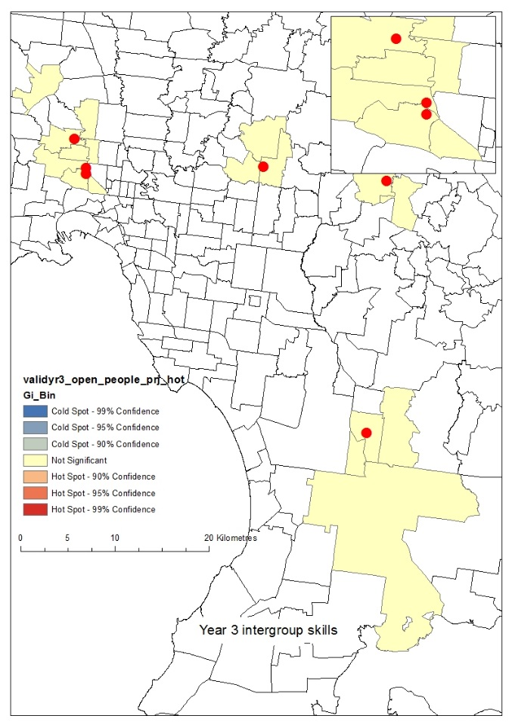 | 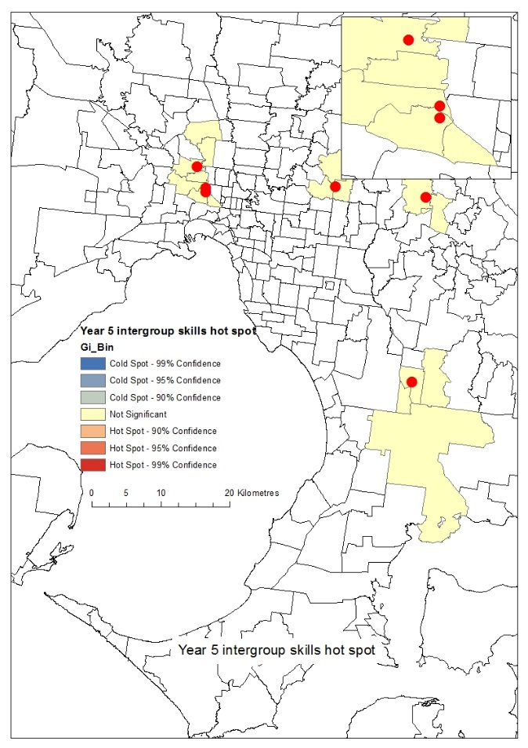
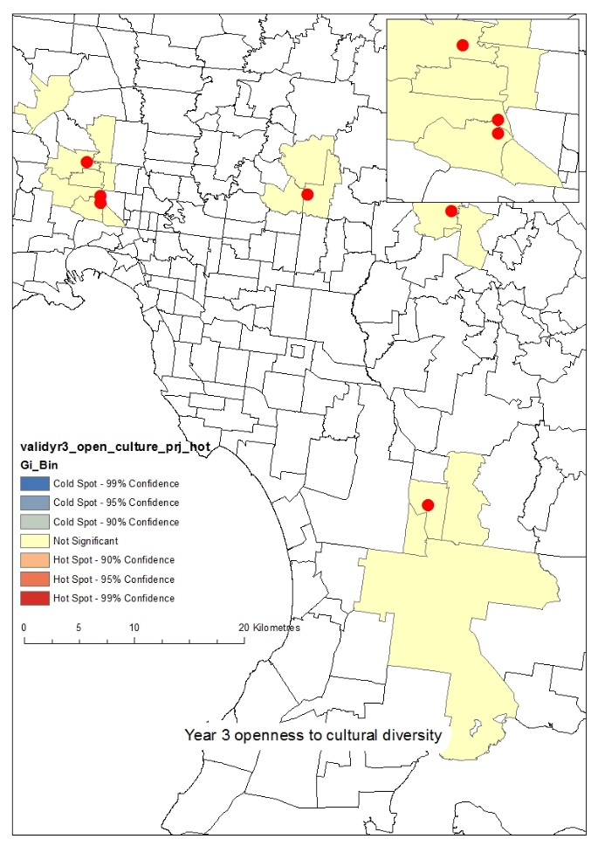 | 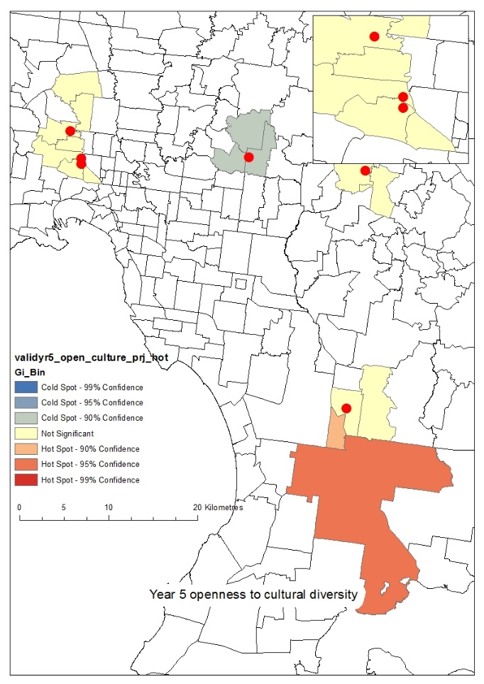
Hot spot analysis for primary level students
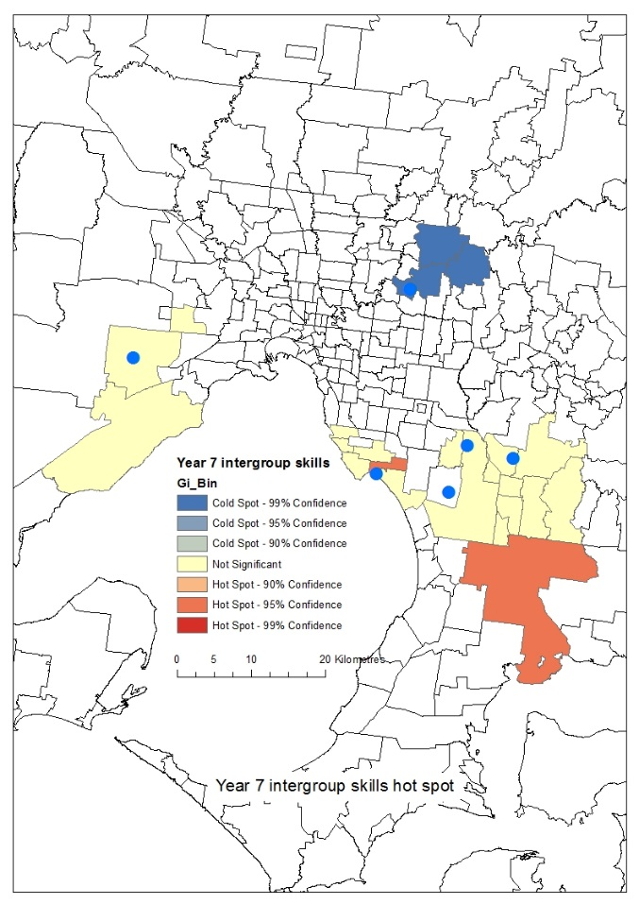 |  | 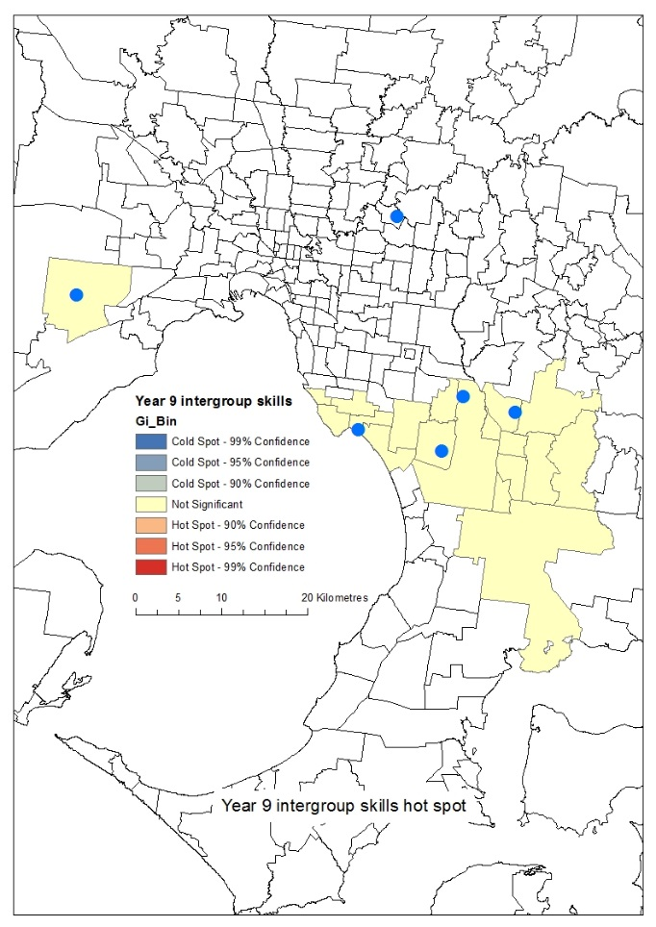
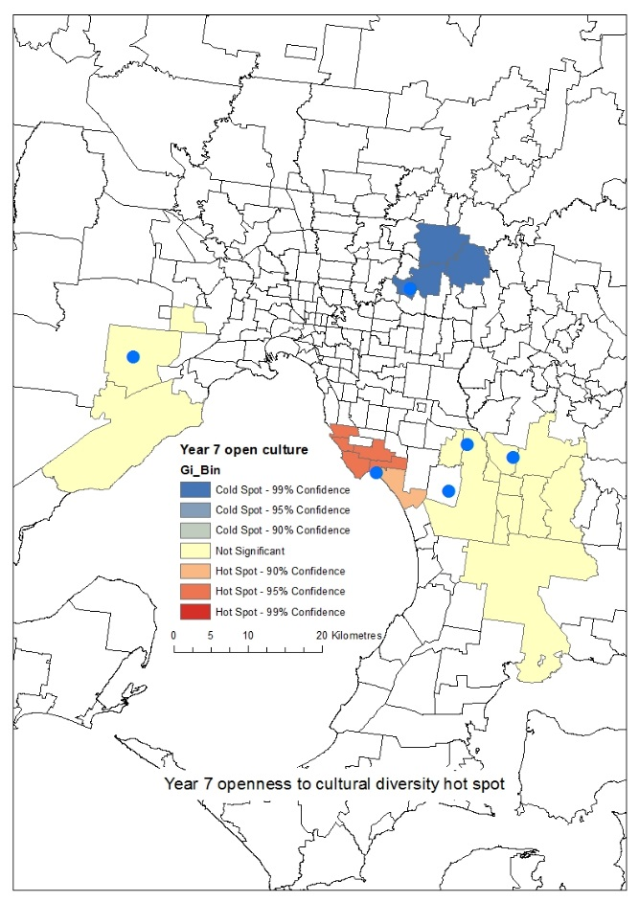 |  | 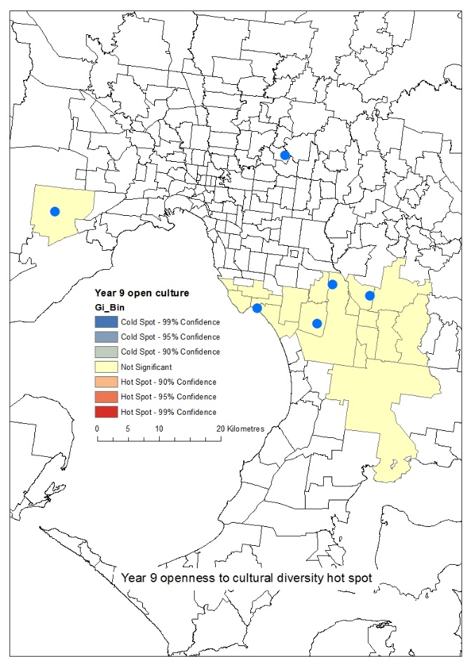
Hot spot analysis for secondary level students

The intercultural capabilities in the lives of children and young people

This research strand examined the acquisition of the intercultural capabilities among students (age 9 to 15 years). It involved two complementary studies with different groups of students using different methods of annual data collection and analysis.
Study 1: Student focus groups
The annual student focus groups (2013, 2014) included two groups of 3-7 students at each of the 12 primary and secondary schools (See Appendix A), and comprised students in Grades 3 - 6 (n=147), and Grades 7 - 10 (n=149). Participants comprised culturally, linguistically and economically diverse group with equal numbers of boys and girls, except in Kirkswood College which is a girls-only school.
The aim of the focus groups was to identify students’ perspectives and experiences of intercultural relations inside and beyond school. Across both years, the focus groups discussed intercultural issues among students, teachers and the school community; what students have been learning about ethnic and cultural diversity in their school; students’ views on the factors that facilitate and impede positive intercultural relations in schools; and how this can be best supported, including resources for teaching and learning. The focus groups also discussed students’ understanding and views on contemporary intercultural issues, including political and media debates about asylum seekers arriving in Australia by boat; a government proposed amendment to the Racial Discrimination Act; a public debate about using languages other than English in Australian public spaces; and cultural appropriation by popular musicians.
The focus groups were audio recorded, transcribed and de-identified before being entered into QSR NVivo for thematic analysis. Data were thematically and inductively coded to explore students’ dispositions to interculturality and the different discourses (attitudes, values, behaviours) towards ethnic and cultural diversity reflected in students’ talk.

Study 2: Longitudinal biographical study
Annual biographical interviews were conducted with the same cohort of students in 2013, 2014 and 2015. There was some attrition in the sample because students moved schools (see Table 2), with the final 2015 cohort comprising 37 primary and 38 secondary students. Data collection with the primary students commenced in Grade 4 (approx. 9 years of age) and continued until Grade 6 (approx. 12 years of age). Data collection with the secondary students commenced in Grade 7 (approx. 13 years of age) and continued until Grade 9 (approx. 15 years of age). Participants were a culturally, linguistically and economically diverse group of students drawn from eight schools in the larger study that constituted a maximum variation sample in terms of ICSEA and students’ ethnic and language backgrounds.
Data collection entailed biographical interviews using identity-trajectory method. This is both a method and a learning theory that uses life history to document the experiences, emotions and agency of individuals through time and to identify critical moments, events and turning points in knowledge acquisition (Webster & Mertova, 2007). The identity-trajectory approach has been used to study learning in higher education and workplaces (e.g. Elliott, 2005; Sfard & Prusak, 2005), and the impact of social and race relations on the formation of individuals (e.g. Arber, 2008; Halse, 2002; Mansouri, 2009). This study was the first use of this method, nationally or internationally, to document the identity-trajectory of intercultural understanding among children and young people.
Interviews were structured using international approaches to longitudinal research with young people (Henderson et al, 2007). Specifically, they focused on: relationships with peers, family and school; understanding of and engagement with ethnic, cultural and religious sameness and difference, inclusion and exclusion; personal encounters with prejudice and racism inside and outside of school; aspirations for the future; and critical moments or experiences that triggered significant change in intercultural knowledge and/or skills.
Elicitation strategies were used to ensure rich data were collected. These included: temporal mapping of friendships, family relationships and critical events; mind maps about individual identifications and subjectivities; ‘anticipated future’ life lines; discussion of an artefact of personal importance; discussion of photographs and videos about interactions between different ethnic, religious and cultural groups; and responses to scenarios/hypotheticals to assist in discovering student attitudes towards ethnic and cultural diversity.
Interviews were audio recorded, transcribed and de-identified before being entered into QSR NVivo for thematic analysis. Data were thematically coded for critical moments identified by students and/or the research team, and for substantive and conceptual patterns in the experiences and life of each student. An individual biography was also developed for each student to enable synchronic analysis (common time-points) to identify commonalities/differences across the sample and diachronic (individual) analysis to identify and explain individual changes over time.
Key Findings
The findings synthesise the analyses from both studies.
- Many students reported that they and their parents regarded intercultural skills as important for a successful future career and life, and this view was more common among students in higher ICSEA schools.
- As a rule, intercultural capabilities develop incrementally through learning that occurs both inside and beyond the curriculum, classroom and school.
- Notable ‘critical moments’ or ‘turning points’ in students’ intercultural awareness and skills are the result of interactions with peers or life experiences outside of school.
- Two key facilitators in the development of students’ intercultural capabilities are:
- Attending a school that emphasises the intercultural capabilities in all areas of school life, as well as the curriculum;
- Friendships with students of different ethnic backgrounds that are sustained inside and outside of school because students live near each other and share the same interests, for example in sport, music or computer games.
- The development of the intercultural capabilities is impeded when students prioritise individualism, competition, and personal success and achievement, rather than empathy and compassion, and was most likely in the more competitive environment of secondary school.
- As a group, students voiced support for egalitarianism, multiculturalism and anti-racism as integral to Australian society and believed that everyone should be treated the same, regardless of physical, ethnic, religious and cultural differences.
- In contrast, a sizable proportion of students reported or demonstrated attitudes and practices that asserted ‘Australian’ culture as the social norm and argued that minority groups, particularly refugees, migrants and those who were visibly different to the social majority in terms of ethnicity, culture or religion, ought to ‘fit in’ with the legal and cultural norms of the social majority.

Discussion

- What are students’ attitudes to ethnic and cultural diversity?
As a group, primary school students regarded racism as a fact of nature that would always exist and there was nothing they or schools could do to stop it. However, they attributed racism to the actions of specific individuals, in line with the notion of racist bullying in school programmes such as Bully Stoppers (Halse 2015a). Friendships and play were key means by which students learned about diversity and built their intercultural knowledge and skills. This learning happened inside and outside of school but was facilitated when students lived in the same geographic area, shared the same religion or interests in sport, music, books, computer games, or faced the same challenges, such as learning English.
By comparison, secondary students, as a group, were: less accepting of ethnic, cultural and religious difference; more inclined to assert the ‘Australian way’ as the social norm; and more likely to attribute responsibility for racism and cultural exclusion to those who were culturally different and excluded. Students suggested that individuals from minority groups can avoid feeling marginalised or ‘left out’ by taking responsibility for their feelings and ‘not let it get to you’; by making themselves acceptable to the social majority by learning English and being friendly; by emphasising how they were similar to the social majority; and resolving to not care whether other students did or did not like them.
At the same time, almost all secondary students agreed with the official discourse of multiculturalism and the principle of appreciating and supporting ethnic and cultural diversity. Nevertheless, some students did not support initiatives that they believed might have a negative impact on the values, norms and lifestyle of the social majority, for example by accepting asylum seekers into Australia or through affirmative action for Aboriginal and Torres Strait Islanders (Mahoney, 2015). The dominant influence on these attitudes were individual students’ beliefs in the merit of competition, individual effort and academic and social success, rather than issues of social class, religion, ethnicity or social justice. As a group, students believed that the concepts of fairness and ability were applicable to all people regardless of their circumstances. This finding highlights the tensions involved in trying to build the intercultural capabilities in educational and social contexts that value individual achievement, competition and that promote the view that everybody is competing on a level playing field.

- What sorts of critical moments shape young people’s intercultural understanding?
Critical moments are experiences or events that have a significant and memorable impact on an individual’s attitudes, behaviour and ways of being in the world. While the school curriculum was influential in equipping students with knowledge of diversity and an understanding of Australia as a multicultural society, the critical moments in the students’ learning and development of intercultural capabilities always occurred through personal experiences outside of the classroom, for example as a consequence of experiencing racism or different cultural perspectives and knowledge.

- What conditions facilitate intercultural understanding?
The curriculum was important in building students’ knowledge, particularly in relation to the principles of multiculturalism but experiences outside of the classroom were decisive in forming the attitudes and behaviours necessary for respectful intercultural relations. This was particularly the case in schools with a large, ethnically diverse student body. In less diverse schools, it was important and necessary to promote cross-cultural exchange and create opportunities for intercultural learning through personal interaction with students from different ethnic, religious or cultural backgrounds from other schools.

Explaining differences between schools
The findings from the Intercultural Capabilities Quiz and Survey demonstrate positive improvement over time in the intercultural capabilities of students and teachers. There were also different patterns and areas of difference between schools. While recognising the influence of out-of-school variables, including geography, parental background, students’ experiences with peers and outside of school, significant qualitative factors made a difference in the development of the intercultural capabilities both within and between schools.

The primary schools generally made faster positive progress in developing intercultural curricula, policies and practices than secondary schools. This is not unusual in school redesign initiatives because the smaller size of primary schools makes it easier to communicate, build consensus and implement changes in practice in schools. Nevertheless, secondary schools also achieved impressive outcomes. Overall, the qualitative data indicates that schools with strongest improvements in survey and quiz outcomes were more likely to:
- move beyond learning about different ethnic groups and cultures to implementing practices that recognised the more complex elements of diversity, including attitudes, relationships, and beliefs, in combination with a reflexive, critical consideration of students’ own cultural practices, beliefs, attitudes and values;
- foster opportunities for students for person-to-person connections with young people from different backgrounds, both face-to-face and on-line;
- recognise the critical role of professional learning for teachers in building students’ intercultural capabilities and provide a range of opportunities and approaches for teachers to build their professional expertise, including on-line, off-site and in-school professional learning workshops; and
- understand that the intercultural capabilities are developed both inside and outside the curriculum so adopt a whole school approach to embed the capabilities as the social norm within the school.
In contrast to surveys which elicit information on predetermined constructs, the qualitative findings indicate that the six intersecting intercultural dimensions of community, leadership, reflexive redesign, curriculum, teachers and students and their accompanying actions (Figure 5) were critical in enabling and supporting the development of the intercultural capabilities in schools.
These dimensions extend beyond the facilitators identified in previous studies of intercultural education in schools (e.g. Walton et al., 2013). However, evidence indicates that it is essential to implement all dimensions and all the related actions in building interculturally capable students and schools and that implementing selected intercultural dimensions and actions has limited impact on students or school practices.

Networked and shared practice with other schools
Sustained relationships with parents and community
Acknowledged tensions and prejudice within the school community
Included all students across all year levels
Engaged students of all ethnic/language backgrounds
Curriculum
Incorporated the intercultural capabilities into their school vision and plans
Sustained involvement of principal
Prioritised engagement with different cultures
Responded to school-based empirical evidence
Evaluated existing initiatives
Reflexive redesign
Students
Teachers
Leadership
Community
Figure 5: Intercultural Dimensions and Actions
What schools do to support intercultural capabilities
Used community resources to critically reflect on culture
Involved all staff across the school in developing interculturality
Deepened teachers’ knowledge and understanding through professional learning
Collaborated with other teachers around the intercultural capabilities
Appointed an intercultural capabilities leadership team and/or coordinator
Embedded the intercultural capabilities across multiple curriculum areas
Demonstrated knowledge and understanding of the intercultural capabilities
Focused on learning about cultures as well as attitudes and behaviours

Eight key principles for building intercultural capabilities
Overall, eight principles of practice emerged as critical for developing interculturally capable students, teachers and schools.

1. Principals make a difference.
Research confirms that the leadership of the school principal is essential for school improvement but that it is the sort of leadership that makes a difference (Fullan, 2001). Schools where principals applied the practices of effective leadership detailed below to implement the intercultural capabilities had higher levels of achievement in intercultural expertise overall, based on both the quantitative and qualitative data. Based on Leithwood et al (2004), the core practices of effective leadership are:

- Developing People by enabling teachers to do their jobs effectively, offering intellectual support and stimulation to improve their work, and providing models of practice and support;
- Setting School Directions by developing shared goals, monitoring performance, and promoting effective communication;
- Redesigning the Operation of their School by creating a productive school culture, building genuinely collaborative processes and modifying organisational structures that undermine the goal and quality of the school’s work.

Effective principals look beyond merely improving existing practices to creating dynamic environments where students thrive (Robinson, Lloyd & Rowe, 2008), building teacher expertise (McLaughlin & Talbert, 2006) and supporting teachers so they can focus on student outcomes (DuFour, 2002).

2. Research-based decision-making improves outcomes
All schools welcomed the systematic feedback and advice the research team provided throughout the study, and used this in various ways to improve school practices. For example, responses among the schools included:
- asking for targeted teacher professional learning to address weak areas in the survey findings;
- making the TFH on-line modules mandatory for all teacher inductions;
- broadening their focus from a single subject to a whole school approach to ensure the intercultural capabilities were embedded in all aspects of schooling;
- organising staff meetings to discuss the research findings; and
- developing collaborative action for improvements.
There were two exceptions to this rule. In one school, repeated changes in principals and staff meant that the research knowledge was not always communicated and implemented. In another school, follow-up action was constrained by the principal’s pre-existing beliefs that the ‘few red-necks’ among teachers was ‘pretty typical of Australia as a whole’ and ‘not much could be done about it’.
3. Strategic use of finances makes a difference.
All participating schools received funds to support their involvement in the study. Most schools chose to use their funds for teaching relief so staff could attend professional learning and network meetings, and for the purchase of ‘diversity’ related resources. There was a correlation between how schools used their funds and improvements in intercultural capabilities, based on the student quiz and teacher survey data. There were minimal improvements in schools that assigned their funds to general revenue, and significant improvements in schools that used their funds to buy specialist intercultural expertise, such as a Multicultural Aid or Intercultural Coordinator.

4. Professional learning makes a difference.
Research confirms that professional learning is critical for building teacher expertise needed to improve students’ learning (McLaughlin & Talbert 2006) and principals and teachers repeatedly stress the need for professional learning on how to teach intercultural capabilities. Yet, it is also important to remember that translating teacher learning into permanent improvements in practices, student outcomes and school culture is not automatic or seamless. Teachers engage with and apply their professional learning differently, and this is influenced by a myriad of other conditions including curriculum and school priorities. Moreover, many schools experience frequent staff changes and this impedes the implementation of professional learning and school improvements. During the course of our project, one school had three principals and a 50% turnover in staff; another had three Intercultural Capability Coordinators because of staff movements; another had a 100% turnover in their intercultural leadership team because of maternity leave. This reality of school life means that repeated teacher professional learning over the long term is essential to embed the intercultural capabilities in the curriculum and other areas of school life as the established norm of a school culture.

5. Personal intercultural experiences, including travel, enhances teacher expertise.
Research shows that direct, personal experience of cultural diversity is the most influential factor for an ‘Asia literate’ teaching profession (Halse, 2015b; Halse et al, 2013). Our study also found that principals and teachers with extensive experience with ethnic diversity and intercultural situations inside and outside of school were more aware and proactively engaged in building the intercultural capabilities. This was vividly illustrated in two schools where the principals had experienced the intercultural benefits of overseas study and supported their less experienced teachers to also do an overseas study tour, all of whom returned to take up intercultural leadership roles in their schools.
6. Intercultural capabilities are fostered in schools that are inclusive learning environments.
Schools with a genuine commitment to being a learning environment that includes students, teachers, parents and community, made faster, stronger progress towards becoming interculturally capable. In these schools, the senior leadership was reflexive about and eager to improve their own intercultural knowledge and capabilities and nurtured a similar approach in their school community.
7. A whole school approach is most effective in improving intercultural capabilities.
Principals strongly endorsed the inclusion of intercultural capabilities in the Victorian Curriculum and this gave the intercultural capabilities the ‘status’ to ensure they were addressed in schools. The research evidence indicates that a whole school approach is most effective for improving the intercultural capabilities of students, teachers and schools. Illustrating this point, in the first year of the study, two schools chose to limit their focus on intercultural capabilities to a single subject and school year, with negligible improvement in interculturality, based on quiz and survey results. In contrast, more positive results were shown in schools using a multi-level, whole school approach. Consequently, both of the former schools adopted a broader approach in Year 2 which aligned with improvements in quiz and survey results.

8. Curriculum innovation is essential.
The curriculum focus is on learning to be intercultural rather than merely learning about ethnic and cultural diversity. Principals and teachers found the new focus challenging, requiring curriculum innovations to ensure authentic, intercultural learning experiences for students. Typical experiences developed by schools included: strengthening the parental and community involvement in curriculum delivery and school activities; greater use of ‘sister school’ relationships for intercultural learning; developing local collaborative activities with schools of different ethnic, religious, racial and linguistic profiles; utilising TFH to deliver intercultural workshops to students and teachers; exchanging ‘know-how’ with teachers and schools in their project network; deeper exchanges between international and domestic students; and embedding intercultural experts in the school, such as a Multicultural Aid and an ‘intercultural artist in residence’.

References
Abdallah‐Pretceille, M. (2006) Interculturalism as a paradigm for thinking about diversity. Intercultural Education 17 (5), 475-83.
ACARA (2013) http://www.acara.edu.au/default.asp [individual pages not identified to maintain anonymity of participant schools]
ACARA (2015) Australian Curriculum endorsed http://www.acara.edu.au/curriculum.html date accessed 20 October 2015.
Antonio, A. L., Chang, M. J., Hakuta, K., Kenny, D. A., Levin, S. & Milem, J. F. (2004), Effects of racial diversity on complex thinking in college students, Psychological Science 15 (8), 507-10.
Arber, R. (2008). Race, ethnicity and education in globalised times. London: Springer.
Arber, R. (2009). Social disconnection or popular racism. In F. Mansouri (Ed.) Youth identity and migration: Culture, values and social connectedness. Altona, Vic: Common Ground.
Arber, R. (2011). Encountering an-other: The culture of curriculum and inclusive pedagogies. In Z. Bekerman & T. Geisen (Eds.), International handbook of migration, minorities, and education: Understanding cultural and social differences in processes of learning. New York: Springer.
Australian Government (2013). Australia’s multicultural policy – December 2013, Canberra: Australian Government Printing Services.
Bodkin-Andrews, W., Seaton, M., Nelson, G. F., Craven, R. G. & Yeung, A. S. (2010). Questioning the general self-esteem vaccine: General self-esteem, racial discrimination, and standardised achievement across Indigenous and non-Indigenous students. Australian Journal of Guidance & Counselling, 20 (1), 1-21.
Charles, C., Mahoney, C., Fox, B. & Halse, C. (2016). School principals and racism: Responding to Aveling." Discourse: Cultural Studies in the Politics of Education 37 (2), 230-244.
Cotton, K. (1993). Fostering intercultural harmony in schools: Research finding. Northwest Regional Educational Laboratory. http://educationnorthwest.org/webfm_send/522 date accessed 3 October 2011.
Denson, N. & Chang, M. (2009) Racial diversity matters: The impact of diversity-related student engagement and institutional context, American Educational Research Journal 46 (2), 322-53.
Denson, N. & Zhang, S. (2010) The impact of student experiences with diversity on developing graduate attributes, Studies in Higher Education 35 (5), 529–43.
DET (State of Victoria, Department of Education and Training) (2015) Education State: Schools policy http://www.education.vic.gov.au/Documents/about/educationstate/launch.pdf date accessed 12 October 2015
DuFour, R. (2002) The learning-centred principal. Educational Leadership 59 (8), 12-15.
Elliott, J. (2005). Using narrative in social research: Qualitative and quantitative approaches. London: Sage.
Fang, Z. (1996). A review of research on teacher beliefs and practices. Educational Research, 38 (1), pp. 47-45.
Fullan, M. (2001) Leading in a culture of change. San Francisco: Jossey-Bass.
Gillborn, D. (2008). Coincidence or conspiracy: Whiteness, policy and the persistence of the black/white achievement gap, Educational Review 60 (3), 229-48.
Gorski, P. (2006) The unintentional undermining of multicultural education: Educators at the crossroads. In J. Landsmen & C. Lewis (Eds.), White teachers in diverse classrooms: Building community, combating racism. Sterling, Virginia: Stylus Publishers.
Greco, T., Priest, N. & Paradies Y. (2010) Review of strategies and resources to address race-based discrimination and support diversity in schools. Carlton, Vic.: Victorian Heath Promotion Foundation (VicHealth).
Halse, C. (1996). Cultures of curriculum change: Teachers’ stories of implementing studies of Asia. Melbourne: AEF.
Halse, C. (2002) A Terribly Wild Man: The Life of the Reverend Ernest Gribble, Sydney: Allen & Unwin.
Halse, C. (2013). Culture and the future of education research. Australian Educational Researcher (AER), 40(2), pp.139-153.
Halse, C. (2015a) Responsibility for racism in the everyday talk of young people. Discourse: Studies in the Cultural Politics of Education. DOI: 10.1080/01596306.2015.1104848
Halse, C. (Ed.) (2015b) Asia literate schooling in the Asian Century. London: Routledge.
Halse, C., Cloonan, A., Dyer, J., Kostogriz, A., Toe, D. & Weinmann, M. (2013) Asia literacy and the Australian teaching workforce. Melbourne: Education Services Australia.
Hill, N. E. (2006) Disentangling ethnicity, socioeconomic status, and parenting: interactions, influences, and meaning. Vulnerable Children and Youth Studies 1, 114-124.
Leeman, Y. A. M. (2003) School leadership for intercultural education. Intercultural Education 14 (1), 31-45.
Leithwood, K., Seashore Louis, K., Anderson, S. & Wahlstrom, K. (2004). Executive summary: How leadership influences student learning. Learning From Leadership Project. New York: The Wallace Foundation.
MacNaughton, G. & Hughes, P. (2007) Teaching respect for cultural diversity in Australian early childhood programs, Journal of Early Childhood Research 5 (2), 189-204.
Mahoney, C. (2015) Neoliberal discourses and young people’s attitudes towards addressing disadvantage. Presented at The Australian Sociological Association Conference 2015, Cairns.
Mansouri, F. & Jenkins, L. (2010) Schools as sites of race relations and intercultural tension. Australian Journal of Teacher Education 35 (7), 93-108.
Mansouri, F., Jenkins, L., Leach, M., & Walsh, L. (2009) Building bridges: Creating a culture of diversity. Melbourne: Melbourne University Publishing.
Mansouri, F. & Percival Wood, S. (2008) Identity, education and belonging: Arab and Muslim youth in contemporary Australia. Melbourne: Melbourne University Publishing.
MCEETYA (Ministerial Council of Education, Employment, Training and Youth Affairs) (2008) Melbourne Declaration on Educational Goals for Young Australians, December 2008. http://www.curriculum.edu.au/verve/_resources/National_Declaration_on_the_Educational_Goals_for_Young_Australians.pdf date accessed 12 October 2015
McLaughlin, M. & Talbert, J. (2006) Building school-based teacher learning communities: Professional strategies to improve student achievement, New York: Teachers College Press.
MySchool (2014) http://www.myschool.edu.au/
Pachter, L. M., & Coll, C. G. (2009) Racism and child health: A review of the literature. Journal of Developmental & Behavioral Pediatrics 30 (3), 255-263.
Paradies, Y., Ben, J., Denson, N., Elias, A., Priest, N., Pieterse, A., Gupta, A., Kelaher, M., Gee, G. (2015) Racism as a determinant of health: A systematic review and meta-analysis. PLOS ONE 10 (9), e0138511.
Priest, N., Baxter, J., & Hayes, L. (2012) Social and emotional outcomes of young Australian children from Indigenous and culturally and linguistically diverse backgrounds. Australian and New Zealand Journal of Public Health 36 (2), 183-91.
Priest, N., Mackean, T., Davis, E., Briggs, L., & Waters, E. (2012) Strengths and challenges for Koori Kids: Harder for Koori Kids, Koori Kids doing well - Exploring Aboriginal perspectives on social determinants of Aboriginal child health and wellbeing. Health Sociology Review 21 (2), 165-80.
Pusch, M. D. (2004) ‘Intercultural training in historical perspective’, in D. Landis, J. M. Bennett and M. J. Bennett (Eds.) The Handbook of Intercultural Training, 3rd edn. Thousand Oaks: Sage.
Sfard, A., & Prusak, A. (2005). Telling identities: In search of an analytic tool for investigating learning as a culturally shaped activity. Educational Researcher, 34(4), 14-22.

Robinson, V., Lloyd, C. & Rowe, K. (2008) The impact of leadership on student outcomes: An analysis of the differential effects of leadership types, Educational Administration Quarterly 44 (5), 635-74.
UNESCO (2006) Guidelines on Intercultural Education. Paris: UNESCO.
UNESCO (2010) Education for intercultural understanding. Bangkok: UNESCO.
UNESCO (2013) Intercultural competences: Conceptual and operational framework. Paris: UNESCO
VCAA (2015) Victorian Curriculum: Foundation -10 http://victoriancurriculum.vcaa.vic.edu.au/intercultural-capability/introduction/rationale-and-aims date accessed 12 October 2015.
Webster, L., & Mertova, P. (2007). Using narrative inquiry as a research method: An introduction to using critical event narrative analysis in research on learning and teaching. London: Routledge.

Appendices
Appendix A: student focus groups
- Total student focus groups: 23 (2013) + 21 (2014) = 44
- Total number of student participants: 129 (2013) + 148 (2014) = 277

 | 2013 |  |  |  | 2014
 | Date | No. of students | Year level | Gender | Date | No. of students | Year level | Gender
Ackenham  Primary School | 3/9 | 6 | 3 & 4 | 3 x F, 3 x M | 4/6 | 5 | 3 & 4 | 2 x F, 3 x M
 | 3/9 | 6 | 5 & 6 | 4 x F, 2 x M | 4/6 | 5 | 5 & 6 | 3 x M, 2 x F
Blackmede  Primary School | 19/9 | 4 | 5 | 3 x F, 1 x M | 29/5 | 6 | 3 & 4 | 2 x M, 4 x F
 | 19/9 | 4 | 6 | 2 x M, 2 x F | 29/5 | 6 | 5 & 6 | 3 x M, 3 x F
Claire Creek  Primary School | 5/9 | 6 | 3 & 4 | 3 x F, 3 x M | 19/6 | 9 | 3 & 4 | 2 x F, 7 x M
 | 5/9 | 6 | 5 & 6 | 3 x F, 3 x M | 19/6 | 8 | 5 & 6 | 5 x M, 3 x F
Dalmorning  Primary School | 4/9 | 6 | 3 & 4 | 2 x F, 4 x M | 12/8 | 6 | 3 & 4 | 3 x M, 3 x F
 | 4/9 | 5 | 5 & 6 | 3 x F, 2 x M | 12/8 | 6 | 5 & 6 | 4 x F, 2 x M
Everard Creek  Primary School | 26/8 | 6 | 3 & 4 | 2 x F, 3 x M | 28/5 | 6 | 3 & 4 | 2 x F, 4 x M
 | 26/8 | 5 | 5 & 6 | 3 x F, 2 x M | 28/5 | 6 | 5 & 6 | 3 x F, 3 x M
Fraser Hills  Primary School | 3/9 | 7 | 3 & 4 | 7 x F | 5/5 | 8 | 3 & 4 | 3 x F, 5 x M
 | 3/9 | 6 | 5 & 6 | 4 x F, 2 x M | 5/5 | 6 | 5 & 6 | 5 x F, 1 x M
Grindlewake College | 28/8 | 6 | 3 – 8 (aged 9-14yrs) | 3 x F, 3 x M | 30/7 | 12 | P-9 (mixed  10-15 yrs) | -
Haskell Peak College | 23/8 | 3 | 7 & 8 | 3 x F | 2/6 | 7 | 8 | 6 x M, 1 x F
 | 23/8 | 5 | 9 & 10 | 2 x F, 3 x M
Jardleigh College | 12/9 | 6 | 7 & 8 | 5 x M, 1 x F | 26/5 | 8 | 7 & 8 | 5 x F, 3 x M
 | 12/9 | 7 | 9 & 10 | 5 x F, 2 x M | 27/5 | 8 | 9 & 10 | 4 x F, 4 x M
Kirkswood College | 16/10 | 6 | 7 & 8 | 6 x F | 4/6 | 4 | 7 & 8 | 4 x F
 | 16/10 | 6 | 9 & 10 | 6 x F | 4/6 | 7 | 9 & 10 | 7 x F
Leighburns College | Sept | 6 | 7 & 8 | 3 x F, 3 x M | 15/10 | 8 | 7 & 8 | 4 x F, 4 x M
 | 9/10 | 6 | 9 & 10 | 4 x F, 2 x M | 15/10 | 8 | 9 & 10 | 5 x F, 3 x M
Mallore Hills College | Sept | 5 | 7 & 8 | 3 x F, 2 x M | 26/5 | 9 | 7 - 9 | 4 x F, 5 x M
 | Sept | 6 | 9 & 10 | 3 x F, 3 x M

Appendix B: teacher focus groups
- Total teacher focus groups: 14 (2013) + 14 (2014) = 28
- Total number of teacher participants: 69 (2013) + 90 (2014) = 159

 | 2013 |  |  | 2014
 | Date | No. of teachers | Gender | Date | No. of teachers | Gender
Ackenham  Primary School | 19/8 | 3 | 1 x M, 2 x F | 4/6 | 5 | 3 x F, 2 x M
Blackmede  Primary School | 13/8 | 6 | 2 x F, 4 x M | 6/8 | 6 | 5 x F, 1 x M
Claire Creek  Primary School | 5/8 | 6 | 5 x F, 1 x M | 19/6 | 10 | 8 x F, 2 x M
Dalmorning  Primary School | 24/6 | 6 | 4 x F, 2 x M | 12/8 | 14 (incl. prac teachers) | 2 x M, 12 x F
Everard Creek  Primary School | 6/8 | 7 | 4 x F, 3 x M | 22/5 | 6 | 4 x F, 2 x M
Fraser Hills  Primary School | 3/9 | 5 | 4 x F, 2 x M | 10/6 | 6 | 5 x F, 1 x M
 | 3/9 | 5 | 3 x F, 2 x M | 10/6 | 7 | 6 x F, 1 x M
Grindlewake College | 28/8 | 6 | 2 x M, 4 x F | 22/8 | 4 | 5 x F, 1 x M
Haskell Peak College | 5/8 | 5 | 4 x F, 1 x M | 11/8 | 6 | 6 x F
Jardleigh College | 20/8 | 4 | 2 x F, 2 x M | 27/5 | 6 | 3 x F, 3 x M
 | 23/8 | 2 | 2 x F | 29/5 | 6 | 5 x F, 1 x M
Kirkswood College | 29/8 | 5 | 4 x F, 1 x M | 2/6 | 5 | 5 x F
Leighburns College | 9/10 | 4 | 2 x F, 2 x M | 15/10 | 4 | 1 x F, 3 x M
Mallore Hills College | Sept | 5 | 2 x F, 3 x M | 2/9 | 5 | 2 x F, 3 x M

Appendix C: factor analysis
The below tables show each school’s survey statistically significant changes across the three timepoints. These have been colour-coded using the following legend as a guide:
 | Legend
 | Increase |  | ** p < .01
 | Increase |  | * p < .05
 |  |  | non-significant change
 | Decrease |  | * p < .05
 | Decrease |  | ** p < .01
Grindlewake College
Factor comparisons from Time 1 to Time 3
Factor |  |  |  |  | Change in factor scores from baseline (T1)
Staff |  |  |  |  | T1 --> T2 | T2 --> T3 | T1 --> T3
 |  | Culturally inclusive teaching strategies
 |  | Reflexivity
 |  | Adaptability / Flexibility
 |  | Openness to cultural diversity
Primary Students
 |  | Intergroup skills
 |  | Openness to cultural diversity
Secondary Students
 |  | Intergroup skills
 |  | Openness to cultural diversity
Note: All items are on a 4-point Likert scale from 1 = strongly disagree to 4 = strongly agree.

Ackenham Primary School
Factor comparisons from Time 1 to Time 3
Factor |  | Change in factor scores from baseline (T1)
Staff |  | T1 --> T2 | T2 --> T3 | T1 --> T3
 | Culturally inclusive teaching strategies
 | Reflexivity
 | Adaptability / Flexibility
 | Openness to cultural diversity
Students
 | Intergroup skills
 | Openness to cultural diversity
Note: All items are on a 4-point Likert scale from 1 = strongly disagree to 4 = strongly agree.

Blackmede Primary School
Factor comparisons from Time 1 to Time 3
Factor |  | Change in factor scores from baseline (T1)
Staff |  | T1 --> T2 | T2 --> T3 | T1 --> T3
 | Culturally inclusive teaching strategies
 | Reflexivity
 | Adaptability / Flexibility
 | Openness to cultural diversity
Students
 | Intergroup skills
 | Openness to cultural diversity
Note: All items are on a 4-point Likert scale from 1 = strongly disagree to 4 = strongly agree.

Claire Creek Primary School
Factor comparisons from Time 1 to Time 3
Factor |  | Change in factor scores from baseline (T1)
Staff |  | T1 --> T2 | T2 --> T3 | T1 --> T3
 | Culturally inclusive teaching strategies
 | Reflexivity
 | Adaptability / Flexibility
 | Openness to cultural diversity
Students
 | Intergroup skills
 | Openness to cultural diversity
Note: All items are on a 4-point Likert scale from 1 = strongly disagree to 4 = strongly agree.

Dalmorning Primary School
Factor comparisons from Time 1 to Time 3
Factor |  | Change in factor scores from baseline (T1)
Staff |  | T1 --> T2 | T2 --> T3 | T1 --> T3
 | Culturally inclusive teaching strategies
 | Reflexivity
 | Adaptability / Flexibility
 | Openness to cultural diversity
Students
 | Intergroup skills
 | Openness to cultural diversity
Note: All items are on a 4-point Likert scale from 1 = strongly disagree to 4 = strongly agree.

Haskell Peak College
Factor comparisons from Time 1 to Time 3
Factor |  | Change in factor scores from baseline (T1)
Staff |  | T1 --> T2 | T2 --> T3 | T1 --> T3
 | Culturally inclusive teaching strategies
 | Reflexivity
 | Adaptability / Flexibility
 | Openness to cultural diversity
Students
 | Intergroup skills
 | Openness to cultural diversity
Note: All items are on a 4-point Likert scale from 1 = strongly disagree to 4 = strongly agree.

Jardleigh College
Factor comparisons from Time 1 to Time 3
Factor |  | Change in factor scores from baseline (T1)
Staff |  | T1 --> T2 | T2 --> T3 | T1 --> T3
 | Culturally inclusive teaching strategies
 | Reflexivity
 | Adaptability / Flexibility
 | Openness to cultural diversity
Students
 | Intergroup skills
 | Openness to cultural diversity
Note: All items are on a 4-point Likert scale from 1 = strongly disagree to 4 = strongly agree.

Kirkswood College
Factor comparisons from Time 1 to Time 3
Factor |  | Change in factor scores from baseline (T1)
Staff |  | T1 --> T2 | T2 --> T3 | T1 --> T3
 | Culturally inclusive teaching strategies
 | Reflexivity
 | Adaptability / Flexibility
 | Openness to cultural diversity
Students
 | Intergroup skills
 | Openness to cultural diversity
Note: All items are on a 4-point Likert scale from 1 = strongly disagree to 4 = strongly agree.

Leighburns College
Factor comparisons from Time 1 to Time 3
Factor |  | Change in factor scores from baseline (T1)
Staff |  | T1 --> T2 | T2 --> T3 | T1 --> T3
 | Culturally inclusive teaching strategies
 | Reflexivity
 | Adaptability / Flexibility
 | Openness to cultural diversity
Students
 | Intergroup skills
 | Openness to cultural diversity
Note: All items are on a 4-point Likert scale from 1 = strongly disagree to 4 = strongly agree.

Everard Creek Primary School
Factor comparisons from Time 1 to Time 3
Factor |  | Change in factor scores from baseline (T1)
Staff |  | T1 --> T2 | T2 --> T3 | T1 --> T3
 | Culturally inclusive teaching strategies
 | Reflexivity
 | Adaptability / Flexibility
 | Openness to cultural diversity
Students
 | Intergroup skills
 | Openness to cultural diversity
Note: All items are on a 4-point Likert scale from 1 = strongly disagree to 4 = strongly agree.

Fraser Hills Primary School
Factor comparisons from Time 1 to Time 3
Factor |  | Change in factor scores from baseline (T1)
Staff |  | T1 --> T2 | T2 --> T3 | T1 --> T3
 | Culturally inclusive teaching strategies
 | Reflexivity
 | Adaptability / Flexibility
 | Openness to cultural diversity
Students
 | Intergroup skills
 | Openness to cultural diversity
Note: All items are on a 4-point Likert scale from 1 = strongly disagree to 4 = strongly agree.

Mallore Hills College
Factor comparisons from Time 1 to Time 3
Factor |  | Change in factor scores from baseline (T1)
Staff |  | T1 --> T2 | T2 --> T3 | T1 --> T3
 | Culturally inclusive teaching strategies
 | Reflexivity
 | Adaptability / Flexibility
 | Openness to cultural diversity
Students
 | Intergroup skills
 | Openness to cultural diversity
Note: All items are on a 4-point Likert scale from 1 = strongly disagree to 4 = strongly agree.

The study was funded by an Australian Research Council in partnership with the Victorian Department of Education and Training (DET), the non-for-profit foundation Together for Humanity (TFH), the Victorian Curriculum and Assessment Authority (VCAA), and Pukunui Technology (ARCLP 120200319)
Three of the schools referred to as secondary were not exclusively secondary as they enrolled students from pre-primary to secondary years.
All schools and individuals are de-identified with pseudonyms.
ICSEA is a scale that details the socioeconomic status of each school to enable numerical comparisons of the average level of educational advantage of the school student population. It is a more finely-tuned proxy for socio-economic status (SES) used by education systems in Australia. The Australian Curriculum and Assessment Reporting Authority (ACARA) calculates the ICSEA score for each school in Australia using variables that include the family background of each student, including parental education and occupation, the proportion of indigenous students, and number of students with a language background other than English, and the school’s metropolitan, regional or remote geographical location (ACARA, 2013)
Koori is a term by which Aboriginal Australians in Victoria, parts of New South Wales and Tasmania refer to themselves.

