Cross-Sector Collaboration Toolkit

This Toolkit provides practical guidance to principals and school leaders who wish to engage in cross-sector collaboration in their own school setting.
Included are resources, templates and examples to assist schools to develop positive and effective cross-sector partnerships.

What is cross-sector collaboration?
Cross-sector collaboration occurs when a school partners with a school from another sector (government, independent or Catholic) to deliver shared curriculum, initiatives, teaching or facilities for students.
Cross-sector collaboration should improve access to an opportunity or a benefit that would not otherwise be available for schools and students.

How can cross-sector collaboration benefit my school?
Students can benefit from:
- broader senior secondary options and opportunities
- improved curriculum provision, particularly for VCE and VCAL
- specialised areas of learning
- access to shared facilities and resources
- shared education, social and sporting activities.
Principals and teachers can benefit from:
- increased opportunities for professional development
- knowledge or resource sharing to address shared challenges
- peer mentoring
- joint curriculum planning and assessment delivery.

My school is already in a cross-sector partnership – how can we share the ways we are benefiting?
You can share how cross-sector collaboration is benefiting your school through completing this template and emailing it to ngs.support@edumail.vic.gov.au.
The Department of Education and Training’s Strategy and Integration Division will be in touch to discuss the development of a short case study.

How do I start a cross-sector partnership?
As principals and school leaders, you are best placed to determine the type of collaboration that will be most effective in achieving improved outcomes for your students and staff.
The table below includes suggested practical first steps to engage partner schools. Templates and examples are also provided as guidance
Practical first steps |  | Resources
Invest in the relationship | Informally meet with nearby schools with similar needs, regardless of sector.  If possible, this should involve a face-to-face conversation to discuss shared challenges and consider the benefits that each school is seeking. | Government schools  Find my school  Catholic schools  School directory search  Independent schools  School directory search
Embed communication and leadership at all levels | Embed ongoing communication.  Involve staff in consultation and decision making and communicate regularly to all staff involved in the partnership. | Communications Plan (Template)
Adopt a shared focus on teaching and learning | Document shared objectives and develop a shared strategy.  Establish appropriate governance arrangements. For example, consider creating a Memorandum of Understanding or Terms of Reference document. | Terms of Reference (Template)  Memorandum of Understanding - VCE Collaboration Fund (Template)  Memorandum of Understanding - VCE sharing (general) (Template)
Consider a facilitator | Consider specifically appointing a facilitator (either an external facilitator or a dedicated staff member) to manage the collaboration or look into the VCE Collaboration Fund to see if you are eligible for potential funding. | VCE Collaboration Fund

Ongoing management of the partnership | Establish a method and criteria for evaluating the partnership and embed periodic review into partnership planning.  For guidance on establishing facility sharing arrangements, visit:  Shared Use of School Facilities Policy (Example)  For examples of tools that can help organise shared VET, VCE or assessment provision, see:  Joint VET provision (Example)  VCE subject blocking (Example)  Shared assessment schedule (Example)  For an example of how to run governance meetings, see:  Facilitated cluster meeting minutes (Example)

Is there funding available to support my school’s cross-sector partnership?

The VCE Collaboration Fund is provided by the Victorian Government to support schools across Victoria to form partnerships that will broaden the range of VCE subject offerings for rural and regional students.

Funding of up to $40,000 per partnership is available, noting that at least one school in the partnership must be a government school in a rural or regional area.

This funding may be used to cover costs associated with managing the partnership, including:
- professional learning opportunities
- hiring a facilitator to build the partnership
- time release for teachers to design and/or support the shared arrangements
- purchasing costs of equipment (e.g. software and technology).

To find out more about this fund, including eligibility requirements and how to send in an Expression of Interest, visit VCE Collaboration Fund
How do I ensure my cross-sector partnership is a success?

Schools can adopt a number of practices to ensure cross-sector collaboration between schools is a success.

Below are tips and examples that can help ensure an effective partnership.

Establishing a relationship across sectors |  | Sharing the workload |  | Managing additional costs
Take the time to engage face-to-face with potential partner schools.  Consider starting small with low-risk initiatives, such as a pilot program.  Seek opportunities to build trust and collegiality at professional development and/or networking events.  Remove barriers to communication by sharing contact details across schools, for example providing an email or phone list for teachers (after seeking staff consent).  If there is a distinct cultural or religious difference between sectors, consider improving student understanding in an educational setting.  Where there has been a history of competition, consider appointing an external facilitator to discuss the benefits with principals from each school. |  | Streamlining organisational processes across a partnership allows the necessary time release to assist teachers and all staff to invest in teaching and collaborating.  Collaboration can provide greater opportunities for local professional development, reducing travel time in regional and rural areas.  Consider having a dedicated facilitator to manage the partnership. |  | Consider a per head, token amount for each student to ensure ongoing commitment and goodwill.  Often schools choose to share costs on a case-by-case basis.  If necessary, consider establishing a shared use agreement or setting up a Terms of Reference document with the partner school.  Look into the VCE Collaboration Fund to see if your school is eligible for funding assistance.
For example, two schools organise a tour for teachers from both schools to visit the other school to improve understanding of different school contexts and establish relationships between teachers. |  | For example, Business Managers at a cluster of schools in north-east Victoria meet regularly to discuss a coordinated approach to school maintenance and purchasing. |  | For example, two schools offering a shared VCE curriculum provide a $10 token fee per student to a joint fund.

Cross-sector collaboration case studies
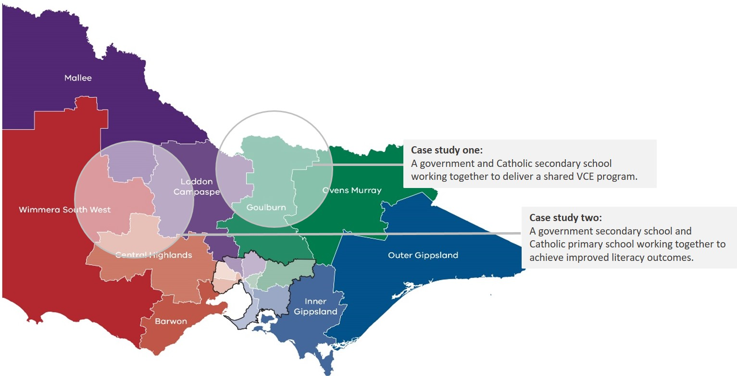
The following case studies illustrate instances of successful cross-sector collaboration in rural and regional Victoria.

Case study one: Delivering a shared VCE program across sectors
In a small town in northwest Victoria, a Catholic and a government secondary school have been working together for over 40 years to provide a shared VCE program for students at both schools. This partnership has enabled both schools to substantially increase their subject offerings, providing a choice of approximately 25 VCE subjects.

Up until the late 1970s, the two schools operated independently, often providing subjects by correspondence when class sizes were too small. Budgeting and resource constraints meant that students had limited access to VCE subjects and had a relatively narrow choice of what to study in senior years. A strong relationship between teachers lead to the realisation that the government school was teaching a subject that the Catholic school was currently running by correspondence. In a practical bid to put teachers at the front of classes for all students, the two schools began integrating students in classes at the partner school.
The system ran on an informal basis for twenty years, until the partnership was formalised with the development of common bell times, timetable blocking and joint curriculum provision. Now, the schools provide a comprehensive range of VCE subjects to students at both schools, including VCAL and VET. They also provide combined social events and sporting opportunities.

Increasing cohesion between schools
Bell times/timetabling – The two schools established shared bell times and timetabling to ensure students could easily move between classes. Both schools teach English at their home school, and the Catholic school also teaches Religious Studies. Students at the government school have a timetabled study period at this time.
Software and Learning Management System – The schools are in the process of updating software to the same system and share a cloud-based drive to assist in timetabling arrangements.
Communication between teachers – The two schools are located walking distance apart and teachers often move between the two campuses. At the start of every school year, the schools distribute a list of teacher emails and phone numbers to the partner school. Note - When sharing details of staff with another school, schools should ensure that the rationale for sharing personal details is appropriate and that proper consent is sought.
Planning for events – At the start of each year, principals and senior leaders get together to establish the annual calendar. Joint planning is done to minimize disruption for VCE students. For example, the schools ensure that the Catholic school’s Spirituality Day coincides with the government school’s Cross Country Day.
Creating sporting teams – The two schools share a football team where there would not otherwise be enough students for a team.

Commitment to the partnership
All levels of school leadership are supportive of the partnership. Principals, VCE Coordinators and a dedicated facilitator meet regularly in an informal setting to discuss shared logistical barriers and how to overcome them.
Finances are shared on a goodwill basis, with a contribution of $10 per student in each subject. At the end of year exams, the Catholic school provides finances for the chairs and desks and the government school provides the room.

Providing shared VCE provision:
- As well as VCE Coordinators, the partnership has a dedicated coordinator who manages the timetabling process for the two schools.
- Students from each school select their VCE subjects from a list of subject offerings (including potential subjects that are not currently being taught).
- The student preferences from both schools are then combined and preferences for each subject are counted.
- Both school principals and the VCE Coordinators meet and examine the budget to see how many sequences can be offered. They then go through the subject list and select subjects based on preference numbers.
- A minimum of 6-7 students is required to run a subject. This is because the schools commit to run a VCE 3/4 class the following year, if they commit to run the VCE 1/2 class.
- The principals then go through the subject list and allocate teachers based on past history of teaching these subjects and experience.
- Schools coordinate timetables to minimise disruption. Each school needs to teach English at their own school and the Catholic school needs to provide two blocks of Religious Education. The government school blocks these with ‘study periods’.
- Schools consider whether teachers should move between schools or if the classes should move between schools. In making this decision, schools should consider the risks of students moving between schools and ensure that appropriate supervision and means of transit are arranged.

Case study two: Uniting to improve literacy outcomes
Identifying a shared goal can help to overcome barriers and encourage greater collaboration between sectors.
In a small town in north-west Victoria, a government secondary school and a Catholic primary school partnered together to improve literacy outcomes for junior students.

The ‘Reader Leader’ project was one of several initiatives that came out of a community-wide program to address declining literacy standards across Early Years and primary level students. NAPLAN results were declining across all schools and the percentage of students who were entering school as Developmentally Vulnerable was more than double the Victorian average.
In response to the alarming downward trend, a government secondary school partnered with three local primary schools (including a Catholic primary school), to improve reading and oral language in Prep and Grade one.
Each week, students from Year 9 and Year 10 at the secondary school would dedicate an hour to assist Prep and Grade one students with their reading practice. The secondary students would spend this time reading to the students, listening to them read and acting as mentors to improve confidence and articulation. As well as participating in these regular visits, the secondary students were provided with formal training from a local literacy coach and speech pathologist.
Outcomes for students
By participating in the program, secondary school students were given the opportunity to develop strong communication and leadership skills and were simultaneously able to gain experience of being a teacher and mentor. The junior school ‘mentees’ developed greater enjoyment of reading and were able to focus on their literacy and oral language skills in a one-on-one environment. They also developed strong relationships with positive role models.
A shared vision
The program included a government and a Catholic school working together to address a shared problem. Focusing on the broader vision of improving student outcomes, the schools were able to effectively overcome the differences between sectors and engage successfully in cross-sector collaboration.

Is your school

Further Reading

Department of Education and Training

- VCE Collaboration toolkit https://www.education.vic.gov.au/about/programs/Pages/vcecollaborationfund.aspx
- Shared use of school facilities web page, including joint-use agreements: http://www.education.vic.gov.au/school/teachers/management/infrastructure/pages/propertysha re.aspx

Networks

- UMNOS- The University of Melbourne Network of Schools.
A membership-based partnership program that involves collaboration with schools and researchers to invest in evidence-based practices and networks.
https://education.unimelb.edu.au/community/university-of-melbourne-network-of-schools

Analysis of evidence on partnerships
- Mary Atkinson, et al., Inter-school collaboration: a literature review National Foundation for Educational Research (NFER), 2007. Accessible at: https://eric.ed.gov/?id=ED502393
- Paul Armstrong, Effective school partnerships and collaboration for school improvement: a review of the evidence. UK Department of Education, 2015. Accessible at: https://www.gov.uk/government/publications/school-improvement-effective-school-partnerships
- Tom Bentley and Ciannon Cazaly, The shared work of learning: Lifting educational achievement through collaboration. Mitchell Institute, 2015. Accessible at: http://www.mitchellinstitute.org.au/reports/the-shared-work-of-learning/
- Robert Hill, Achieving more together: Adding value through partnership. Association of School and College Leaders, 2008.

Rural areas

Analysis of the benefits and challenges of school partnerships in rural areas:
- Daniel Muijs, ‘Widening opportunities? A case study of school-to-school collaboration in a rural district’ (2008) 11(1) Improving Schools 61-73. Accessible at: http://journals.sagepub.com/doi/10.1177/1365480207086755
- Expert Advisory Panel for Rural and Regional Students: https://www.education.vic.gov.au/Documents/about/educationstate/expert-advisory-panel-for-rural-and-regional-students.pdf
- Robert Hill, Kelly Kettlewell and Jane Salt, Partnership working in small rural primary schools: The best of both worlds. Education Development Trust, 2014. Accessible at: https://www.educationdevelopmenttrust.com/en-GB/our-research/our-research-library/2014/r- partnership-working-2014

The purpose of a Memorandum of Understanding is to document and formalise an agreement between two parties. It sets out the terms of the agreement, including the roles of each party. Terms of Reference can set out the working arrangements for a partnership and can list vital information about the partnership, such as its purpose, chair and membership, meeting schedule, level of administrative support, and dispute resolution processes.
The VCE Collaboration Fund Memorandum of Understanding template should be used for recipients of the VCE Collaboration Fund.
Children who score below the 10th percentile in the Australian Early Development Census. https://www.aedc.gov.au/about-the-aedc/how-to-understand-the-aedc-results

