teacher recruitment difficulty census

frequently asked questions

Q. What is the Teacher Recruitment Difficulty Census?
The Teacher Recruitment Difficulty Census (TRD Census) has been conducted in each February Census since 2000. Census day is the last school day in February.
The census asks schools:
- whether they employed Teaching staff in the reference period for the current school year
- whether they experienced difficulties recruiting teaching staff during the reference period
- the subject areas that were difficult to recruit teachers for
- the strategies employed to fill difficult vacancies
- any subjects schools were forced to drop for want of suitably qualified teachers.
This data will enable the Department to assess more accurately which localities and in which subject or specialist areas schools may be experiencing difficulties recruiting teachers. The Department uses the data in devising strategies to assist schools to overcome these problems.
The TRD Census is to be completed online and submitted by all schools by the closing date. See: Teacher Recruitment Difficulty Census
Enquiries relating to the TRD Census can be directed to the School Census Hotline on (03) 7022 0359.

Q. I did not recruit any teachers for this year. Do I need to complete the census?
Yes, all schools need to complete the census including those schools with a nil return.
Schools not recruiting any teachers will still need to answer questions 1, 2, 10, 11 and 12 and the Principal will need to endorse the TRD Census, before submitting it back to the Department of Education and Training.

Q. What happens if I am half way through completing the Teacher Recruitment Difficulty census and I need to stop?
You can save the census as a draft and re-enter the website to complete it at a later time. Your information will not be lost if you click on the 'Save as Draft' button located at the bottom of the census page. Do not exit before you do this, otherwise you will lose all the information that you have entered.
However, if you have saved the Teacher Recruitment Difficulty census as a draft remember to complete and submit the census prior to the expiration of the census closing date.

Q. What happens if I submit the Teacher Recruitment Difficulty census, but realise there are mistakes?
If the closing date has not expired, then go to the website. All your data will appear as you have entered it. Make the necessary changes and resubmit. Only the latest return from your school will be used.
Print a copy of the census before you submit so you have a copy for reference after the census has closed.
If the closing date has expired, then please direct your enquiries to the Census Hotline at email: census@edumail.vic.gov.au or by phone on (03) 7022 0359.

completing the TRD Census
The TRD Census website can be accessed using either the School EduMail account or the Principal’s EduMail account. The TRD census takes approximately 10 minutes to complete.
- Go to: www.eduweb.vic.gov.au/forms/school/trd
- Log in to the website using either the School EduMail account or the Principal’s EduMail account.
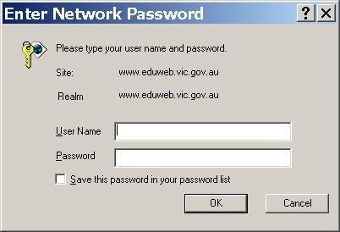
- Complete the questions
- Print a copy for your reference after the census has closed
- Submit.

School EduMail accounts
The User Name for the school account will take the form of: SXXXXYY
where:
XXXX = School number (e.g. Ararat Primary school number is 800 = 0800)
YY = Admin Centre Campus Number (E.g. Admin Centre Campus is 1 = 01)
Thus the User Name for Ararat Primary School's school account would be S080001
If you are unaware of the password for the school account, both the Principal and the delegate have the permission to reset the password.
To change the password:
- Access the EduMail Homepage through the Principal’s or the delegate’s account. The web address for the EduMail homepage is: www.EduMail.vic.gov.au
- Click on Support, then select 'EduMail Account Administration'.
- By choosing 'Account Management', a list of all staff members registered at your school will appear.
- Select the account for which you wish to reset the password, and click 'Reset this user's password'.

