Verifying and recording data in CASES21
What to do:

- the Department requires the principal to verify that the process undertaken and student information collected is accurate
- nominated school staff member enters verified data for each identified student in CASES21 following the instructions in the CASES21 Administration User Guide: Chapter 7, pages 24-28: CASES21 Administration User Guide
- When all data has been entered in CASES21, schools are encouraged to run the following reports for referencing next year:
  - Students with Disability – Disability Summary [ST21428]
  - Students with Disability – Student Summary [ST21429]

In 2018, the final date for submitting data is 3th August via the CASES21 system (data can be recorded prior to this time).

Four pieces of data need to be entered from drop down menus in the CASES21 record for each student included in the NCCD:

- Step 1: Is the student provided with a reasonable adjustment to address a disability as defined by the Disability Discrimination Act 1992?
- Step 2: What level of adjustment is provided to the student?
- Step 3: What is the broad category of disability?
- Step 4: Has the school principal verified this data? This will need to be completed each year as this field will revert to 'N' following the annual CASES21 End of Year Process run.

The format screen below will be displayed:

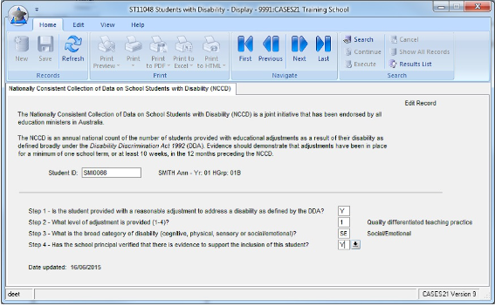

Following reporting of your data, DET extracts your data and forwards it to the Australian Government Department of Education and Training. All states and territories provide a list of schools, with their Australian Government Education IDs (AGE ID) and the numbers of primary and secondary student enrolments, number of students with disability by school, student level of education, category of disability and level of adjustment, to the Australian Government Department of Education and Training.

No personal identifying details of students are collected.

