General Notes:
- This guide is for viewing PSD application outcome notifications on PSDMS. This is applicable for:
- All notifications are now stored and published on. It is important that you check PSDMS regularly (at least once a week) when you are anticipating an outcome of a submitted application.
- All PSDMS Quick Reference Guides are obtainable from: www.education.vic.gov.au/school/principals/finance/Pages/swdsystems.aspx

1 | A PSDMS registered user for your school can log into the PSDMS system using their Edumail ID and password at: https://www.eduweb.vic.gov.au/psdms
Note: If you are not a registered user in PSDMS see:
‘Quick Reference Guide - Adding / Changing PSDMS Users’.

2 | Select Administration from the top menu bar.  You are directed to recently published outcomes via the shortcut Notifications Last 7 Days on the home page. | 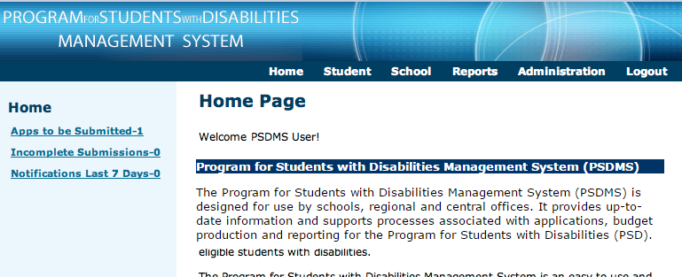

3  3 | Click (a) Search to reveal all existing outcomes on PSDMS for your school.  Scroll right and select (b) View to access the notification letter.  If required refine the search for a student by entering their (c) name or PSDMS number. |  | 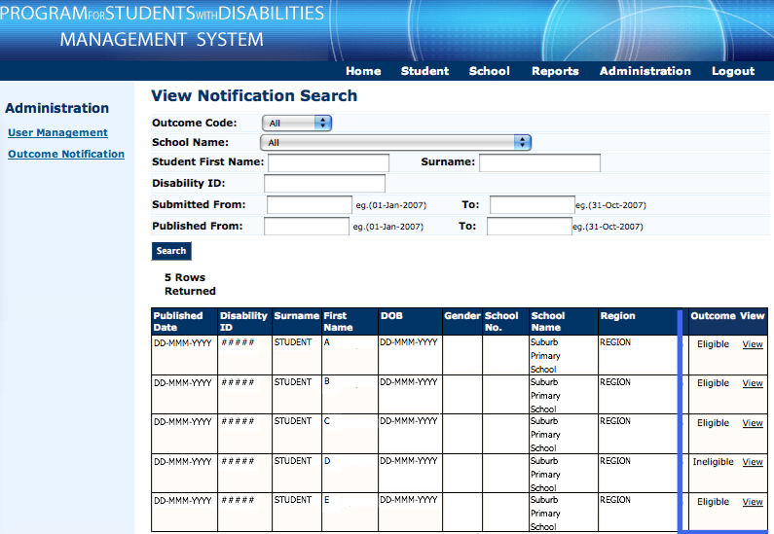  c  b  a
4 | The View Notification letter details the outcome of the current application.  Scroll down the screen to select options (a) Print or (b) Return. | 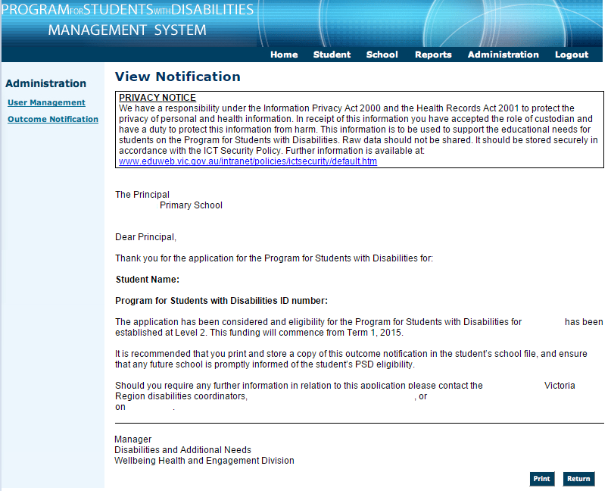  b  a
 | Note: Outcomes of ‘current’ applications are permanently stored in PSDMS and can be accessed at any time. It is recommended that a copy of each notification be printed and placed in students’ school files.
If technical assistance is required, please contact the DET Service Gateway
P) 1800 641 943 or W) https://www.eduweb.vic.gov.au/servicedesk/

