General Notes:
- This guide is for adding and changing PSDMS users for your school.
- In order to access PSDMS, the user must be registered at your school on the Edumail system.
- All PSDMS Quick Reference Guides are obtainable from: www.education.vic.gov.au/school/principals/finance/Pages/swdsystems.aspx

1 | An existing PSDMS registered user for your school can log into the PSDMS system using their Edumail ID and password at: https://www.eduweb.vic.gov.au/psdms

2 | Select Administration from the top menu bar. | 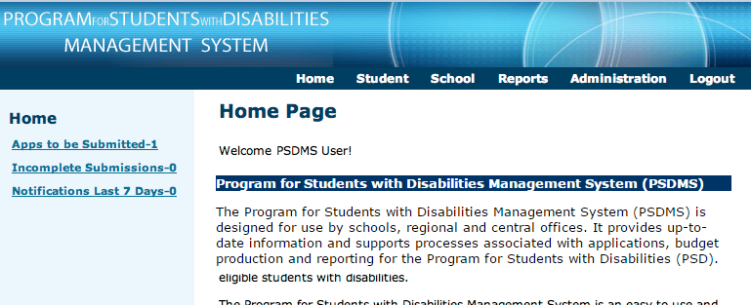

3 | Select (a) User Management from the left then click (b) Search to reveal all current PSDMS users at your school. | 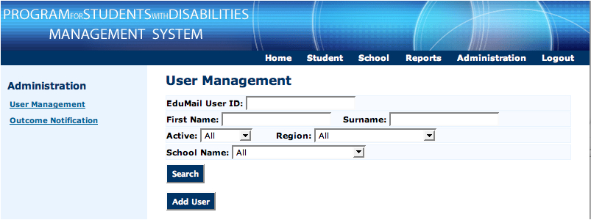  b  a

4 | Select Add User | 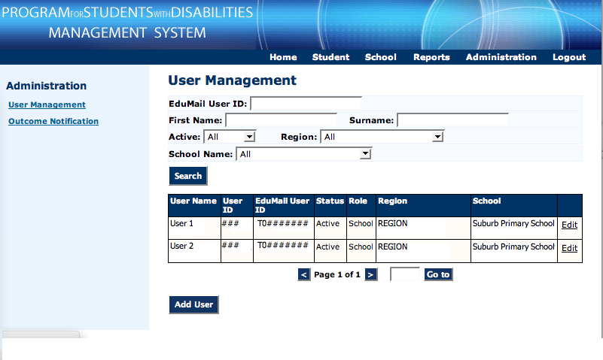

5 | Current staff listed in Edumail at your school will appear in the drop down (a) Staff Member menu. Select the appropriate staff member, then (b) check in Edumail to process. Choose (c) Active then click (d) Save | 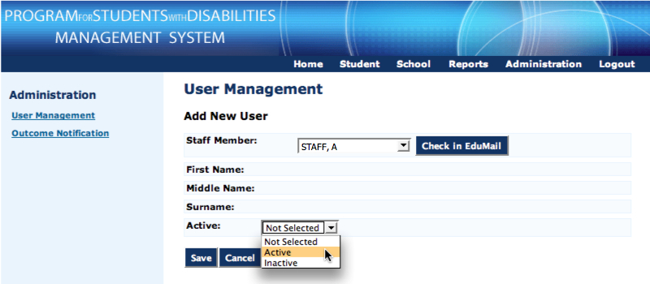  d  c  b  a

6 | After clicking 5(d) Save, you will be taken to an updated list of PSDMS users for your school.  From this screen you may also Edit access to modify a user’s status to ‘Inactive’ if required. |  |  | 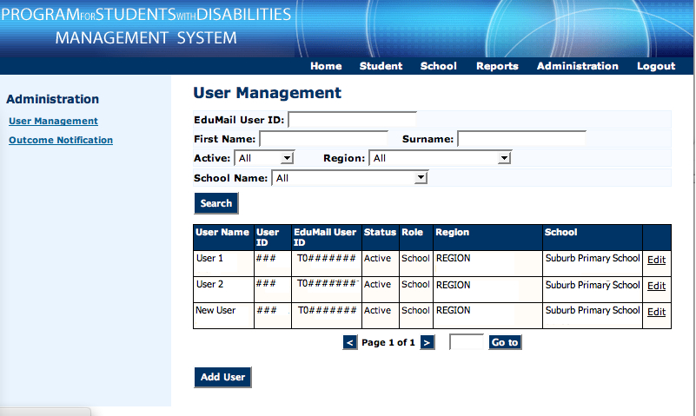
 |  |  | Note: It is not possible to update user details of someone with a de-activated Edumail ID (in the case of retired/left staff members). In such cases, these users can no longer log in to the system.
If technical assistance is required, please contact the DET Service Gateway
P) 1800 641 943 or W) https://www.eduweb.vic.gov.au/servicedesk/

