Hagaha nidaamka kaas oo loogu talagalay waalidiinta iyo daryeelayaasha

Sida loo isticmaalo internetka Gunnada Kaydinta Dugsiga (School Saving Bonus) nidaamka onlaynka waalidka iyo daryeelaha

Ku saabsan Gunnada Keydka Dugsiga (School Saving Bonus)

Dawladda Victoria waxay nolosha u fududeynaysaa qoysaska iyadoo siinaysa $400 oo   
ah Gunnada Keydka Dugsiga (School Saving Bonus). Taageeradani waxay ka caawin doontaa inay ku dabaraan kharashka dharka dugsiga, buugaagta, iyo hawlaha dugsiga   
sida kaamamka, dalxiisyada iyo ciyaaraha.

Helitaanka Gunnada Keydka Dugsiga

Waalidiinta iyo daryeelayaasha ardayda ka diiwaangashan dugsiyada dawladda   
sanadka 2025 waxay Waaxda Waxbarashada ka heli doonaan iimayl laga bilaabo   
26-ka Nofeembar 2024.

Iimaylka waxaa ku qornaan doona:

* Koodhka adiga qaaska kuu ah ee Gunnada Kaydinta Dugsiga si aad u isticmaasho deeqda lacag ee $400
* isku xirka [nidaamka online-ka ah ee waalidka iyo xannaaneeyaha gunnada Kaydinta Dugsiga.](https://www.schoolsavingbonus.vic.gov.au/)

Waalidiinta iyo daryeelayaasha ayaa heli doona hal iimayl iyo koodh loogu talagay arday kasta oo qoyskooda ka tirsan ee u qalma.

Haddii aadan helin iimaylka, ka fiiri Isbaam (spam) kaaga ama galka jankinga(junk).

Fadlan ogow, Waaxda Waxbarashada iyo Dawlada Victoria weligood kaama codsan doonaan inaad la wadaagto bangigaaga ama faahfaahinta maaliyadeed si aad u hesho Gunnada Kaydinta Dugsiga.

Sida aad ku heli karto Gunnada Kaydinta Dugsiga nidaamka online-ka ee waalidiinta iyo daryeelayaasha

1. Booqo [Gunnada Kaydinta Dugsiga nidaamka online-ka ee waalidiinta iyo daryeelayaasha](https://www.schoolsavingbonus.vic.gov.au/)
2. Bogga internetka ee soo socda ayaa la soo bandhigi doonaa:

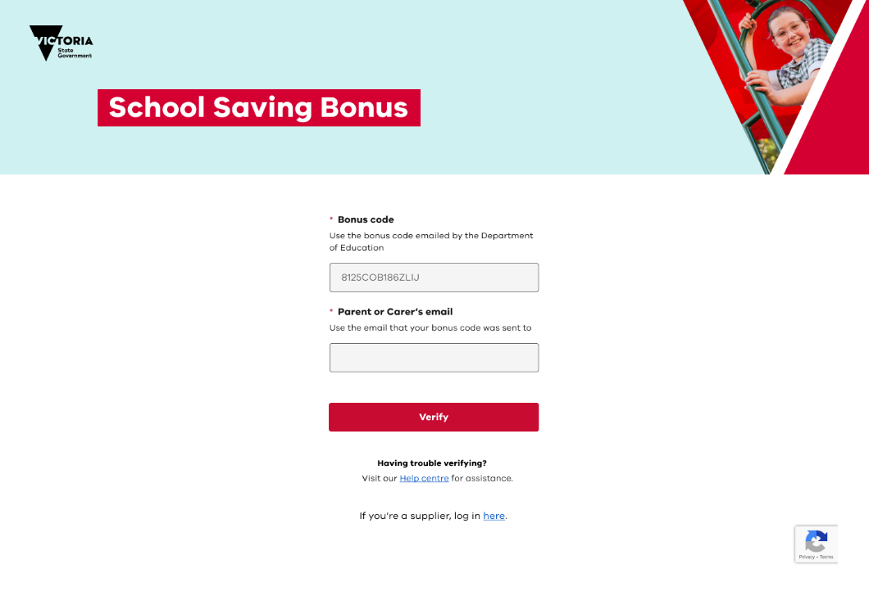

1. Geli koodhka adiga khaaska kuu ah ee Gunnada Kaydinta Dugsiga ee ay kuu soo dirtay Waaxda Waxbarashada iyo ciwaanka iimaylka loo soo diray oo guji meesha   
   ay ku qoran tahay **xaqiiji (verify)**.
2. Markaad gujiso kadib **xaqiiji (verify),** waxaad arki doontaa boggaga Gunnada Kaydinta Dugsiga oo kooban.

Bogga Kooban ee Gunnada Kaydinta Dugsiga

Bogga ay ku qoran tahay qormada kooban ee Gunnada Kaydinta Dugsiga waxaad ka heli kartaa macluumaad muhiim ah wuxuuna sidoo kale kuu ogolaanayaa inaad doorato sida aad doonayso inaad u isticmaasho Gunnada Kaydinta Dugsiga.

Xiriirinta degdega ah   
ee aad ku tagi karto ficilada muhiimka ah   
iyo ikhtiyaarka aad kaga bixi karto.

Xidhiidhiyayaashani waxay kuu oggolaanayaan inaad doorato sida loo isticmaalo gunnada. Wax badan oo ku saabsan xidhiidhiyayaashan qaybta meesha ay ku qoran tahay 'How to use your School Saving Bonus' ee hagahan ka baro.

Guji falaarahaha hoos u dhaca si aad wax badan uga barato ama raac xiriirinta degdega ah.

Waxay isku xirtaa tafaasiisha ilmahaaga, inta hadda kaaga hartay Gunnada Keydka Dugsiga iyo shirkadaha markaas dugsiga u keena qalabka.

Sida loo isticmaalo Gunnada Keydinta Dugsiga

Taageerada Gunnada Kaydinta Dugsiga waxa loo isticmaali karaa in dukaan gudihiis wax looga iibsado, onlaynka wax looga iibsado, iyo hawlaha dugsiga. Iyada oo loo marayo bogga Gunnada Kaydinta Dugsiga, waxaad sidoo kale dooran kartaa inaad aragto codes-ka, ama lacagihii hore u baxay oo dhan.

Markaad u qoondayso gunnadaada inaad wax uga iibsato dukaan, ama aad wax uga iibsato online-ka, ama hawlaha dugsiga, lagama laaban karo.

Haddii aad hayso wax lacag ah oo aadan isticmaalin, ama lacagaha aad u qoondaysay in wax looga iibsado dukaan gudihiis ama online-ka wax looga iibsado lama isticmaali karo, lacagahan si toos ah ayaa loogu heli doonaa akoonka dugsiga ilmahaaga si ay u noqoto credit 1 Luulyo 2025.

Wax ka iibsiga dukaanka dhexdiisa ah

Si aad ugu isticmaashid Gunnada Kaydinta Dugsiga dukaan ku yaala dugsigaaga, guji **wax iibsiga gudaha dukaanka** si aad u hesho koodka gunnada. Koodhka gunnada ayaa ku soo bixi doona isagoo qaab qoraal ah iyo/ama QR code. Booqo alaab-qeybiyaha aad dooratay oo soo bandhig code-ka Gunnada Kaydinta Dugsiga, qaabka ay doonto ha ahaato, marka la hubinayo.

Lacag celin kasta ama beddelaad kasta waxa lagu maarayn doonaa iyadoo la isticmaalayo alaab-qeybiyaha shuruucdooda iyo hababka jira. Fadlan ogow.

* lacag celin looma heli karo waalidka/daryeelaha leh Gunnada Kaydinta Dugsiga.
* lacag caddaan ah lama bixin doono.

Wax ka iibsashada onlaynka

Haddii aad jeclaan lahayd inaad ku bixiso qayb ama dhamaan taageerada Gunnada Kaydinta Dugsiga online ah, guji meesha ay ku qoran tahay **Wax ka iibsashada onlaynka (online purchase)** oo raac talaabooyinkan soo socda.

1. Dooro nooca alaab-qeybiyaha Tani waxay noqon doontaa:
   1. Lebiska (uniform)
   2. Buugaagta wax laga aqristo ama
   3. Buugaagta wax laga aqristo iyo lebis (uniform).
2. Markaad doorato nooc alaab-qeybiye ah (supplier), waxaad awoodi doontaa inaad aragto liiska alaab-qeybiyeyaasha dugsigaaga.
3. Dooro alaab-qeybiyaha dugsiga ee aad doorbidayso.
4. Waxaad u baahan doontaa inaad doorato lacagta aad ku bixinayso alaab-qeybiyaha. Qiimaha lacagta waxay noqon karta mid ka mid ah inta soo socota ee kala ah $50, $100, $200, $300 ama $400.

Marka aad ku qanacdo nooca alaab-qeybiyaha dugsiga ee aad dooratay, iyo qiimaha,   
guji meesha ay ku qoran tahay **Next. Fadlan si taxadir leh dib u eeg maadaama aan xulashadan la bedeli karin ama laga noqon karin.** Marka dib loo eego, guji meesha   
ay ku qoran tahay **Confirm (Xaqiiji)**.

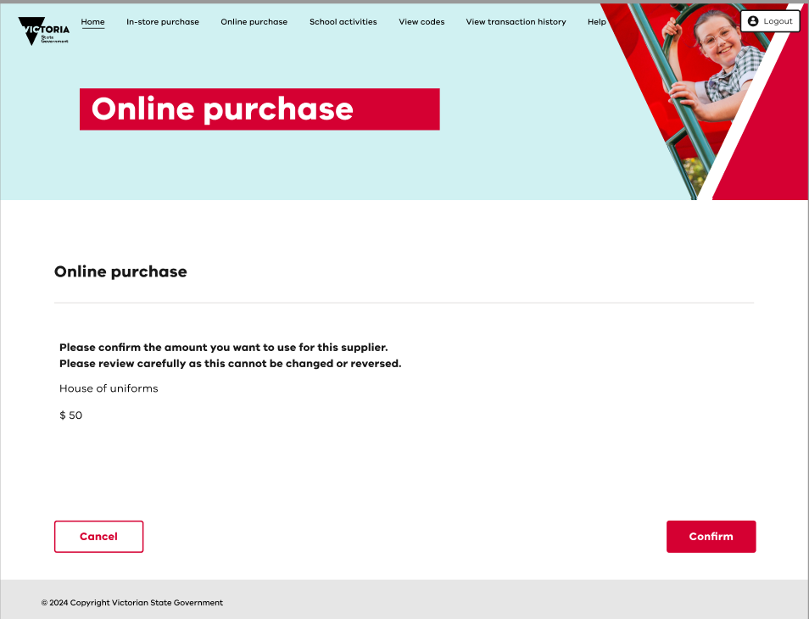

1. Koodhka online ka waa inuu hadda soo muuqdaa. Waxa kale oo koodhkan laguugu soo diri doonaa iimay.

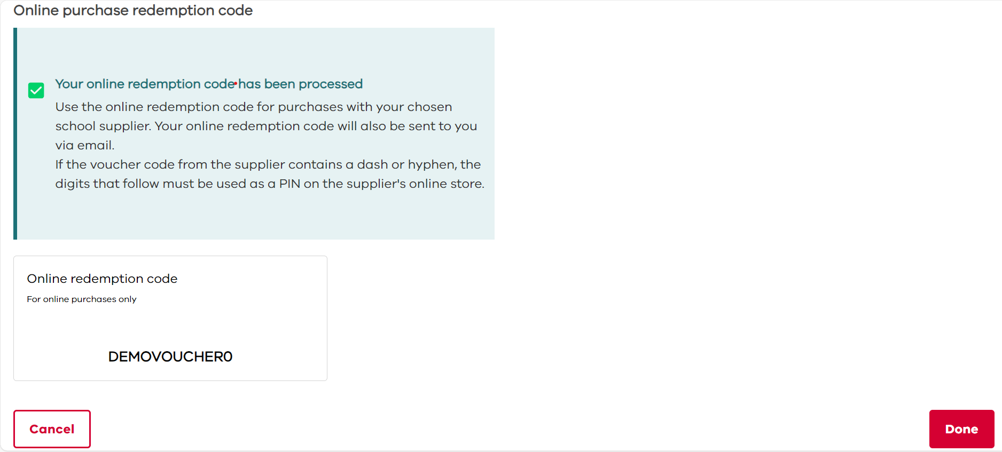

Fadlan ogow.

* Xeerkan waxa kaliya oo loo isticmaali karaa alaab-qeybiyaha aad dooratay, qiimaha aad dooratay.
* Haddii koodka foojarka alaab-qeybiyaha uu ka kooban yahay xargo ama xargo, lambarrada soo socda waa in loo isticmaalaa sidii PIN ahaan dukaanka online-ka   
  ee alaab-qeybiyaha (tusaale: ABC123-PIN).
* Booqo dukaanka online-ka ee alaab-qeybiyaha oo codso koodhka internetka   
  (iyo PIN haddii loo baahdo) goobta hubinta. Haddii aad kharash garayso wax ka badan inta aad ku qoondaysay koodka internetka, waxaad u baahan doontaa inaad bixiso faraqa u dhexeeya.
* waxaad sii wadan kartaa inaad isticmaasho koodka internetka ee alaab-qeybiye la mid ah ilaa inta wadarta lacagta la kharash gareeyay.
* Koodhka online-ku wuxuu dhacayaa 30ka Juun 2025.

Lacag kasta oo ah Gunnada Kaydka Dugsiga ee aan la isticmaalin marka la gaaro   
30ka Juun 2025 waxa lagu wareejin doonaa akoonka dugsiga ilmahaaga ee hawlaha dugsiga mustaqbalka sida kaamamka, ciyaaraha iyo dalxiisyada.

U qoondaynta gunnada kaydinta dugsiga hawlaha dugsiga

Guji meesha ay ku qoran tahay **hawlaha dugsiga** in loo qoondeeyo dhamaan ama qayb ka mid ah Gunnada Keydka Dugsiga ee hawlaha dugsiga. Bogga hoose ayaa soo bixi doona, halkaas oo aad ka dooran karto qaddarka aad jeclaan lahayd inaad magacowdo. Marka aad doorato cadadka, dhagsii **kan xiga (next).**

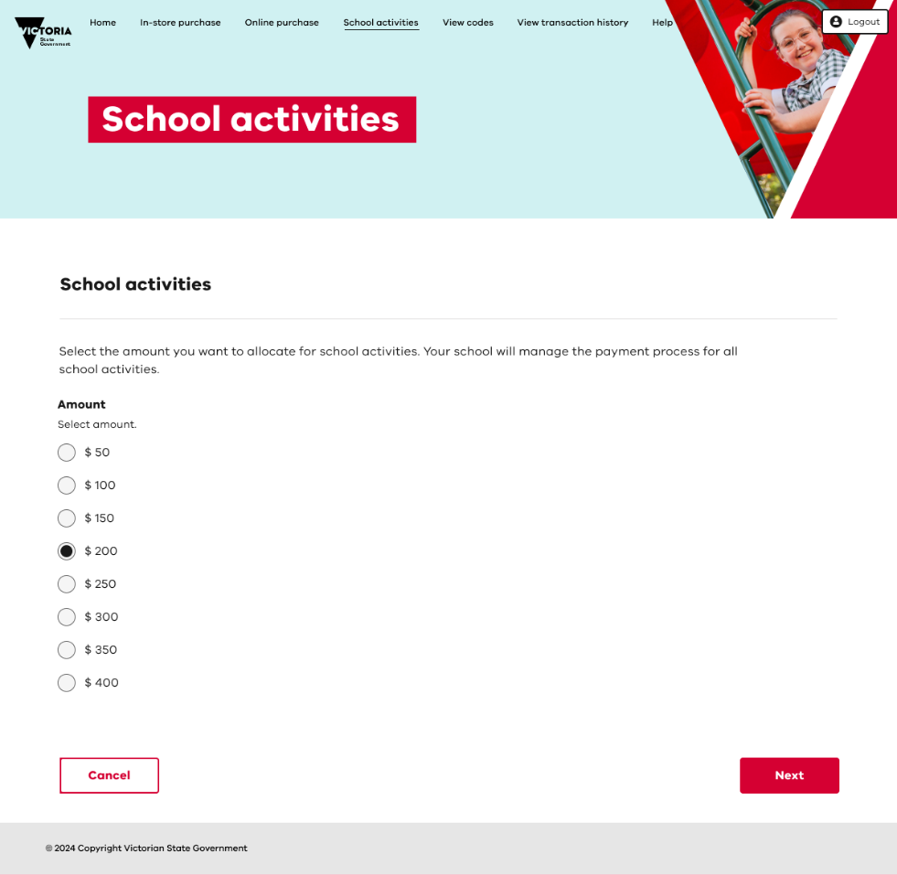

Waxaa lagu weydiin doonaa inaad xaqiijiso qoondayntaada. **Fadlan si taxadar leh u eeg qoondayntaada sababtoo ah tan lama bedeli karo ama dib looma celin karo.**

Qadarka la doortay waxa lagu heli doonaa akoonka ilmahaaga ee dugsiga uu ilmahaagu ka diiwaangashan yahay 2025. **Fadlan u ogolow 48 saacadood wareejintu inay dhacdo.**

Waxa kale oo aad heli doontaa iimayl xaqiijinaya qoondaynta.

Arag summada iyo/ama arag taariikhda wax kala iibsiga

Si aad u aragto koodka gunnada kaydinta dugsigaaga, iyo/ama koodka alaab-qeybiyaha onlaynka ah, guji **View codes** laga bilaabo bogga gunnada kaydinta dugsiga.

Si aad u aragto sida aad u isticmaashay lacagtaada kaydinta dugsiga ee dukaanka, dhagsii **Arag taariikhda wax kala iibsiga** laga bilaabo bogga kooban. Fadlan ogow in wax kala iibsiga dukaanka oo kaliya la muujiyo.

Caawin iyo taageero

Macluumaad dheeraad ah oo ku saabsan nidaamka online-ka ah ee waalidka iyo xannaaneeyaha gunnada Kaydinta Dugsiga ayaa laga heli karaa bogga kooban.

Taageerada degdega ah iimayl [school.saving.bonus@education.vic.gov.au](mailto:school.saving.bonus@education.vic.gov.au).

Laga bilaabo Isniinta 25ka Nufeembar 2024 xulashooyinka dheeraadka ah ee soo socda ayaa shaqayn doona:

* Wac 1800 338 663 inta lagu jiro saacadaha shaqada.
* Buuxinta [foomkan weydiinta onlaynka ah.](https://www.schoolsavingbonus.vic.gov.au/s/enquiry-form)