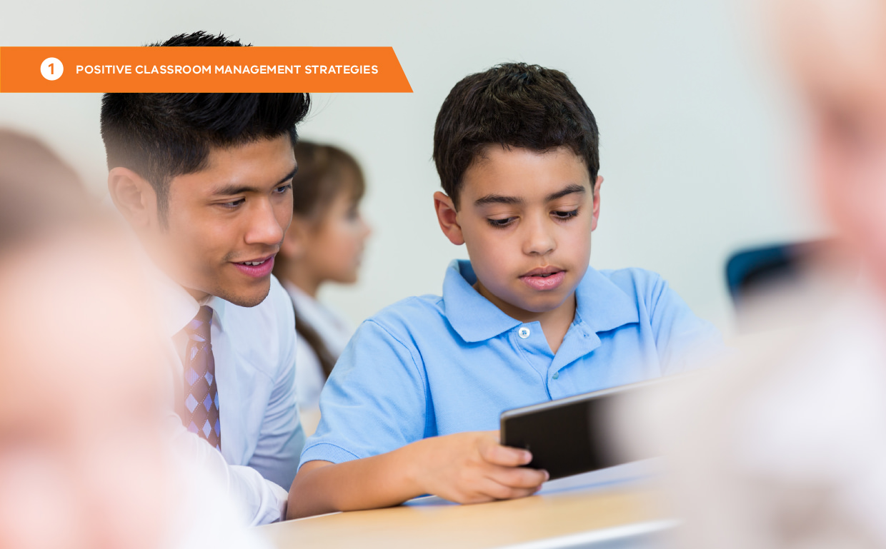

# Practice 5: Active supervision

### What is active supervision?

Active supervision is the deliberate practice of moving, scanning and interacting with students while teaching.

### The power of active supervision

Active supervision helps monitor learning and identify students who may have questions or need assistance. By closely monitoring students, teachers can ensure that expectations are being met.

Active supervision provides several benefits:

* Allows for immediate learning assistance
* Increases student engagement
* Reduces inappropriate behaviour and increases expected behaviour
* Provides insight into students’ adherence to expectations
* Encourages those using expected behaviour
* Facilitates prompts, pre-corrections, and timely corrections of social/behavioural errors
* Helps pre-empt escalations
* Builds positive adult-student relationships

(MISSOURI SCHOOLWIDE POSITIVE BEHAVIOR SUPPORT, 2019)

### Getting started

##### Step 1: Practise the elements of Active Supervision

There are three main elements of active supervision:

|  |  |
| --- | --- |
| **Moving** | Circulating among the students in the classroom |
| **Scanning** | Frequently and intentionally looking around at students in the classroom |
| **Interacting** | Providing contingent and non-contingent attention to students in the classroom |

###### Moving

When circulating, keep moving and avoid spending too much time in one spot. Continuous movement and proximity to all students make your presence known and heighten their attention to tasks and expected behaviours. Move randomly and unpredictably so students are unsure when you will be nearby. Approach non-compliant students as needed and frequently check potential ‘hot spot’ areas (LAMPI ET AL., 2005).

Circulating allows you to be near students to show your interest in them, assist with learning tasks by answering questions, build relationships, and provide both positive and corrective feedback.

###### Moving - working with a group

Movement can be challenging when working with a small group or providing individual instruction while also needing to supervise other students. However, you can still incorporate ways to supervise the entire group periodically and unpredictably. For example, during small group writing instruction, assign a brief task to the students, then take a moment to move among the larger group before returning to the small group. This ensures that all students are being monitored and supported.

###### Scanning

Whether moving around the room, working with a small group or individual, or leading from the front, frequently and intentionally look around at the students. This visual scanning includes making eye contact. When circulating, visually sweep all areas of the room, paying attention to both the students nearby and those farther away.

###### Scanning – working with an individual

When working with an individual student, position to scan the entire room simultaneously, or stand up occasionally to look around the room before returning to the student.

###### Scanning – working with a group

When working with a group, look up and scan the room while also focusing on the group. This visual scanning helps identify instances of expected or inappropriate behaviour that need immediate response and helps identify students who may need assistance.

###### Interacting

Frequently interact with students while moving and scanning. A friendly, open, and helpful demeanour communicates care, trust, and respect, helping to build relationships. These interactions remain consistent whether teaching, encouraging, or addressing problem behaviour.

##### Step 2: Anticipate difficult times and plan

Many techniques that encourage expected behaviour can be intensified through active supervision to enhance expected behaviour and maximize student engagement. Active Supervision includes:

|  |  |
| --- | --- |
| **Reminders** | **Contingent and non-contingent attention** |
| Frequent interactions can include reminders. Simply saying, “Please make sure your iPad is charged and ready for the morning,” or “Remember to pause and wait for the prompt before you hold up your answer,” will increase  expected behaviour. Periodic prompts to the group will help keep students on track (LAMPI ET AL., 2005). | Frequent interactions should include both contingent and non-contingent attention. Non- contingent attention includes greetings, smiles, and conversations that provide time and attention unrelated to performance. After interacting with or assisting a student, take a moment to remind them of the expectations. This will increase the likelihood  that they will demonstrate the expected behaviour or adjust their work accordingly. |

### Self-assessment: Active Supervision

|  |  |  |  |
| --- | --- | --- | --- |
| **Self-assessment feature** | **In place** | **Partially in place** | **Not in place** |
| I have designed the classroom floor plan to allow for ease  of movement for active supervision. |  | | |
| I continually monitor all areas of the room by moving and interacting frequently and strategically. |  | | |
| I continually monitor all areas of the room by scanning and interacting frequently and strategically. |  | | |
| When designing a lesson, I consider student groupings, location and activity level. |  | | |
| I provide positive contact, positive and corrective feedback while moving around the room. |