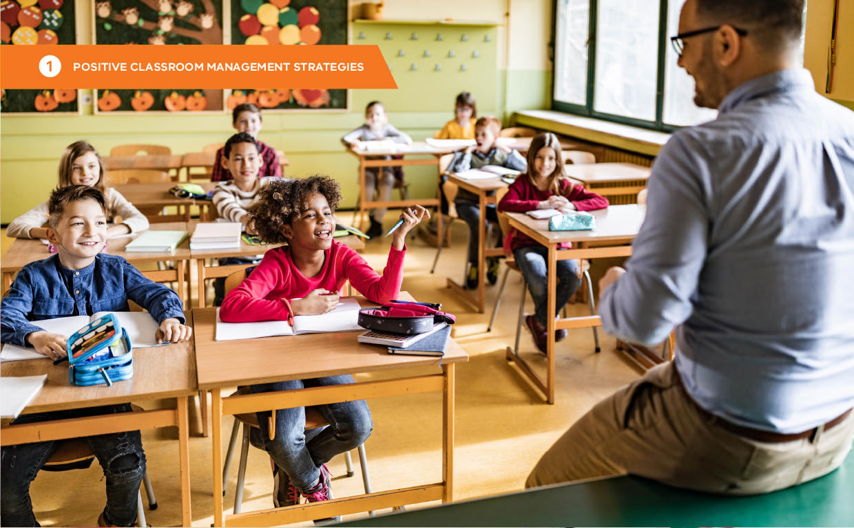

# Practice 4: Discouraging inappropriate classroom behaviour

### Preventing and addressing inappropriate behaviour

When students make academic errors, it is important to respond by re-teaching, providing guided practice, and allowing them to practise with frequent monitoring. Similarly, viewing inappropriate behaviours as learning errors supports taking a supportive, educative approach. Effective responses to inappropriate behaviour in the classroom involve fair and consistent corrective actions. By explicitly

teaching and providing constructive, specific feedback, students can learn and practise new behaviours. Discouraging inappropriate behaviour involves developing and using a range of techniques. Ideally, these should be established and agreed upon throughout the school. Teachers select and apply the least intrusive response necessary to prevent and address social behaviour errors.

Students should be expected to make social learning errors just as they make academic errors. When students do not demonstrate expected behaviours, it is usually due to one or both of the following reasons:

* They have yet to acquire the necessary skills to perform the expected behaviour (skill-related).
* Insufficient motivation to demonstrate the expected behaviour (performance-related).

Students may be less motivated to practice behaviours they find too difficult, irrelevant to their life experiences, or that do not help meet their needs. A lack of motivation may indicate a learner does not know the skill well enough to perform it effortlessly or does not experience enough benefit from

performing it. For example, students may not be motivated to complete homework if there is no feedback or acknowledgement from the teacher.

Both issues can be addressed by teaching, providing opportunities to practice, and offering meaningful feedback.

|  |  |
| --- | --- |
| **Skill-related** | **Performance-related** |
| Lack of skill or insufficient opportunity and practice of the expected behaviour | Student does not view the behaviour as relevant or important enough to invest the effort required |

### Getting started

##### Step 1: Define inappropriate behaviours

List the types of inappropriate behaviour that might occur in classrooms. Describe the behaviour in observable terms that leave little open to interpretation. This will help distinguish between major and minor inappropriate behaviours and establish a predictable continuum of effective responses.

It is preferred to agree on these at a ‘whole-school’ level so that students learn to expect consistent responses from staff.

###### Distinguishing minor and major inappropriate behaviour

For a consistent response, staff must agree on which misbehaviours are minor and which are major. The severity of the behaviour will guide the level of response:

* **Minor inappropriate behaviours** are managed when and where they occur by the adult present at the time. Most commonly this is a teacher in the classroom, but it could also be, for example, a staff member working in the office or on the school grounds.
* **Major inappropriate behaviours** are managed beyond the context in which they occur, often by a senior leader within the school. Persistent minor inappropriate behaviour by the same student may require a major misbehaviour response, depending on the timespan in which the behaviours occur and their intensity. Major misbehaviour may require the student to be temporarily exited from the setting. Depending on school policy and severity, major behaviours may be managed by the principal, another senior manager, a senior teacher, a buddy teacher, or the teacher concerned (at a later time or outside the classroom). Major incidents should always be documented.
* **Critical incidents:** Certain major inappropriate behaviours may also be classified as critical incidents according to Department policy. For detailed guidance on these situations, please refer to the Department’s Policy Advisory Library.

Below are some suggested definitions for major and minor inappropriate behaviours.

**Suggested minor behaviour definitions**

|  |  |
| --- | --- |
| **Behaviour** | **Definition** |
| **Inappropriate language** | Communications, or use of words in an inappropriate way for the developmental age of the student (e.g., name calling, teasing). |
| **Physical contact** | Non-serious, but inappropriate physical contact (e.g., over-affectionate, patting, light tapping). |
| **Non-compliance language** | Mildly defiant/disrespectful behaviour. Low-intensity failure to respond to adult requests (e.g., yelling, ‘No!’ when asked to do something). |
| **Mild disruption** | Persistent talking while teacher is speaking. Loud voices or noises indoors. |
| **Property misuse** | Low-intensity damage of another student’s equipment/possession or work in an inappropriate way (e.g., scribbling on another student’s page, snapping another student’s pencil through rough handling). |
| **Dress code violation** | Wearing clothing or shoes that do not fit within the school setting policies. |
| **Late to class** | Missing the beginning of class time. |
| **Cheating/ Dishonesty** | Acting dishonestly or unfairly to gain an advantage, especially in a game or examination. |
| **Other** | Other minor problem behaviour that cannot be categorised within the available definitions. |

**Suggested major behaviour definitions**

|  |  |
| --- | --- |
| **Behaviour** | **Definition** |
| **Abusive language** | Abusive language, inappropriate language or profanity.  Communications that include swearing, name calling or use of words in an inappropriate way for the developmental age of the child. |
| **Defiance** | Disrespect or non-compliance; refusing to follow directions, talking back and/or socially rude interactions. In this case, the student refuses to follow directions after an initial request has been made directly to that student. |
| **Non-compliance** | Non-compliance or refusing to follow directions; talking back and/or socially rude interactions. |
| **Disruption** | Causing an interruption in a class or activity. This could include sustained loud talk, yelling or screaming; noise with materials; rough play, and/or sustained out-of-seat behaviour (i.e., tantrums, excessive yelling or screaming). |
| **Physical aggression** | Actions involving serious physical contact where injury may occur (e.g., hitting, punching, hitting with an object, kicking, hair pulling, scratching). |
| **Forgery or theft** | Possessing, having passed on, or being responsible for removing someone else’s property (i.e., taking someone else’s personal belongings). This also includes identity theft. |
| **Harassment** | Harassing, teasing or taunting; delivering disrespectful messages (verbal or gestural) to another person that includes threats and intimidation, obscene gestures, pictures, or written notes. Disrespectful messages include negatives comments based on race, religion, gender, age, and/or national origin; sustained or intense verbal attacks based on ethnic origin, disabilities or other personal matters. |
| **Property damage** | Causing any form of injury or damage caused to property, due to negligence, or intentionally, by someone who is not the owner of the property. |
| **Absconding** | Trying to run away (either within or outside of school grounds); leaving suddenly; hiding from staff (fence, roof, gates), or other safety issues. |
| **Technology Violation** | Inappropriate use of an electronic device, such as texting in class, accessing social media, unauthorized games or unsafe material. |
| **Unexcused partial absence** | Missing whole lessons or part lessons. |
| **Plagiarism/ Dishonesty** | Intentionally using another person’s work as their own, or engaging in unauthorised use of material, information, notes, study aids, devices or communication during an academic exercise. |
| **Pattern of bullying** | Repeated, unwanted interactions in which there is a power imbalance. Includes on-going teasing, repeated taunting, repeated name calling, leaving someone out, and spreading rumours. |

##### Step 2: Techniques to address minor inappropriate behaviour

The PCMS provide guidance for direct and indirect techniques shown to discourage inappropriate behaviour. These approaches are described in more detail below.

|  |  |
| --- | --- |
| **Indirect strategies** | **Direct strategies** |
| * Proximity * Signal or non-verbal cue * Ignore, attend, praise | * Re-direct * Re-teach * Corrective feedback * Provide choice * Student conference * Logical consequences |

###### Indirect techniques

Indirect techniques do not involve explicitly discussing inappropriate behaviour. When staff actively supervise and identify potential problems early, these approaches can efficiently return students to the expected behaviour.

|  |  |  |
| --- | --- | --- |
| **Technique** | **Explanation** | **Example** |
| **Proximity control** | Strategic movement or placement can encourage expected behaviour. | When Ali is off task and talking, the teacher continues to teach the group while moving to stand next to him for a moment. Once Ali returns to the task, the teacher gives brief positive feedback to help maintain the expected behaviour. |
| **Signal or non-verbal cue** | There are various signals that communicate your expectations to students. These include eye contact, hand gestures, a handclap, clearing your throat, and so on. A simple  non-verbal cue like this suggests you are aware of a student’s inappropriate behaviour and prepared to intervene if it continues. | When Olivia begins to talk to her neighbour, the teacher glances in her direction and holds the look until she is quiet again and listening. The teacher then praises Olivia for her attention. |
| **Ignore, attend, praise (proximity praise)** | Praise an appropriately behaving student near a second student who is not. The praise indirectly reminds the misbehaving student of expectations (and reinforces the first student’s behaviour). When  the second student starts behaving appropriately, provide attention and praise. | Paulo is off task during independent work time. The teacher briefly ignores Paulo and specifically praises a nearby student: ‘Good work, Tania. You’re making great progress on your assignment’.  When Paulo begins to get back to work, the teacher immediately praises him: ‘Thanks, Paulo, for being on task.’ |

###### Direct techniques

Direct techniques involve providing students with corrective feedback, which consists of informative statements given after a behavioural error. These statements describe the observed behaviour and guide the student on what to do next time. While this technique is commonly used by teachers, there are ways to make redirection more effective. Corrective feedback should be:

* brief, concise, calm and respectful
* provided to individuals privately, or discreetly
* consistent with fair consequences
* instructional.

|  |  |  |
| --- | --- | --- |
| **Technique** | **Explanation** | **Example** |
| **Prompt** | Anticipating that one or more students may not follow expectations, prompt them about the expected behaviour. A prompt (or pre-correct) may also give you the opportunity to acknowledge students for following an expectation. | ‘Remember to move back to your desks safely and quietly.’ (Soon after) ‘Well done on returning to your desks without disturbing others.’ |
| **Re-direct** | Provide a brief, clear restatement of the expected behaviour. This can link to a behaviour from the behaviour expectation matrix. | ‘Jason, please begin your writing assignment.’ (Later) ‘Nice job, Jason, you’ve begun your assignment.’ |
| **Re-teach** | A re-teach builds on the re-direct above by reviewing the expected behaviour  or routine more thoroughly. It briefly capitalises on the teachable moment.  Describe the behaviour, unpack it, and give the student the immediate opportunity to practise by demonstrating it to you.  Once the student behaves as expected, praise them. | ‘Leo, you need to stay on task. That means your desk is clear of everything but your book, you continue working until you’re finished, and if you need help, raise your hand.’ (Soon after) ‘Excellent, Leo,  it looks like you’re ready to learn. Let me know if you need help.’ |
| **Provide choice** | Providing choice can be used when re-directing or re-teaching have been  unsuccessful. With this technique, direct the student to choose between the expected behaviour and a less preferred alternative. When options are paired in this way, students will often make the preferable choice. Pause after providing the choice, and when the student chooses wisely, give praise. | ‘Mai, you can get on task and work here with the group, or you can work by yourself in the quiet area.’ (Soon after) ‘Thanks, Mai, I’m glad to see you’ve chosen to stay working with your friends.’ |
| **Conversation** | This provides a lengthier re-teaching or problem-solving opportunity when  misbehaviour is more frequent or intense. Discuss the problem, teach the expected behaviour and explore the reasons for  it, and make a plan to make sure the behaviour is used in future. A conversation with a student can include helping the student to practise the behaviour. | ‘Lauren, several times today I’ve had to remind you about being on task. When you’re given an assignment, you need to work on it until it’s finished. That way  you’ll learn what you need to and help your friends to learn too. Tell me what you’ll do next time … OK, how can I help you to do that? … Let’s practise it.’ |

##### Fair and logical consequences

Pairing consequences with teaching expected behaviour can enhance behaviour change. Effective consequences promote greater learning and often involve tasks or opportunities directly related to the inappropriate behaviour. Just as additional practice and activities support students struggling academically, similar strategies can help address behavioural issues. Some effective learning-based consequences include:

* role-play or practice
* reflecting on the behaviour and more appropriate alternatives
* arranging a situation for the student to demonstrate the skill
* making amends for behaviour that impacted others

Appropriate consequences maintain student dignity and invite the student to take responsibility for their behaviour and be a part of the solution.

It is not the size of the consequence that promotes behaviour change, but the certainty something will be done. For example, when students see all teachers consistently stopping and addressing the same infractions in the corridors, they are more likely to use the expected behaviour. However, increasingly harsh consequences may lead to antisocial behaviour. An overemphasis on punishment focuses the student’s attention on the looming consequence, limiting their consideration of the impact of their behaviour on themselves or others (ALBERTO & TROUTMAN, 2012).

Consequences are most effective when tailored to fit the individual, the specific behaviour, the setting, the frequency, and the severity of the behaviour.

##### Step 3: Techniques to reduce and de-escalate major inappropriate behaviour

While it is always preferable to prevent inappropriate behaviour or address minor misbehaviour before it escalates, this is not always possible in practice. When such incidents do occur, it is crucial to manage them effectively to minimise their impact on individuals and the learning environment.

Well-planned responses to inappropriate behaviour can alleviate stress for teachers by providing clear guidelines for managing challenging situations. These responses also reassure the wider school community that problem behaviours are being handled based on sound evidence and are consistently applied across the school.

In addition to the above techniques, consider the following approaches for addressing instances of major inappropriate behaviour:

|  |  |  |
| --- | --- | --- |
| **Technique** | **Explanation** | **Example** |
| **De-escalation** | Largely preventative technique. It needs good knowledge of the student and the events that can trigger anxiety, anger, or other strong, hostile, emotional responses. De-escalation relies on an understanding of the optimum time to intervene, how to do this safely, and how to debrief with the student after the event (COLVIN & SUGAI, 1989). | Eric sometimes responds aggressively because of challenges in relating to others and accepting disappointment or perceived unfairness. Teachers who  know Eric well are able to recognise the signs of imminent distress, anxiety, and aggression and intervene with prompts/ reminders that help him to calm down.  Eric is becoming better at using self- managing strategies, such as removing himself from the situation, taking deep breaths and counting to 10, and seeking help from a trusted adult or peer. |
| **Conference** | A conference takes place well after a behavioural incident, when the student is calm and more likely to respond positively. A conference aims to strengthen relationships, to support the student  to make better future choices, and to plan strategies that will support ongoing positive behaviour.  The conference should take place with an adult who is liked and trusted by the student. Involve members to work in partnership to support the student. | Fatima has been involved in a major incident in the playground involving verbal and physical abuse. While other staff have supported the victim of the abuse, the Assistant Principal has arranged  to meet with Fatima and her mother to discuss the incident.  During the discussion, she is reminded about playground behaviour expectations and the kinds of activities that are appropriate at lunchtime. The three participants also discuss other issues affecting Fatima’s engagement and success at school and develop a plan  to check in each day with the Assistant Principal. |
| **Conference and consequence** | It may be appropriate to apply a fair and logical consequence. | Inappropriate behaviour involving alcohol during a school sports trip has resulted in a conference with the Assistant Principal and Jon’s mother.  Concerns are shared, behaviour expectations reconfirmed, and plans for ongoing monitoring agreed. Jon agrees to miss the next football match, research the dangers of excessive drinking and write a letter of apology to his team, and coaches. |

##### Step 4: Consider environmental triggers for inappropriate behaviour

As previously discussed, behaviour is functional, serving a purpose or addressing a need. A student’s behaviour may be a way to obtain something desirable or to avoid something unpleasant.

Based on the likely function of the behaviour, consider adjusting environmental factors to either remove the trigger for the inappropriate behaviour or eliminate its rewarding consequences. For example, if the behaviour aims to gain teacher attention, using the ‘ignore, attend, praise’ technique can be effective. This approach reinforces expected behaviour while avoiding reinforcement of inappropriate behaviour through adult attention.

Alternatively, if the inappropriate behaviour is aimed at gaining peer attention, an effective response could include teaching the student appropriate ways to seek peer attention and positioning the student closer to the teacher, away from peers who reinforce the behaviour.

Network diagram showing 4 layers to a 'Problem Behaviour': 
Line 1: Problem behaviour: 
Line 2: Obtain/Get something, Escape/Avoid something
Line 3: Stimulation/Sensory, Social, Tangible/Activity
Line 4: Adult, Peer

### Self-assessment: Discouraging Inappropriate Classroom Behaviour

|  |  |  |  |
| --- | --- | --- | --- |
| **Self-assessment feature** | **Yes** | **No** | **In progress** |
| I respond to social errors in a respectful way that reduces the probability of escalating the behaviour and causing student embarrassment. |  | | |
| I use a continuum, or ‘menu’, of strategies that focus  on learning appropriate replacement behaviours. |  | | |
| I use appropriate strategies to de-escalate or diffuse intense behaviour. |