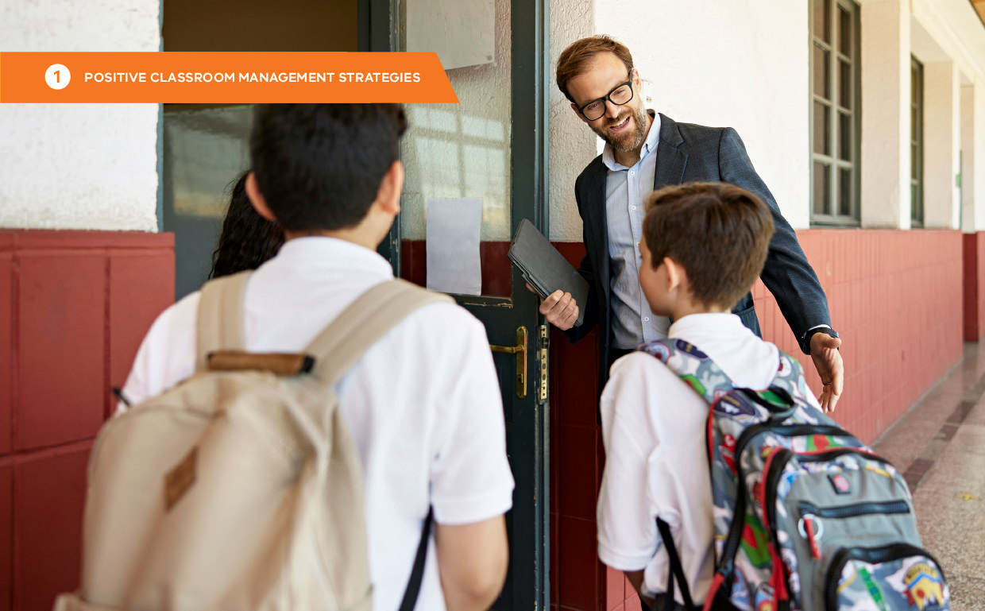

# Practice 2: Classroom procedures and routines

### What are classroom procedures and routines?

Procedures describe the steps needed to successfully accomplish a classroom activity. They break down behaviour expectations and rules into smaller, teachable steps. Classroom procedures make it clear how things operate in specific classrooms. Examples include where and how to hand in work, where to get necessary materials, or how to store personal items.

When classroom procedures are well established, taught and practised, they become routines. The table below describes the relationship between procedures and routines.

Common examples of classroom procedures and routines include:

* handing out/collecting materials
* entering/exiting the classroom
* classroom attention signal
* whole class activities
* small group activities
* independent work
* use of electronics
* transitions
* lining up
* getting teacher assistance
* greeting visitors.

|  |  |
| --- | --- |
| **Procedures** | **Routines** |
| * Procedures break down rules into teachable processes and routines; they are the steps we take to complete a task. * They explain the accepted process for carrying out a specific activity. | * Routines are the habits we form by repeating the same set of steps over and over. * Clear procedures form routines, the regular behaviours that help students meet expectations as stated in school-wide and classroom rules. * Routines develop from consistent teaching and practise of procedures. |

### Defining and teaching classroom procedures

Student learning is enhanced by basic classroom structures such as procedures and routines (BROPHY, 2006). When clear routines are in place and consistently used, students are more likely to be engaged with school learning and less likely to demonstrate problem behaviour.

Routines free up students’ working memory and reduce cognitive load so that instead of dedicating their focus on day-to-day tasks like sitting or transitioning between activities, they can focus on the intended learning of the lesson (LEINHARDT, WEIDMAN, & HAMMOND, 1987).

There are many other benefits of establishing classroom procedures and routines:

|  |  |  |  |
| --- | --- | --- | --- |
| **Increased instructional time** | **Improved classroom climate** | **Shared ownership of the classroom** | **Improved student self-management** |
| Procedures show students how to behave, minimising the amount of non-academic time and increasing time for academic instruction. | When we take time to explain how things are to be done, we appear fair and concerned. Students  then experience higher success rates and satisfaction, ensuring a positive learning environment. | Students are empowered when we involve them in the management of the learning environment. It helps them to feel a partnership for their success and that of others. | Procedures provide students with productive work habits that lead to personal accountability and effectiveness later in life. |

Establishing classroom routines and procedures early in the school year helps to create a structured and predictable environment for students.

### Getting started

##### Step 1: List procedures to prioritise

Make a list of procedures that would help create predictability and structure in your classroom. Consider problem areas or problem times. Below are some common examples of classroom procedures and routines you can consider to get started.

|  |  |
| --- | --- |
| **Setting** | **Examples** |
| **Room areas/use** | * Student desks, tables, storage areas * Learning centres, stations * Teacher’s desk, storage * Drinking taps, sink, toilets, pencil sharpener |
| **Small group activities** | * Moving into and out of the group * Bringing materials to a group * Expected behaviour of students in the group * Anticipated behaviour of students not in the group |
| **Whole class activities** | * Participating * Listening to/responding to questions * Paying attention during the presentation * Handing out/collecting papers, books, supplies * Indicating when you understand * Asking a question |
| **Seatwork** | * Getting to work immediately * Talking among students * Getting help * Out-of-seat policy * Activities after completing work * Handing in work * Keeping your desk orderly * Placing name and headings on papers |
| **Other procedures** | * Beginning the day/class * Ending the day/class * Relief teachers * Office referrals * Student conduct during delays/interruption * Leaving/returning to the room * Handing out playground equipment * When visitors are in the classroom * Submitting homework |
| **Consider the whole-school approach for the following** | * Going to the office * Walking in the corridor during class time * Toilets * Being dismissed at end of class * Responding to emergencies * Entering the classroom * When you are late * When you are absent * Going to assemblies |

(WONG & WONG, 2005; EVERTSON & EMMER, 2008).

##### Step 2: Write the steps to each procedure

These are the steps you will teach and practise. Make each step comply with the OMPUA guidelines (Observable, Measurable, Positively stated, Understandable and Always applicable).

Below are examples of and non-examples of procedures:

|  |  |  |
| --- | --- | --- |
| **Example arrival routine (primary school)** | **Example session routine (secondary school)** | **Non-examples** |
| * Hang up coat and backpack * Put notes and homework in the ‘In’ basket * Sharpen two pencils * Go to the desk and begin the warm-up activities listed on the board * If you finish early, read a book | * Complete warm-up activity with students * Review previous content * Provide instruction for new material * Provide opportunities for guided or independent practice * Participate in reflection / wrap up activities | * Assume students will automatically know your routines and procedures without instruction and feedback * Omit tasks * students are regularly expected to complete * Miss opportunities to provide (a) visual and auditory * reminders to students about your routines and procedures (e.g., signs, posters, pictures, hand signals, certain music playing, timers) and/ or (b) feedback about student performance |



### Component skills

* + Consider the component skills needed. For example, the unpacking process requires the ability to zip and unzip a bag.
  + Some students will need extra support and teaching to perform these tasks. For example, low vision learners may require adjustments to access warm-up activities written on the board.

##### Step 3: Teach classroom procedures directly

Procedures must be taught and practised to become routines. The best time to teach procedures is before they are needed. Teach at the beginning of the year and throughout year whenever a new procedure is needed.

When teaching a new skill, consider including the following elements:

|  |  |
| --- | --- |
| **Tell** | Introduce the procedure and why it is important. |
| **Show** | Teacher or other student models the steps.  Teachers may also demonstrate non-examples as appropriate. |
| **Practise** | Allow students to practise the procedure – preferably in the context where it is to be demonstrated. |

Once the skill has been acquired, help students to make the behaviour into a habit:

|  |  |
| --- | --- |
| **Pre-correction/ reminding** | Anticipate when the skill will be needed and remind students ahead of time. |
| **Supervise** | Move, scan and interact with students. |
| **Feedback** | Observe student performance and give positive specific feedback to students. Acknowledge students when they demonstrate the skills correctly. |
| **Re-teach** | Practise throughout the day and re-teach as needed. |



### ‘Booster’ lessons

* + Booster lessons are taught periodically to help students maintain skills over time.
  + Use the *Maintenance ‘booster’ lesson plan* in Appendix 2 to help your planning.

##### Step 4: Create visual reminders

Consider using posters with student-friendly language to provide both staff and students with a visual reminder of classroom procedures.

**Lining up to exit the classroom**

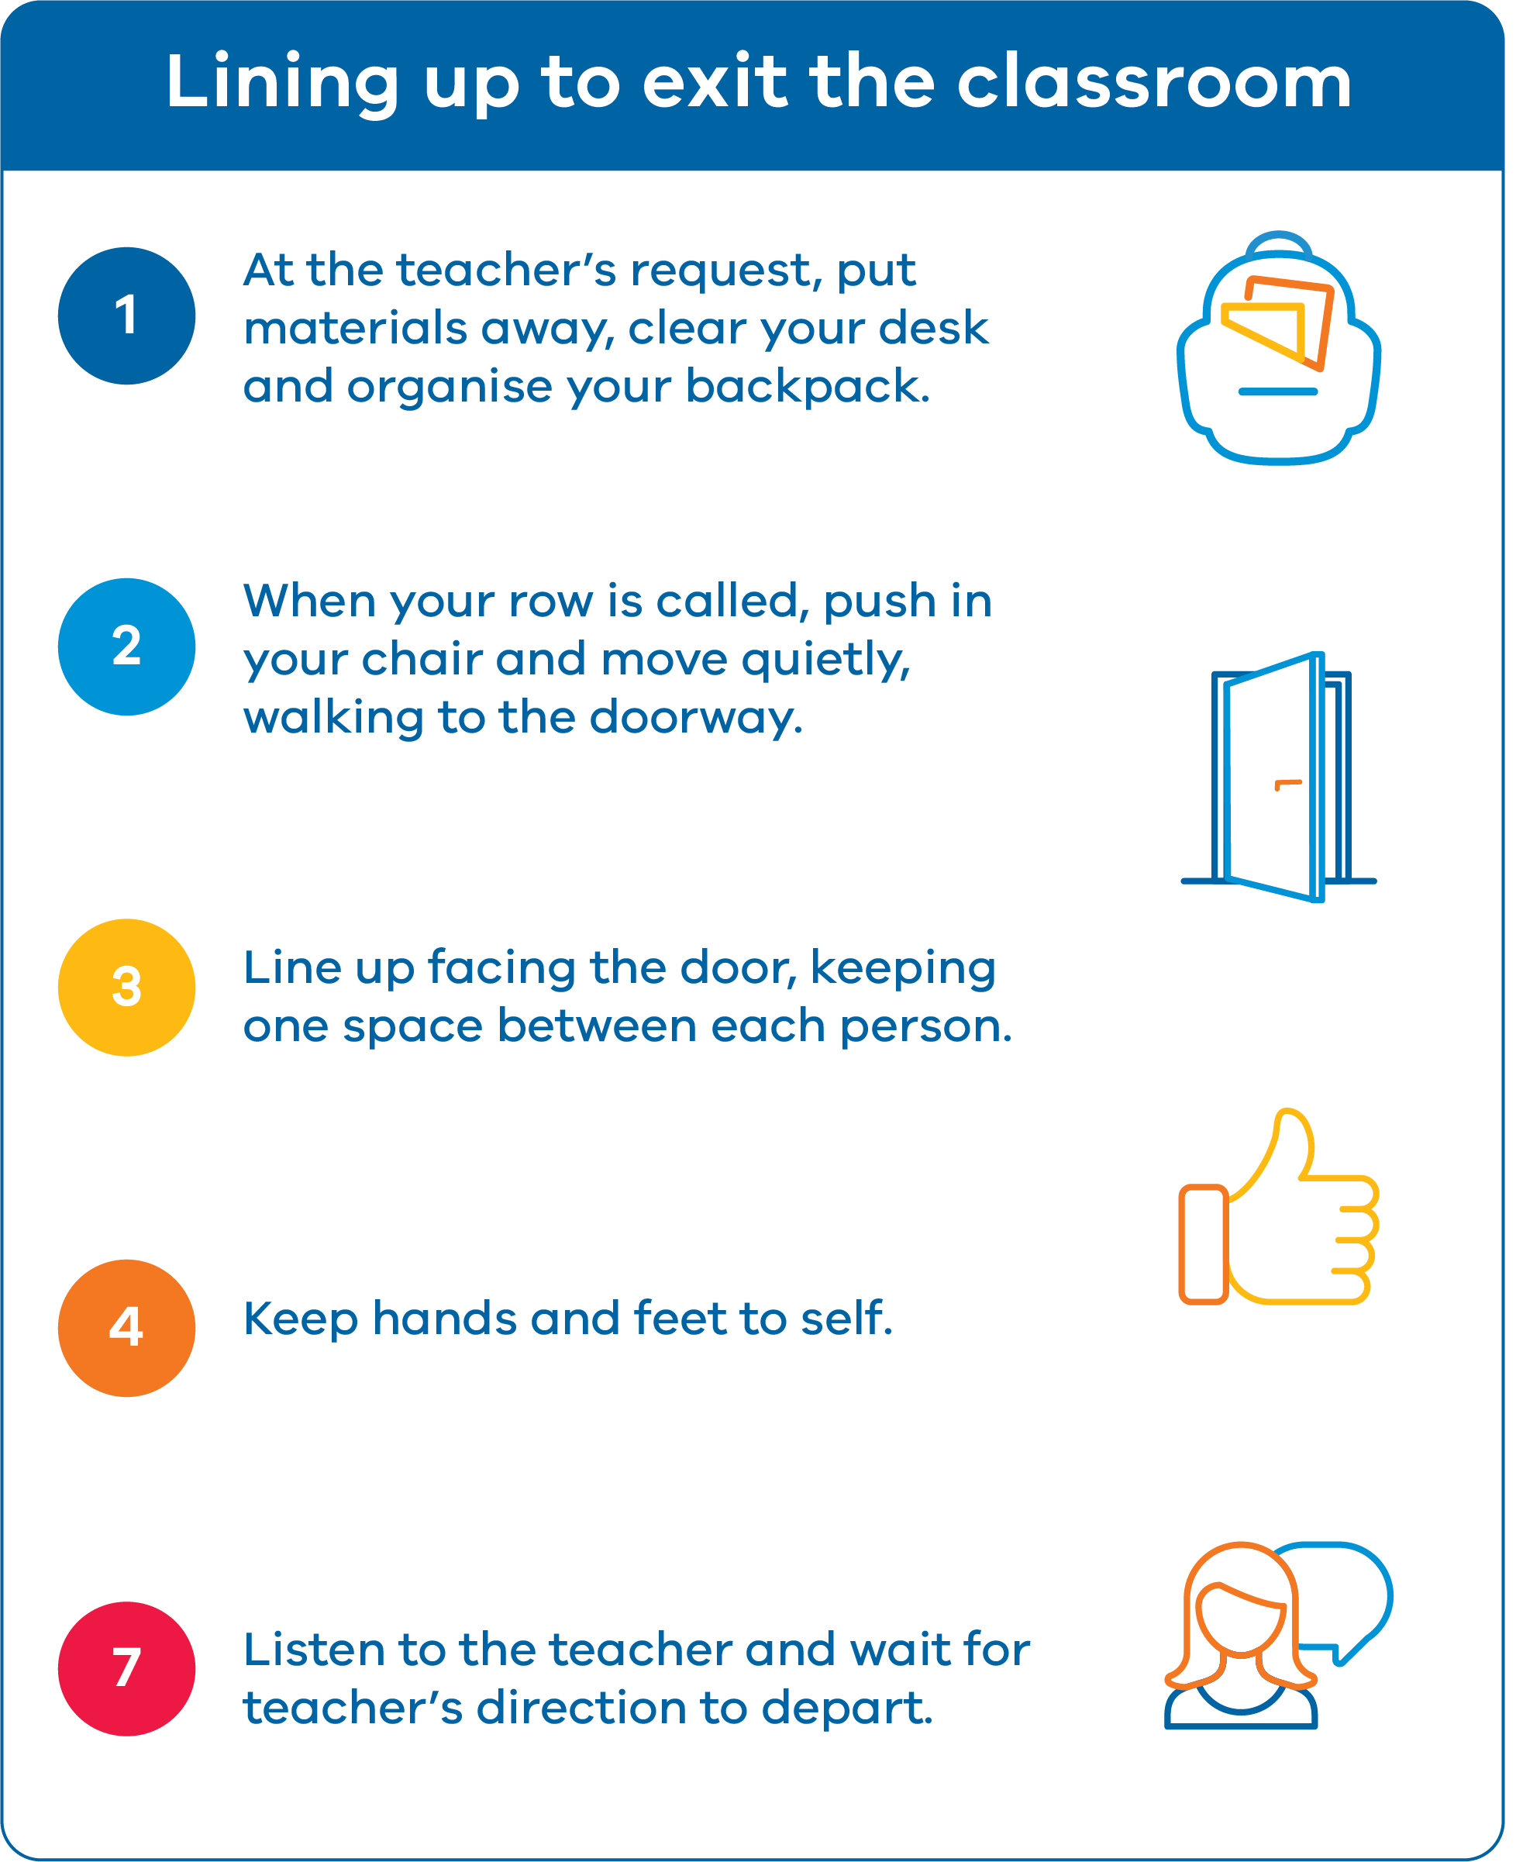

**Independent Seatwork**

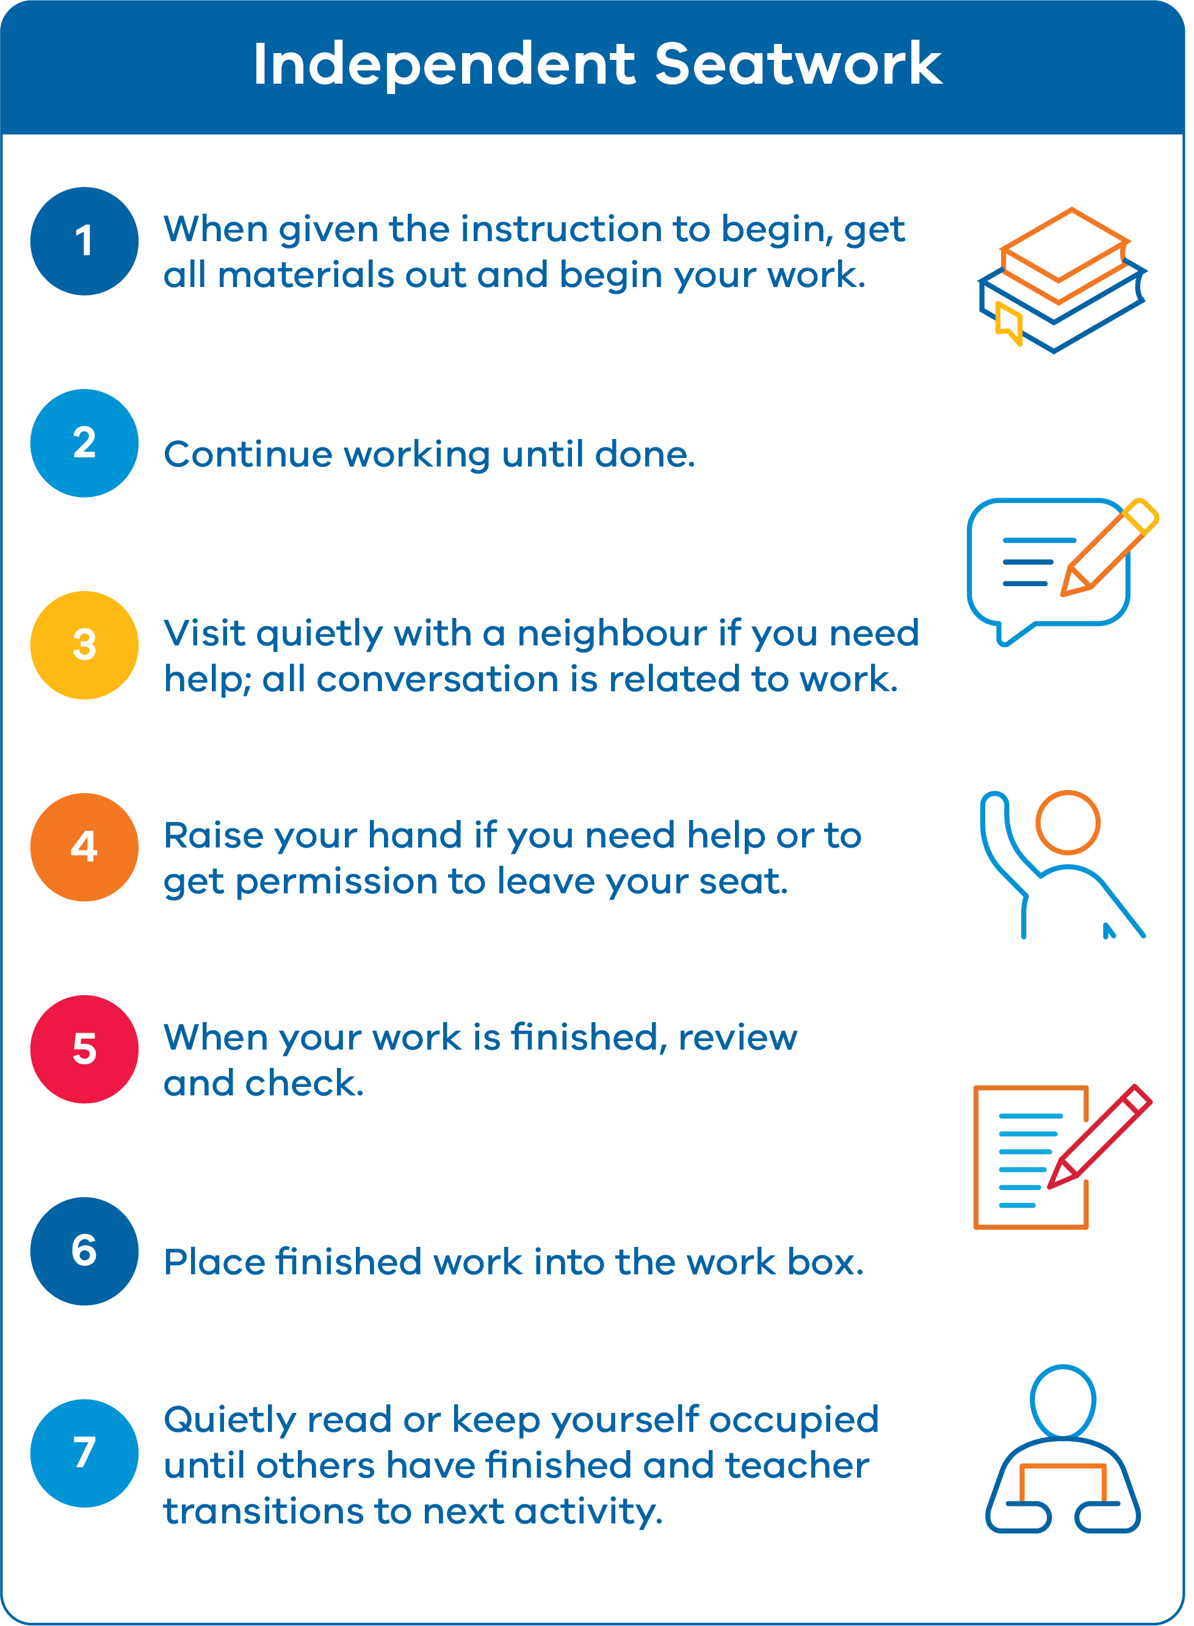

##### Step 5: Display procedures and routines alongside expected behaviour

Display expectations and rules prominently, so you can refer to them throughout the day as needed. You can also document the most important procedures and routines by adding them to the classroom matrix, as demonstrated in the example below:

|  |  |  |  |  |  |
| --- | --- | --- | --- | --- | --- |
| **School expectations** | **All routines** | **Entering and leaving the classroom** | **Small group instruction** | **Whole group instruction** | **Independent work time** |
| **Be responsible** | * Follow classroom rules and procedures. * Complete tasks and assignments on time. | * Arrive on time * Have any necessary materials and equipment | * Stay on task and contribute to the group * Follow group norms and roles | * Pay   attention and participate when appropriate.   * Follow teacher directions the first time. | * Complete and submit work on time. |
| **Respect others** | * Listen actively when others are speaking. * Use polite language and gestures. | * Greet others politely and quietly. * Wait your turn and enter/exit quietly | * Use quiet voices to not disturb other groups. | * Raise your hand and wait to be called on. * Show appreciation for others’ contributions. | * Work quietly and respect others’ need for a quiet space. |
| **Care for the environment** | * Use resources wisely to avoid waste * Keep your area and the classroom clean | * Recycle any waste and pick up litter. | * Share materials and equipment and use them appropriately | * Dispose of rubbish and return   property and equipment its place | * Use materials only as needed and avoid wasting resources. * Clean up your workspace after finishing tasks. |
| **Classroom Routines and Procedures** | | | | | |
| **Classroom entry** | **Attention signal** | **Classroom interruptions** | **Asking for help** | **Classroom departure** | **Cleaning up** |
| * Gather necessary materials * Find and take your seat * Begin warm up activity | * Teacher says “ Class, class” * Students say “Yes, yes” * Put down equipment * Look at the teacher * Wait for instructions | * Stop and listen * Focus on teacher * Follow instructions | * Pause and asses * Use classroom resources * Ask a peer * Raise a hand * Prepare to explain * Listen and apply | * Return materials * Clear desk * Organise bag * Push in chair * Wait for directions | * Gather materials * Clear common areas * Dispose of waste properly * Check for forgotten items * Final inspection * Return to seats |

### Self-assessment: Classroom Procedures and Routines

|  |  |  |  |
| --- | --- | --- | --- |
| **Self-assessment feature** | **Yes** | **No** | **In progress** |
| I have identified essential classroom procedures, and all meet OMPUA. |  | | |
| My classroom procedures are prominently posted. |  | | |
| I directly teach classroom procedures. |  | | |
| I review and practise classroom procedures regularly throughout the school year. |  | | |
| Students receive high rates of specific positive feedback when they follow classroom procedures. |  | | |
| At least 80% of my students can tell and demonstrate the classroom procedures. |  | | |