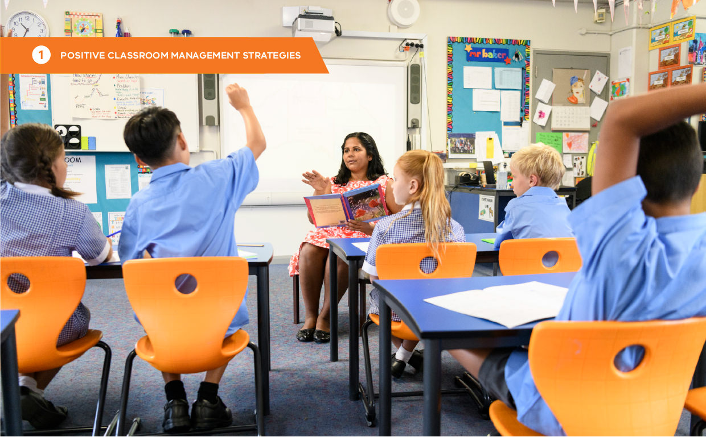

# PART 1: POSITIVE CLASSROOM MANAGEMENT STRATEGIES

# Practice 1: Classroom behaviour expectations and rules

### What are behaviour expectations?

Behaviour expectations are broad goals for behaviour, or the general ways we would like staff and students to act. They serve as guidelines for behaviour and apply to all members of the school community, across all settings.

Whenever possible, behaviour expectations should be developed for the entire school, providing a framework to help establish a positive school culture.

### How behaviour expectations and rules are related

Behaviour expectations are often broad concepts and can be too abstract for many students to grasp effectively. That is why we create rules. Rules help clarify how behaviour expectations are applied in different situations. Rules define the specific skills or behaviours students will need to demonstrate. These behaviours should be concrete, observable, and measurable and may vary depending on the setting (e.g., classroom, canteen, sports field).

Teachers can use a matrix to plan and organise rules that reflect each behaviour expectation, demonstrating how it can look in different contexts. For example, being responsible might involve walking directly to a destination when entering and exiting the classroom. However, during independent work time and whole group instruction, being responsible will look different.

The example matrix below shows how rules can be anchored to broad behaviour expectations.

|  |  |  |  |  |  |
| --- | --- | --- | --- | --- | --- |
| **School expectations** | **All routines** | **Entering and leaving the classroom** | **Small group instruction** | **Whole group instruction** | **Independent work time** |
| **Be responsible** | * Give your best effort * Ask for help when you need it | * Walk * Go directly to your destination | * Have a go * Bring the necessary materials to class | * Engage with the lesson * Take notes | * Make a plan * Read or listen to directions * Focus on your work |
| **Respect others** | * Keep your hands, feet and objects to self * Help   others at appropriate times | * Use ‘inside’ voice * Enter through the door on the left | * Include others * Share equipment | * Raise your hand to share | * Limit noise * Focus only on your task |
| **Care for the environment** | * Recycle * Clean up after self * Leave the space better than you found it | * Put litter in the bin | * Leave group materials at the table * Use materials carefully | * Sit in your seat safely * Have necessary materials ready | * Return materials * to their proper place after use |

### The importance of behaviour expectations and rules

Clear expectations for behaviour are the foundation of effective classroom management. Rules provide clarity on the behaviours that align with our shared values. Research shows that clarifying and teaching rules can decrease problem behaviours and increase student engagement. Increased structure helps students engage with instructional tasks (BROPHY, 1998).

* Teaching rules and routines to students at the beginning of the year and enforcing them consistently increases student academic achievement and task engagement (EVERTSON & EMMER, 2008; JOHNSON, ET AL., 1996).
* Clearly stating expectations and consistently supporting them increases teacher credibility (BROPHY & GOOD, 2000).

By clarifying, teaching and encouraging expected behaviour, teachers assist all students to achieve academic success and social competence.

### Getting Started

##### Step 1: Identify behaviour expectations

Connect classroom rules and expectations to school-wide expectations whenever possible. The example on the previous page demonstrates the expectations ‘Be responsible’, ‘Respect others’, and ‘Care for the environment’. When students demonstrate appropriate behaviour, such as putting away equipment, you can express appreciation and point it out as an example of being responsible. This helps clarify to students what we mean when we ask them to be responsible.

If your school has not established behaviour expectations, you can select three to five class-wide expectations instead. Consider how you will involve student voice in the process. Expectations need to be meaningful and relevant for students. Expectations should be few in number, but broad enough to support teaching and discussion about any relevant behaviour – expected or otherwise. Below are some options to consider.

|  |  |  |  |  |  |
| --- | --- | --- | --- | --- | --- |
| **Some valued behaviours** | | | | | |
| Accepting | Authenticity | Belonging | Caring | Commitment | Community |
| Compassion | Confident | Collaboration | Cooperation | Courage | Dedication |
| Effort | Excellence | Hardworking | Helpful | Honesty | Inclusivity |
| Integrity | Learning | Participation | Persistence | Polite | Productive |
| Respectful | Responsible | Safe | Supportive | Tolerance | Welcoming |

##### Step 2: List contexts where behaviour problems are likely

Identify the classroom learning contexts where your students are most likely to need support. These will vary depending on age, the needs of the school community, individual students, and the subject you teach. The examples below are appropriate for many classrooms, but may need adjustments for your situation:

Learning contexts examples:
1. During transitions, 2.  Whole group, 3. Small group, 4. Independent work, 5. Needing help, 6. At all time

##### Step 3: Write positively-stated rules

* Develop a small number (between 2-5) of positively stated behaviours (rules) for each context (use OMPUA).
* Create rules collaboratively with students

|  |  |
| --- | --- |
| **Guideline** | **This means** |
| **Observable** | I can see it |
| **Measurable** | I can count it |
| **Positively stated** | Focus on what students need to do |
| **Understandable** | The vocabulary is appropriate for the students I teach |
| **Always applicable** | Appropriate and inclusive of your students, can be applied at all times |

The table below shows some examples and non-examples of rules written using the OMPUA guidelines.

|  |  |  |
| --- | --- | --- |
| **Guideline** | **Meets OMPUA** | **Not OMPUA** |
| **Observable** | Use positive self-talk when working | Think positively |
| **Measurable** | Bring book, pens, calculator and ruler to class | Be ready to learn |
| **Positively stated** | Move safely (e.g. walk) | No running |
| **Understandable** | Keep your body and materials to yourself | Maintain adequate personal space |
| **Always applicable** | Stay in your assigned area | Remain seated unless given permission to move |

##### Step 4: Develop a matrix of expectations

Populate the matrix with the behaviours (rules) your students would demonstrate to be successful in the classroom. These are the skills you will teach explicitly.

|  |  |  |  |  |  |  |  |
| --- | --- | --- | --- | --- | --- | --- | --- |
| **School expectations** | **Always** | **Entering and leaving the classroom** | **Small group instruction** | **Whole group instruction** | | **Independent work time** | |
| **Be responsible** |  |  |  | |  | |  |
| **Respect others** |  |  |  | |  | |  |
| **Care for the environment** |  |  |  | |  | |  |

##### Step 5: Display and teach expectations and rules

Once developed, expectations and rules should be prominently displayed. They should be visible to support staff and students throughout the day. You should plan to directly teach the rules described in your matrix. Consider the following questions:

* How will you make behaviour expectations and rules visible?
* How and when will the skills be taught?
* Which skills should be taught first?
* How will you revise and re-teach the skills throughout the year?
* How will you acknowledge students that perform the skills correctly?
* How will ensure all skills are taught? How will you monitor success (i.e., how will you know when at least 80% of students demonstrate mastery of the skill)?

Use the *Behaviour skills acquisition lesson template* in Appendix 1 to guide planning.



### Classroom expectations and rules

* + Focus on what you want to see
  + Relate to behaviours that can be seen or heard; counted or timed.
  + Use developmentally appropriate language and visuals (where relevant).
  + Display them for easy reference.
  + Should be as inclusive as possible – consider all learners

### Self-assessment: Classroom Behaviour Expectations and Rules

|  |  |  |  |  |  |
| --- | --- | --- | --- | --- | --- |
| **Self-assessment feature** | **In place** | **Partially in place** | | | **Not in place** |
| My classroom rules are anchored to a small number of expectations (three to five). |  | |  |  | |
| My classroom rules are Observable, Measurable, Positively stated, Understandable and Always applicable (OMPUA). |  | |  |  | |
| My classroom expectations/ rules are visible throughout the space. |  | |  |  | |
| I refer to rules regularly when interacting with students. |  | |  |  | |
| I plan to ensure classroom rules are taught and revisited throughout the year (including for new students). This is reflected in my curriculum planning documentation. |  | |  |  | |
| 80% of my students can tell the classroom expectations and rules. |  | |  |  | |
| Students receive high rates of specific positive feedback when they follow classroom procedures. |  | |  |  | |