Sample Personal Emergency Evacuation Plan (PEEP)

What is a PEEP?
A Personal Emergency Evacuation Plan (PEEP) is a practical measure to ensure appropriate actions are taken for an individual in the event of an emergency, where that person requires additional or specific assistance to evacuate a building or premises.

Who needs a PEEP?
A PEEP is recommended for employees who may need assistance in the event of an emergency due to:
- Mobility impairment
- Hearing impairment
- Visual impairment
- Cognitive impairment
- Temporary condition (medical condition or short-term injury)
Where a child has additional needs or needs that are not accommodated by the evacuation procedures for the other children in the facility, the sample form can be modified as required.

How is a PEEP used?
The role of PEEPs is to ensure that planning is completed for the individual and the buddy/ assistant on the process to evacuate in an emergency situation. While a PEEP is not mandatory for employees, it is highly recommended to develop one if an individual requires assistance to evacuate in emergency situations. PEEPs are rehearsed, and if necessary adjusted as a part of the facility’s overall emergency drills/exercises – PEEPs are not intended to be used for reference in the actual emergency situation.
The plan should outline the specific procedure to be followed in the event an evacuation is triggered and will also state the designated person(s) who will provide assistance (buddy/ assistant) during the evacuation. This is a sample template and can be tailored to suit the individual’s circumstances.

Who receives a copy of a PEEP?
Once completed, a copy of the PEEP should only be shared by the relevant officer-in-charge (e.g. Manager, Nominated Supervisor) on a ‘need to know’ basis. This generally includes the individual (in the case of an employee), parent/carer if the PEEP is for a child, the specified buddy/assistant and the relevant warden.
To ensure compliance with the Privacy and Data Protection Act 2014 (Vic), this PEEP must be securely stored and only made accessible to the above listed audience. It should be kept separate to your facility’s Emergency Management Plan (EMP).
Where the PEEP is for a child, modify the form so the parent/carer completes the first section for completion by the Employee, and sign and receive a copy of the final agreed form as appropriate.

Personal Emergency Evacuation Plan (PEEP)
Note: This sample template is a guide only and should be used as an aid to develop or supplement your EMP. Please adapt it as appropriate to ensure relevance to your school.

This part is to be completed by the employee
Name
Location (Building/floor)
Is an assistance animal involved? Yes ☐ No ☐
Do you understand the emergency response and evacuation procedures? Yes ☐ No ☐
What type of assistance do you require?
(Describe the procedure/actions necessary to assist you, including being notified of an emergency if appropriate)

What, if any, equipment is required for evacuation?
(List the equipment e.g. mobility aid, ventilator)

This part is to be completed by the officer in charge (nominated supervisor/manager)
How will the employee receive updates to the emergency response procedures?
(E.g. text, email, Braille etc.)

How will the employee be notified of an emergency?
(E.g. visual alarm, personal vibrating device, SMS etc. or N/A)

Step by step evacuation procedure
(List the procedure agreed with the employee)
Example only
- As directed by floor warden: After main flow of evacuation, make way to the designated area or assembly point at own speed with evacuation buddy
- Evacuation route may depend on location/type of emergency: (refer to diagram on next page)
  - Closest / quickest – to Stairwell 1
  - Alternate – to Stairwell 2
- Seek refuge in emergency stairwell or other suitable location with evacuation buddy, and wait for further instruction from floor warden or emergency services on site
- If no instruction received from fire warden, call 000
- Proceed to assembly point

Is the buddy/s trained in the emergency response and evacuation procedures?
Yes ☐ No ☐
Is the buddy/s trained in the use of any required evacuation equipment?
Yes ☐ No ☐ N/A ☐
Diagram of preferred route for assisted evacuation
(Insert diagram here or attach to this form)
EXAMPLE ONLY
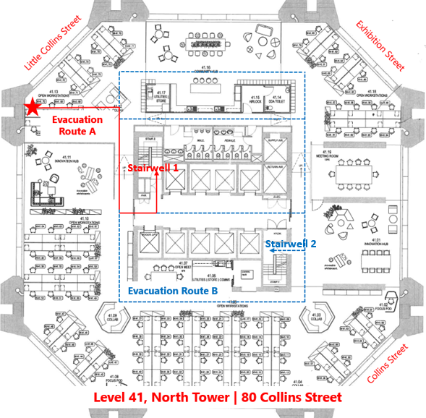

Issue/Created Date: ..... / ..... / .......... Review Date: ..... / ..... / ...........

Employee: ................................................ Date: ……./ …….../ ………
(signature)

Nominated Supervisor Name .............................................

.…………………………………….…… Date: ……./ …….../ …………
(signature)

Distribution
(Add or delete rows as required. If the PEEP relates to a child, include parent/carer in the distribution)
Name | Position Title/Role | Mobile | Email
<employee name>
<buddy name>
<supervisor in charge name>
<warden name>
<other person receiving this PEEP>

