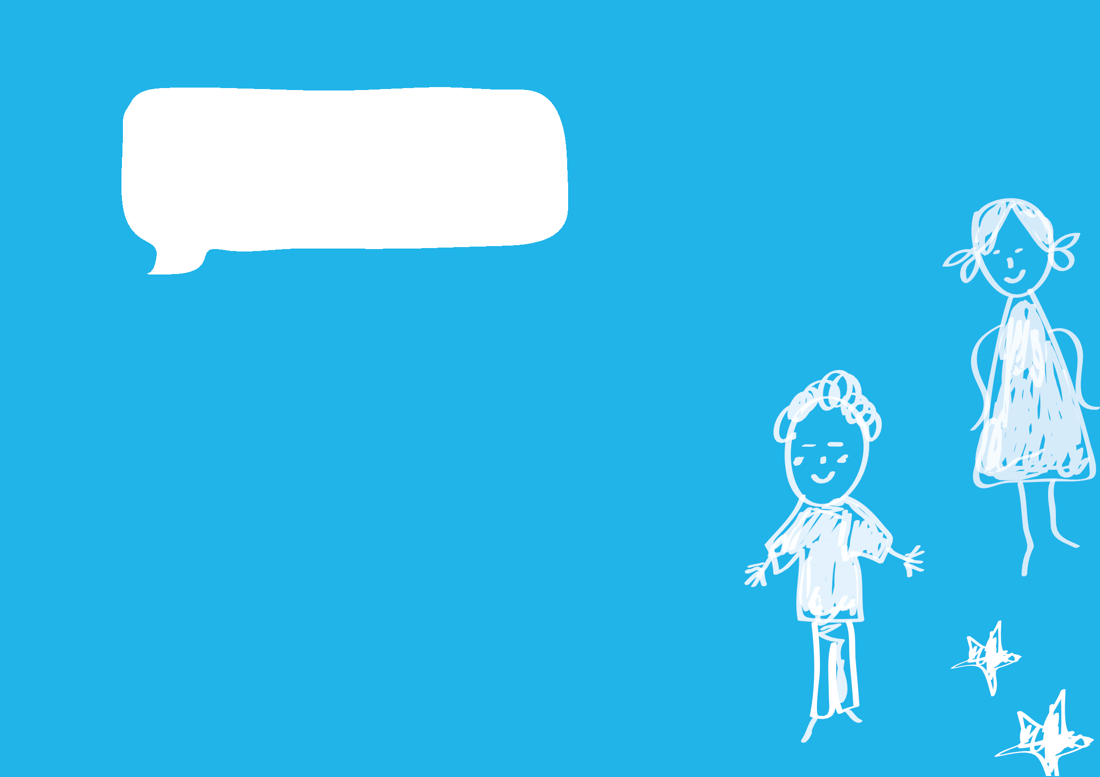

# Hello Kinder!

Starting kindergarten is a big milestone for children and families. It is important that everyone feels comfortable in their new environment. Finding ways to help children feel settled and make

smooth transitions will help them settle into their new kindergarten.

As well as communicating with children and families before and during orientation about processes, it is also helpful to provide an information booklet. The booklet can include photos and feature parts of the kindergarten children will use, such as where they will put their bag and play. It can also highlight routines such as drop-off and lunchtime.

This is an editable resource, which means that you can easily tailor it for your service and children. You can change the wording as you need, add additional pages or remove pages that you do not need. For example, long day care centres and standalone (sessional) kindergartens may have different routines around food being provided rather than packed in a lunch box. In this instance, you might choose to remove the reference to bringing a lunch box on page 11.

Try to get a photo of each child at your service on their first day or in their first week for the front page. Families will also enjoy seeing the special booklets.

Research tells us that ‘Identity is aligned with belonging, the sense of feeling included and secure in the social settings (family, community, early childhood services and schools) that are part of everyday life’ (The Victorian Early Years Learning and Development Framework).

# A speech bubble in white against solid blue background contains the words, Hello Kinder! A dotted line rectangle in the middle of the page indicates where a child's photo can be placed. Hello Kinder!

**A photo of me**

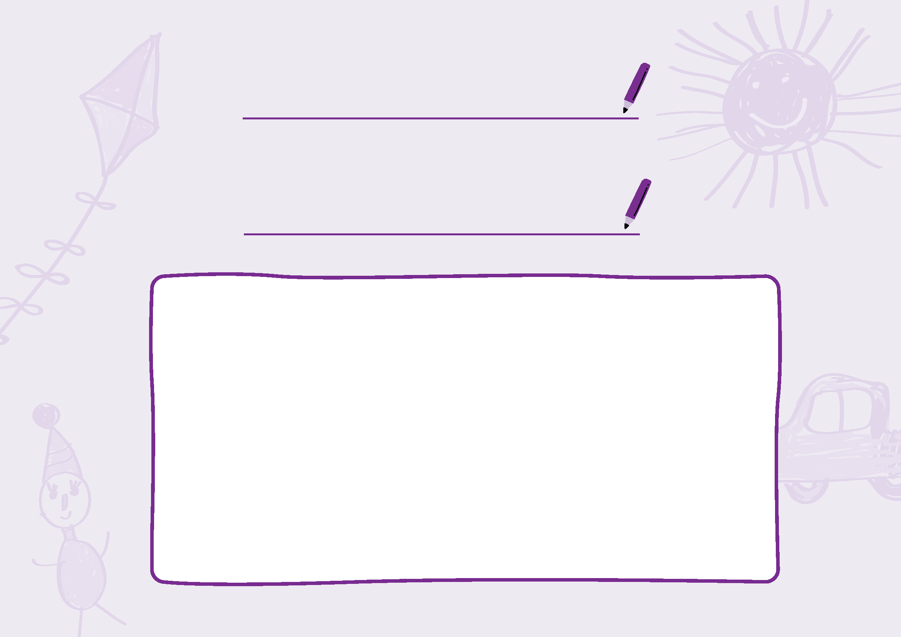**My name is**

**and I go to kinder at**

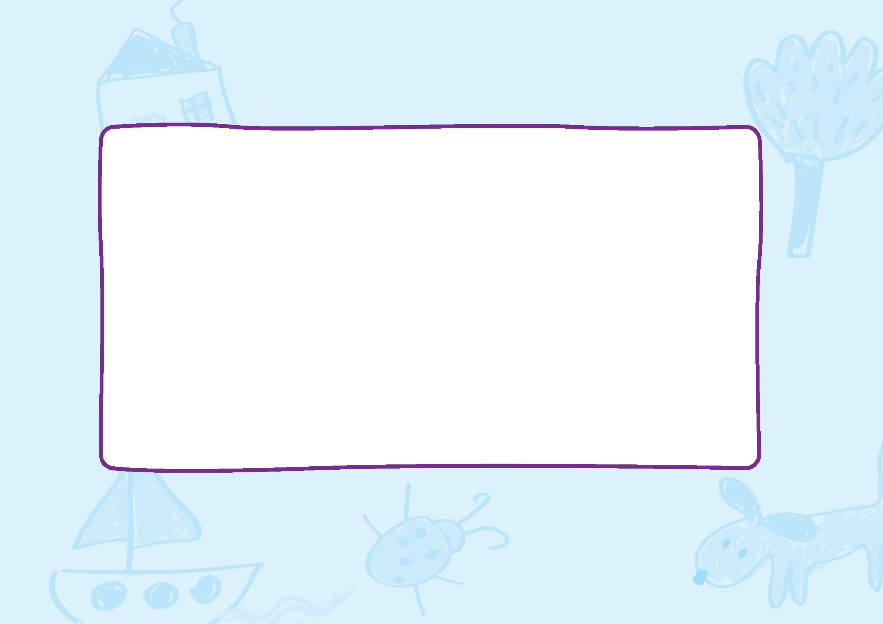**My kinder days are:**

**Monday to**

**Tuesday to**

**Wednesday to**

**Thursday to**

**Friday to**

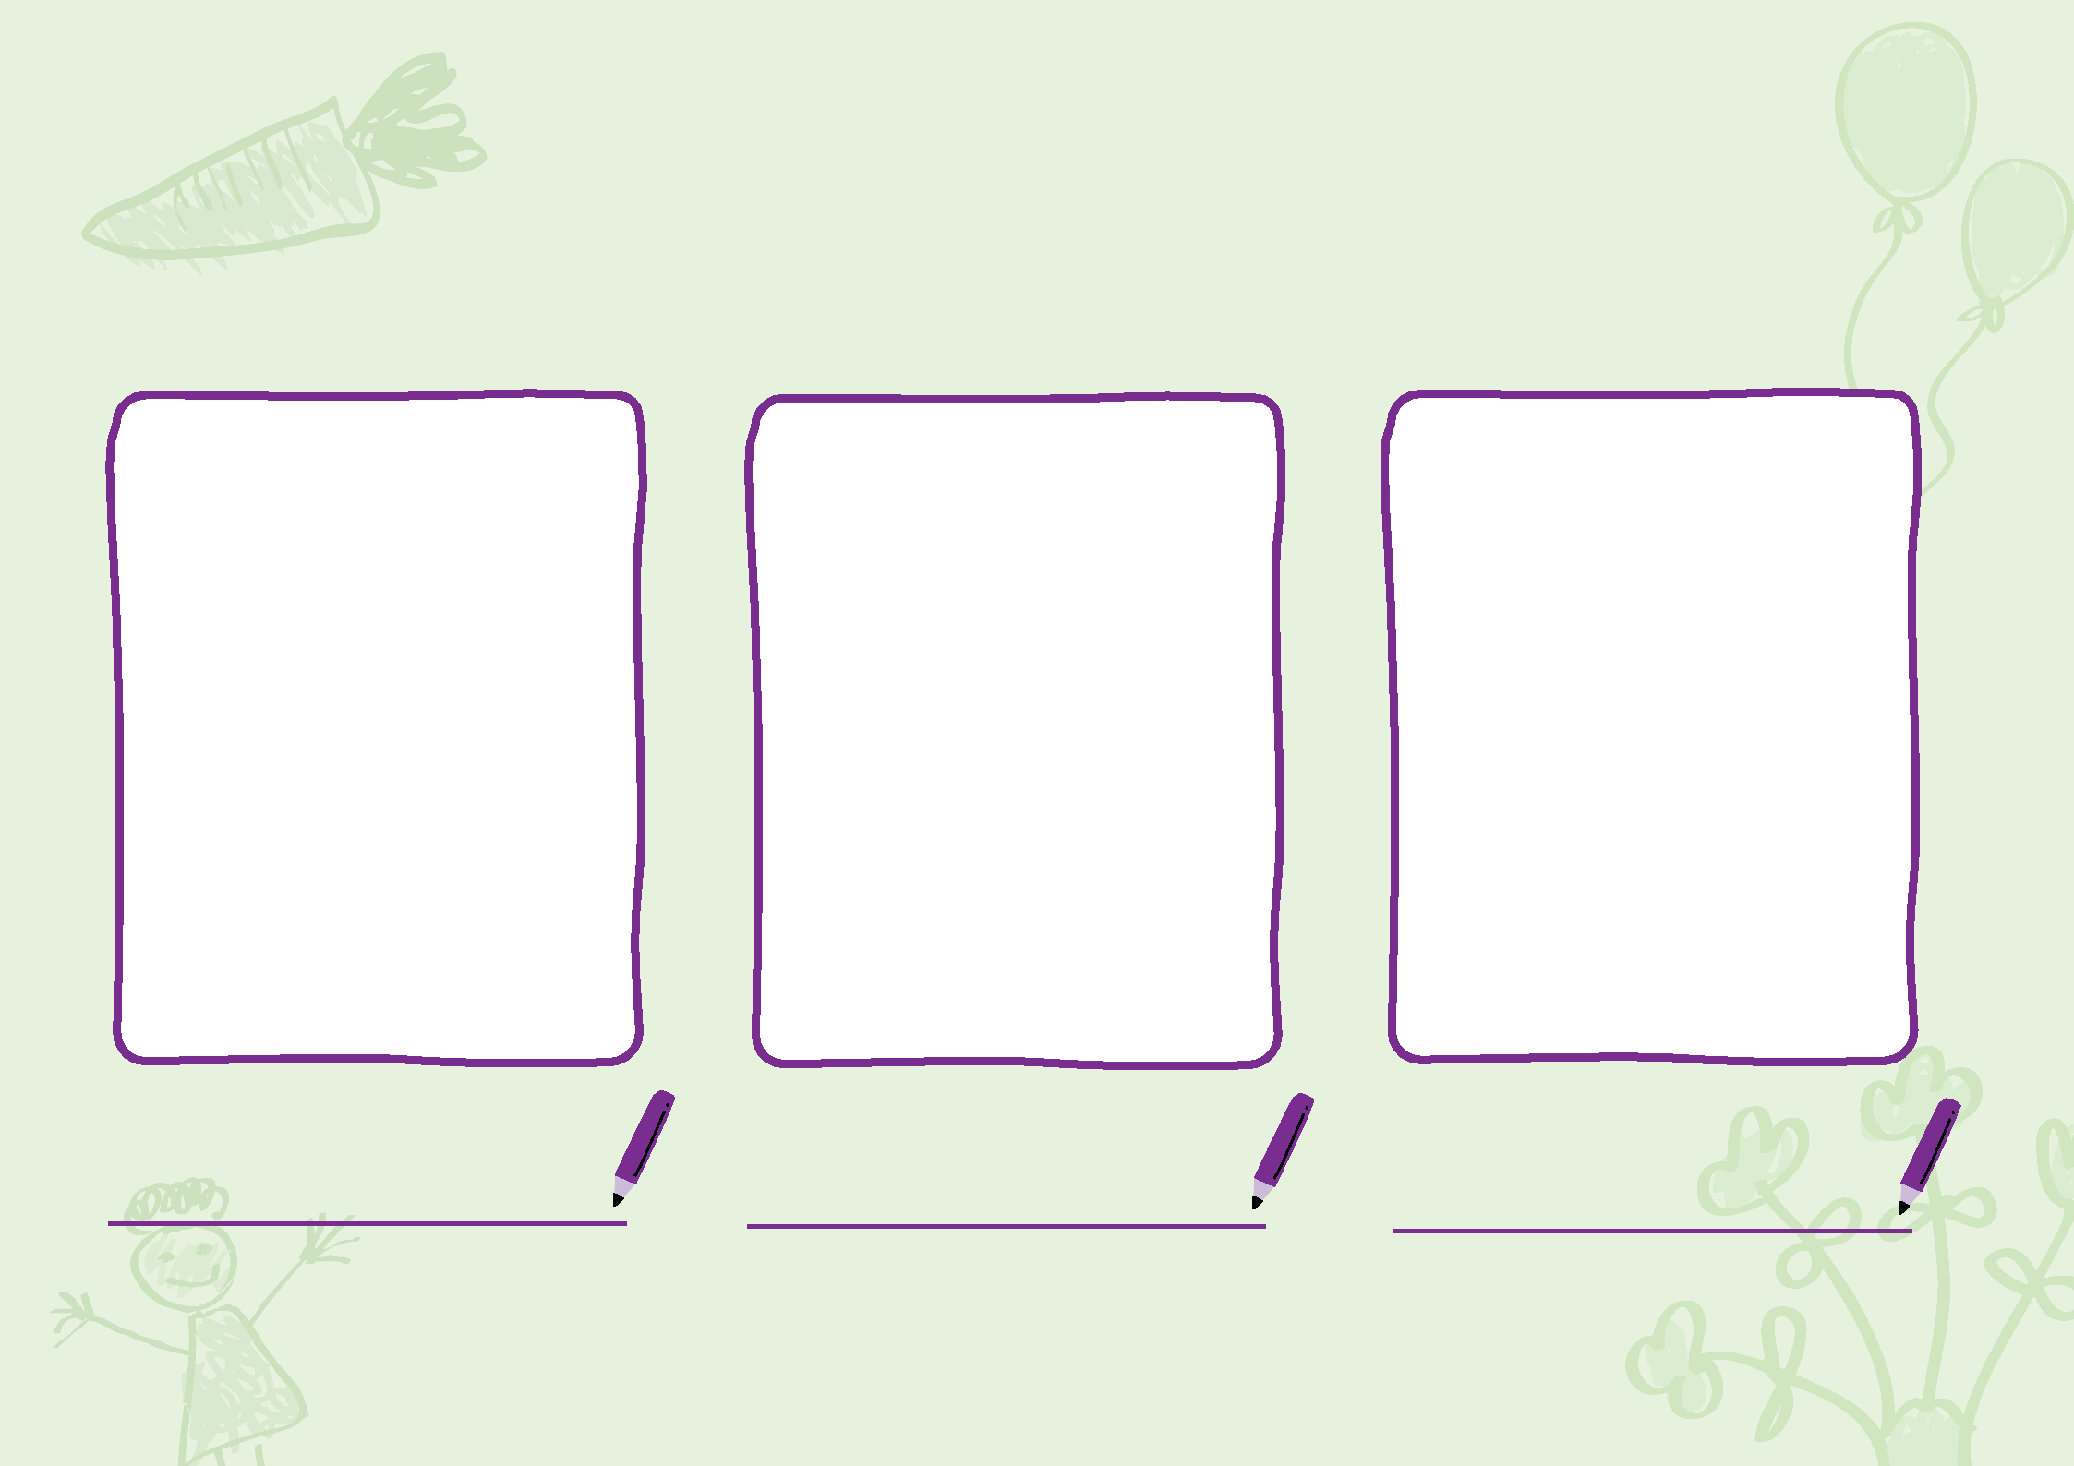**My kinder teachers are:**

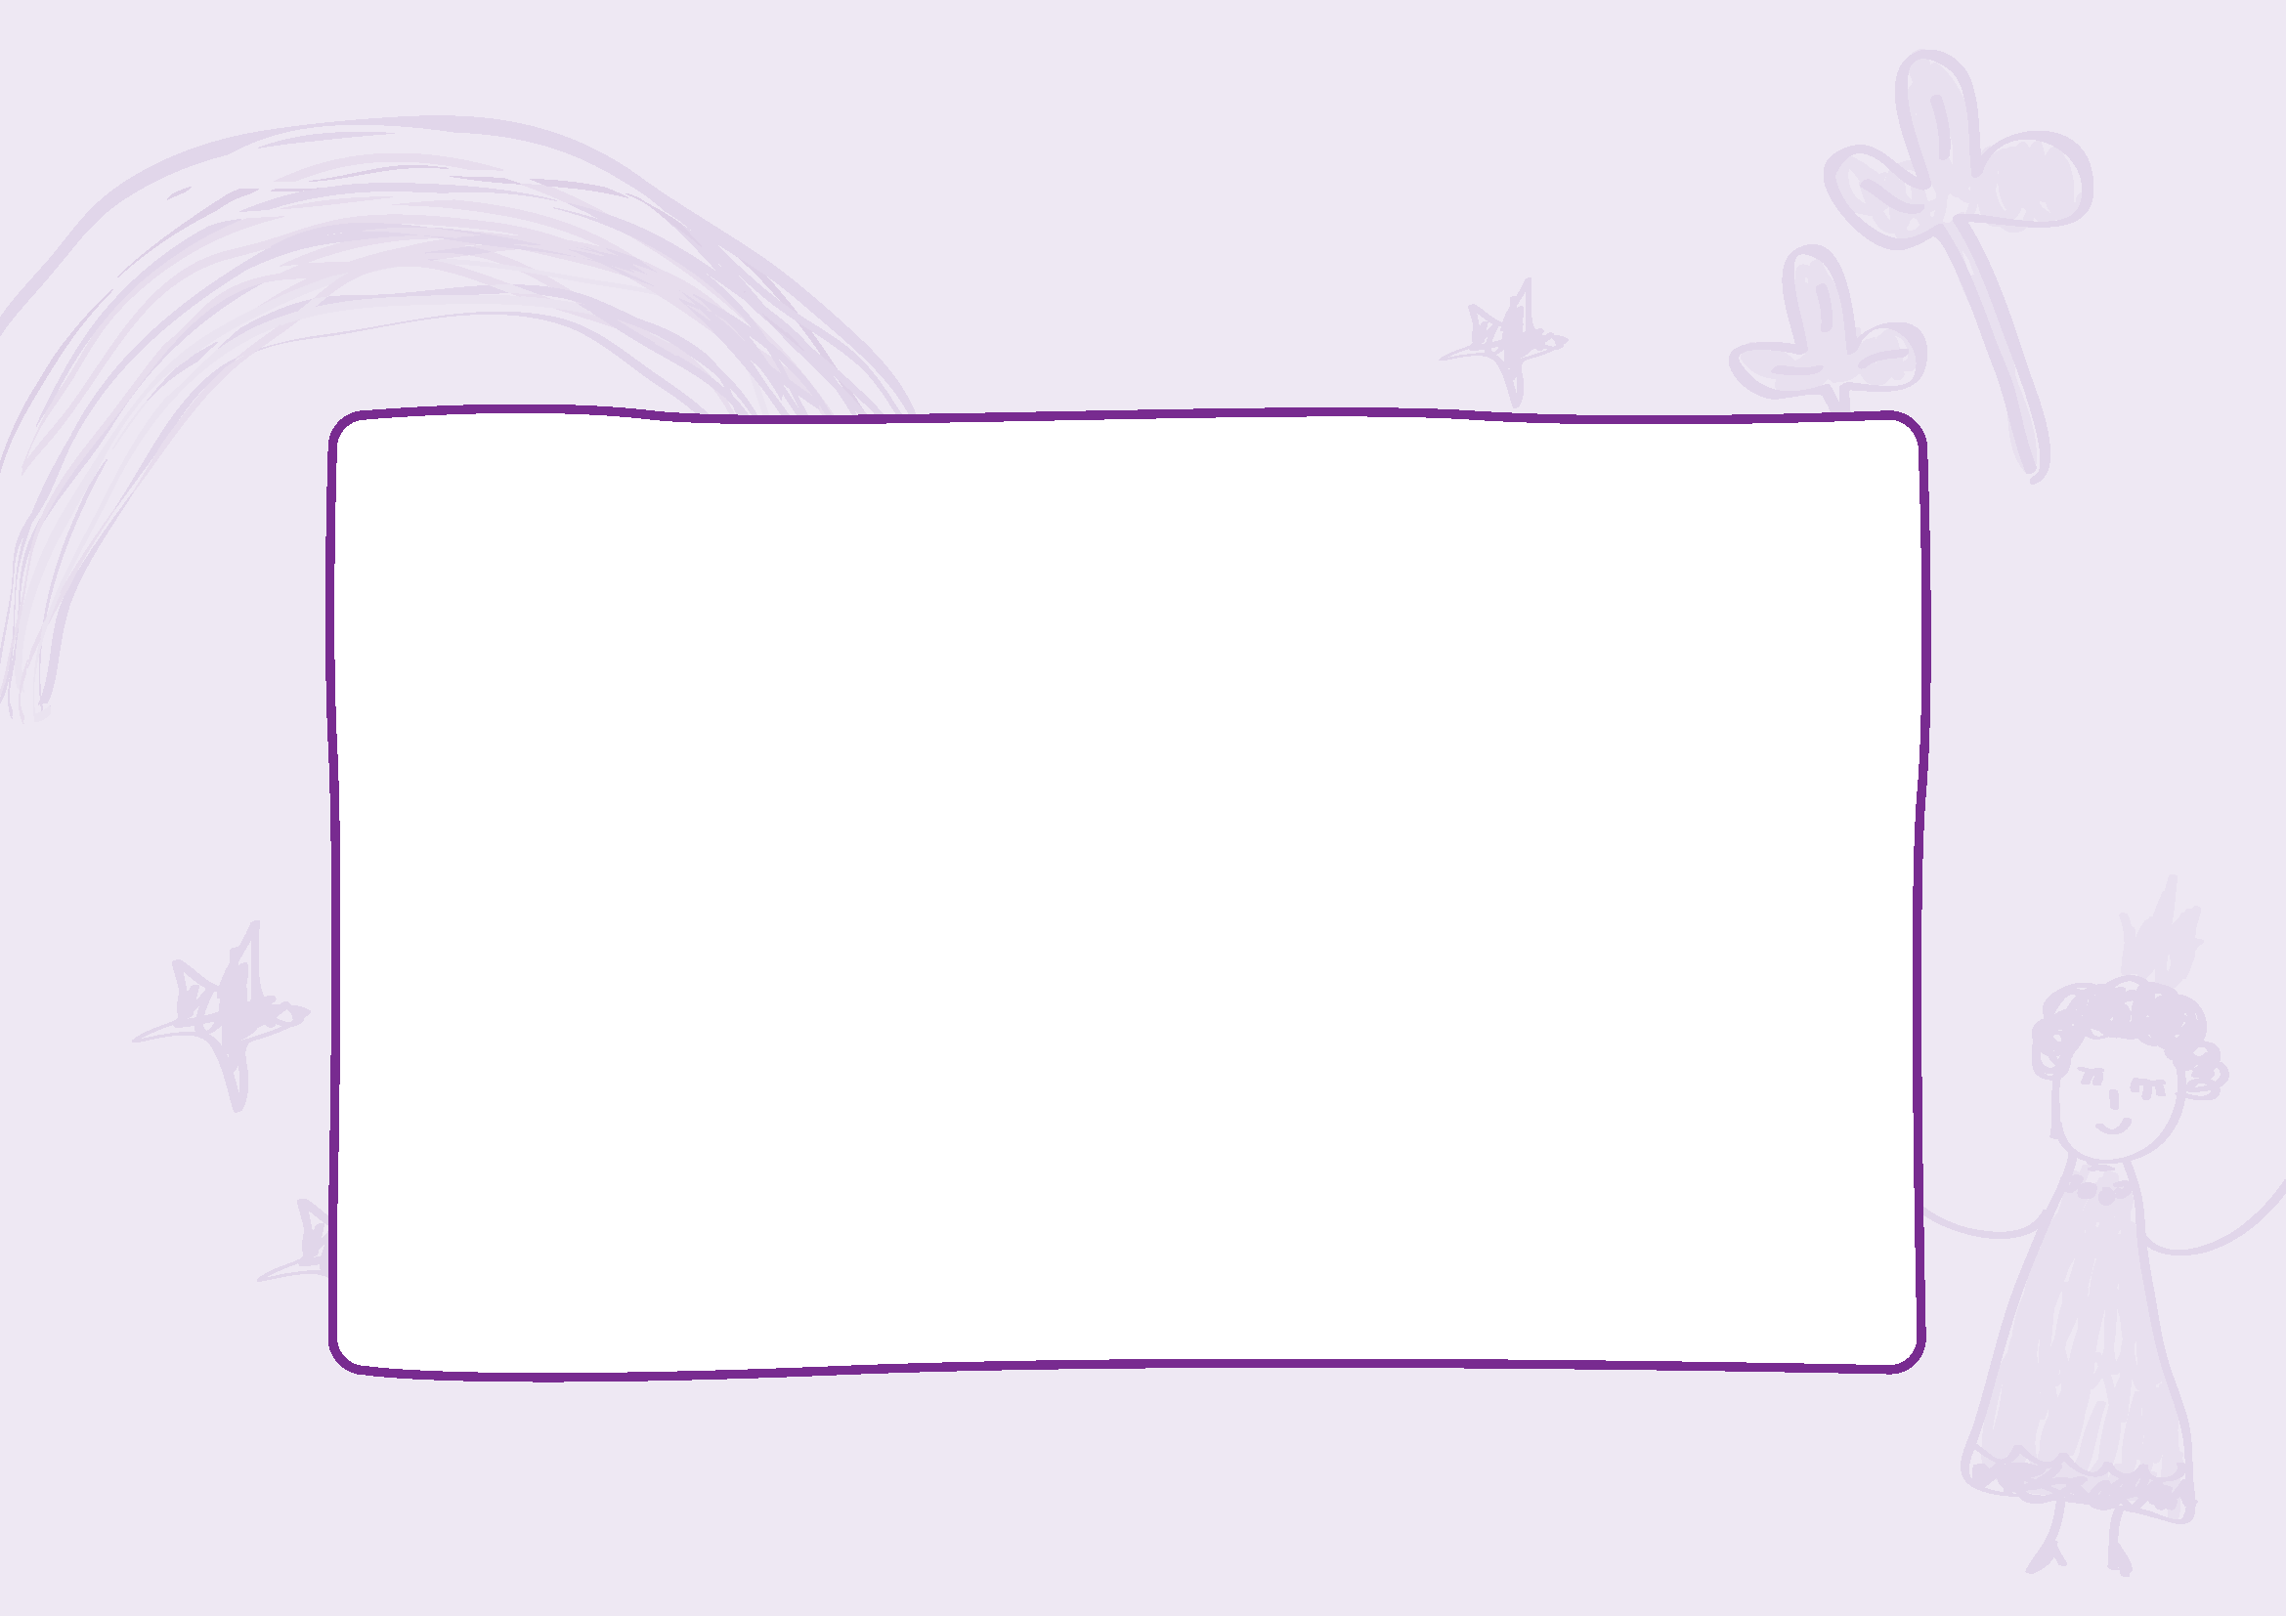**When I arrive at kinder, I put my bag here:**

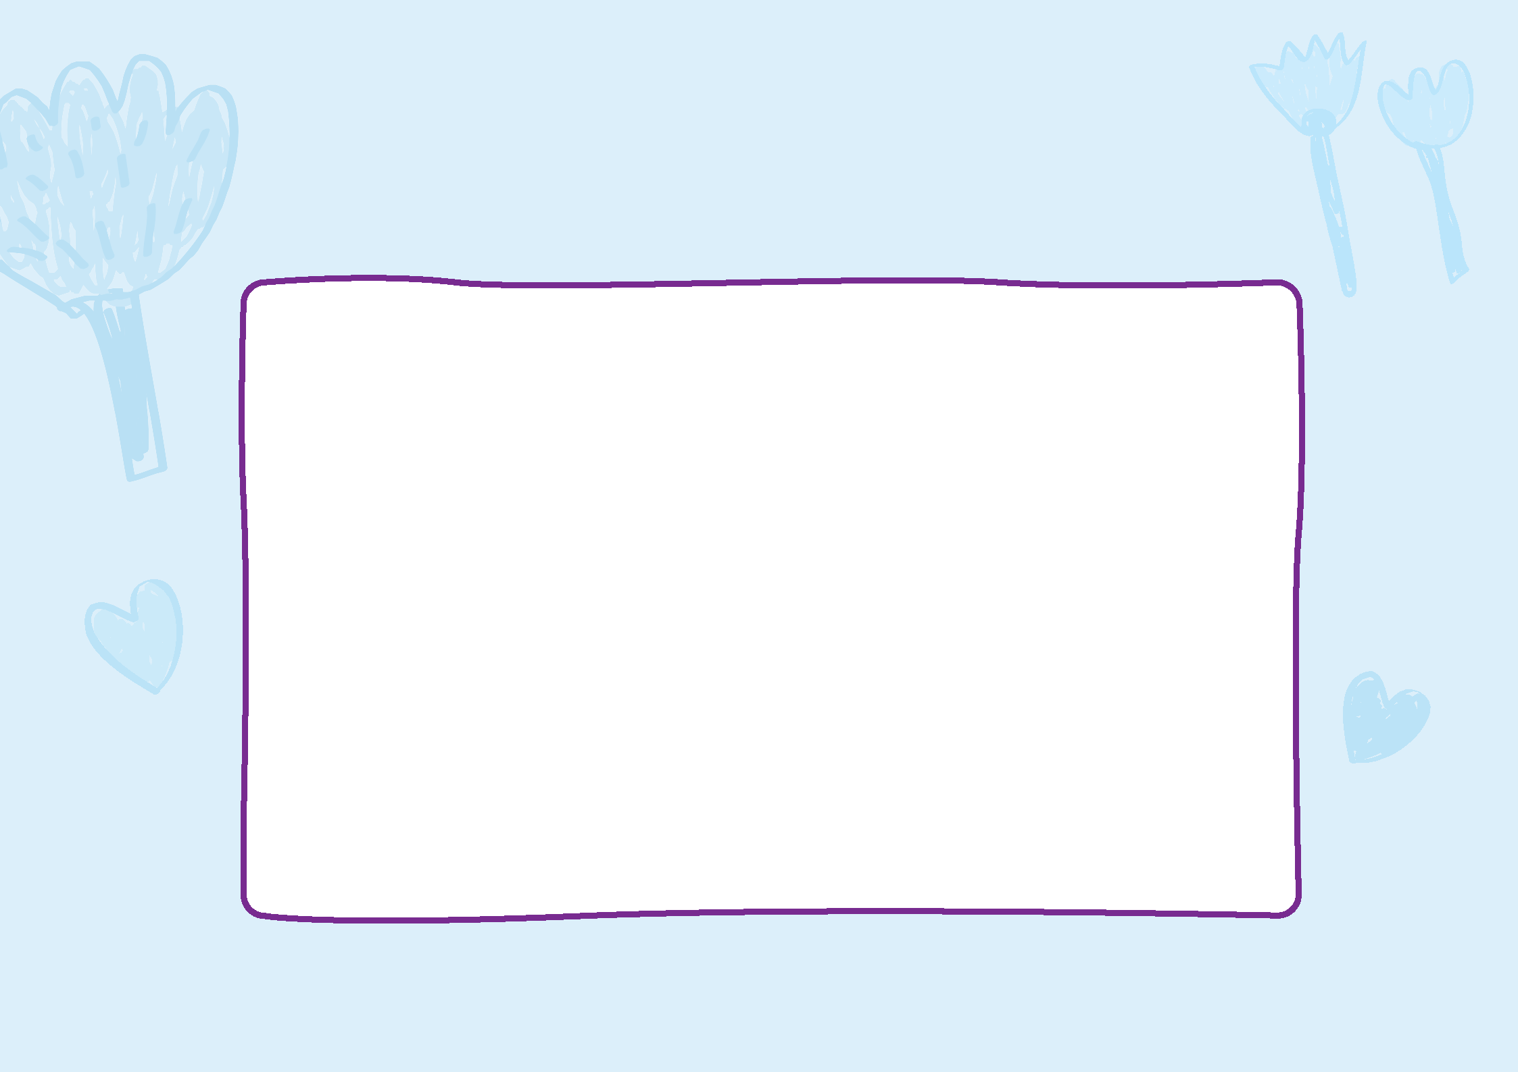**Then I say goodbye to my family.**

**They will come back at the end of the session.**

**This is a picture of my family:**

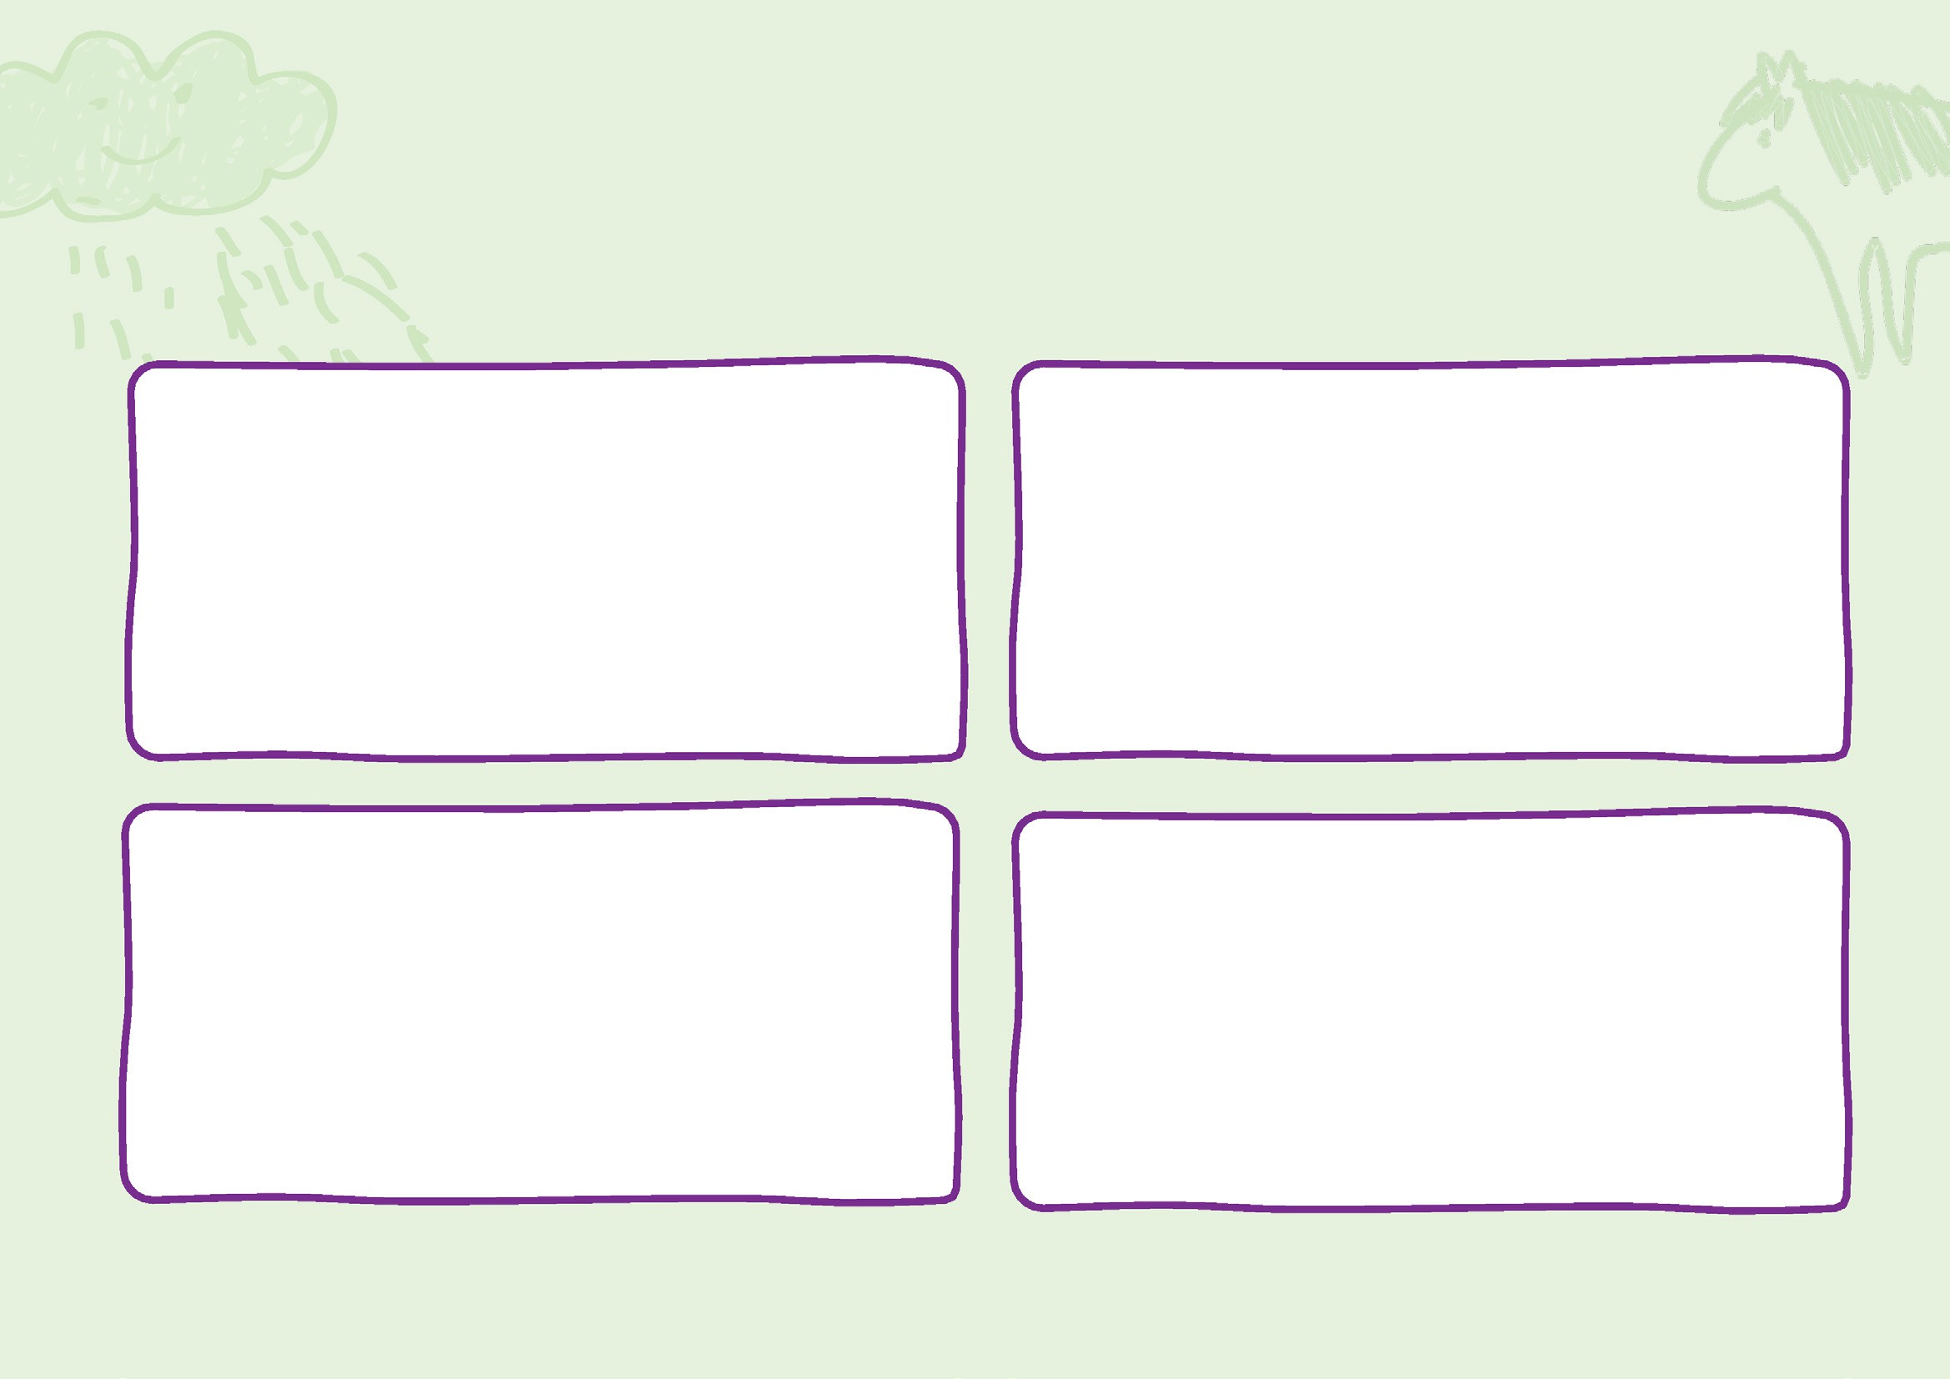**I will learn about myself and the world as I play at kinder. Here are some of the areas I can play in:**

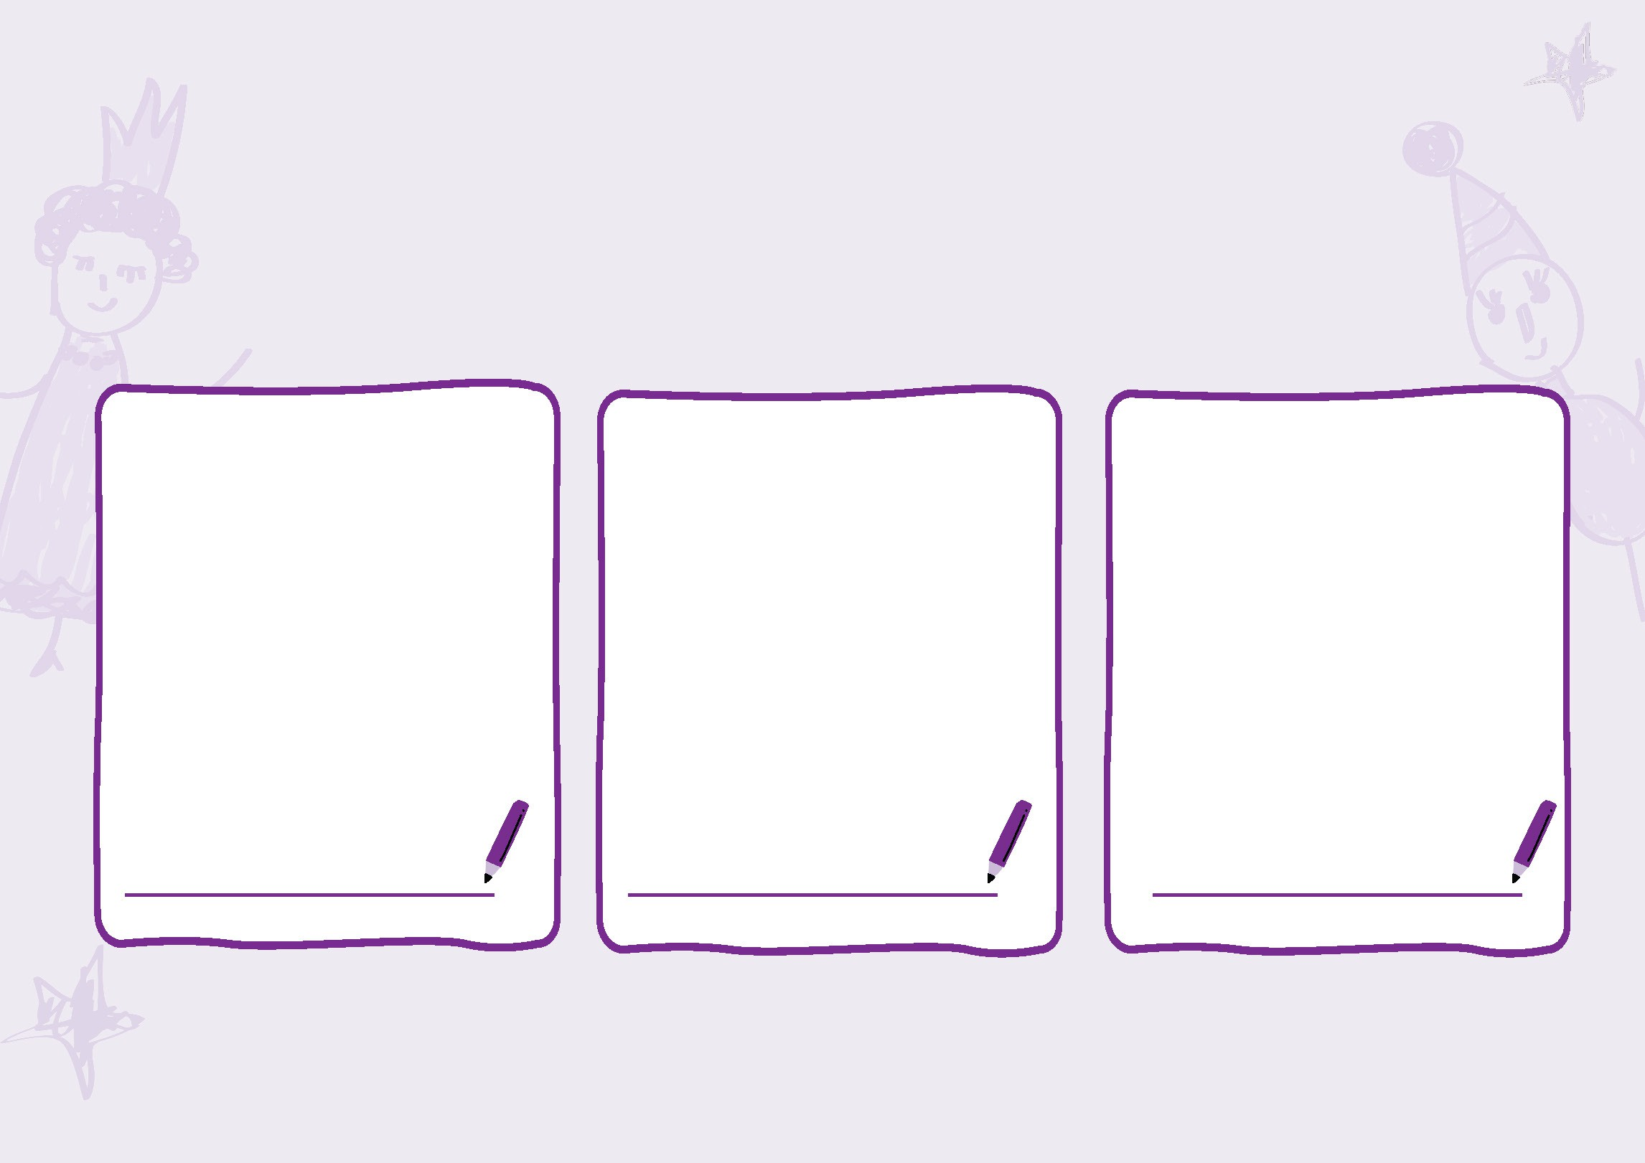**At kinder, I have group time. I can sit with my friends and listen to stories, sing songs, and talk.**

**Some of my favourite things to talk about include: Book Colour Animal**

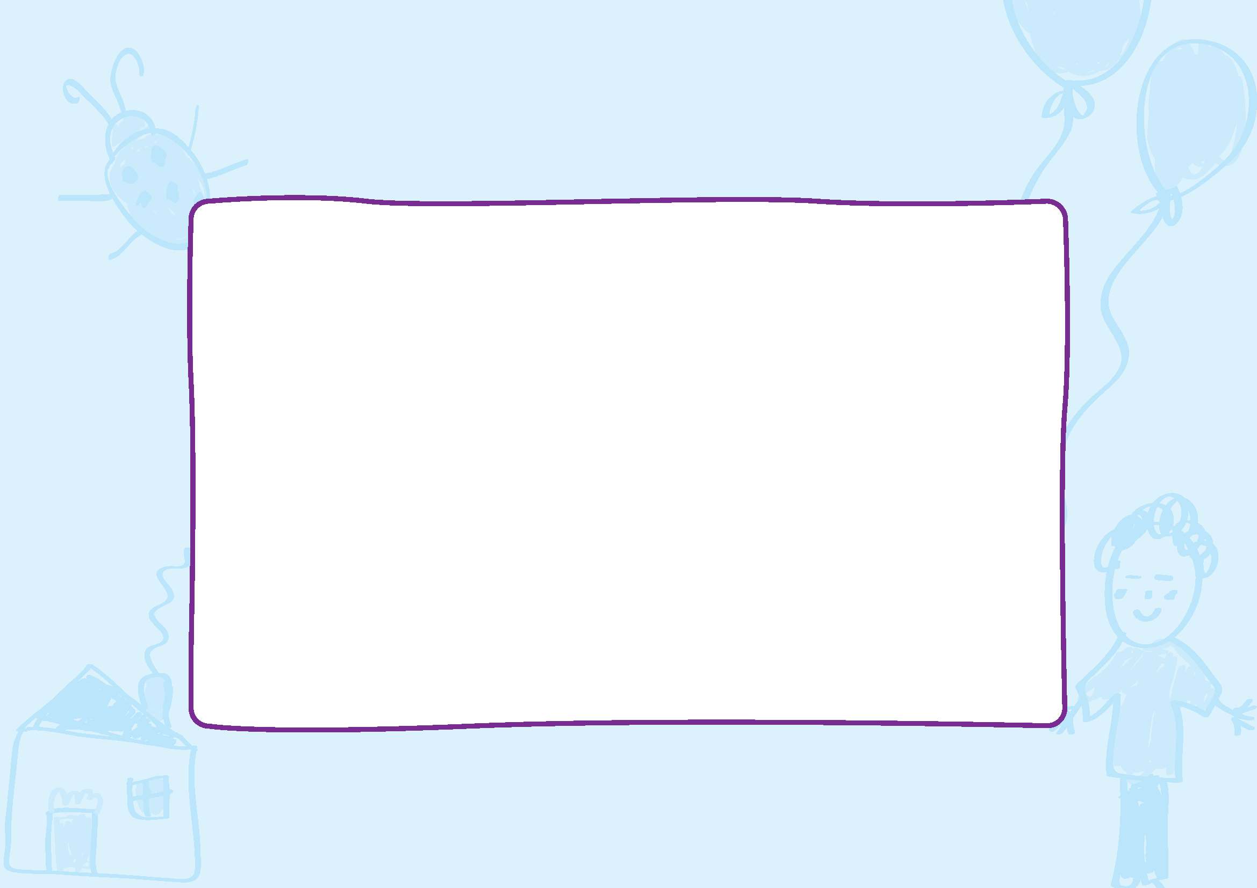**The bathroom at kinder looks like this:**

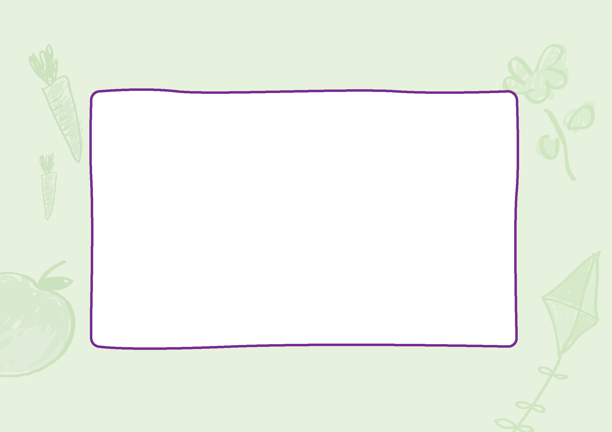**I will bring a lunchbox to kinder. It will have my lunch and some fruit and snacks.**

**I will have mealtimes with my teachers and friends.**

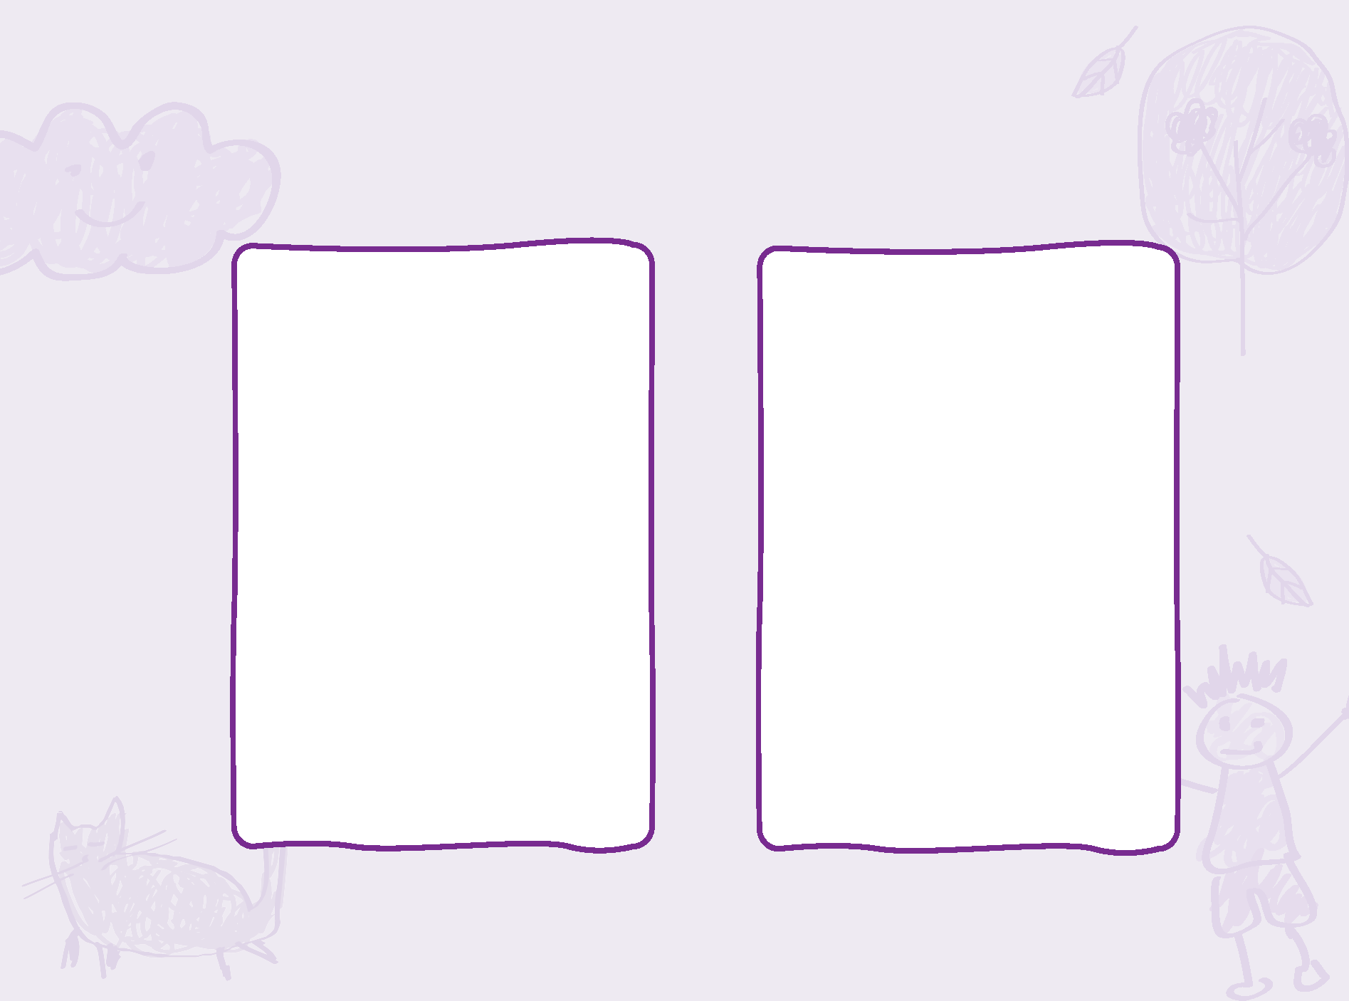**At kinder, I will learn and grow. I will have fun with my friends!**

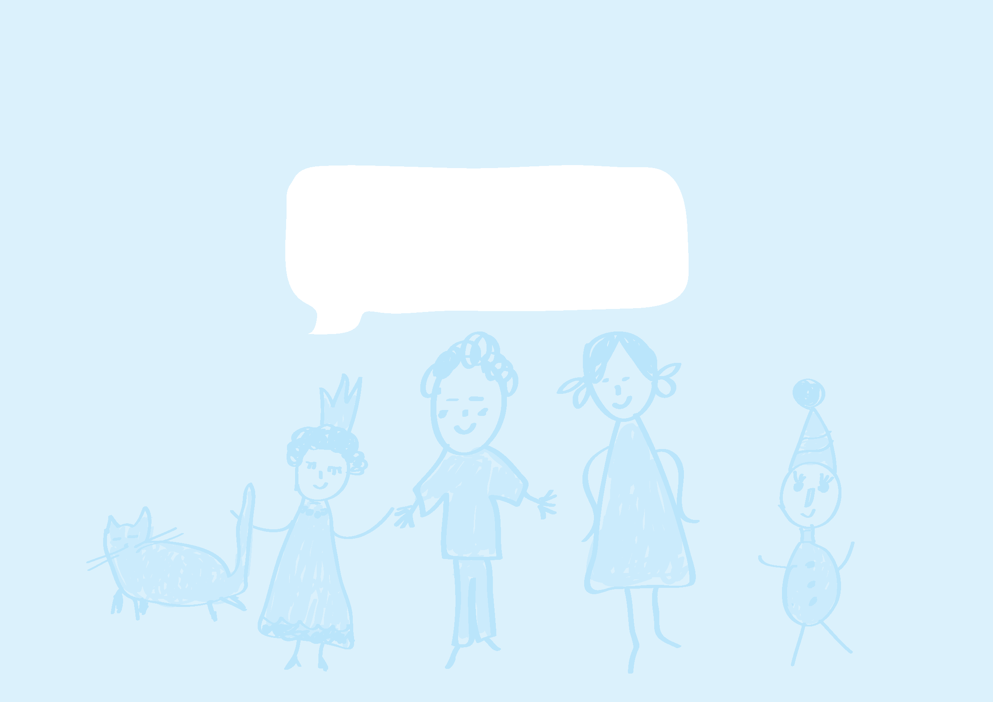**At kinder, I will learn and grow. I will have fun with my friends!**

**Bye Kinder!**

** **