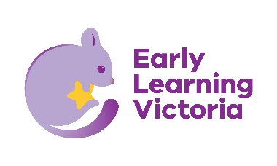

**Attachment 1: Public use of images consent form**

Dear [Parent/carer],

Occasionally at Early Learning Victoria (ELV) centres, children may be photographed, filmed or recorded as they take part in centre activities or events.

This consent form applies to images of children that are takenby a *professional photographer or videographer* engaged by the **Department of Education**.

Note that the department will not share or distribute photographs taken by ELV centre staff, including images taken during the educational program, in the ways described in this form.

If you do not understand any aspect of this consent form, or you would like to talk about any concerns, please contact your centre director, [insert phone number and/or email].

Our *ELV Electronic Devices and Photography Policy* describes how we collect and use photographs, video and recordings (images) of children. The policy also explains when parent/carer consent is required and how it can be provided and withdrawn.

**Privacy**

Photographs, video and recordings (images) in which your child is identifiable are considered personal information under privacy law. This means that any images of your child taken by ELV may be a collection of your child’s personal information.

ELV is part of the Department of Education. The department values the privacy of every person and complies with applicable privacy legislation, including the *Privacy and Data Protection Act 2014* when collecting and managing all personal information. See also the *ELV Privacy Policy*.

**Ownership and reproduction**

Copyright of images will be wholly owned by the Department of Education. Owning the images means ELV does not need to inform you each time the image is used. However, the Department of Education will only use the images for the purposes described in this form.

**Consent for uses of images**

**If you consent**,photographs, videos or recordings of your child may be used by the Department of Education (including by ELV and the Victorian School Building Authority) in publications that are accessible to the public. Publication could be:

* on a website
* in emails
* in newsletters
* via social media
* in the department’s reports and publications.

If the department would like to use images for purposes not described in this form, ELV will contact you to seek your consent for this additional use. We will contact you individually and seek permission if we are considering using images of your child for specific advertising or promotional purposes.

**Your consent**

I have read and understand this form, and I consent to ELV collecting photos, video or recordings of my child while at the centre, and using these photos, video or recordings in the ways described.

|  |  |
| --- | --- |
| **Name of child:** |  |
| **Name of parent/carer:** |  |
| **Signature:** |  |
| **Date:** |  |

For further information about how ELV collects and uses photos, video and recordings of children, see the *ELV Electronic Devices and Photography Policy*. This includes details of our use of images that we must collect to fulfil legal obligations or for identification purposes.