2026 Kinder Kits
Communication resources

Contents

Contents 2
Introduction 3
Talking points 3
Eligibility 3
What is a Kinder Kit 3
Learning through play 4
Call to action 4
Materials for use on your own platforms 4
Newsletter content 4
Web content 5
Guide for Families 5
Other resources 5

Introduction
Kinder Kits are back again for 2026 and are available for every child enrolled in a funded Three-Year-Old Kindergarten program or their first year of Early Start Kindergarten or Access to Early Learning.
This pack includes talking points, videos, links to more information, details about the Kit items and more. You can use it to help you talk about the Kinder Kits with your families.
Services and/or service providers will receive an email asking them to confirm their Kinder Kit order by the end of Term 1, 2026. Kinder Kits will be delivered throughout Term 1, 2026.
If you have not placed your 2026 Kinder Kit order by the start of Term 2, 2026, please email kinderkit@baoandco.com.au for instructions on how to submit your order.

Talking points

Eligibility
- Children starting funded Three-Year-Old Kindergarten or their first year of Early Start Kindergarten or Access to Early Learning in 2026 are eligible to receive a Kinder Kit.

What is a Kinder Kit
- Kinder Kits are designed to help children develop their love for learning with fun and educational toys, books, and educational resources.
- All Kinder Kit items are age-appropriate, child-safe, and inclusive of Victoria’s diverse communities. The items have been recommended by education experts to ensure that they align with the Victorian Early Years Learning and Development Framework and meet criteria relating to product quality and safety, inclusion and sustainability.
- The Kinder Kits are carefully curated to enhance your child’s learning and development. Each Kinder Kit includes a range of different items made especially for your three-year-old.
- Items in your Kinder Kit may include an Australian Animal stacking toy set, a shape threading game and shape pattern cards, a koala catch ball game, alfalfa seeds, Wild Dough playdough, an Aboriginal Australia dough stamp, stackable crayons, felt stickers to be used with the felt board on the interior of the Kinder Kit backpack and Flip Make Play Family Cards developed by the Department of Education, in collaboration with Assoc. Professor Gervasoni, Monash University.
- In addition, each child will receive three books from a selection of five, including Bugs in the Bush by Aunty Fay Stewart-Muir & Jeannette Rowe, The Kindness Club by Kate Bullen-Cassanova and Dave Petzold, Can you Dance? by Sally Morgan and illustrated by Kathy Arbon, Busy Beaks by Sarah Allen and Country by Aunty Fay Muir & Sue Lawson and illustrated by Cheryl Davison.
- The Kinder Kit backpack can be used every day. Leave the items at home and pack it ready for kindergarten.
- Your child can practise their drawing and pre-writing skills on the cardboard tag at the back, so they know which backpack is theirs. Unfold the backpack and secure with the Velcro tabs to use the felt surface with the felt garden stickers for imaginative play.
- Local suppliers, authors, and locally designed and/or manufactured products have been selected.
- Kinder Kits are part of the Victorian Government's $14 billion Best Start, Best Life reforms, which aim to provide all Victorian children access to 2 years of quality kinder before starting primary school, regardless of their life circumstances, background or postcode.

Learning through play
- Play is a fun and engaging way to support your child’s learning and development. Parents, carers and families are a huge part of that journey.
- Kinder Kits provide families with an opportunity to engage with their children through play and support their learning and development. This approach to early childhood education supports children to learn and extend their development through enjoyable and interesting activities and experiences.
- Learning through play is central to the Kinder Kits initiative and can support children to develop their language and social skills and find new ways to express their emotions and creativity.
- Learning through play is an effective way to support children's exploration and understanding of themselves and the world around them. It builds on children's natural curiosity and helps them learn in many ways.
- Kindergarten is an important step for children. Research shows that 2 years of quality kindergarten programs before school gives children the best start in life.
- 90% of a child’s brain develops by the time they turn 5 — the benefits of going to kinder for 2 years before school can last a lifetime.

Call to action
- Take your child’s Kinder Kit home and play together, using the books and educational toys to help give your child the best start in life.
- Learn more about the Kinder Kits, including tips on how to use the contents of your Kit to help your child’s learning, ask our staff or visit: vic.gov.au/KinderKits.

Materials for use on your own platforms

Newsletter content
Kinder Kits are here! All children enrolled in a funded Three-Year-Old Kindergarten program will receive a Kinder Kit.
Kinder Kits are full of educational toys, books, and resources, which are designed to help children develop their love for learning at home and at kinder.
This year, your child can use their Kinder Kit backpack for everyday adventures.
Kinder Kits provide families with an opportunity to engage with their children through play and support their learning and development.
Learning through play is an effective way to support children's exploration and understanding of themselves and the world around them. It builds on children's natural curiosity and helps them learn in many ways.
All Kinder Kit items are age-appropriate, child-safe, and inclusive of Victoria’s diverse communities.
The items have been recommended by education experts to ensure they align with the Victorian Early Years Learning and Development Framework and meet criteria relating to product quality and safety, inclusion and sustainability.
Kinder Kits items have been sourced from Australian businesses, with around 60 Victorian businesses, creative talents, and makers proudly represented in the Kit's design and items.
If you have a child who will be 3 next year, talk to us about how to enrol for 2027.
Learn more about the Kinder Kits, including tips on how to use the contents of your Kinder Kit: vic.gov.au/KinderKits.

Web content
Every child enrolled in funded Three-Year-Old Kindergarten in Victoria in 2026 at our service is eligible for a Kinder Kit. Kinder Kits are filled with educational toys, books, and resources to help children develop their love for learning at home and at kinder.
Kinder Kits contain age-appropriate, child-safe, and inclusive items recommended by education experts. The items have been sourced from Australian businesses, with around 60 Victorian businesses, creative talent, and makers proudly represented in the Kit's design and items.
If you have a child who will be 3 next year, talk to us about how to enrol for 2027.
To learn more about the Kinder Kits initiative, and how the Kits help your child’s learning, ask our staff or visit vic.gov.au/KinderKits.
Watch the video below to see what’s included in the 2026 Kinder Kits:
Introducing the 2026 Kinder Kits

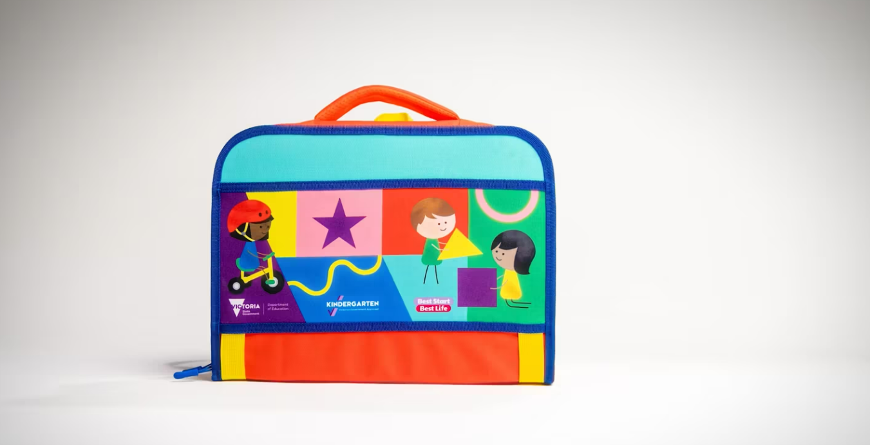
Kinder Kit 2026 on Vimeo

Guide for Families
Each Kinder Kit comes with a Guide for Families, which provides lots of play-based learning activities. These Guides have also been translated into various languages. Download the Guide for Families PDF
For more information visit: vic.gov.au/kinder/translations.
Auslan videos are available at: vic.gov.au/kinderkits#auslan-readings-of-kinder-kit-books

Other resources
The resources below can also be used in your communications with families.
Resource | Details
Online kindergarten starting age calculator | To help families find out what year they can start Three- and Four-Year-Old Kindergarten.
Pre-Prep calculator | Use the Pre-Prep calculator to find out if your child is eligible to attend Pre-Prep and when they can start.
The Evidence behind 2 years of kinder | Find out more about the research that tells us early brain development is very important for children’s learning, development, health and wellbeing.
Kindergarten Sector Guide | Key information about the Best Start, Best Life reforms, and the support available for children to access and participate in kindergarten programs.
Kinder Tick | The Kinder Tick helps Victorian families find a funded kindergarten program. Order Kinder Tick materials, including signage for your service.
Order printed materials | Services can order printed materials, which are paid for by DE and printed and delivered to your service. including posters. These materials are paid for by DE and printed and delivered to your service.
Free Kinder factsheets and brochures | A range of factsheets and brochures are available to explain Free Kinder, and the benefits of kindergarten.  - Advice for families factsheet (long day care)  - Advice for families factsheet (sessional)  - What is play-based learning  - When to start at Three-Year-Old Kindergarten
Communicating about kindergarten to your community webpage | Resources for services and providers to communicate with families about kindergarten and its benefits:  - Additional resources to help welcome all families to your service  - Brochures  - Posters (including editable versions), factsheets, and postcards  - Infographics to show the benefits of 2 years of kindergarten for children.

