Serious incident notification

Children’s’ Services Act 1996, Children’s Services Regulations 2009

This form must be completed and sent to the relevant regional office of the Department of Education and Training when a serious incident involving a child being cared for or educated by the service has occurred (section 29C and regulation 90(2)).

The contact details for Regional Offices can be found at www.education.vic.gov.au

Notification of a serious incident (select):

Death of a child while being cared for or educated by the service.

Injury or trauma to a child requiring the attention of a registered medical practitioner or admission to a hospital. A child appears to be missing or otherwise cannot be accounted for.
A child appears to have been taken or removed from the service. Any incident requiring attendance by emergency services.

Reporting requirements
The prescribed manner for notifying the Secretary or delegate is by telephone within 24 hours of the incident followed by written notification as soon as practicable.

Service details

1. Name of Proprietor: Licence ID:

2. | Name of Service:
3. | Address: |  | Postcode:
4. | Name of contact person: | Phone number:
5. | Email address:

Notifier details

- Name:

- Phone number (if not an employee of the service):

- The notifier is the: Licensee Primary nominee Nominee Other employee

Other (specify)

Notification details

- When did the serious incident occur?

Date: / / Time: am / pm

- When was the department notified of the serious incident by telephone? Date: / / Time: am / pm
Name of the person who made the notification: ……………………………………………………..

Name of the person you spoke to (if known): ………………………………………………………………..

Privacy The Secretary to the Department of Education and Training is committed to responsible and fair handling of personal information, consistent with the Information Privacy Act 2001 (Vic), the Health Records Act 2001 (Vic) and other statutory obligations including obligations under the Children’s Services Act 1996 (Vic). The Department of Education and Training may need to disclose your personal information to other State and Commonwealth agencies to check or confirm the information you have provided. You can request access to or update your personal information by contacting us. Our information privacy policy is available at www.education.vic.gov.au.

- Details of the serious incident

- Has the service made any changes as of result of the serious incident (if more space is required, please attach an additional clearly labeled page)

Details of any children involved

If more space is required, please attach an additional clearly labeled page.

Family Name:
13. | First name:
14. | Date of birth: | / | /

- What was the child doing at the time?

- Was any child harmed in any way? (please provide details)

- Please indicate where the child was injured (if applicable):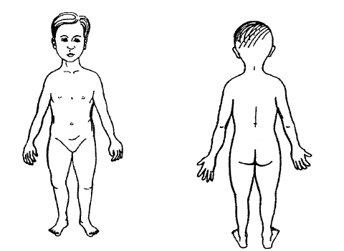

- What actions were taken by the service?

Applied first aid (provide details)

Called emergency services | Time: | am / pm | police | fire brigade | ambulance
Called parents  Other (provide details) | Time:  Time: | am / pm  am / pm

- If the child appeared to be missing or otherwise could not be accounted for:

What time did staff notice the child was missing? | Time: | am / pm
What time was the child found? | Time: | am / pm
Where was the child?
Who found the child?
- If the child appeared to have been taken or removed from the service:

What time did staff notice the child was missing? | Time: | am / pm
What time was the child found? | Time: | am / pm
Where was the child?

Who found the child?

- Is the child still attending the service? Yes No (if no, date child withdrawn and why) / /

Numbers of children present

- How many children were present in the area where the incident occurred? Under 3 Years: Over 3 years:
- How many children were present in total at the service at the time?

Under 3 Years: Over 3 years:

Staffing details

- What are the name(s) of any persons* present who observed, or were involved in, the incident? (please indicate which staff member(s) had first aid training).

*For the purpose of this question, persons includes staff members, family day carers, volunteers and any other person who observed the incident.

- What were the staff member(s) who observed, or were involved in, the incident doing at the time?

- What are the names and qualifications of the staff members present at the service at the time? (you may attach a copy of the staff roster).

Name | Qualification/s

- Total number of staff members: Of these how many are qualified*:
*for the purposes of this question qualified means a teaching staff member or a staff member that has successfully completed a 2 year full time, or part time equivalent, post secondary early childhood qualification or for OSHC, a post secondary child care or youth recreation qualification approved by the Secretary

Equipment

- Details of any products/structures/equipment involved

- Date of the last equipment maintenance check you conducted (if equipment involved): / /

Draw a plan indicating where the serious incident occurred and where the staff member(s) were positioned.

Declaration and signature

- I declare/certify that:

  - the information in this serious incident notification and any attachments are true and correct

The following people can sign this form:

  - The owner of the service
  - The licensee representative
  - The primary nominee

Signature Printed name Position Date
X

DET Office use only:

Received by: Received: / /

Was the notification to the Department within the prescribed timelines Yes No

