Complaint notification

Children’s’ Services Act 1996, Children’s Services Regulations 2009

This form must be completed and sent to the relevant regional office of the Department of Education and Training when a complaint has been received by the children’s service alleging that:

- the health, safety or wellbeing of any child being cared for or educated by the service may have been compromised; or
- there has been a contravention of the Children’s Services Act 1996 or Children’s Services Regulations 2009 (regulation 105).

Contact details for Regional Offices can be found at www.education.vic.gov.au

Notification of a complaint alleging that (select):

The health, safety or wellbeing of any child being cared for or educated by the service may have been compromised. There has been a contravention of the Children’s Services Act 1996 or Children’s Services Regulations 2009.

Reporting requirements
The prescribed manner for notifying the Secretary or delegate is by telephone within 48 hours followed by written notification as soon as practicable.

Service details

1. Name of Proprietor: Licence ID:

2. | Name of Service:
3. | Address: |  | Postcode:
4. | Name of contact person: | Phone number:
5. | Email address:

Notifier details

- Name:

- Phone number (if not an employee of the service):

- The notifier is the: Licensee Primary nominee Nominee Other employee

Other (specify)

Notification details

- When was the licensed children’s service notified of the complaint?

Date: / / Time: : am / pm

Verbally By telephone In writing

- When was the department notified of the complaint by telephone? Date: / / Time: am / pm
Name of the person who made the notification:

Name of the person you spoke to (if known):

Privacy The Secretary to the Department of Education and Training is committed to responsible and fair handling of personal information, consistent with the Information Privacy Act 2001 (Vic), the Health Records Act 2001 (Vic) and other statutory obligations including obligations under the Children’s Services Act 1996 (Vic). The Department of Education and Training may need to disclose your personal information to other State and Commonwealth agencies to check or confirm the information you have provided. You can request access to or update your personal information by contacting us. Our information privacy policy is available at www.education.vic.gov.au.

Complainant details

- Name:

- Phone number (if not an employee of the service):

13. | The complainant is the: | Parent/Guardian of a child attending the service
 |  | Other (specify)

14. Details of the complaint

15. How was the complaint dealt with - include details of response to the complainant and any changes made to at the service as of result of the complaint (If more space is required, please attach an additional clearly labelled page)

Details of any children involved

If the notification relates to the health, safety or wellbeing of any child(ren) being cared for or educated by the service possibly being compromised please complete this section (if more space is required, please attach an additional clearly labelled page)

Family Name:
16. | First name:
17. | Date of birth: | / | /

- What were the child(ren) doing at the time?

- Was the child(ren) harmed in any way? (please provide details)

- 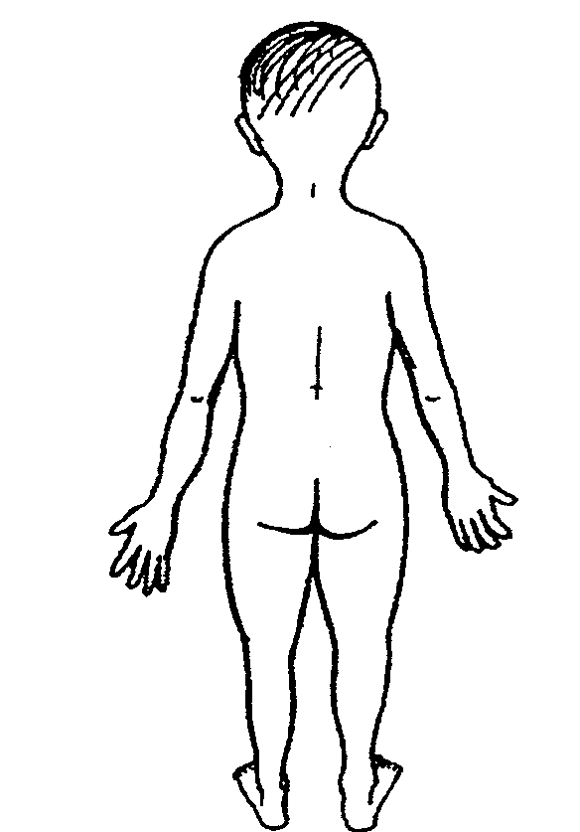Please indicate where the child(ren) were injured (if applicable):

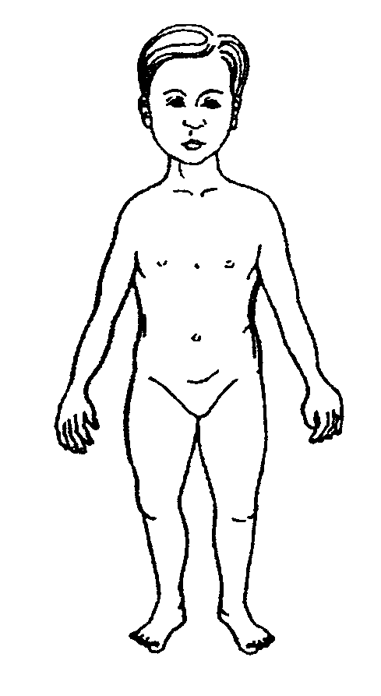

- What actions were taken by the service?

Applied first aid (provide details)

Called parents | Time: | am / pm
Other* (provide details) | Time: | am / pm

*If emergency services were required to attend or the child required the attention of a registered medical practitioner or admission to hospital please complete the Serious Incident Notification form

- Are the child(ren) still attending the service?

Yes

No (if no, date child(ren) withdrawn and why) / /

Numbers of children present

- How many children were present in the area where the incident occurred? Under 3 Years: Over 3 years:
- How many children were present in total at the service at the time?

Under 3 Years: Over 3 years:

Staffing details

- If the complaint is about staff member(s) of the service, what are the names of those staff member(s)?

- What are the name(s) of all persons* present who observed the incident? (please indicate which staff member(s) had first aid training).

*For the purpose of this question, persons includes staff members, volunteers and any other person who observed the incident.

- What were the staff member(s) who observed, or were involved in, the incident doing at the time?

- What are the names and qualifications of the staff members present at the service at the time? (you may attach a copy of the staff roster).

Name | Qualification/s

- Total number of staff members: Of these how many are qualified*:

*for the purposes of this question qualified means a teaching staff member or a staff member that has successfully completed a 2 year full time, or part time equivalent, post secondary early childhood qualification or for OSHC, a post secondary child care or youth recreation qualification approved by the Secretary

Equipment

- Details of any products/structures/equipment involved

- Date of the last equipment maintenance check you conducted (if equipment involved): / /

Draw a plan indicating where the event occurred and where the children and staff members were positioned

Declaration and signature

- I declare/certify that:

  - the information in this complaint notification and any attachments are true and correct

The following people can sign this form:

  - The owner of the service
  - The licensee representative
  - The primary nominee

Signature Printed name Position Date
X

DET Office use only:

Received by: Received: / /

Was the notification to the Department within the prescribed timelines Yes No

