Regulation and Quality Assessment Update

This newsletter includes information for children’s services operating under the National Quality Framework and services operating under the Children’s Services Act 1996.
Issue 17 | October 2015

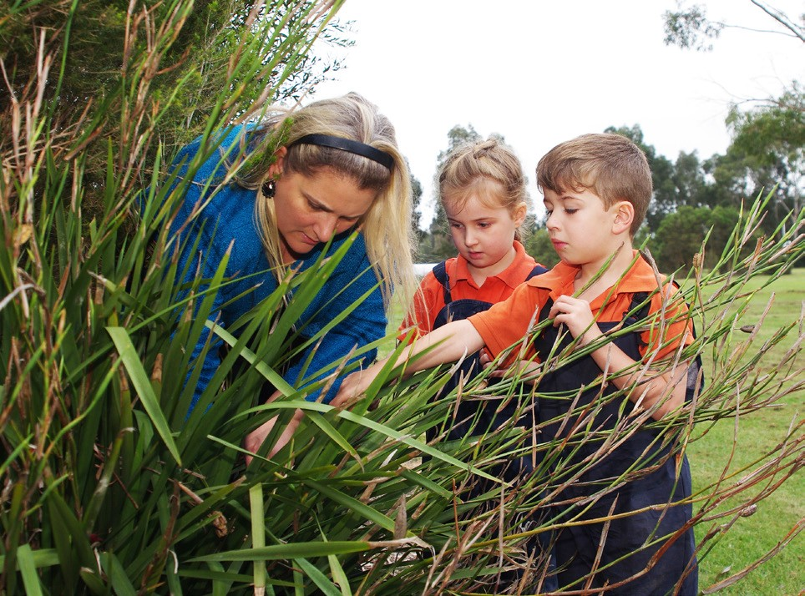Early childhood teacher registration
Latest news
Welcome to the seventh edition for 2015 of the Regulation and Quality Assessment Update.
As the bush fire season has started early this year, I wish to stress the importance of services reviewing their emergency and evacuation procedures, ensuring that it
includes a risk assessment and instructions for what must be done in the event of an emergency. I recommend that services and family day care educators in areas at risk of bush fire rehearse their emergency and evacuation procedures with staff members
and children in preparation for the fire season.
I encourage you to regularly check the Working with Children Check (WWCC) or Victorian Institute of Teaching (VIT)
registration for your staff members, educators and family day care educators to ensure they are current. In particular, before engaging any educator at your service or registering
a family day care educator it is imperative that you have read their WWCC or VIT registration. In addition, the criminal history check for a family day care educator must also be read and considered before they are engaged or registered.
In this edition, there is also information about the new online Mandatory Reporting eLearning Module to assist early childhood educators to increase their capacity to respond effectively to children whose safety or wellbeing may be at risk. This training also supports VIT registered early childhood teachers to meet their responsibilities as mandatory reporters.
I hope you are enjoying celebrating Children’s Week. This year’s children’s week celebrates the 25th anniversary of Australia signing the United Nations Convention on the Rights of the Child.
Further information is available at: www.education.vic.gov.au/about/events/ Pages/childrensweek.aspx
Please share this edition with educators and staff members at your service.

Madeleine Smith Executive Director
Quality Assessment and Regulation Division Department of Education and Training
Excellent rating – Little Beacons Learning Centre
Little Beacons Learning Centre located in Pakenham was awarded the Excellent rating on 22 September 2015. This is the seventh service in Victoria to achieve the Excellent rating.
This service has demonstrated its exceptional commitment to children and families through embedded, respectful practice that celebrates culture and diversity at the highest level. The service has developed a strong and empowering indigenous program that supports children’s cultural competence and integrates Aboriginal and Torres Strait Islander perspectives into the service’s educational program.
There is a demonstrated commitment to embedding excellent practice in the program by actively promoting exceptional practices within the Beaconhills College and in the
wider education and care sector by modelling and sharing practices to support other services.
Approved providers with a service that has received an overall rating of ‘Exceeding National Quality Standard’ are eligible to apply to ACECQA for the Excellent rating. Further information is available at: www.acecqa.gov.au/excellent-rating
All qualified early childhood teachers who are employed or engaged as an early childhood teacher in a Victorian education and care service or a Victorian children’s service need to be registered with the Victorian Institute of Teaching.
To see who is registered, search the public register via the Victorian Institute of Teaching website:

www.vit.vic.edu.au
Early childhood teachers who are not registered and have:
- completed the online application only – should check the email the Institute sent them and post their documents to the Institute as soon as possible.
- completed the online application and posted their documents – the Institute will get them registered as soon as possible.
Early childhood teachers who should be registered but haven’t started an application yet should talk to their employer and apply TODAY.
More information and the early childhood teacher registration application form can be accessed via the Victorian Institute of Teaching website: www.vit.vic.edu.au
Early childhood teachers and employers who cannot find the information they need about early childhood registration on the Institute website, should call the Institute on 1300 977 263. The Institute is open from 8:00a.m. to 6:00p.m. Monday to Friday except on public holidays. A good time to call is usually between 10:30a.m. and 12:30p.m. and from 4:30p.m. to 6:00p.m.

Services operating under the
Children’s Services Act 1996

Volunteers
Children’s services may use volunteers to assist staff members to implement the children’s program by working with the children, preparing materials and learning experiences or doing administrative duties. In limited hours and short term services, volunteers can also be counted in the child to staff ratios provided they are not:
- more than half the number of staff members caring for or educating the children
- under age 18
- counted as qualified staff members
- counted in the minimum staff requirements, where at least 2 staff members must be on duty whenever children are being cared for or educated by the children’s service (regulation 50 and 58).

Working with Children Checks (WWCC)
A licensee or nominee must read a person’s WWCC or check that the person is registered with the Victorian Institute of Teaching before the person becomes a volunteer at a children’s service.
The staff record for each staff member, employee, early intervention worker and volunteer must also include:
- the date the WWCC was read by the licensee, the primary nominee or nominee who was in charge at the time the WWCC was read
- the reference number of the WWCC
- the expiry date of the WWCC.
A volunteer, including a student or person on work experience, does not require a WWCC if they are:
- supervised at all times by the proprietor or a qualified staff member if they are caring for or educating the children at the service.
- under 18 years of age
- not included in the child to staff ratios, if the service is a limited hours or short term service (regulation 70 and 70A).

Further information for Children’s Services Act services
Information and resources for Children’s Services Act services are available on the Department of Education and Training website: www.education.vic.gov.au/childhood/providers/regulation/Pages/vcs. aspx
The following resources are available:
- Children’s Services Act 1996 and Children’s Services Regulations 2009
- licensing forms and children’s service forms (complaints, staffing and enrolment)
- the register of Children’s Services Act services
- resources (fact sheets, guides and practice notes)
- child to staff member ratio calculator.

Updated fact sheets for services operating under the Children’s Services Act are available at: www.education.vic.gov.au/childhood/providers/ regulation/Pages/vcsfactsheets.aspx

Changes to educator to child ratios 1:11
To assist services to transition to the new ratio requirements of
1 educator to 11 children for children 36 months to preschool age, from 1 January 2016, two fact sheets have been developed:
- Educator to child ratios from 1 January 2016 – Centre-based services
- Educator to child ratios for funded kindergarten programs from 1 January 2016
These fact sheets are available at: www.education.vic.gov.au/ childhood/providers/regulation/ Pages/nqffactsheets.aspx.

Early childhood teacher mentoring program
Seventy early childhood teachers have participated in the Department’s October Early Childhood Teacher Mentoring program. There are another two sessions scheduled this week in Bendigo and Traralgon.
Further mentoring training sessions will be available in 2016.

Early childhood qualifications fund
Early childhood educators are invited to apply for a scholarship to support an upgrade or attainment of an early childhood qualification.
The Early Childhood Qualifications Fund supports early childhood educators currently working in licensed children’s services and qualified primary teachers to build their professional capacity through attainment of a qualification.
The next application round will open on 30 November 2015 and close on 5 February 2016.
More information is available at: www.education.vic.gov.au/about/ careers/Pages/fund.aspx or via phone1300 651 662 or email early.years.workforce@edumail.vic.gov.au

Early childhood scholarships for Aboriginal people
Early childhood scholarships are available for Aboriginal people working in a Victorian early childhood setting, or for Aboriginal people who can demonstrate willingness and commitment to working in
an early childhood setting to attain or upgrade an early childhood education qualification.
Following completion of the course, successful recipients are required to work for a minimum period of time in a Victorian early childhood setting, including Multicultural Aboriginal Children’s Services (MACS), Children and Family Centres (CFCs), Aboriginal Best Start, Aboriginal Playgroups, In Home Support, Home based learning or Child and Family Services in an Aboriginal cooperative or corporation.
Scholarships range from $1,500 for a Certificate III in Early Childhood Education and Care to $12,000 for an Early Childhood Teaching Degree Applications are accepted at any time, and are available at: www.education.vic.gov.au/about/careers/Pages/aboriginal.aspx
For more information contact 1300 651 662 or email early.years. workforce@edumail.vic.gov.au

Employment incentives for early childhood teachers
Employment incentives for early childhood teachers valued at up to $15,000 are available to provide kindergarten and long day care services in regional and remote communities and Aboriginal early
childhood services with financial support to attract and retain qualified early childhood teachers to deliver an approved kindergarten program.
Applications are accepted at any time. More information and application documentation is available at: www.education.vic.gov.au/about/ careers/Pages/incentives.aspx

Quality area 3: Physical environment

The physical environment must be safe, suitable and provide a rich and diverse range of experiences which promote children’s learning and development.

Gardening
Gardening can provide valuable opportunities for children to learn about and develop respect for the natural environment by exploring the relationship between people, plants, animals and the land. When children engage
in gardening experiences that involve physical and sensory activities, investigation and collaboration, children develop new skills including:
- Responsibility – by caring for plants and the environment
- Understanding – as they learn about cause and effect (for example, plants die without water, weeds compete with plants)
- Self-confidence – by achieving their goals and enjoying the food they have grown
- Appreciation of nature – by learning about the natural environment, the interdependence of living things and environmental sustainability
- Reasoning and discovery – learning about the science of plants, animals, weather, the environment, and simple construction
- Physical activity – doing something fun and productive
- Cooperation – including shared play activity, positive relationships, effective communication and teamwork
- Creativity – designing gardens or finding new and exciting ways to grow food
- Nutrition – learning about where fresh food comes from1.

Educators must provide a safe environment and ensure activities do not pose a risk to the safety, health and wellbeing of children. It is important to follow these safety precautions when gardening:
- when working outdoors, wear a hat, sunscreen, suitable clothing and footwear. Be sun smart by working in the shade where possible
- wear gardening gloves to protect hands against cuts, soil, insect bites and skin irritants
- ensure children are supervised when using tools, potentially harmful materials, or when accessing water. Store gardening tools and materials
safely and securely when not in use
- check for natural hazards such as splintered wood, prickly plants and biting or stinging insects
- observe safety instructions when using potting mix or soil, sprays or fertilizers. Wear a mask and gloves when using potting mix, as it can
cause serious illness such as legionnaires’ disease.
Research and explore mulching, composting and companion planting with children to reduce the need for gardening chemicals. Garden organically and sustainably whenever possible.

What’s new in transition to school?
The Transition: A Positive Start to School website provides resources that are designed to support all family day care, long day care, preschool (kindergarten), primary schools, and out of school hours care in the important role that you play in a child’s transition to school.
The Department has recently launched a new section of the Transition: A Positive Start to School website – ‘What’s new in transition?’. This new section of the website will provide updates on current programs, projects, and research related to transition from early childhood settings to school.
Check out the latest research, resources and ideas in transition available at: www.education.vic.gov.au/childhood/professionals/ learning/Pages/transition.aspx#link31

Partnerships with professionals video
A new video is available for early childhood professionals to support the implementation of the Victorian Early Years Learning and Development Framework (VEYLDF) and to promote continuous improvement of the National Quality Standard (NQS). Narrated by Anne Stonehouse it features footage of children, educators and other professionals working together in a range of children’s services and emphasises the importance of partnerships among a broad range of professionals to support children’s learning and development.
A resource sheet will be available soon to use in conjunction with the video to stimulate thinking and critical reflection processes for the purpose of deepening understanding.
The video is available at: www.education.vic.gov.au/childhood/ providers/edcare/Pages/profresource.aspx

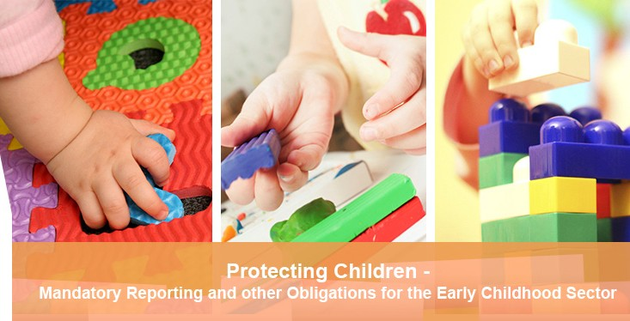Mandatory reporting module
The Protecting Children – Mandatory Reporting and Other Obligations for the Early Childhood Sector eLearning Module is now available online. The module has been developed to support early childhood teachers who become mandated reporters of child abuse once registered with the Victorian Institute of Teaching. It also supports all professionals in early childhood settings to increase their capacity to respond effectively to children whose safety or wellbeing may be at risk.
The module provides information regarding the roles and responsibilities for protecting children, and provides specific advice on how to identify, respond to and report concerns regarding children at risk of abuse or neglect. It also provides advice regarding the new criminal offences that have been introduced to protect children.
The module is available at no cost to participants and provides a certificate on successful completion and is available at: www.elearn.com.au/det/earlychildhood
Login: ecec
Password: staff (all lowercase)
All early childhood professionals are strongly encouraged to undertake this module.

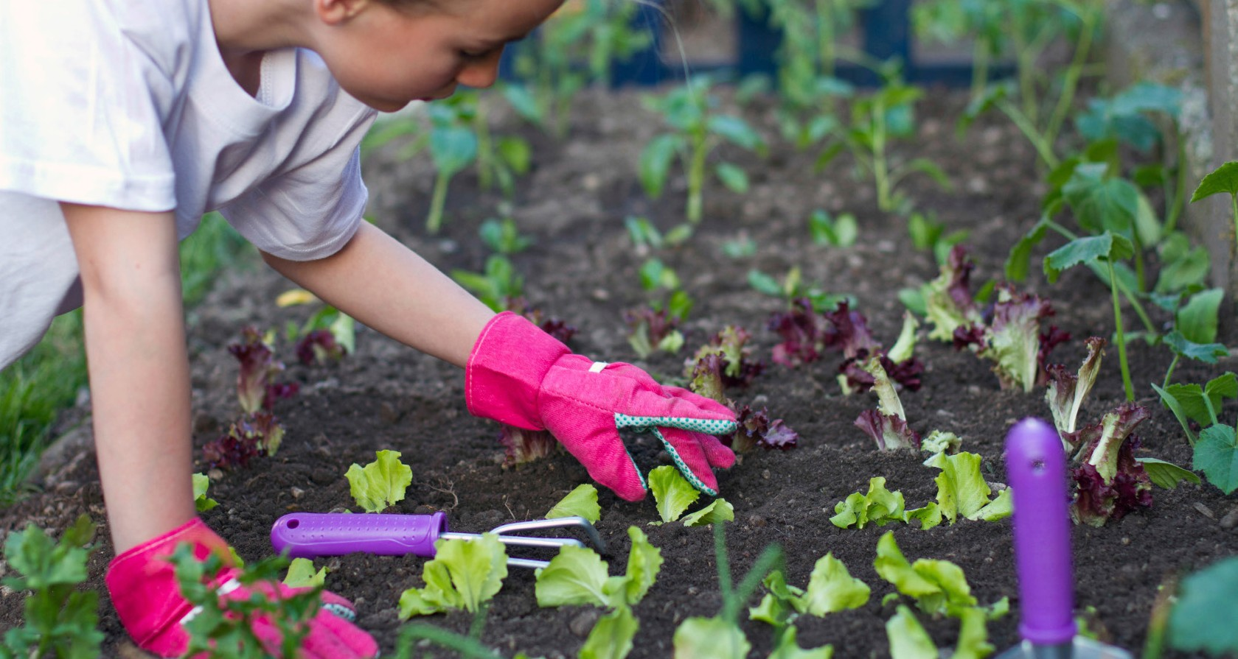

1. Fruit and vegetables | Better Health Channel - www.betterhealth.vic.gov.au/ bhcv2/bhcarticles.nsf/pages/fruit_and_vegetables

No Jab, No Play update
The proposed ‘No Jab, No Play’ legislation has been passed by the Victorian Parliament. It is intended that the legislation will commence on 1 January 2016.

Who will the ‘No Jab, No Play’ law impact and how?
From 1 January 2016, these laws will apply to all early childhood education and care services in Victoria providing:
- long day care
- kindergarten
- occasional care
- family day care.
The legislation will not apply to:
- enrolment in primary or secondary school
- outside school hours care (after care, before care, vacation care)
- school children enrolled in long day care, family day care or occasional care
- casual occasional care services that offer care of less than 2 hours per day and less than 6 hours per week
- playgroups.
Children whose enrolments are already confirmed or will be confirmed before 31 December 2015, will not be impacted by the legislation.
Further information about the ‘No Jab, No Play’ legislation is available at: www.health.vic.gov.au/immunisation/factsheets/ no-jab-no-play.htm

How to promote healthy eating?
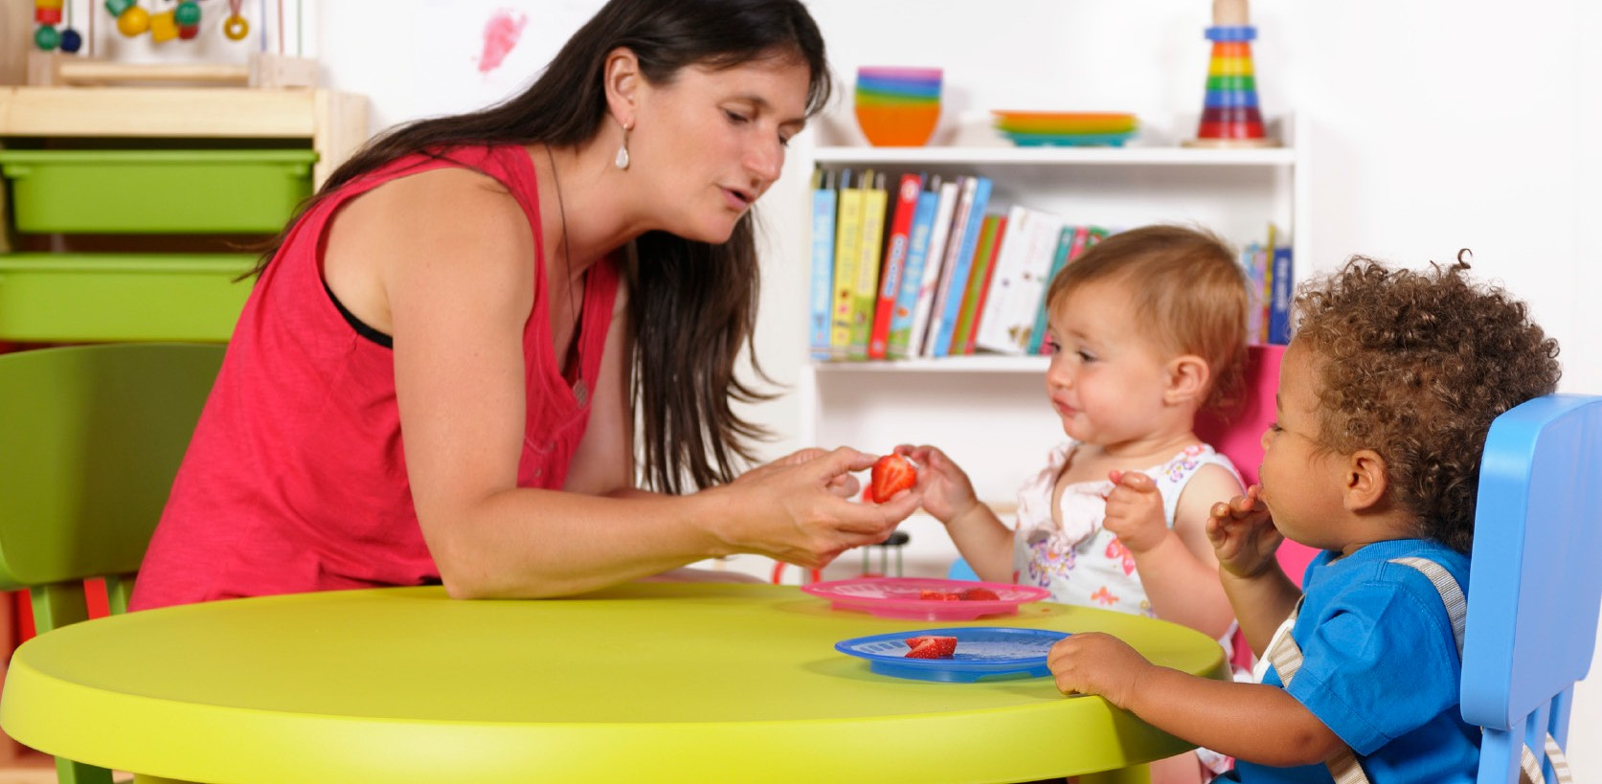Educators have an important role to play in promoting healthy eating to children in their care. There are numerous ways to role model healthy eating including:
  - making mealtimes relaxed and comfortable
  - sitting and eating with the children
  - talking in positive ways about the healthy foods the children are eating
  - encouraging fussy eaters to try new foods
  - being a good role model with the foods you eat
  - teaching the children about healthy eating through discussions, questions, games and activities.
This short video by the Healthy Eating Advisory Service shows you how to become a great health promoter, available at: http://heas. healthytogether.vic.gov.au/early-childhood-services/promoting- healthy-eating
Children are great imitators, so give them something great to imitate.
~Unknown

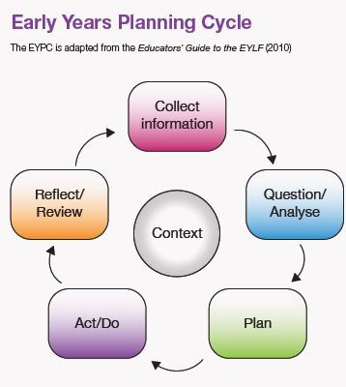Proposed implementation of Child Safe Standards from 1 January 2016

Assessment for Learning Tool has been updated
The Early Years Planning Cycle supports:
- collecting purposeful information and evidence over time
- analysing and assessing individual and group learning and development in different contexts
- making plans for each child and groups of children
- implementing intentional teaching strategies
and practices to extend learning and development
- reflecting on all aspects of planning and practice, including learning relationships
- collaborating with children, families, colleagues and other professionals to collect and analyse evidence and plan and implement programs
that extend learning and development
- using professional inquiry to inform planning and practice decisions, and support continuous improvement.
This updated resource is available at: www.vcaa.vic.edu.au/ Documents/earlyyears/Assess4LearnTool.pdf
As part of the Victorian Government’s response to the ‘Betrayal of Trust Inquiry’, Child Safe Standards are being introduced to ensure the safety and wellbeing of children in their care and education. The proposed ‘Child Safe Standards’ legislation is expected to come into effect from 1 January 2016 for early childhood services. The purpose of the Child Safe Standards is to raise awareness about child abuse and assist services and organisations to create and maintain child safe environments.
Services can incorporate the requirements of the Child Safe Standards into some of the existing policies and procedures already required by the National Quality Framework. Services must have a child safe environment policy and procedures and a staffing policy and procedures that include a requirement for a code of conduct for staff members. It is recommended that the service’s child safe environment policy is reviewed and revised to outline the way in which the service will meet the Child Safe Standards.
Importantly, the child safe environment policy will include how the service’s human resources processes during recruitment will incorporate procedures for thoroughly screening prospective employees, always checking referees and working with children checks.
The service’s staffing policy should be reviewed and revised to ensure there are clear expectations for appropriate behaviour with children, processes for responding to and reporting suspected harm to children and strategies to reduce or remove risks of child abuse.
Further information on the Department’s website about the Child Safe Standards is available at: www.education.vic.gov.au/about/programs/health/Pages/ childsafe.aspx and on the Department of Health and Human Services website at: www.dhs.vic.gov.au/about-the-department/documents-and-resources/ policies,-guidelines-and-legislation/child-safe-standards.
Further information about the Betrayal of Trust report is available at:
www.parliament.vic.gov.au/fcdc/inquiries/article/1788
Any questions regarding Child Safe Standards can be directed to:
csrr@edumail.vic.gov.au

Assessment and rating update
At 12 October 2015, 81 per cent of approved education and care services in Victoria have received a quality rating, compared to 70 per cent nationally.
Victoria is tracking well to complete assessment and rating visits for the majority of education and care services by the end of 2015.

Guide for the management and control of gastroenteritis outbreaks
This guide has been produced to assist in the management and control of outbreaks of gastroenteritis (gastro) in early childhood services.
The guide provides useful posters to assist services communicate about gastroenteritis outbreaks and to assist in managing these outbreaks.

Emergency management plans 2015-16
Services listed on the Bushfire at Risk Register (BARR) are required to meet the conditions that are imposed on their service approval/licence.
A list of the services placed on the BARR is published on the Department’s website and is available at: www.education.vic.gov.au/about/programs/ health/Pages/bushfirerisk.aspx
Services listed on the BARR must submit their current emergency management plan to their respective Quality Assessment and Regulation (QAR) Regional Office by 21 November 2015.
Contact details of the relevant QAR Regional Offices of the Department are available at: www.education.vic.gov.au/childhood/providers/ regulation/Pages/nqf.aspx

Services that have submitted an emergency management plan in 2015 are not required to re-submit the same emergency management plan again, unless it has been changed or updated.
Further information is available in the fact sheets:
- Managing bushfire risks in centre-based services
- Managing bushfire risks in family day care
These fact sheets are available at: www.education.vic.gov.au/ childhood/providers/regulation/Pages/nqffactsheets.aspx

This guide is available at: http://docs.health.vic.gov.au/docs/doc/A- guide-to-for-the-management-and-control-of-gastroenteritis-out- breaks-in-childrens-centres

Emergency management plan resources
The Department has developed a range of resources to assist early childhood services in developing their emergency management plans:
- Guide to Developing an Emergency Management Plan
- Emergency Management Planning FAQs
- Emergency Management Plan template for early childhood services
- A number of short video tutorials are available to assist with developing area maps, evacuation diagrams and
communication trees within the Emergency Management Plan template document.
These resources available at: www.education.vic.gov.au/childhood/ providers/support/Pages/emergency.aspx

Other resources:
- Guide for children’s services - Excluding children to manage infectious diseases
- Minimum period of exclusion from
primary schools and children’s services for infectious cases and contacts
are available at:

http://ideas.health.vic. gov.au/guidelines/school-exclusion-table.asp

Resources
New or updated resources are available at: www.education.vic.gov.au/childhood/providers/regulation/Pages/nqffactsheets.aspx

- Transporting children - centre-based services
- Transporting children in family day care
- Excursions
- Managing bushfire risks in centre-based services
- Managing bushfire risks in family day care

You can get in touch with us by:
Keeping in touch
Visiting our website www.education.vic.gov.au

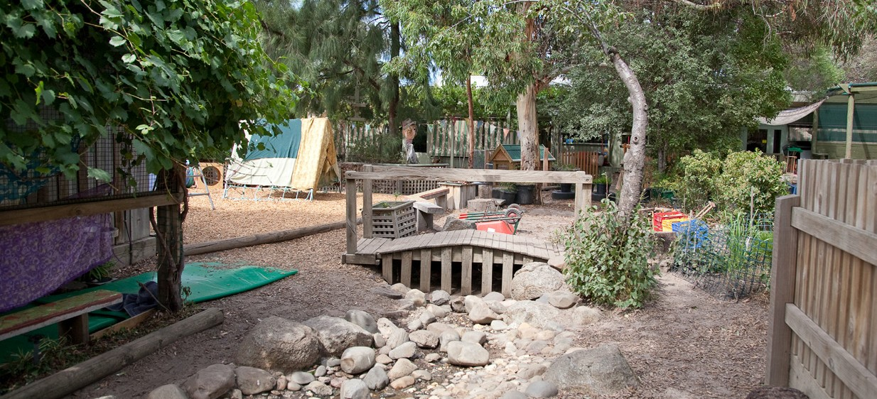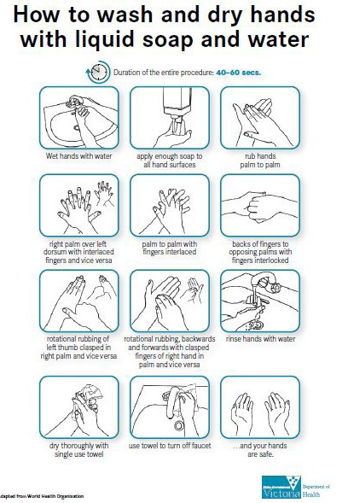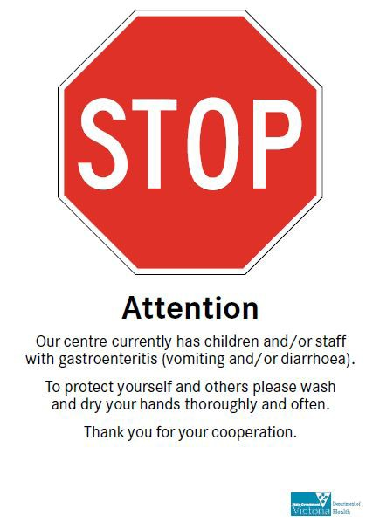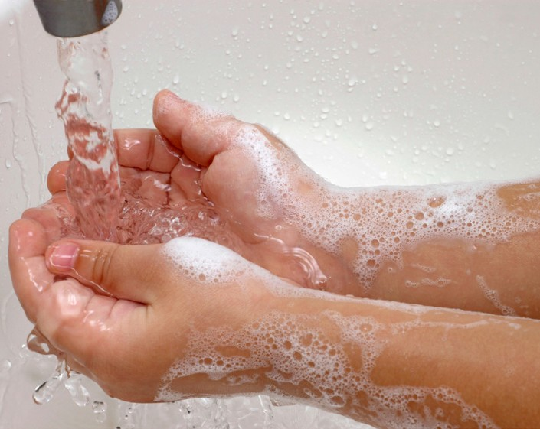Department of Education and Training
GPO Box 4367, MELBOURNE VIC 3001
Phoning us on 1300 307 415
Emailing us on licensed.childrens.services@edumail.vic.gov.au

