Regulation and Quality Assessment Update

This newsletter includes information for children’s services operating under the National Quality Framework and services operating under the Children’s Services Act 1996.
Issue 13 | May 2015

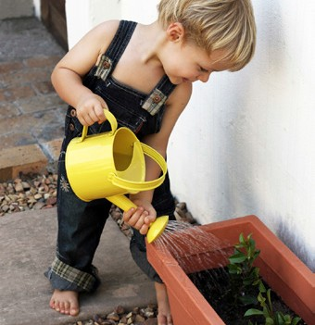

Latest news
Welcome to the third edition of our newsletter for 2015.
This edition promotes the importance of the many ways we communicate with you and provides information, including:
- the forthcoming changes to educator to child ratios for children aged 36 months
to preschool age commencing in 2016
- new requirements for early childhood teachers (ECT) to register with the Victorian Institute of Teaching (VIT) that commence in September 2015.
It focuses on resources to support services in meeting Quality Area 7 relating to
staff induction (7.1.2) and performance improvement (7.2.2).
I would also like to update you on the 2014 Review of the National Partnership Agreement on the National Quality Agenda for Early Childhood Education and Care (NQA review). Feedback from the early childhood sector has now closed.
The contribution made by the sector is acknowledged. This feedback will assist governments to make decisions on what
changes may be made in 2016 and beyond. Written submissions are available at: www.deloitteaccesseconomics.com.au/ our+services/nqf+consultation+ris
Finally, the Quality Assessment and Regulation Division (QARD) has published the 2014 Annual Report. It gives an overview of the work QARD does, regulating almost 4000 education and care services under
the National Quality Framework (NQF) and over 450 services which operate under
the Children’s Services Act. The report is available at: www.education.vic.gov.au/ childhood/providers/regulation/Pages/ newsletters.aspx
I hope you enjoy reading this edition.

Madeleine Smith Executive Director

Quality Assessment and Regulation Division Department of Education and Training

Ratios – changes coming into effect on 1 January 2016
The implementation of the National Quality Framework (NQF) in 2012 included a transitional provision under regulation 360 of the Education and Care Services National Regulations 2011 that applied to the educator to child ratios for children aged 36 months to preschool age for services operating in Victoria. This transitional provision applies until 31 December 2015.
From 1 January 2016 the educator to child ratios for children aged 36 months to preschool age will be 1 educator to 11 children (regulation 123(c)). This change will bring the educator to child ratios for services providing education and care for children in Victoria into alignment with the majority of other jurisdictions in Australia.
Age | Ratio  (1 January 2016) | Qualifications
Birth to 24 months | 1 educator to  4 children (regulations 123(1)(a)  and 357) | At least 50 per cent of required educators must have or be actively working towards1 at least an approved diploma level qualification (regulation 126(1)(a)).  All other required educators:  - must have, or be actively working towards, at least an  approved certificate III level qualification (regulation  126(1)(b)); or  - can be counted as a certificate III level qualified  educator without meeting the requirements of regulation  126(1)(b) if they have been employed on a probationary basis for not more than 3 months (regulation 126(1A)).
Over 24 months and less than 36 months of age

36  months to preschool age | 1 educator to  11 children (regulation 123(c))
Over preschool age | 1 educator to  15 children  (regulation 355) | At least 50 per cent of required educators must hold, or be enrolled in and studying for, at least a diploma level qualification approved for educators working with children over preschool age in Victoria (regulation 356(2)).  All other required educators must:  - hold or be actively working towards at least a certificate  III level qualification approved for educators working  with children over preschool age in Victoria; or  - commence obtaining that qualification within 6 months  of commencing to educate and care for children  (regulation 356(3)).
1 To be actively working towards a qualification an educator must:
- be enrolled in an at least an approved certificate III level education and care qualification; and
- provide the approved provider with documentary evidence from the provider of the course that—
  - the educator has commenced the course; and
  - is making satisfactory progress towards completion of the course; and
  - is meeting the requirements for maintaining the enrolment (regulation 10).

Regulation and Quality Assessment Update Issue 13 | May 2015 1

Children’s Services Act services

Behaviour guidance
Guiding children’s behaviour is an important aspect of caring for or educating young children. Positive strategies need to be developed to assist children to manage their own behaviour, respond appropriately to the behaviour of others and to communicate effectively to resolve conflict.

Staff members in children’s services can assist children to guide and
self-manage their behaviour through responsive interactions and positive communication that demonstrate respect for children and is based on the knowledge of each child including their developmental needs, individual differences, background and age.

There are important obligations for children’s services in relation to guiding children’s behaviour that include that no child being cared for or educated by the service is subjected to any form of corporal punishment or any discipline that is unreasonable in the circumstances (section 28).

Each service must have a policy on behaviour management that is available for inspection at the children’s service at all times the service is open for the care or education of children (regulation 41). The policy should include all the strategies staff members use and are expected to use to guide children’s behaviour and outline how the behaviour guidance strategies to be used with children are assessed.

The behaviour management policy may also include the procedures the service will follow for children with additional needs who may need to have an individual behaviour guidance strategy developed specifically for the child. In this circumstance it is essential that staff members consult with the child’s parents and seek additional professional assistance. If required, a suite
of behaviour guidance practice notes to assist services to guide children’s behaviour and develop a behaviour management policy are available at: www.education.vic.gov.au/childhood/providers/regulation/Pages/ vcspracnotes.aspx

Reporting serious incidents and complaints

Serious incidents
A children’s service is required to notify the Department when a serious incident occurs at the service. A serious incident is defined as:
- the death of a child while being cared for or educated by the service (section 29C(a)).
- any incident involving injury or trauma to a child while being cared for or educated by the service requiring the:
  - attention of a registered medical practitioner; or
  - admission to a hospital (section 29C(b))
- a child being cared for or educated by the service appears to be missing or otherwise unaccounted for or appears to have been taken or removed from the service contrary to the regulations (section 29C(c))
- any incident requiring attendance by emergency services (section 29C(d) and regulation 90(2)).
A children’s service must notify the relevant regional office by telephone within 24 hours of the incident, followed by written notification as soon as practicable (regulation 90(1)). Written notification is to be provided by using the Serious incident notification form available at: www.education.vic.gov.au/childhood/ providers/regulation/Pages/vcsforms.aspx

Complaints
The Department must also be notified of any complaint made to the service where the complaint alleges that:
- the health, safety or wellbeing of any child being cared for or educated by the children’s service may have been compromised; or
- there has been a contravention of the Act or Regulations (regulation 105(2)).
The complaint must be notified to the Department within 48 hours of the complaint being made, followed by written notification as soon as practicable (regulation 105(2)). Written notification should be provided by using the Complaint notification form available at: www.education.vic.gov.au/ childhood/providers/regulation/Pages/vcsforms.aspx

Responding to complaints
A children’s service must deal with, and respond to, any complaint relating to the children’s service:
- as soon as practicable after the complaint is made; and
- as discreetly as practicable in the circumstances (regulation 105(1)).
Written procedures for dealing with complaints must be developed and available at the service for inspection at all times the service is open for the care or education of children (regulation 41(i)).
As well as having a written complaints procedure, the following information must be displayed at the entrance to the service:
- name and telephone number of the person at the children’s service to whom complaints may be addressed (regulation 40(1)(h))
- Department’s regional office address and telephone number (regulation 40(1)(i)).
More information about serious incidents and complaints is available at: www.education.vic.gov.au/childhood/providers/regulation/Pages/ vcspracnotes.aspx
Details of the Department’s regional offices can be found in the fact sheet Quality assessment and regulation - regional offices available at: www.education.vic.gov.au/childhood/providers/regulation/Pages/ vcspracnotes.aspx

Updated fact sheets for services operating under the Children’s Services Act are available at: www.education.vic.gov.au/childhood/providers/regulation/ Pages/vcsfactsheets.aspx
- Standard licence - updated
- Limited hours licence - updated
- Volunteers in licensed children’s services - updated

Children’s Services Act services

Criminal history check requirements

The licensee, approved provider (in the case of an approved associated service), primary nominee
or nominee currently present and in charge of a children’s service must read the current assessment notice or volunteer assessment notice or VIT registration:
• before that person becomes an employee or is otherwise engaged as a staff member of a children’s service
• for each visiting early childhood intervention staff member (under regulation 70(7A) an early intervention worker is not required to have an assessment notice when they are under the immediate supervision of the proprietor or a qualified staff member)
• volunteers (under regulation 70(7)(a) & (b) a volunteer is not required to have an assessment notice when they are not considered as part of the child/staff ratios and is at all times under the immediate supervision of the proprietor or a qualified staff member).

Staff members include:
• all persons considered as part of the child/staff ratios
• cooks and administrative staff
• persons employed under traineeship programs who care for or educate the children
• persons appointed as inclusion support workers who care for or educate the children
• relief staff.
An employee or volunteer is not required to have an assessment notice or volunteer assessment notice if they are aged under 18 years and care f or or educate children under the immediate supervision of the proprietor or a qualified staff member.
An assessment notice and VIT can be checked for currency at:
• the Victorian Institute of Teaching register: www.vit.vic.edu.au/finditfast/Pages/ TeacherSearch.aspx
• an assessment notice should be checked regularly: https://online.justice.vic.gov.au/ wwccu/checkstatus.doj
More information is available in the practice note Criminal history check requirements available at: www.education.vic.gov.au/childhood/providers/ regulation/Pages/vcspracnotes.aspx

This article is provided by Gowrie Victoria

Self-Assessment Tool - Professional Learning Plan
The performance of educators, co-ordinators and staff members is evaluated and individual development plans are in place to support performance improvement. (7.2.2 ACECQA 2011)
The introduction of the Long Day Care Professional Learning Programme (LDCPLP) has drawn focus on the professional learning needs of all early years’ educators and the need for services to have a rigorous and robust plan, not only to improve the quality of current practices but to effectively manage professional learning budgets.
In recognition of the importance of developing a sound plan for professional development, the Professional Support Coordinator Alliance (PSCA) has developed a tool to assist services to determine the future learning needs of their educators by applying a strategic approach to quality improvement.
The Self-Assessment Tool - Professional Learning Plan aims to work within the context of the service’s existing Quality Improvement Plan (QIP) and philosophy and can be applied
service-wide or on an individual basis. The tool assists staff teams to reflect on current skills and practices, revealing strengths and identifying gaps.
The tool is divided into quality areas using statements that reflect the NQS standards and elements in a way that allows for honest evaluation by using a numbered rating scale, level 1 (aspiring) to level 4 (confident) to assess competence in relation to each statement.
After reflection and rating using the scale, it quickly becomes clear, simply by looking at the levels, where the learning gaps exist. Using the tool in team meetings supports reflective and stimulating discussions and contributions, allowing all voices to be heard. Service needs recognised as a priority can be fed directly into the QIP.
In light of the plethora of advertisements from a range of professional learning providers promoting opportunities and associated resources, an important aspect of the tool is to assist services in determining the professional learning approach required to target the learning need and how to select quality professional learning providers.
The recent ACECQA workshops delivered throughout Victoria were a great opportunity for services to be introduced to the tool and to think about what shape their future professional learning needs might take.
The Self-Assessment Tool - Professional Learning Plan (PSCA) can be found on the Gowrie Victoria website by visiting Professional Learning Home>Resources<Quality Area 7. The tool is downloadable in Word format and provides live links within the document, and is available at: www.gowrievictoria.org.au
For further information about LDCPLP please contact Linda Smart, Manager, Professional Learning at: psc@gowrievictoria.org.au

Annual fee reminder
The Education and Care Services National Law requires approved providers to pay an annual fee for each approved service. The fee is due by 1 July each year to the Regulatory Authority in the state or territory where the services are located, regardless of suspension, closures or subsequent transfers.

The annual fee invoices will be issued via email at the end of May 2015 to the approved provider’s email address listed on the NQAITS. You can update your contact e-mail address at: www.acecqa.gov.au/national-quality-agenda-it-system.
If your service is not operating a notification of surrender of service approval must be submitted by close of business 29 May 2015.

National Quality Framework

Focus on element – 7.1.2 and 7.2.2
There are many aspects to effective leadership and service management. The induction of educators and staff when they first start at a service and the evaluation of individual development plans to promote continuous performance improvement are two key facets that encourage an environment of collaboration, high expectations and a commitment to continually learn and improve.

Element 7.1.2 The induction of educators, co-ordinators and staff members is comprehensive
An induction process that is well planned and considered plays an important part in establishing a culture of professionalism and competency. It enables new and relief educators and staff members to have a clear understanding of expectations, their roles and responsibilities and to feel supported. It assists to install a sense of belonging and
contributes to a shared understanding of the service’s philosophy, code of conduct, practices and policies.
The induction process should be documented so that the process is consistent for each new educator and staff member and focus on promoting quality relationships that contribute to an environment that benefits children’s learning and development.
It is essential that the documented induction process includes the support provided to relief educators and staff members and how the service will continue to support each new educator and staff member through their ongoing orientation the service.
The induction process may include details about:
- information that will be prepared for each new educator and staff member when they start at the service
- how the new educator or staff member will gain an understanding of the service’s philosophy, code of conduct and ethics, policies and expectations
- whether a visit to the service will be arranged before actually starting to assist the educator or staff member become familiar with the service
- who will greet the new educator or staff member on their first day
- how will the children be introduced to the new educator or staff member
- who will be available to answer any questions and provide support
- who will give them information about the children and families in their room
- where will they store their personal belongings or will they have a designated clean area to work from depending on their role.

Element 7.2.2 The performance of educators, co-ordinators and staff members is evaluated and individual development plans are in place to support performance improvement.
Individual development plans must be documented for educators, co-ordinators and staff members. It is expected that a documented position description is in place when the educator, co-ordinator or staff
member begins at the service, so they have a clear understanding of their roles and responsibilities.
An individual development plan should be in place within 3 or
4 months of appointment and be reviewed on a regular basis thereafter, taking into account the length of engagement at the service.
The intention is that the performance of educators,
co-ordinators and staff members is evaluated regularly to inform the individual development plans and support performance improvement. Further information about
induction and managing performance is available at: www.elaa.org.au/services_ resources/free_resources.
The Professional Support Coordination Alliance (PSCA) has developed a self-assessment tool to support the performance improvement of educators (refer to page 3 of this newsletter).

Early childhood teacher registration information seminars
The Victorian Institute of Teaching is holding a series of one hour seminars about early childhood teacher registration during May and June in metropolitan and regional locations.
These seminars will help to ensure that early childhood teachers and their employers fully understand the requirements for registration, and provide an opportunity to meet Institute staff and ask questions.
Details about dates, venues and how to register are available at: www.vit.vic.edu.au/finditfast/ earlychildhood/Pages/default.aspx
Early childhood teachers and employers are also invited to submit an intent to register form to receive updates about early childhood teacher registration via a monthly circular which will be emailed to them. Intent to register form is available at: www.vit.vic.edu.au/finditfast/ earlychildhood/Pages/IntenttoRegisterForm.aspx
Early childhood teacher registration does not commence until 30 September 2015 and applications will not open until July.

Consultation on transition: a positive start to school initiative
Since the Transition: A Positive Start to School initiative was implemented in 2009, the Department, early childhood services, schools and outside school hours care (OSHC) services have continued to support children and families to transition to primary school.
The Department has commissioned Semann and Slattery to undertake a series of consultations from May to June 2015, to strengthen its understanding of:
- successful strategies being implemented to facilitate positive transitions to school for children and families
- how the Transition Learning and Development Statements and supporting resources are used
- how transition strategies are currently being evaluated by schools and services.
Early childhood, school and OSHC professionals, and families and children have been invited to participate.
The findings from this consultation will inform a review of transitions resources, and future work to strengthen children and families’ transition to school experiences.
More information about Transition: A Positive Start to School is available at: www.education.vic.gov.au/about/ programs/pathways/Pages/transabout.aspx

Leading people in early childhood settings
Applications are now open for Intakes 3 & 4 of Leading People in Early Childhood Settings, a professional learning opportunity offered by the Bastow Institute of Educational Leadership.
Learn how to enhance your ability to act effectively in early childhood settings, especially in maintaining healthy and productive relationships, and fostering a collaborative work environment.
The professional learning opportunity is suited to early childhood professionals responsible for, or aspiring to, a leadership role in an organisation or service based within an early childhood setting. Early childhood intervention professionals are also encouraged to apply.
Applications close Friday 29 May 2015 at 5.00 pm.
More information is available at: www.bastow.vic.edu.au/ courses/early-childhood

Regulation and Quality Assessment Update Issue 13 | May 2015 4

Focus on the National Quality Standard
As at March 2015, 65 per cent of approved education and care services in Victoria have received a quality rating. The pie charts below reflect the rating of Victorian education and care services by service type. The data is drawn from published assessment and ratings as at 31 March 2015.
Top 10 elements ‘not met’ in Victoria
The information below reflects the top 10 elements not met in Victoria in the period January to March 2015. Services may wish to consider how they are meeting these requirements.
1 | Element 1.2.1 | Each child’s learning and development is assessed as part of an ongoing cycle of planning, documentation and evaluation.
2 | Element 1.2.3 | Critical reflection on children’s learning and development both as individuals and groups, is regularly used to implement the program.
3 | Element 7.2.2 | The performance of educators, coordinators and staff members is evaluated and individual plans are in place to support performance improvement.
4 | Element 3.3.2 | Children are supported to become environmentally responsible and show respect for the environment.
5 | Element 1.1.3 | The program, including routines, is organised in ways that maximise opportunities for each child's learning.
6 | Element 3.3.1 | Sustainable practices are embedded in service operations.
7 | Element 2.1.1 | Each child’s health needs are supported.
8 | Element 7.3.5 | Service practices are based on effectively documented policies and procedures that are available at the service and reviewed regularly.
9 | Element 4.1.1 | Educator-to-child ratios and qualification requirements are maintained at all times.
10 | Element 1.1.4 | The documentation about each child’s program and progress is available to families

Resources

ACECQA NQF Snapshot Q1 2015 – May
ACECQA produces a quarterly NQF Snapshot that provides analysis and information on the state of the sector, progress of assessment and rating, quality rating of services and waivers held by the services.
The latest NQF Snapshot includes data drawn from the National Quality Agenda IT System (NQAITS) as at 31 March 2015 and is available at: www.acecqa.gov.au/national-quality-framework- snapshots

Publication of ratings and display of information
Services that have received their final ratings are required to display the ratings for each quality area and the overall rating (notice of rating) at the education and care service premises (including all family day care residences, venues and principal offices). For services not yet assessed the rating is Provisional Rating – Not Yet Assessed. Services not yet assessed must display:
  - a notice of provisional rating; and
  - the previous accreditation by the National Child Care Accreditation Council if applicable.
If no application for review of rating is made within 14 days of the Department’s rating decision, the rating set out in the notice of rating will be considered final and be published. The rating for each quality area and the overall rating for each service are available at: www.mychild.gov.au or at: www.acecqa.gov.au

New or updated resources are available at: www.education.vic.gov.au/childhood/providers/regulation/Pages/nqffactsheets.aspx

- Applying for provider approval - family day care - new
- Applying for service approval - family day care - new
- Family day care - updated
- Serious incidents and complaints - updated
- Operating an approved associated children’s service - updated
- Children with medical conditions attending education and care services - updated
- Meeting children’s health needs - updated
- Transporting children - updated

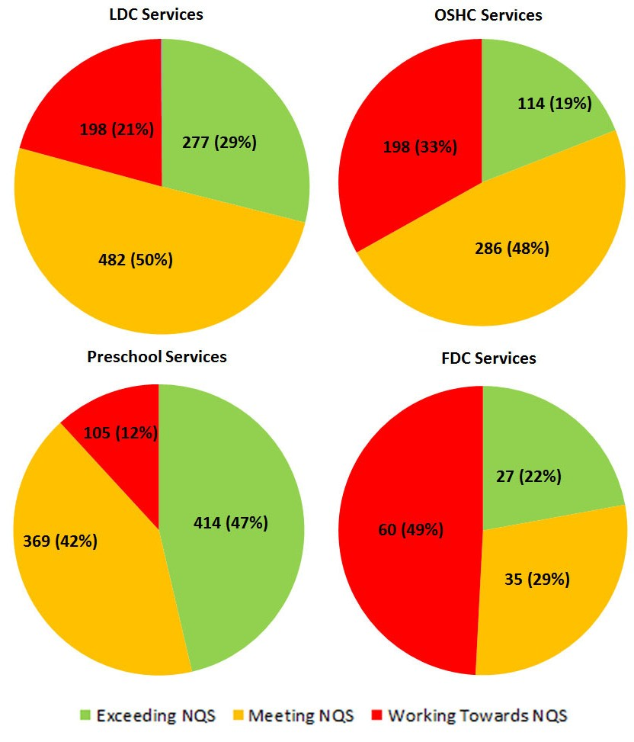
Keeping in touch
Department of Education and Training GPO Box 4367, MELBOURNE VIC 3001
You can get in touch with us by:
Visiting our website www.education.vic.gov.au
Phoning us on 1300 307 415
Emailing us on licensed.childrens.services@edumail.vic.gov.au
Regulation and Quality Assessment Update Issue 13 | May 2015
5

