Smoking bans

New smoking bans to apply to long day care and kindergarten grounds and entrances.

From 13 April 2015 there will be new laws banning smoking within four metres of an entrance to a long

that ‘No smoking’ signs must be installed at all entrances to an early childhood service or school. Signs can be ordered online at the Department of Health and Human Services (DHHS) website

[www.health.vic.gov.au/tobaccoreforms/](http://www.health.vic.gov.au/tobaccoreforms/) and any questions about the Tobacco Act can be directed to

the Tobacco Control Section on (03) 9096 0469 or [tobacco.policy@health.vic.gov.au](mailto:tobacco.policy@health.vic.gov.au)

Focus on element 2.1.2 Children’s requirements for sleep, rest and relaxation

Requirements for sleep, rest and relaxation of children are met having regards to the ages, developmental stages and individual needs of the children (regulation 81) (elements 2.1.2, 2.3.1 and 2.3.2). Babies have different sleeping needs to toddlers and older children.

**Safe sleeping**

Safe sleeping remains a critical safety issue for all education and care services, noting a recent coroner’s report regarding the sudden and unexpected death of a five month old child in an education and care service in Queensland.

Are the educators, staff members and volunteers at your service up to date with the latest research about safe sleeping?

Are sleeping children in a safe environment at your service? Are sleeping children adequately supervised?

Are cots, mattresses and any other bedding used by children safe? The following must be considered in relation to safe sleeping:

* all educators, staff members and volunteers implement safe sleeping practices and supervise sleeping children
* mattresses are firm and flat and meet the new Voluntary Australian Standard (AS/NZS 8811.1)
* cots meet the Australian Standards (AS/NZS 2172)
* the bedding available for children considers the age and size of the child, the activity levels of children and the desire of children to get out of cots.

It is recommended that when putting babies under 12 months of age to sleep:1

* they are put to sleep on their back from birth
* their head and face are uncovered
* the baby is kept smoke free
* blankets are tucked in firmly
* pillows, soft toys or doonas are never used in the cot.

A revised SIDS and Kids *Infant Safe Sleeping Child Care Kit* has been developed to inform services that educate and care for babies of the current and evidence-based SIDS and Kids Safe Sleeping recommendations. The Child Care kit is available at [www.sidsandkids.org/safe-sleeping/education-](http://www.sidsandkids.org/safe-sleeping/education-and-care-services/) [and-care-services/](http://www.sidsandkids.org/safe-sleeping/education-and-care-services/)

Further information about safe sleeping is available at Royal Children’s Hospital [www.rch.org.au](http://www.rch.org.au/)

Kidsafe Victoria [www.kidsafevic.com.au](http://www.kidsafevic.com.au/)

1. Source: SIDS and Kids - safe sleeping [www.sidsandkids.org/safe-sleeping](http://www.sidsandkids.org/safe-sleeping)

Regulation and Quality Assessment Update Issue 12 | March 2015

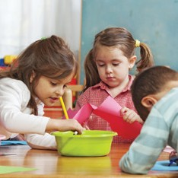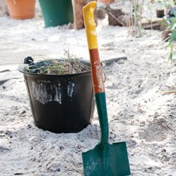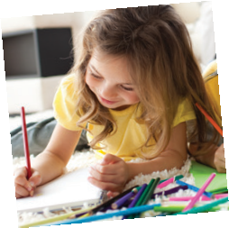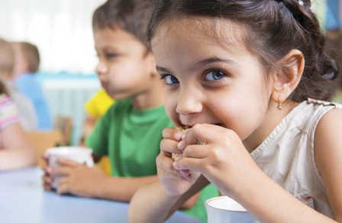

Issue 12 | March 2015

Quality Framework and services operating under the Victorian children’s services legislation.

**Latest News**

day care service, kindergarten or school as well as within the grounds. The Tobacco Act now requires

Pg 1

**Children’s Services Act services**

**New first aid and anaphylaxis management training courses have been approved for services operating under the *Children’s Services Act 1996* and others have been removed (or revoked). More details are available at** [**www.education.vic.gov.au/**](http://www.education.vic.gov.au/childhood/providers/regulation/Pages/vcs.aspx)[**childhood/providers/regulation/Pages/vcs.aspx**](http://www.education.vic.gov.au/childhood/providers/regulation/Pages/vcs.aspx)

Welcome to our second newsletter for 2015. This newsletter focuses on keeping children safe and providing quality education and care for babies and toddlers. It includes articles about keeping children safe when sleeping, when children use the school bus and bottle feeding babies.

Now that we are well into the year, services may be considering planning excursions or outings in the local community and some services also may be planning to incorporate a bush kinder as part of the educational program. Services must prioritise how to keep children safe and educators must be aware of their responsibility to keep children safe at all times. Active supervision, identifying hazards and risks and ensuring the relevant number of educators are with children are some ways of keeping children safe. Having children actively engaged in

programs which meet their developmental needs also contributes to their safety and wellbeing. Several factsheets to assist services to keep children safe during excursions and setting up

a bush kinder are available at [www.education.](http://www.education.vic.gov.au/childhood/providers/regulation/Pages/nqffactsheets.aspx) [vic.gov.au/childhood/providers/regulation/Pages/](http://www.education.vic.gov.au/childhood/providers/regulation/Pages/nqffactsheets.aspx) [nqffactsheets.aspx](http://www.education.vic.gov.au/childhood/providers/regulation/Pages/nqffactsheets.aspx)

Also in this newsletter there is information providing support to educators in the quality of programs for infants, toddlers and their families.

**Madeleine Smith Executive Director**

*Quality Assessment and Regulation Division Department of Education and Training*

Regulation and Quality Assessment Update

This newsletter includes information for children’s services operating under the National

Bottle feeding

There are important issues that need to be managed when bottle feeding babies:

* + bottles must be properly sterilised and prepared (regulations 77(1) and 168)
  + correct formula, as per instructions must be used
  + formula or breast milk must be refrigerated at the correct temperature
  + the temperature of the milk and ways of warming the bottle must be safe. Microwaves are not recommended for heating bottles as they warm bottles

unevenly and create hot spots in the milk.

Babies must never be left alone when feeding from a bottle as this carries a risk of choking. Babies and older children should never be given bottles to take to their cots or beds, as this can cause tooth decay from the milk sugars and damage teeth.

Educators should use bottle feeding as an opportunity for quality one on one time to further cement warm nurturing and trusting relationships with children (standard 5.1). Services may consider putting comfortable furniture, such as chairs or sofas, in babies’ rooms to support feeding times.

More information about bottle feeding is available on the following websites: Bottle feeding – safety issues [www.betterhealth.vic.gov.au/Bhcv2/bhcpdf.nsf/](http://www.betterhealth.vic.gov.au/Bhcv2/bhcpdf.nsf/ByPDF/Bottle_feeding_safety_issues/%24File/Bottle_feeding_safety_issues.pdf)

[ByPDF/Bottle_feeding_safety_issues/$File/Bottle_feeding_safety_issues.pdf](http://www.betterhealth.vic.gov.au/Bhcv2/bhcpdf.nsf/ByPDF/Bottle_feeding_safety_issues/%24File/Bottle_feeding_safety_issues.pdf)

Bottle feeding <http://raisingchildren.net.au/articles/how_to_bottle-feed.html>

Pg 2

Focus on the National Quality Standard (NQS)

Overall the final ratings for services in Victoria have continued to compare favourably with the national results, with 78 per cent of services meeting or exceeding the NQS compared to

65 per cent nationally.

The graphs below display the quality ratings results of each of the seven quality areas by service type. In Victoria, services are more likely to be:

* + - rated as Meeting or Exceeding NQS in Quality Areas 6 (95%), 4 (93%) and 5 (93%)
    - rated as Working Towards NQS in Quality Areas 1 (18%), 7 (17%), 2 (13%) and 3 (12%).

**Applying for Excellent rating**

The approved provider of a service with an overall rating of Exceeding NQS can choose to apply for an Excellent rating. The Excellent rating is the highest rating an education and care service can achieve.

The Excellent rating is awarded by the Australian Children’s Education and Care Quality Authority (ACECQA) and is assessed using the following criteria:

* + - the service exemplifies and promotes exceptional education and care that improves outcomes for children and families
    - the service demonstrates leadership that contributes to the development of a community, a local area, or the wider education and care sector
    - the service demonstrates commitment to sustained excellent practice through continuous improvement and comprehensive forward planning.

To apply for the Excellent rating, providers must complete the application form and demonstrate how their service meets the criteria. Further information about the Excellent rating, guidelines for applicants and the application form is available at [www.acecqa.gov.au/excellent-rating](http://www.acecqa.gov.au/excellent-rating)

Regulation and Quality Assessment Update Issue 12 | March 2015

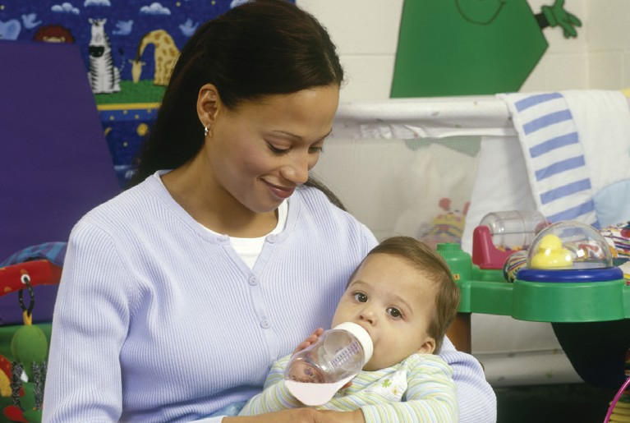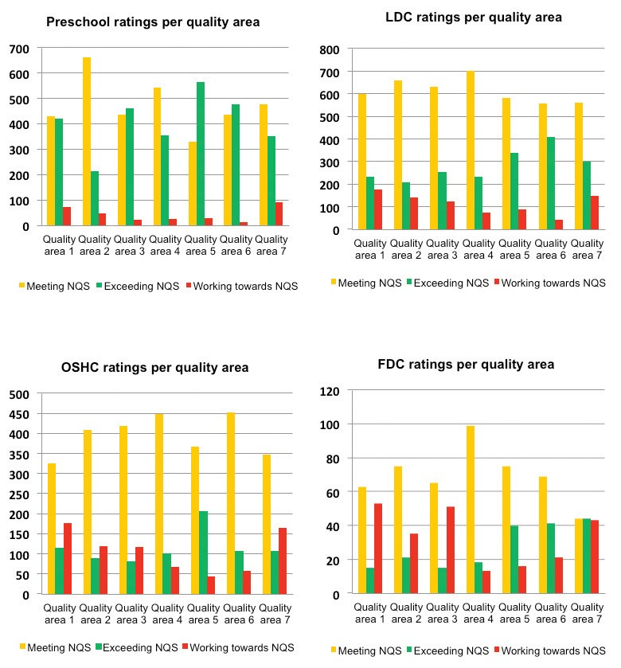

Travel by school bus

Families in rural and regional Victoria with pre-school children who have turned four years of age may use the School Bus Program to transport their children to and from preschool. There have been a number of occasions over the past couple of years where children travelling on a school bus have not been delivered to their education and care service, and have remained on the school bus alone and unsupervised.

All services that have arrangements in place for children to travel by school bus to the education and care service are requested to review their policies and procedures to ensure that all children travelling to the education and care service are safely collected from the school bus.

Each service should include in their delivery and collection policy and procedures details of these arrangements including communication protocols between the parents and the service where a child does not arrive at the service by bus when expected.

The School Bus Program has specific requirements for both education and care services and for families accessing the School Bus Program. More information is set out in the School Bus Program Policies and Procedures available at [www.education.vic.gov.au/studenttransport](http://www.education.vic.gov.au/studenttransport)

More information about excursions and transporting children is available at [www.education.vic.gov.au/childhood/providers/regulation/Pages/nqffactsheets.](http://www.education.vic.gov.au/childhood/providers/regulation/Pages/nqffactsheets.aspx) [aspx](http://www.education.vic.gov.au/childhood/providers/regulation/Pages/nqffactsheets.aspx)

Focus on element

2.2.1 Nutrition

for children in

education and

care services

**In the last newsletter, we spoke about the importance of healthy eating**

**for children. All education and care services are required to meet the requirements and ensure children’s nutritional needs are met.**

**What are the requirements?**

**All services (whether providing food or not) must:**

* **ensure that healthy eating is promoted and food and drinks provided by the service are nutritious and appropriate for each child (element 2.2.1)**
* **have in place policies and food and beverages, dietary**



**and procedures are followed (regulation 168(2) and 170)**

* **ensure children have access to safe drinking water at all times (regulation 78)**
* **ensure children are offered food**



**the needs of each child on a regular basis throughout the day**



**In addition, services who provide food must:**

* **ensure that food and beverage is nutritious and adequate in quantity (regulation 79)**
* **ensure that food and beverage is appropriate for each child’s**

**growth and developmental needs and cultural, religious or health**



* **have the weekly menu displayed**



**children being educated and cared for by the service (regulation 80)**

* **ensure that the weekly menu accurately describes the food and beverages to be provided by the service each day (regulation 80).**

**More information about planning nutritious meals, promoting healthy eating and developing healthy eating policies is available at** [**www.heas.**](http://www.heas.healthytogether.vic.gov.au/early-childhood-services/early-childhood-services)[**healthytogether.vic.gov.au/early-**](http://www.heas.healthytogether.vic.gov.au/early-childhood-services/early-childhood-services)**childhood-services/early-childhood-services**

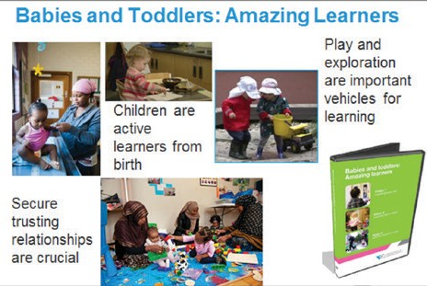

Regulation and Quality Assessment Update Issue 12 | March 2015 Pg 3

Improving the quality of programs and supports for infants, toddlers and their families

The Victorian Curriculum and Assessment Authority (VCAA) Early Years Exchange (EYE) is an online resource to support ongoing implementation of the Victorian Early Years Learning and Development Framework (VEYLDF). EYE edition number 14 was released in November 2014, and is a special edition that focuses on the importance of learning in the birth-to-three years period. This edition is available on the VCAA website at [www.vcaa.vic.edu.au/Pages/earlyyears/eye/index.aspx](http://www.vcaa.vic.edu.au/Pages/earlyyears/eye/index.aspx)

**Video resource:** *Babies and toddlers: Amazing learners* a series of 3 videos with narration by Anne Stonehouse AM. Selected examples of significant learning in the birth-to-three period are showcased and include everyday learning that occurs frequently in a variety of settings.

**Video 1:** Learning about me-learning about culture, family and community

**Video 2:** Learning about others-learning to be with others and how to relate with others

**Video 3:** Learning about my world using our senses and abilities to explore

**Using the videos**

A booklet is provided to support early childhood professionals to use this resource. It includes suggested questions to use with any of the three videos, notes about the children in the videos, key messages and examples of evidence of children’s learning in ‘every day learning‘. The visual footage lends itself to discussion about the likely learning that is occurring.

Critical reflection with colleagues and with families over time supports rich discussions. Wondering about young children’s learning, sharing evidence and asking questions is important.

This resource can be used to support educators in a range of services and settings in looking closely at the learning that is occurring and linking the content to the five Learning Outcomes in the VEYLDF and in the Early Years Learning Framework for Australia (EYLF). These Outcomes are daily priorities for early childhood professionals in providing rich and varied learning experiences for young children.

**Embedded literacy experiences in the curriculum for babies and toddlers**

*Literacy resource developed by five educators at Gowrie Victoria, Docklands in consultation with Anne Stonehouse*

Becoming literate is complex and begins at birth. This resource in the EYE 14 edition describes a number of curriculum areas that support children learning skills and understandings for now and for long term learning. Educators describe the ways that rich literacy learning opportunities for all children are woven through their daily experiences and interactions in a variety of areas.

This literacy resource can be used to talk with families about the educational program and how educators embed literacy into many everyday opportunities in ways that have meaning for children.

Some of these experiences are planned ahead and offered at a particular time, whilst others feature in interactions and conversations with children and occur throughout the day.

**Literacy action plan**

This resource document can be used as an audit tool to discuss and review practices in the service, room or within a team of educators.

The more adults appreciate babies’ and toddlers’ learning, the more effectively they can support it. Key considerations would include a focus on identifying new opportunities to identify subtle learning

and plan for children’s ongoing learning.

How might small teams review open – ended conversations with children in which you encourage them to express their ideas, interests and preferences?

How might small teams review the ways that they observe children’s cues and initiate conversations based on them?

For further information contact Carmel Phillips, Manager, Early Years Unit, Victorian Curriculum and Assessment Authority at [phillips.carmel.j@edumail.vic.gov.au.](mailto:phillips.carmel.j@edumail.vic.gov.au)

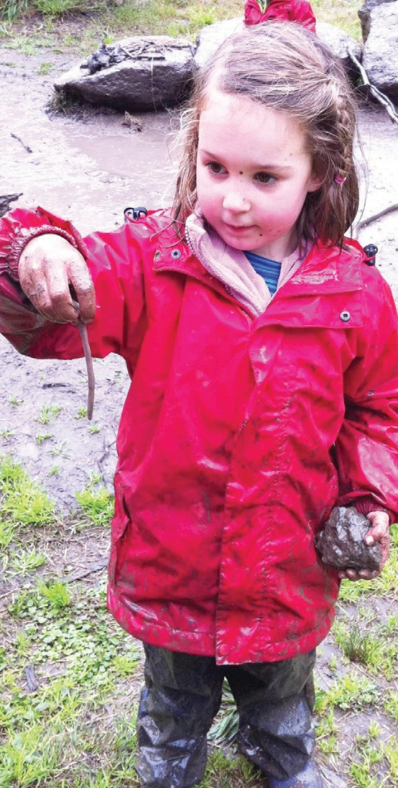

Visiting our website [**www.education.vic.gov.au**](http://www.education.vic.gov.au/)

**Keeping in touch You can get in touch with us by:**

**Department of Education & Training** Phoning us on **1300 307 415**

**GPO Box 4367, MELBOURNE VIC 3001** Emailing us on [**licensed.childrens.services@edumail.vic.gov.au**](mailto:licensed.childrens.services@edumail.vic.gov.au)

Regulation and Quality Assessment Update Issue 12 | March 2015 Pg 4

**Resources**

New or updated resources for services are available at [www.education.vic.gov.au/childhood/providers/regulation/Pages/nqffactsheets.aspx](http://www.education.vic.gov.au/childhood/providers/regulation/Pages/nqffactsheets.aspx)

* + Bush kinders – updated
  + Assessment and rating fact sheets - updated

**Other resources**

Victorian Assessment and Curriculum Authority [www.vcaa.vic.edu.au/Pages/earlyyears/eye/index.aspx](http://www.vcaa.vic.edu.au/Pages/earlyyears/eye/index.aspx)

NQAITS

The National Quality Agenda IT System (NQAITS) is a useful online tool for educators and providers. Registered users of the NQAITS can view provider and service details, submit applications and notifications and pay invoices related to their provider, service and certified supervisor approvals using NQAITS. Information is available at [acecqa.gov.au/national-quality-agenda-it-system](http://acecqa.gov.au/national-quality-agenda-it-system)

Nature play week

**Nature Play Week is a state-wide initiative of The Kids in Nature Network, supported by Sport and Recreation Victoria. It promotes the benefits of natural spaces**

**and their limitless options for children to play and imagine. All Victorian events are listed on the online Calendar including the Early Childhood Outdoor Learning Seminar. Further information is available at** [**www.natureplayweek.org.au**](http://www.natureplayweek.org.au/)

Early childhood teacher registration

All qualified early childhood teachers who are employed or engaged as an early childhood teacher in an education and care service or a children’s service need to be registered with the Victorian Institute of Teaching (the Institute) from 30 September 2015.

Further information about registration as an early childhood teacher including frequently asked questions is available on the Institute website at [www.vit.vic.edu.au](http://www.vit.vic.edu.au/)

If you submit an ‘intent to register’ form ([www.vit.vic.edu.au/finditfast/earlychildhood/](http://www.vit.vic.edu.au/finditfast/earlychildhood/Pages/IntenttoRegisterForm.aspx) [Pages/IntenttoRegisterForm.aspx](http://www.vit.vic.edu.au/finditfast/earlychildhood/Pages/IntenttoRegisterForm.aspx)) the Institute will email you a monthly circular about early childhood teacher registration. Submitting the form is not a commitment to register, so anyone can submit it and receive the information.

Scholarships and incentives

**Employment incentives for Early Childhood Teachers** valued at up to $15,000 are available to provide kindergarten and long day care services in regional and remote communities and Aboriginal early childhood services with financial support to attract and retain qualified early childhood teachers to deliver an approved kindergarten program.

Applications are accepted at any time. For more information and application documentation is available at [www.education.vic.gov.au/about/careers/Pages/incentives.](http://www.education.vic.gov.au/about/careers/Pages/incentives.aspx) [aspx](http://www.education.vic.gov.au/about/careers/Pages/incentives.aspx)

**Early childhood scholarships for Aboriginal People** are available for Aboriginal people working in a Victorian early childhood setting, or for Aboriginal people who can demonstrate a willingness and commitment to working in an early childhood setting to attain or upgrade an early childhood education qualification. Following completion of the course, successful recipients are required to work for a minimum period of time in a Victorian early childhood setting, including Multifunctional Aboriginal Children’s

Services (MACS), Children and family centers (CFCs), Aboriginal Best Start, Aboriginal Playgroups, In Home Support, Home Based Learning or Child and Family Services in an Aboriginal cooperative or corporation.

Scholarships range from $1,500 for a Certificate III in Early Childhood Education and Care to $12,000 for an Early Childhood Teaching Degree.

Application are accepted at any time, and application documentation is available at [www.](http://www.education.vic.gov.au/about/careers/Pages/aboriginal.aspx) [education.vic.gov.au/about/careers/Pages/aboriginal.aspx](http://www.education.vic.gov.au/about/careers/Pages/aboriginal.aspx)

For more information contact **1300 651 662** or email

[early.years.workforce@edumail.vic.gov.au](mailto:early.years.workforce@edumail.vic.gov.au)