Regulation and Quality Assessment Update

This newsletter includes information for education and care services operating under the National Quality Framework and Children’s services operating under the Children’s Services Act 1996.

Issue 14 | June 2015

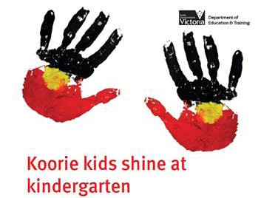
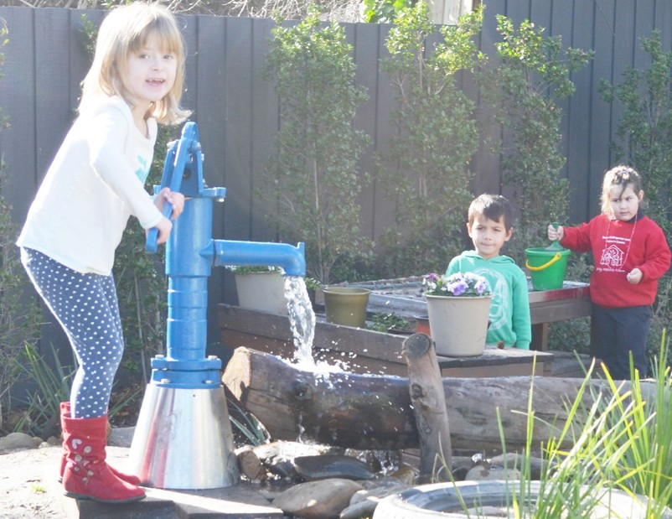
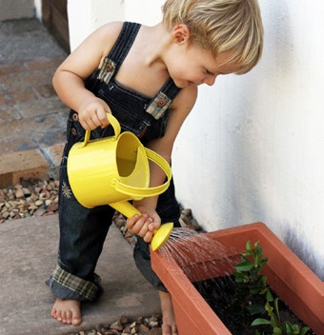

Latest news
Excellent rating - Baxter Kindergarten and Children’s Centre

Welcome to the fourth edition of our newsletter for 2015.
The Victorian Government has recently begun a state-wide consultation to make Victoria the Education State. You are encouraged to share information about this consultation with parents at your service so they can contribute their ideas and help to shape a shared vision for our early education system. Information for parents, including a letter that can be sent to the parents encouraging them to get involved in making Victoria the Education State is available at: www.education.vic.gov.au/Pages/ educationstate.aspx
In this edition you will find information about the ratings of different service care types. I am pleased that more than 65 per cent of services
have now been assessed and rated. We plan to assess and rate nearly all services by the end of the year.
Services should regularly complete their own self-assessment to inform their practices and quality improvement plan. The responsibility for complying with the Education and Care Services National Law Act 2010 rests with the approved provider. A range of resources to assist
services is available on both the Department of Education & Training and Australian
Children’s Education and Care Quality Authority (ACECQA) websites.
Gowrie Victoria, the Professional Support Coordinator (PSC) for Victoria, also provides support to services to meet the requirements of the National Quality Standard.
In this newsletter there is further information for early childhood teachers as they prepare for Victorian Institute of Teaching (VIT) registration, which commences on 30 September 2015.
To assist services prepare for the new educator to child ratios of 1:11 for children 36 months
to preschool age on 1 January 2016, two fact sheets have been developed: Educator to child ratios - centre-based services and Educator to child ratios for funded kindergarten programs. These fact sheets are available at: www. education.vic.gov.au/childhood/providers/ regulation/Pages/nqffactsheets.aspx

Madeleine Smith Executive Director
Quality Assessment and Regulation Division Department of Education and Training
Baxter Preschool & Children’s Centre (Baxter) was awarded the Excellent rating on 5 May 2015, the fifth service in Victoria to achieve the excellent rating. The service is located in Baxter and works with financially vulnerable families and children with additional needs.
Baxter operates a high quality service that exemplifies an outstanding education and care program that is closely tailored to children’s and families’ needs. Drawing on data on the local area from the Australian Early Development Census (AEDC), the service initiated an extended hours education and care program which wrapped around the service’s preschool hours, as well as a Saturday program which
enabled families to work on the weekends. The service also identified a need to encourage local indigenous families to access the preschool program, engaging with local elders and the Yarn Strong Sista to assist with the development of cultural competence and programming. The service reaches out to families who may not usually attend kindergarten, to improve outcomes for children.
Baxter’s leadership is committed to the professional development of educators including inviting schools and services in the wider community to professional development sessions to continually improve knowledge, practices and environments to enhance children’s learning and growth.
This service is an example of excellence in education and care for all children.

Koorie Kids Shine at Kinder
In April 2015, Minister Mikakos launched the Koori Kids Shine at Kinder campaign aimed at narrowing the gap of Aboriginal children’s participation in kindergarten. The first wave of communication was sent to parents, with the message that it’s not too late to enrol Aboriginal children in three or four year old kindergarten. Community and early childhood
services assisted in displaying and distributing material sending this important message.
We urge services to continue working with community partners to ensure that Aboriginal and Torres Strait Islander children are
prioritised to access a quality kindergarten program in all settings.
For further information about the Koorie Kids Shine at Kinder Campaign, contact your regional office or Priya Devendran, Early Learning Participation Unit on 9651 3397 or devendran.priya.p@ edumail.vic.gov.au

This artwork is adapted from original artwork by Dixon Patten. Dixon is an Aboriginal person from the Yorta Yorta peoples (Murray River) and Gunnai peoples (Gippsland area) of Victoria. Dixon is a freelance graphic designer and uses a new age digital medium (computer art) that is
contemporary, organic and yet, Aboriginal.

Regulation and Quality Assessment Update Issue 14 | June 2015 1

Questions and answers about QARD

Do Authorised Officers have Early Childhood Education qualifications?
Regional authorised officers employed by the Quality Assessment and Regulation Division (QARD) at the Department of Education and Training (DET) have relevant early childhood or school aged care qualifications and experience in the early childhood or school aged care sector.

What ongoing training do Authorised Officers complete and how regularly is it updated?
On appointment all authorised officers complete orientation and mandatory training that has been developed for authorised officers in each state or territory across Australia. The training includes topics such as the legislative framework for the National Quality Framework, the approved learning frameworks, compliance and monitoring and the assessment and rating process.
Authorised officers must also complete a reliability test prior to commencing to assess and rate services. The reliability test ensures that they have developed a consistent approach to assessment and rating. Thereafter, a drift test must be completed annually to ensure that they continue to maintain reliability.
Ongoing training is regularly provided to authorised officers to ensure that each authorised officer has current knowledge and skills required to support them in their role including in conducting compliance visits, investigations and assessing and rating services. The training also addresses changes to the legislation, policy and practices and promotes consistent practice. Recently 20 authorised officers from QARD completed the Certificate IV in Government Investigations.
Professional development is also provided to update authorised officers on contemporary practice and to ensure they understand the context of each service type operating in the National Quality Framework (preschools, long day care, family day care and outside school hours care services). In 2014 speakers included:
  - Professor Iram Siraj - Key determinants of quality in education and care services
  - Dr Jillian Rodd - Leadership and the pathway to quality improvement
  - Heather Barnes and Catharine Hydon presented sessions about the National Quality Framework including discussion of the unique contexts for outside of school hours care and family day care services.
In addition ACECQA has an Authorised Officer website that provides a variety of on-line training covering relevant topics such as writing an assessment and rating report or Cultural competence.

Who can services contact if they require clarification after a compliance visit?
Regionally based QARD area teams are responsible for conducting compliance visits to education and care services. Where further clarification is required after a compliance visit this may be provided by the relevant QARD area team.
The contact details of area offices are available in the fact sheet Quality Assessment and Regulation – Regional Offices available at: www.education.vic.gov.au/childhood/ providers/regulation/Pages/nqffactsheets.aspx

Who can a service speak to if they are in doubt about the interpretation of a regulation?
Services and members of the public who have queries about the interpretation of a regulation may contact the QARD enquiry line on 1300 307 415 or by email to: licensed. childrens.services@edumail.vic.gov.au

Where can up to date QARD news or resources be found? Can services subscribe to regular updates or newsletters?
QARD provides information specifically to support education and care services to comply with the requirements of the National Quality Framework. This information is in addition to the resources that ACECQA provides on their website at http://acecqa.gov.au/welcome
Information including resources such as fact sheets, frequently asked questions and guides can be found on the QARD section of the Department’s website at: www.education.vic. gov.au/childhood/providers/regulation/Pages/default.aspx

Children’s facilities capital grants program
‘GRANT ROUND NOW OPEN’
The Victorian Department of Education and Training invites applications from eligible organisations for the following capital grants:
  - Integrated Children’s Centre grants
  - New Early Learning Facility grants
  - Early Learning Facility Upgrade grants
  - Minor Infrastructure grants
These grants are available to establish new children’s facilities or for upgrading existing early years’ facilities to support the delivery of a funded kindergarten program. The Children’s Facilities Capital Program grants round is now open with expressions of interest closing on
7 August 2015 for major infrastructure grants, and applications for minor grants closing on 17 July2015.
Application guidelines and forms can be downloaded from: www.education.vic.gov.au/ecsmanagement/ capitalprogram
Enquiries about the application process can be directed by email to: childrens.capital.program@edumail.vic. gov.au

Employment incentives for early childhood teachers
Employment Incentives for Early Childhood Teachers valued at up to $15,000 are available to provide kindergarten and long day care services in regional and remote communities and Aboriginal early childhood services with financial support to attract and retain
qualified early childhood teachers to deliver an approved kindergarten program.
Applications are accepted at any time. For more information and application documentation visit: www.education.vic.gov.au/about/careers/Pages/ incentives.aspx

Early childhood scholarships for Aboriginal people
Early childhood scholarships are available for Aboriginal people working in a Victorian early childhood setting, or for Aboriginal people who can demonstrate willingness and commitment to working in an early childhood setting to attain or upgrade an early childhood education qualification. Following completion of the course, successful recipients are required to work for a minimum period of time in a Victorian early childhood setting, including MACS, CFCs, Aboriginal Best Start, Aboriginal Playgroups, In Home Support, Home based learning or Child and Family Services in an Aboriginal cooperative or corporation.
Scholarships range from $1,500 for a Certificate III in Early Childhood Education and Care to $12,000 for an Early Childhood teaching degree.
Applications are accepted at any time, and are available at www.education.vic.gov.au/about/ careers/Pages/aboriginal.aspx
For more information contact 1300 651 662 or email

early.years.workforce@edumail.vic.gov.au
Children’s Services Act - new licensing fees and penalties
The Children’s Services Act 1996 and the Children‘s Services Regulations 2009 identify a range of fees and penalties payable in relation to the licensing of children’s services.Licensing fees and penalties are updated annually on 1 July based on an increase to the value of a fee unit and penalty unit announced by the Treasurer. From 1 July 2015 to 30 June 2016 the value of a fee unit will be $13.60 and the value of a penalty unit will be $151.67.
Updated licensing fees and penalties will be available from 1 July 2015 on the Department of Education and Training website at:
www.education.vic.gov.au/childhood/providers/regulation/Pages/feesandpenalties.aspx

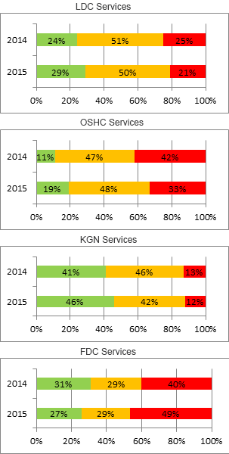
Focus on the National Quality Standard
At March 2015, 65 per cent of approved education and care services in Victoria had received a quality rating compared to 39 per cent at March 2014. The graphs below show a comparison of the ratings for Victorian education and care services by service type, comparing the published service ratings for March 2014 and March 2015.

The above data indicates an increase in exceeding ratings from 2014 to 2015 for all service types except FDC, where the exceeding ratings have decreased from 31 per cent in March 2014 to 27 per cent in March 2015. Similarly, an overall decrease is observed in working towards ratings from 2014 to 2015 for all service types except FDC, where the working towards ratings have increased from 40 per cent in March 2014 to 49 per cent in March 2015.
Providing feedback on the draft assessment and rating report
The approved provider has the opportunity to provide a response to the Department following receipt of the draft assessment and rating report if there are any factual inaccuracies or specific concerns that the approved provider believes would impact on the service’s rating. This feedback must be received within 10 working days of receipt by the service of the draft report. The Department will consider the service’s feedback and any amendments will be reflected in the final assessment and rating report. In some instances, this may change the service’s rating.
The approved provider should use the ACECQA template for providing feedback to provide feedback on the draft assessment and rating report, available at: www.acecqa.gov.au/assessment-and-rating-resources
For further information about the process see the ACECQA Information sheet The assessment and rating report, available at: www.acecqa.gov.au/ assessment-and-rating-resources
Note: The ‘kindergarten services’ type in the graphs above refers to stand alone kindergarten services only, it does not refer to kindergartens that are part of a long day care service. In case of services that offer more than one type of care the predominant type of care is considered.
Annual fee reminder
The National Law requires approved providers to pay an annual fee for each approved service. The fee is due by 1 July each year to the Regulatory Authority in the state or territory where the services are located, regardless of suspension, closures or subsequent transfers.
Annual fee invoices were issued via email on 29 May 2015 to the approved provider’s email address listed on the NQA ITS. Payment is due by 1 July 2015.
If you have any queries about annual fee invoices please email childrens.services.register@edumail.vic.gov.au

Children’s Services Act services
Nutrition for children
Services operating under the Children’s Services Act 1996 are required to ensure children’s nutritional needs are met.
What are the requirements?
All services (whether providing food or not) must ensure that:
- children have access to fresh drinking water at all times (regulation 79)
- food and beverages are offered to the children at frequent and regular intervals (regulation 80(a))
- food and beverages are stored, handled and prepared on the premises
in a clean manner and protected from contamination (regulation 80 (b)(c))
- there are suitable eating arrangements for children at the premises (regulation 80(d))
In addition, where food is provided by the service, ensure that:
- a weekly menu is displayed and accurately describes the food to be provided each day (regulation 81(a))
- food is nutritious, varied and adequate in quantity, and appropriate to the children’s growth, cultural and developmental needs (regulation 81(b)).
Resources for Children’s Services Act services are available online at: www.education.vic.gov.au/childhood/providers/regulation/Pages/vcs. aspx
Did you know?
Answers to frequently asked questions (FAQs) have been developed by the Department on a range of topics, such as children’s health and safety, educational programs and practice, leadership and service management, monitoring and compliance and staffing arrangements.
These FAQs are available at: www.education.vic.gov.au/childhood/ providers/regulation/Pages/nqffaq.aspx
The Australian Children’s Education and Care Quality Authority (ACECQA) has also developed answers to frequently asked questions on the National Quality Framework, these FAQs are available at: www.acecqa.gov.au/ searchfaqs

Managing gastro outbreaks
Gastroenteritis (gastro) outbreaks may occur in early childhood services from time-to-time. This article provides information for services operating under the Education and Care Services National Law Act 2010 and the Children’s Service’s Act 1996 about what do if an outbreak occurs.
Gastro is an illness that is caused from a variety of different bacteria, viruses or parasites. Symptoms include diarrhoea, nausea, vomiting and abdominal pains and may be experienced over several hours, days or weeks, and may also be accompanied by fever, headache and lethargy. Generally, gastro is spread through person-to–person contact (viruses), or by consuming contaminated food or water (bacteria, viruses or parasites).
Note: an outbreak is defined as two or more cases of vomiting and/or diarrhoea occurring among children and/ or staff within 48 hours of each other.

Who should a service contact in the event of a gastro outbreak?
Notify the Department of Health and Human Services (DHHS) on 1300 651 160 within 24 hours. The department officer will collect information and provide advice on any actions required. It is essential that details of the outbreak, and the control measures in place, are conveyed to staff and families.
The service or approved provider does not need to notify the Department of Education and Training, as DHHS will automatically send an alert to the Department of Education and Training.

Did you know? Effective hand washing is the most important measure in preventing the spread of infection.
Further resources:
  - A guide for the management and control of gastroenteritis outbreaks in children’s centres - docs.health.vic.gov.au/docs/doc/A-

guide-to-for-the-management-and-control-of-gastroenteritis- outbreaks-in-childrens-centres
  - Guidelines for the Investigation of Gastrointestinal Illness - ideas. health.vic.gov.au/diseases/gastrointestinal-Illness-guidelines. asp
  - The minimum period of exclusion from primary schools and children’s services for infectious diseases - ideas.health.vic.gov. au/guidelines/school-exclusion-table.asp

Long day care services with funded kindergarten programs are missing out on Early Start Kindergarten grants!
Recent work with providers and Child FIRST highlighted that a significant number of long day care (LDC) services are unaware of Early Start Kindergarten (ESK) funding and how this can work with other entitlements to support the sustained participation of vulnerable children in quality kindergarten programs.
ESK and ESK Extension grants can be used in combination with other entitlements (such as CCB and CCR) for eligible three and four year olds. It has been particularly useful in transitioning from SCCB funding.
Identification of eligibility is simple; workers, carers or family members can alert services verbally or in writing that the child identifies as Aboriginal
or Torres Strait Islander or is known to Child Protection. Applications are made using the Kindergarten Information Management (KIM) system.
For more information you can access the Kindergarten Guide 2015 available at: www.education.vic.gov.au/childhood/providers/funding/ pages/kinderfundingcriteria.aspx

ResourceSmart Education Awards 2015
Victoria’s ResourceSmart Education Awards recognise and reward a huge range of imaginative and inspiring activities that have led to great sustainability outcomes in Victoria’s primary and secondary schools, as well as early childhood services. The ResourceSmart Education Awards is Victoria’s largest sustainability awards program for schools and early childhood services. There are cash prizes along with an opportunity to share your achievements.
For early childhood services there is one category available for entry: Early Childhood Service of the Year

Entries close Monday 17 August 2015, 8pm.
To enter: www.sustainability.vic.gov.au/educationawards

Early childhood teacher’s registration
The series of 27 one hour childhood teacher registration information seminars held by the Victorian Institute of Teaching will conclude on 24 June 2015 with the final seminar in Leongatha.
For those who were unable to attend a seminar, the seminar presentation will be published on the Institute website on Friday 26 June 2015, at: www.vit.vic.edu.au/finditfast/earlychildhood/ Pages/default.aspx
Early childhood teachers and employers are advised to submit an ‘intent to register’ form to receive regular updates about early childhood teacher registration via the Institute’s Early Childhood Circular, which will be emailed to them.
The Intent to register form is available at: www.vit.vic.edu.au/ finditfast/earlychildhood/Pages/IntenttoRegisterForm.aspx Past copies of the circular can also be found in this section of the website.
Please note that early childhood teacher registration does not commence until 30 September 2015.
Applications for early childhood teacher registration will not open until July. More information about the date that applications will be accepted and the application process will be provided in the Institute’s Early Childhood Circular.

Keeping in touch
Department of Education and Training GPO Box 4367, MELBOURNE VIC 3001
You can get in touch with us by:
Visiting our website www.education.vic.gov.au
Phoning us on 1300 307 415
Emailing us on licensed.childrens.services@edumail.vic.gov.au
Resources
New or updated resources are available at: www.education.vic.gov.au/childhood/providers/regulation/Pages/nqffactsheets.aspx
- Educator to child ratios from 1 January 2016 - centre-based
services - new
- Educator to child ratios for funded kindergarten programs from 1 January 2016 - new
- Who’s who in the Children’s Services Act - new
- Who’s who in the National Quality Framework - new
- Transporting children - centre-based services- updated
- Transporting children - family day care services - updated
Transporting children
The health and safety of children is of upmost importance at all times where children are being educated and cared for, and services must ensure that every reasonable precaution is taken to protect children from harm and any hazard likely to cause injury (section 167). This obligation includes when transporting children to and from the service, whether as part of the service or as an arrangement that is outside the service operation.
The same legislative requirements apply to services regardless of the mode of transport selected, and whether the transport is regular or on a single occasion. Transport may include - but is not limited to – the following examples:
    - Walking/ driving children from a family day care service to a kindergarten and picking them up after the session
    - A one-off excursion to the zoo
    - A regular outing to the library or to the shops
    - A family day care service driving children to/ from school or a service by car or bus
    - An OSHC service which collects children from school and transports them to the service premises.
If the transport forms part of the service the service must comply with the relevant requirements of the National Law.
When the transportation of children is not part of the service operation, authorisations for children to leave the service must be in place and when the children arrive or leave the service the children are timed and signed in or out of the service in the attendance record. The service’s policy and procedures in relation to the delivery and collection of children (regulation 168(2)) should outline the arrangements for the transportation of children (regulation 158).
The Department has developed two fact sheets to assist services: Transporting children - centre-based services and Transporting children - family day care services. These fact sheets offer detailed information and are available at: www.education.vic.gov.au/childhood/ providers/regulation/Pages/nqffactsheets.aspx
More information about the School Bus Program including the required forms, policies and procedures are available at: www.education.vic.gov.au/studenttransport

Road safety
Road safety is an important consideration for any services transporting children by car.
The appropriate seat belts or car seats must be used according to the child’s weight and height. Child restraints need to be correctly installed by approved installers and used properly on every trip regardless of the distance. Videos showing how to correctly use child restraints have been translated into in six community languages by the RACV and are available at: www.racv.com.au/wps/wcm/connect/racv/internet/primary/road+safety/child-restraints/ using+child+restraints/using-child-restraints-translation
Further information on child restraints is available through VicRoads at: www.vicroads.vic.gov. au/safety-and-road-rules/vehicle-safety/child-restraints

