Complaints Procedure Framework
Quality Assessment and Regulation Division

Published by the
Communications Division
for Quality Assessment and Regulation Division
Department of Education and Training
Melbourne
February 2015

©State of Victoria (Department of Education and Training) 2015

The copyright in this document is owned by the State of Victoria (Department of Education and Training), or in the case of some materials, by third parties (third party materials). No part may be reproduced by any process except in accordance with the provisions of the Copyright Act 1968, the National Education Access Licence for Schools (NEALS) (see below) or with permission.

An educational institution situated in Australia which is not conducted for profit, or a body responsible for administering such an institution may copy and communicate the materials, other than third party materials, for the educational purposes of the institution.

Authorised by the Department of Education
and Training,
2 Treasury Place, East Melbourne, Victoria, 3002.
This document is also available on the internet at
www.education.vic.gov.au/childhood/providers/regulation/pages/complaints

1. Purpose 3
2. Definitions 3
3. Scope 3
4. Principles 3
5. Our Commitment 4
6. Roles and Responsibilities 4
7. Complaint handling process 5
8. Procedure Flow Chart 6
9. Complaints register 6
10. Associated documents 6
11. Appendices 6

Purpose
The purpose of this document is to:
- provide a process for addressing complaints regarding the individual conduct and behaviour of Quality Assessment and Regulation Division (QARD) staff, made by members of the public.
- outline the actions taken by the QARD in dealing with complaints about individual QARD staff.
- provide an efficient, transparent and respectful way for resolving complaints.

Definitions
Complaint | a grievance, expression of dissatisfaction, or written allegation against a QARD staff member.
Complaints register | a record of all complaints received detailing the nature of each complaint and subsequent outcome.
Member of the public | refers to any person not employed by the Department of Education and Training (the Department). For example, a parent, educator, approved provider or nominated supervisor.
QARD staff member | a Quality Assessment and Regulation Division staff member.
QARD team | a regional based Quality Assessment and Regulation Division area team or a central office based Quality Assessment and Regulation Division unit or branch.

Scope
The QARD Complaints Procedure Framework applies to all complaints made regarding the conduct of QARD staff in executing their responsibilities. The framework includes the management of the complaint from receipt of complaint to resolution and outcome. This complaints procedure sits within the context of the Department’s conduct and ethics processes, details of which are at Guidelines for Managing Complaints, Misconduct and Unsatisfactory Performance in the VPS

Principles
Fairness | QARD will ensure that all complaints are handled impartially, respectfully and transparently.
Accessibility | All QARD staff are aware of and able to inform individual members of the public of their right to complain, how to do it, where to do it and how the complaint will be handled.
Privacy and confidentiality | Information gathered during the complaint process will only be used to deal with and resolve the complaint or to address issues arising from the complaint.
Accountability | QARD maintains a complaints’ register detailing the nature of the complaint and subsequent outcome. Information or trends regarding complaints data will be reviewed regularly to address any deficiencies.

Our Commitment
The Quality Assessment and Regulation Division is committed to good complaint handling and requires all staff to be committed to effective complaint resolution.

People want to know their complaints are being managed in a transparent, respectful and sensitive way.

We will:
- acknowledge the complaint promptly
- assess and review the complaint objectively and ensure that it is taken seriously
- investigate the complaint and consider options for resolution
- provide a written response to the complainant that is clear and informative
- if the complainant is not satisfied with the decision provide them with information about alternative review options.

Feedback Loop

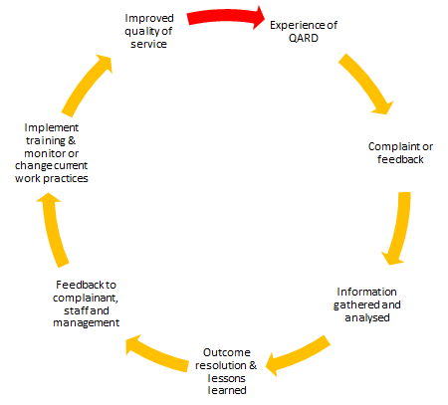

Roles and Responsibilities
Quality Assessment and Regulation Area Manager or Unit/Branch Manager (QARD Manager)
The QARD Manager is responsible for managing and responding to complaints made by members of the public regarding an individual staff member and/or team.

Director, Operations Branch, QARD (Director)
The Director is responsible for managing an effective and professional complaints handling system. If the complaint cannot be resolved in the region or at unit/branch level, the complaint will be dealt with by the Director.

Executive Director, QARD (Executive Director)
The Executive Director is responsible for overseeing the complaints handling system. If a complainant is not satisfied with the outcome of the complaint process conducted by the Director or the complaint involves the Director, the Executive Director will be responsible for managing the complaint.

Complaint handling process
QARD Manager
Complaints will be received, in the first instance, by the QARD Manager and where possible should be dealt with by the QARD Manager. The action taken by the QARD Manager may include an interview, telephone conversation or email correspondence.

The QARD Manager will be required to email the Director, to advise that a complaint has been received. Once the complaint has been resolved the QARD Manager will notify the Director so that the complaint details can be put on the complaints register (Appendix 2).

Director
Where the complaint cannot be resolved by the QARD Manager or the complaint relates to the QARD Manager, a complaint form (Appendix 3) should be completed and forwarded to the Director. Once the Director receives a complaint form, written acknowledgement will be sent to the complainant within 7 days of receipt (Appendix 4).

The Director will review and investigate the complaint. During the investigation of the complaint the action taken by the Director may include a:
- meeting with the complainant.
- meeting with the QARD Manager and/or QARD staff member.
- request that the QARD staff member involved provide to the Director any documentation including visit records or paperwork completed at the time the incident occurred.
- request that the QARD staff member involved prepare a ‘Statement of Events’.

In situations where an individual QARD staff member is involved the Director will ensure the staff member is given an opportunity to provide a reasonable explanation in response to the complaint and they are treated fairly.

If a complaint is taking considerable time to resolve due to the nature of the complaint, the Director will communicate this to all involved.

The Director will ensure that the outcome/resolution is based on the evidence presented to them. The Director will provide the response/outcome to the complainant and specify any recommendations for training or professional development to the QARD Manager. The complaint will then be recorded on the complaints register.

Executive Director
If the complainant is not satisfied with the decision or a complaint is made against the Director, the Executive Director will be responsible for managing the complaint.

The Executive Director will review the complaint and (where appropriate) the investigation conducted by the Director.

Procedure Flow Chart
A procedure flow chart (Appendix 1) has been developed which outlines the steps involved in managing a complaint.

Complaints register
The Complaints register (Appendix 2) will record all complaints received in relation to the conduct of QARD staff in executing their responsibilities. The Complaints register will detail the nature of the complaint and subsequent outcome.

The Project Officer, Operations Branch will manage the Complaints register, which will be overseen by the Director, Operations Branch.

Associated documents
- Human Resources, Guidelines for Managing Complaints, Misconduct and Unsatisfactory Performance in the VPS
- Victorian Ombudsman Good Practice Guide – Guide to complaint handling for Victorian Public Sector Agencies
- VPS Code of Conduct (SSA)

Appendices
Appendix 1: Procedure flow chart
Appendix 2: Complaints register
Appendix 3: Complaint form
Appendix 4: Acknowledgement letter
Appendix 1: Procedure Flow Chart
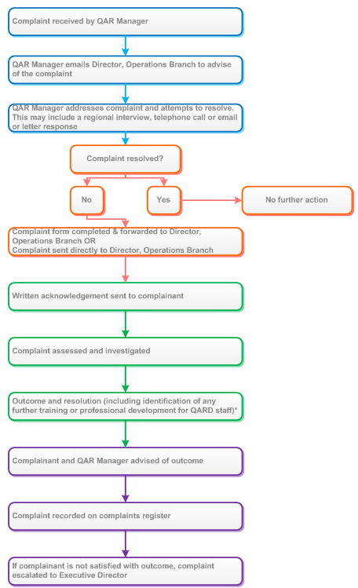

Appendix 2: Complaints register

Complainant’s name | Service name (if applicable) | Date complaint received | QARD staff member’s name | Details of complaint (Where it happened, what occurred, etc.) | Who managed the complaint?  (I.e. QAR Manager, Director, Executive Director) | Complaint form completed | Action taken to resolve complaint  (E.g. letter, email, interview, phone call) | Complaint resolved |  | Time taken to resolve complaint
 |  |  |  |  |  | Y/N |  | Letter sent | Date sent

Appendix 3: Complaint form
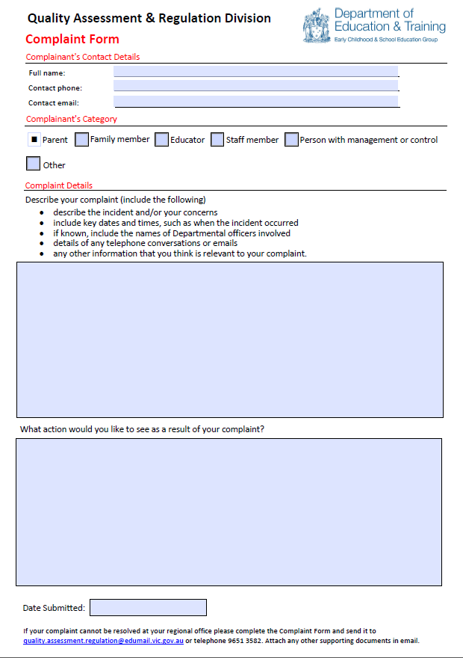
Appendix 4: Example acknowledgement letter

Name
Address
SUBURB STATE POSTCODE

Dear Sir/Madam

RE: Acknowledgement of complaint received (insert date)

I wish to confirm that on [insert date] your complaint was received regarding [insert brief description of complaint details].

An investigation into your complaint is now proceeding and you may be invited to provide further information. Once the investigation has concluded you will be advised of the outcome in writing.

If you have any questions about this or would like to discuss your complaint further, please contact Louise Steffen, Director, Operations Branch, Quality Assessment and Regulation Division, Early Childhood and School Education Group, Department of Education and Training on ph. 9651 3601 or email steffen.louise.a@edumail.vic.gov.au.

Kind regards

Louise Steffen
Director
Operations Branch

__ / __ / __

In some instances a complaint form may be sent directly to the Director and not via the QARD Manager.

