Regulatory Framework
Regulatory Authority for Early Childhood Education and Care Services in Victoria

Contents

Regulating Early Childhood Education and Care Services 3
The Role of the Regulator 3
The National System 4
The Regulatory Landscape and Stakeholders 5
The Regulatory Authority’s Approach to Regulating 7
The Regulatory Model 10
Set Standards 11
Information and Resources 12
Approve and Licence 14
Tailored support and advice 16
Assessment and rating 18
Monitor compliance 20
Investigate 22
Enforce compliance 24
Continuous quality improvement 28
Reviews, feedback and complaints 29
Statutory reviews 29
Feedback 29
Complaints 29
Glossary 31

Regulating Early Childhood Education and Care Services
This document sets out the Regulatory Framework used by the Regulatory Authority in relation to Early Childhood Education and Care Services in Victoria.

The Role of the Regulator
The Secretary of the Department of Education (the department) is the Regulatory Authority in relation to Early Childhood Education and Care (ECEC) Services in Victoria. The Regulatory Authority is responsible for the regulation of around 4,900 ECEC services operating in Victoria. This includes kindergartens, long day care, family day care, outside school hours care, occasional care, early childhood intervention, sports and leisure, and limited hours services.
The role of the Regulatory Authority is established by the Education and Care Services National Law Act 2010 (National Law) and the Victorian Children’s Services Act 1996 (Children’s Services Act). Additionally, the Regulatory Authority is the integrated sector regulator under the Child Wellbeing and Safety Act 2005. This means that the Regulatory Authority uses its existing functions and powers to regulate compliance with the Child Safe Standards in ECEC services in Victoria.
The Regulatory Authority regulates providers of ECEC services to ensure they protect children’s safety, health and wellbeing and comply with the Child Safe Standards. The Child Safe Standards are designed to ensure that organisations that work with children take steps to create a culture of child safety and protect children from all forms of abuse. Under the National Law, the Regulatory Authority also drives continuous improvement in ECEC services in order for children to receive quality education and care to support their health, learning and development.
The National Law’s aspiration for continuous quality improvement within ECEC services creates a distinct regulatory role for the Regulatory Authority; one where quality is embedded within minimum requirements and is therefore regulated alongside, and as part of, ensuring those minimum requirements are met.
The need for such a regulatory environment is clear. Evidence from Australia and overseas indicates that the early years of a child’s life have a profound impact on their future health, development, learning and wellbeing. Research shows that quality education and care early in life can lead to better health, education and employment outcomes later in life.
It is therefore no surprise that the needs and best interests of children form the guiding and paramount concern for the activities, decisions and actions taken by the Regulatory Authority.
This Framework explains how the Regulatory Authority undertakes its regulatory role, including driving continuous quality improvement in ECEC services. It seeks to provide clarity to the regulatory community about what we do and how we do it, and give confidence to the broader community who trust us to undertake such an important role and to do so in a proper and fair manner.
The Regulatory Authority has a strong commitment to transparency and accountability as well as to ongoing reflection and learning. We welcome feedback about this Framework, including the manner in which our staff deliver the activities it describes.

The National System
There has been a national regulatory system in place in relation to ECEC services since the introduction of the National Quality Framework (NQF) from 1 January 2012.
The NQF is governed by the National Law and Education and Care Services National Regulations. The NQF includes the Australian Children’s Education and Care Quality Authority (ACECQA) and regulatory authorities in each state and territory. ACECQA is the independent national body that assists governments in administering the NQF.

Victorian children’s services
The majority of ECEC services in Victoria operate under the NQF. However, around 220 services in Victoria do not fall within the scope of the NQF and operate under the Children’s Services Act and Children’s Services Regulations 2009 (referred to collectively in this document as the Children’s Services legislation). The Children’s Services legislation mirrors many of the provisions of the NQF and these services are also required to comply with the Child Safe Standards.
The types of services that remain regulated under the Children’s Services legislation include limited hours services, former budget-based services not funded for the child care subsidy, occasional care services, early childhood intervention services, mobile services and school holiday care programs that operate for up to 28 days a year.
The Regulatory Authority approaches its role under both legislative regimes in a consistent manner. Where there are substantive differences, this is identified in text boxes or footnotes.

The Regulatory Landscape and Stakeholders
There are approximately 4,700 ECEC services operating under the NQF in Victoria. The diagram below displays the various components of the NQF, including ACECQA and the regulatory authorities.

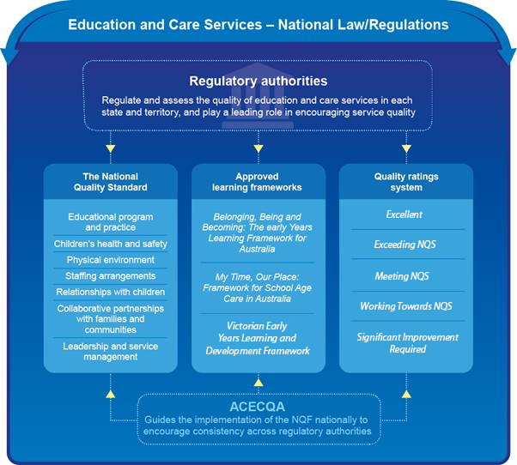

Stakeholders
The child is at the centre of the regulatory environment in which ECEC services operate. In everything that is done within this regulatory environment, by the services themselves, by the Regulatory Authority or by any other stakeholder, the child’s safety, health and wellbeing are paramount.
The other key stakeholders in the regulatory environment are:
- government and law enforcement bodies, such as:
- ACECQA
- The equivalent regulatory authorities in other states/territories
- The Commission for Children and Young People (CCYP)
- Other Divisions of the Department of Education in Victoria, such as in relation to funding
- The Department of Education (Commonwealth)
- The Department of Health (Victoria)
- The Department of Justice (Victoria)
- The Department of Families, Fairness and Housing (Victoria)
- The Victorian Institute of Teaching (VIT)
- The Victorian Registration and Qualifications Authority (VRQA)
- Victoria Police
- The Australian Federal Police (AFP)
- WorkSafe Victoria
- parents and guardians
- approved providers, services, educators and their representatives and peak bodies
- the community of Victoria and their representatives.
The community of Victoria is an important stakeholder in the regulatory environment. The community has a general interest in knowing that ECEC services are adequately regulated so that they operate in a safe and lawful way. Members of the community also play a role in notifying the Regulatory Authority of direct concerns in relation to an ECEC service. By doing so, they form an important part of the Regulatory Authority’s monitoring and intelligence gathering processes.
The Regulatory Authority regularly engages with stakeholders in both formal and informal ways and this is a critical aspect of our regulatory work. Such activities assist the Regulatory Authority to maintain a contemporary understanding of the regulatory community and in turn, to tailor our activities accordingly.
Strong engagement is important for building the relationships that can become partnerships – partnerships that support compliance and allow detected non-compliance to be positively addressed. Engagement with stakeholders also helps the Regulatory Authority meet key objectives such as reducing regulatory burden through information sharing and coordinated targeting of resources with other organisations.
As part of our strong commitment to uphold the rights of children and also to reduce regulatory burden, the Regulatory Authority also shares information with State and Commonwealth Government bodies where this is permitted by the National Law. This includes where the information relates to:
- promoting the objectives of the National Law or Children’s Services Act
- assisting authorities and other government departments to perform or exercise their functions and powers under the National Law or Children’s Services Act,
- Child Safe Standards and Reportable Conduct,
- research or the development of national, state/territory policy with respect to ECEC services
- the funding of ECEC services,
- the payment of benefits or allowances to persons using ECEC services
- compliance, monitoring and enforcement.

The Regulatory Authority’s Approach to Regulating
Objectives and principles
The aim of government regulation is economic or social improvement. In the Regulatory Authority’s case, the rights and needs of children to access safe and high-quality education and care are vital social and economic aims.
Quality education and care shapes a child’s future, and lays the foundation for their development and learning. Research shows that quality education and care early in life leads to better social and economic outcomes, including improved health, education and employment later in life. The Regulatory Authority plays a crucial role in ensuring ECEC services meet the requirements of the NQF and Child Safe Standards and, in doing so, provides the platform for these higher order aims to be met.
The Regulatory Authority’s objectives are:
- ensuring the safety, health and wellbeing of children attending ECEC services
- improving the educational and developmental outcomes for children attending ECEC services
- promoting continuous improvement in the provision of quality ECEC services
- improving public knowledge about the quality of ECEC services, including how to access and interpret the latest quality ratings
- reducing the regulatory and administrative burden for ECEC services by facilitating information sharing between participating jurisdictions and the Commonwealth.
To further support these objectives and guide Regulatory Authority staff on a daily basis; whether in their numerous and sometimes complex interactions with ECEC services, or through development of policy or resourcing decisions; the Regulatory Authority conducts its efforts and actions in line with these principles:
- the rights and best interests of the child are paramount
- children are successful, competent and capable learners
- principles of equity, inclusion and diversity underlie the Act and Regulations
- Australia’s Aboriginal and Torres Strait Islander cultures are valued
- the role of parents and families is respected and supported
- best practice is expected in providing ECEC services.
Risk-based and responsive regulation
In striving to meet its objectives, the Regulatory Authority is continuously making decisions about the best ways to undertake its regulatory activities and where to focus effort and resources. This includes determining priorities and deciding how to address identified problems in specific ECEC services as well as the industry more broadly.
This work starts when the Regulatory Authority approves entrants to the ECEC market. Providers receive approval upon demonstration that they are an entity who is capable of operating an ECEC service in compliance with the National Law and National Regulations, including to provide quality education and care. They are then granted service approval to operate a particular service (if they meet the requirements) on the condition that they will ensure the safety, health and wellbeing of children and operate in a way that complies with the Child Safe Standards. The Regulatory Authority implements both risk-based and responsive regulatory activity when those providers fail to meet these obligations.
Consistent with the objectives and principles outlined above, the Regulatory Authority seeks to focus attention on problems that present the greatest risk to the safety, health and wellbeing of children, including the risk of young children missing out on the benefits of quality education and care. Priority is given to activities determined to have the greatest impact towards meeting these objectives.
These determinations also reflect the principle of ‘earned autonomy’; providers who demonstrate their ability and willingness to voluntarily comply over time receive less regulatory oversight. Providers can also publicise and promote their assessed rating for each ECEC service they operate thereby highlighting their compliance and delivery of quality education and care. Conversely, the Regulatory Authority increases regulatory activity in relation to services with unsatisfactory compliance and this can include enforcement action if necessary to influence the provider to achieve compliance.
The National Law equips the Regulatory Authority with various regulatory powers and tools to address non-compliance. These tools range from approving market entrants and providing information and guidance to support approved providers, through to prosecution before a court or cancelling a provider’s approval to operate where serious failings exist.
The Regulatory Authority is responsive and proportionate in its use of these regulatory powers and tools. Identified non-compliance is responded to with a regulatory response aligned to the seriousness of the issues and the behaviour of those involved (before and after the occurrence of the non-compliance). Compliance history is also a relevant consideration to the Regulatory Authority and regulatory action is escalated if initial steps prove unsuccessful. This approach to enforcement action recognises the important and ongoing relationships that the Regulatory Authority has with ECEC services and their providers. Given that the majority of the regulated community are willing and able to comply, much of the Regulatory Authority’s activity is support-based, educational and/or part of the assessment and rating process.
Our conduct
In carrying out our important regulatory responsibilities, Regulatory Authority staff act with professionalism and integrity in line with certain standards and expectations. Staff of the Regulatory Authority, regardless of their position or functions, abide by the Code of Conduct for the Victorian Public Sector and conduct themselves in a manner that is consistent with the department’s values.
In addition, the Regulatory Authority expects it’s staff to:
- be guided at all times by the Regulatory Authority’s objectives and principles and the content of this Framework
- comply with and promote the Child Safe Standards
- make fair, unbiased and lawful decisions
- be proportionate, timely, responsive and consistent
- follow administrative law requirements, including providing procedural fairness
- be accountable and transparent, including managing conflicts of interest appropriately and in accordance with department guidelines
- act and make decisions in a way that is consistent with the Victorian Charter of Human Rights and Responsibilities Act 2006
- comply with confidentiality and privacy obligations.
Authorised officers are Regulatory Authority staff who have been deemed by the Regulatory Authority as appropriate people to hold that title and to use their powers with the utmost integrity. Authorised officers conduct most public-facing Regulatory Authority activity and work directly with ECEC services, educators, parents and members of the community.

The Regulatory Model

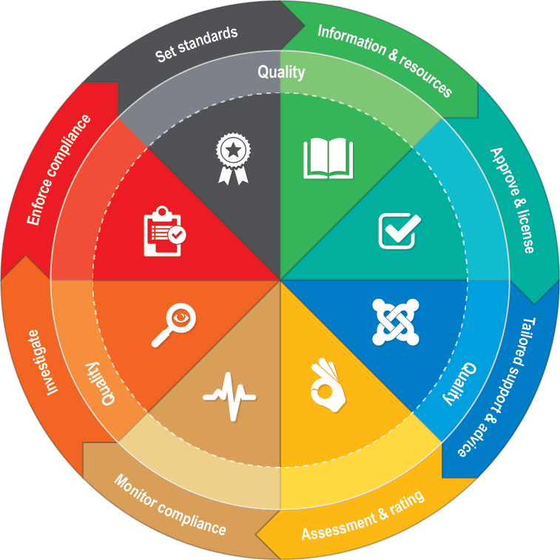
Quality
Continuous quality improvement exists to support children in receiving the best possible ECEC so that educational and developmental needs of children are met or exceeded. Each component of the regulatory model contributes to continuous quality improvement of an ECEC service as well as supporting the safety, health and wellbeing of children when they attend an ECEC service. See page 29.
 | Set standards  Clear, authoritative standards give certainty about what is expected of ECEC services and what they are required to do to comply with the NQF and Child Safe Standards. See page 12. |  | Assessment and rating  Assessment and rating of ECEC services by authorised officers to determine quality and compliance against the National Quality Standard and National Regulations.  See page 19.
 | Information and resources  Information and resources provided to the community, parents/guardians, educators, current and aspiring ECEC services, and to other government and law enforcement bodies about the NQF and Child Safe Standards . See page 13. |  | Monitor compliance  Various activities undertaken to detect and assess non-compliance with the NQF and Child Safe Standards – supported through notifications from various members of the community and other government/non-government organisations. See page 21.
 | Approve and Licence  Assessment and approval processes determine which individuals and organisations can provide ECEC services. See page 15. |  | Investigate  Investigation of reported and alleged  non-compliance with the NQF and/or Child Safe Standards in an ECEC service. See page 2230.
 | Tailored support and advice  Provision of tailored support and advice to assist and guide approved ECEC services to understand and comply with the NQF and Child Safe Standards and to check for and remedy non-compliance. See page 7. |  | Enforce compliance  Application of proportionate enforcement action, including administrative actions and statutory sanctions in order to ensure safety, health and wellbeing of children attending ECEC services. See page 25.

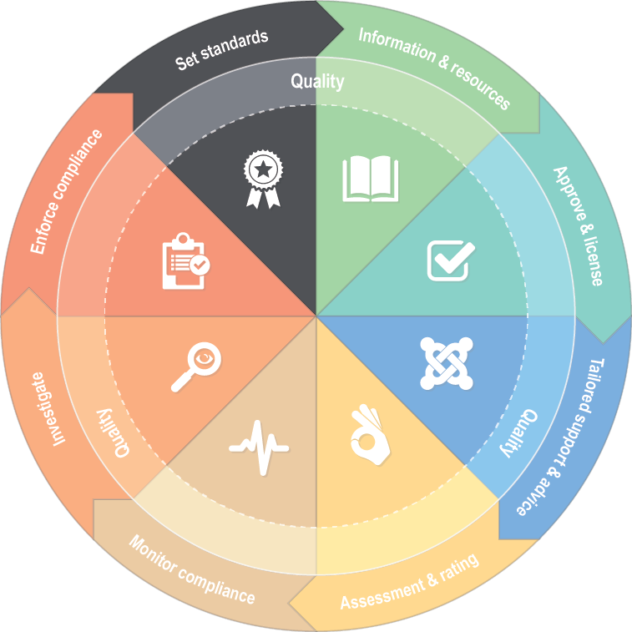
Set Standards
Clear and authoritative standards give ECEC services certainty about what is expected of them and what they are required to do to comply with the NQF and Child Safe Standards.
The Regulatory Authority’s standards and expectations for the regulatory community are founded on the components of the NQF:
- the Education and Care Services National Law Act 2010,
- the Education and Care Services National Regulations 2011,
- the National Quality Standard (NQS) and quality rating system,
- approved Learning Frameworks,
- and the Child Safe Standards.
The Regulatory Authority regulates ECEC services based on these requirements and also plays a key role in supporting the review of, and improvements to, the NQF to ensure it continues to achieve its purpose.
How is legislation and policy developed?
Policy is informed by the legislative requirements, and is developed from evidence-based research, informal and formal stakeholder feedback where appropriate, and the consideration of community expectations. At times, legislation may also be updated or varied, and this will be informed by these same sources of information as well as strict requirements in relation to community consultation. Such a process is communicated by ACECQA and the Regulatory Authority in various ways including through our websites.
ACECQA and the various state/territory regulatory authorities develop and publish policy to support consistent implementation of the NQF across states and territories as well as about legislative or operational information to further assist those seeking to understand or apply the NQF.
The Regulatory Authority seeks to communicate policy to ECEC services in a transparent and accessible manner through online channels such as the website and email communications as well as through our direct interactions with services and stakeholders.

Victorian children’s services

The Regulatory Authority has specific responsibility for developing and reviewing legislation and policy in relation to the Children’s Services legislation.

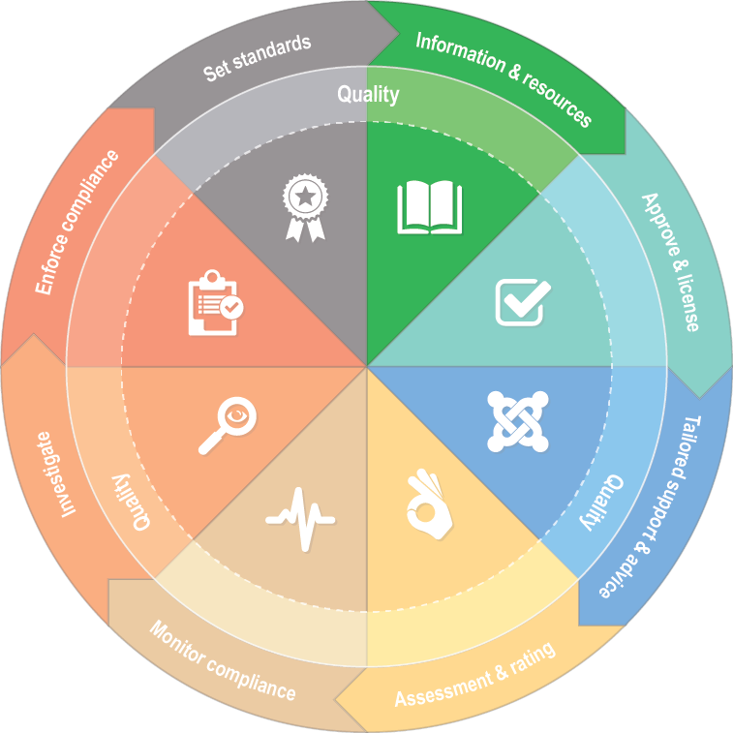
Information and Resources
The Regulatory Authority informs the community, parents/guardians, educators, current and aspiring ECEC services and other government and law enforcement bodies about the requirements and aspirations of the NQF and Child Safe Standards, especially relating to the benefits for children.
A key role of the Regulatory Authority is informing stakeholders about legislative requirements in ECEC services as well as the role and jurisdiction of the Regulatory Authority.
The Regulatory Authority’s information and resources focus on the safety, health and wellbeing of children in
ECEC services, including the Child Safe Standards, and the requirement for
continuous improvement to provide quality
education and care to our next generations.
The Regulatory Authority, along with ACECQA, provides information and resources and makes it accessible to all members of the community, with much of it targeted to current and aspiring ECEC providers and services. The Regulatory Authority delivers information and resources through a range of mechanisms including online and printable materials, newsletters, emails, an information telephone line, forums, seminars and stakeholder meetings.
Through information and resources, the Regulatory Authority promotes the aspirations and benefits of the NQF. Where appropriate, the Regulatory Authority highlights the importance and centrality of the child in everything services do and the role of continuous improvement in providing quality education and care. This helps ECEC services deliver quality programs and helps those using these services to identify quality education and care.
The Regulatory Authority also engages with stakeholders on a regular basis, particularly in relation to legislative change. This engagement informs and assists the Regulatory Authority in providing future information and resources that reflect the needs and concerns of the sector.
Information and resources
Information can be sought by any member of the community whether they are part of an ECEC service or not, through:
- calling the Regulatory Authority on 1300 307 415
- emailing the Regulatory Authority at licensed.childrens.services@education.vic.gov.au
- writing to the Regulatory Authority, GPO Box 4367, Melbourne, VIC 3001
- using our web resources available at www.vic.gov.au/regulation-and-quality-assessment.

Free resources are available from the Regulatory Authority's and ACECQA’s websites including:
- how to comply with particular aspects of the NQF and Child Safe Standards
- enforcement activity undertaken by the Regulatory Authority
- how to make a report or complaint to the Regulatory Authority
- how to become approved
- sector newsletters.

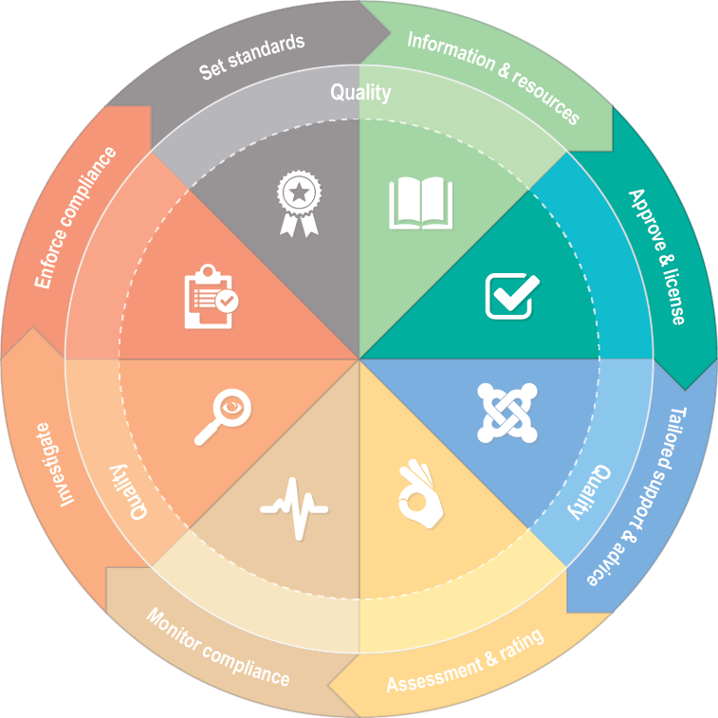
Approve and Licence
The Regulatory Authority is responsible for approving those wishing to enter the industry and operate an ECEC service.
One of the Regulatory Authority’s most influential and critical role’s is in monitoring and approving entry into the ECEC service market.
To advertise and operate an
ECEC service, the Regulatory Authority must have first granted provider approval to the entity who will operate the service as well as service approval in relation to the particular service.
The Regulatory Authority carefully considers applications to be a provider and then again when application is made for a proposed service. The Regulatory Authority focuses on the applicant’s ability to comply with the requirements of the NQF and the Child Safe Standards, including to meet the developmental and educational needs of the children they intend to enrol in their service.
In doing so, the Regulatory Authority also places limitations on certain aspects of the ECEC service such as the number of children that may be educated and cared for in the space provided. Rigorous approval processes assist in ensuring quality and compliant ECEC services are being established. The obligation to ensure the safety, health and wellbeing of children in the ECEC service and to operate in a way that complies with the Child Safe Standards are always conditions of granting service approval.
The approval process is also an opportunity for the Regulatory Authority to form early, positive professional relationships with new operators and set clear expectations about the seriousness and importance of their role before children are educated and cared for.
Granting approvals
Provider approval: Obtaining provider approval is a prerequisite for operating one or more ECEC service under the NQF. The Regulatory Authority assesses the applicant’s suitability and capability to provide education and care to children as an NQF service provider. Each individual who is part of an application for a provider approval must satisfy the Regulatory Authority they are a fit and proper person to be involved in the provision of an ECEC service.
Service approval: Once a provider gains provider approval, they must then obtain service approval to operate a particular ECEC service or services. There are two types of approvals under the NQF:
- centre-based service approval
- family day care service approval.

The process for obtaining approval to operate an ECEC service includes:
- an application by the proposed operator for the appropriate approvals (first the provider and then the service) made to the Regulatory Authority
- assessment of the applications by the Regulatory Authority in accordance with the National Law, National Regulations and Child Safe Standards
- liaison between the Regulatory Authority and the applicant
- decision by the Regulatory Authority about whether or not to grant the approval
- communication by the Regulatory Authority to the applicant of the decision.
The Regulatory Authority grants approvals where it is demonstrated that the ECEC service will:
- ensure the safety, health and wellbeing of the children being educated and cared for
- meet the educational and developmental needs of the children being educated and cared for by the service including through continuous quality improvement
- be operated in a way that complies with the Child Safe Standards.

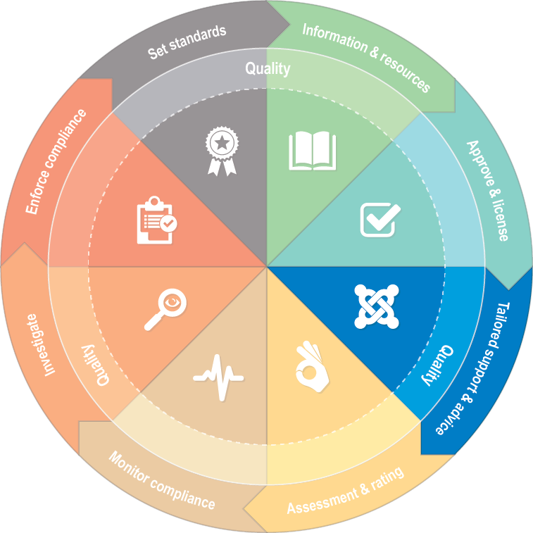
Tailored support and advice
An important aspect of the Regulatory Authority’s role is to provide tailored support and advice to approved ECEC services to help them comply with the NQF and Child Safe Standards, or to remedy non-compliance, in order to ensure continuous quality improvement and the safety, health and wellbeing of children in their service.
The Regulatory Authority advises and supports approved ECEC services, and anyone with an obligation under the NQF, to comply with the requirements of the NQF and the Child Safe Standards.
At all times, the Regulatory Authority’s advice and support is targeted to the safety, health and wellbeing of children and continuously improving the quality of the education and care delivered to those children.
Practical and tailored advice and support is provided to ECEC services by the Regulatory Authority through both reactive and proactive interactions. For example, authorised officer visits to services and associated follow up communications, contact through telephone and email services, attendance at meetings and forums.
In particular, the assessment and rating process provides detailed guidance to each ECEC service about their compliance and practice with clear, specific advice about the strengths and weaknesses identified. Authorised officers also interact regularly with ECEC services in monitoring and investigating non-compliance. Part of this work involves the Authorised officer providing guidance and support about how to comply or how to rectify detected non-compliance. These processes are explained in more detail on the following pages.
Tailored support and advice is a critical aspect of the Regulatory Authority’s role. In most cases, it also supports the Regulatory Authority to build positive relationships with the regulated community so services proactively seek assistance to prevent or quickly rectify problems, before children are seriously impacted. In turn this reduces the need for further compliance or enforcement activity from the Regulatory Authority.
Tailored support and advice for services
Advice: ECEC services can receive tailored support and advice:
- by calling 1300 307 415 or the service’s nearest regional office (details at www.vic.gov.au/quality-assessment-and-regulation-regional-office-contacts)
- by emailing licensed.childrens.services@education.vic.gov.au
- by contacting authorised officers from their nearest regional office or whom they have had recent contact with
- through a visit by authorised officers.
Activities: ECEC services or providers can participate in activities that contribute to their knowledge of the sector, field of expertise and the legal requirements they are bound to comply with through:
- presentations made by peak bodies and sector stakeholders, including regional and stakeholder forums
- information sessions about compliance with legal requirements run by the Regulatory Authority or others
- multi-service provider engagement meetings run by the Regulatory Authority
- ad hoc (as needed) meetings with the Regulatory Authority to support ECEC services with their compliance.

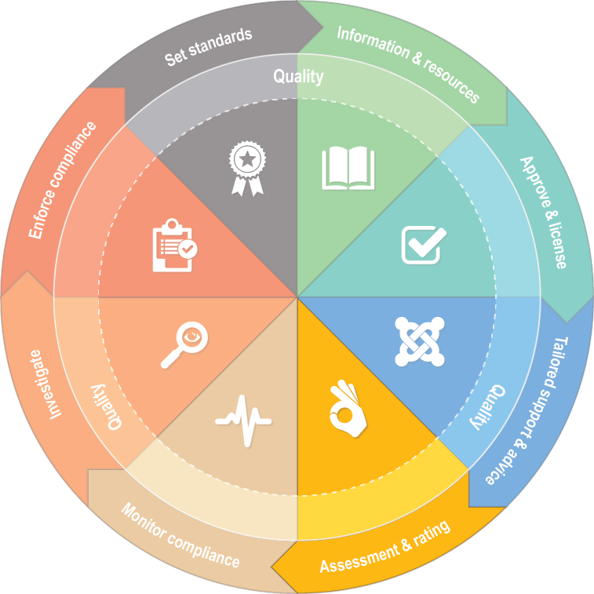
Assessment and rating
Authorised officers assess the quality and compliance of an ECEC service against the National Quality Standard (NQS) and National Regulations.
Assessment and rating of ECEC services forms a critical and unique part of the regulatory framework. All ECEC services in Victoria approved under the NQF are assessed and rated by the Regulatory Authority.
Assessment and rating of ECEC services occurs during a scheduled visit and on a regular basis. The frequency of such a process reflects the earned autonomy model where those with higher ratings have longer between assessments.
ECEC services are assessed against seven quality areas of the NQS and are given a rating based on these results. There are five possible ratings that an ECEC service can achieve:
- Excellent (awarded by ACECQA)
- Exceeding National Quality Standard
- Meeting National Quality Standard
- Working Towards National Quality Standard
- Significant Improvement Required.
The NQS
The NQS aims to promote:
- the safety, health and wellbeing of children
- a focus on achieving outcomes for children through high-quality educational programs
- a greater understanding for families, educators, service providers and stakeholders of what distinguishes a quality service and how this is determined.
The seven quality areas that services are rated against are:
- Educational program and practice
- Children’s health and safety
- Physical environment
- Staffing arrangements
- Relationships with children
- Collaborative partnerships with families and communities
- Leadership and service management.
A full list of quality areas, standards and elements is available on ACECQA’s website at
www.acecqa.gov.au/national-quality-framework/the-national-quality-standard.
The Quality Improvement Plan (QIP) and Final Rating
The QIP is a self-assessment tool for ECEC services required by the National Law. ECEC services must have processes in place that enable them to continuously assess the quality of the practices of the service and identify areas for improvement. This may involve reviewing the practices of educators and staff and assessing if their service meets or exceeds the NQS. These processes and self-assessments, along with a statement of the philosophy of the service are documented in the QIP. It is also important that consultation and discussion with families and educators inform the QIP.
ECEC services are required to provide their QIP to the Regulatory Authority at any time it is requested including before the assessment and rating visit. This allows authorised officers to view the service’s reflections on their strengths, areas for improvement, self-assessment of their programs and practices and information about their service philosophy.
After an assessment and rating visit, every service receives a written report with a rating for each quality area and an overall rating. The written report provides ECEC services with guidance about areas of non-compliance, how well they have met the NQS, issues that must be addressed and observed strengths and opportunities. ECEC services are also encouraged to review and update their QIP after reflecting on the assessment and rating results.
Public rating
A service’s overall rating is published on the ACECQA and MyChild websites and the service must display the rating at their premises. The public nature of the rating provides information to parents, guardians and any other interested persons, about a service’s performance.
ECEC service ratings can be found at www.acecqa.gov.au/national-registers.

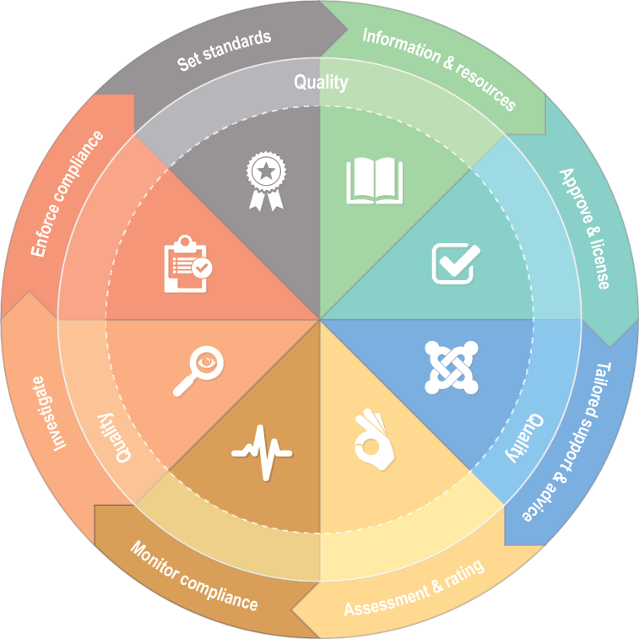
Monitor compliance
The Regulatory Authority monitors ECEC services in various ways in order to assess compliance. The Regulatory Authority is supported in detecting problems through reports from parents, educators, members of the community and government/non-government organisations.
The Regulatory Authority monitors compliance with the NQF and Child Safe Standards to detect whether ECEC services are ensuring the safety, health and wellbeing of children in their service and that quality education and care is being provided.
Monitoring also allows the Regulatory Authority to prevent problems occurring or react to problems before they escalate. The Regulatory Authority conducts monitoring activities using proactive and responsive methods such as:
- visiting services
- undertaking the assessment and rating process
- receiving reports from parents or any member of the community
- receiving notifications from providers and services as required by the National Law
- engaging with stakeholders
- receiving observations or notifications from other agencies or regulatory or enforcement bodies
- collecting and analysing information, such as reports, data and business records.
These varied monitoring methods help the Regulatory Authority to detect, respond to and prevent problems as well as assisting the Regulatory Authority to determine priorities and resource allocation. The Regulatory Authority allocates substantial resources to preventative processes – such as being rigorous in approval processes, providing timely and practical information and resources, tailoring advice and support to help services comply and conducting rigorous assessment and rating.
The Regulatory Authority’s Monitoring Compliance Policy contains more details about monitoring and is available online at www.vic.gov.au/monitoring-and-compliance-early-childhood-services.
Visits by the Regulatory Authority
A significant aspect of monitoring is achieved through the assessment and rating process and by conducting monitoring visits to ECEC service premises.
Authorised officers conduct service visits to assess compliance with the NQF and Child Safe Standards, including the quality of the program and environment. ECEC services are provided with written findings of the visit to assist them to rectify any non-compliance quickly and accurately.
As set out in the Regulatory Authority’s Monitoring Compliance Policy visits are conducted in the following circumstances:
- before granting approval for an ECEC service to start operating
- during the first year of operation (or a change of approved provider)
- for assessment and rating
- to monitor an ECEC service at least every three years
- as often as needed in relation to investigations, data analysis or in response to previously detected non-compliance as part of additional monitoring activities.
For further details about the Regulatory Authority’s monitoring activities, what happens at a visit and how ‘additional monitoring’ is determined and undertaken, please see the Regulatory Authority’s Monitoring Compliance Policy available at www.vic.gov.au/monitoring-and-compliance-early-childhood-services.

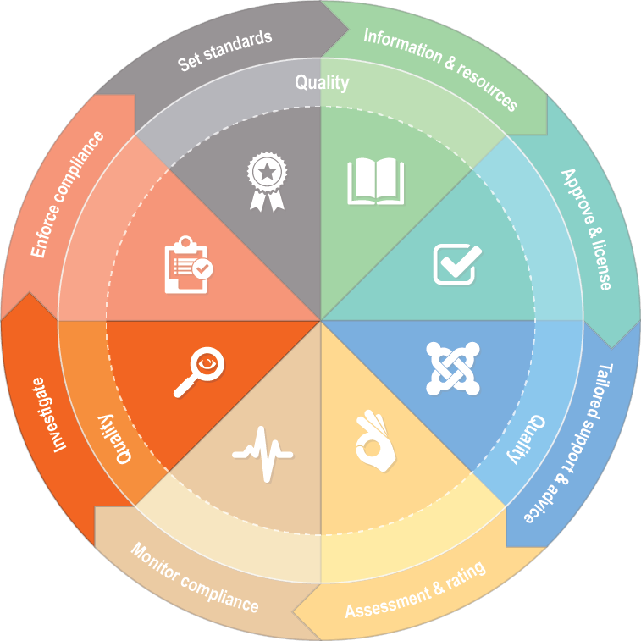
Investigate
The Regulatory Authority assesses complaints and notifications about potential non-compliance with the NQF and Child Safe Standards, including in relation to quality and the program delivered to children, to determine appropriate investigative activities and make findings about whether non-compliance occurred.
The Regulatory Authority conducts investigations where alleged non-compliance poses a risk to the safety, health and wellbeing of a child or children and/or there is a contravention of the NQF or Child Safe Standards.
When becoming aware of alleged
non-compliance, the Regulatory Authority assesses the information (usually received in a notification or complaint) to determine the level of risk to the safety, health or wellbeing of a child or children if it were to be true.
Based on this assessment, the Regulatory Authority determines next steps, including whether the matter is within the scope of the NQF or Child Safe Standards, and, meets the threshold for investigation. Where the alleged incident has or is likely to have a significant impact on the safety, health and wellbeing of a child or children being educated and cared for by a service, the Regulatory Authority treats this as a priority and initiates risk management strategies immediately. Prioritisation in this way ensures effective use of resources and is part of the risk-based regulatory model the Regulatory Authority relies on.
Notifications
Notifications or complaints may be made to the Regulatory Authority by any member of the community. For example, a complaint may be made from a parent about an ECEC service their child attends, an educator may report something they saw, or a non-government or government organisation may pass on information.
ECEC providers are required by the National Law to notify the Regulatory Authority of the following things which may also prompt an investigation:
- serious incidents or complaints in relation to an ECEC service
- any circumstances arising at an ECEC service that posed a risk to the safety, health or wellbeing of a child or children attending the service.
The Regulatory Authority website has information setting out notification requirements in detail. Examples of circumstances that must be reported under the NQF include:
- a child being locked in or out of a service or leaving the service alone
- a child being injured where immediate medical attention was required (or reasonably should have been)
- instances where the service’s premises pose a risk to children, for example the premises in a state of disrepair, or damaged by a natural event like flooding
- observations of children who display concerning behaviour that may indicate they are or may be at risk of physical, emotional or sexual abuse.
In addition, notifications regarding compliance with the Child Safe Standards can be made to the Regulatory Authority at any time. The same processes will then be applied to assess and determine appropriate action regarding those notifications.
The Regulatory Authority’s investigation process
Investigations by the Regulatory Authority seek to find the truth about what occurred by collecting evidence so that a determination can be made as to whether there has been non-compliance with the National Law, National Regulations or Child Safe Standards.
An investigation may include any or all of the following activities:
- talking to parties involved in the matter
- researching public and non-public information, for example the services’ website and advertising and data held by the Commonwealth Department of Education about care provided
- inspecting the service
- collecting relevant documents from the service
- liaising with other government or law enforcement organisations if relevant to the matters raised, such as CCYP, VIT, Victoria Police, Child Protection and WorkSafe Victoria
- taking witness statements from relevant parties
- interviewing the approved provider and/or persons responsible for the alleged non-compliance
- collecting any other evidence that is considered relevant, for example medical records.
Where warranted, the Regulatory Authority collects evidence that is permissible to use in prosecutions or that will assist in taking other enforcement action. At the conclusion of the Regulatory Authority’s investigations, authorised officers also seek to identify ways for ECEC services to improve controls that prevent non-compliance.
The nature and timeframes of an investigation vary depending on issues such as complexity, cooperation levels and the extent of alleged non-compliances being investigated. The Regulatory Authority aims to achieve appropriate outcomes within reasonable timeframes and to minimise service disruption. In any investigation, as with any other regulatory activity of the Regulatory Authority, the safety, health and wellbeing of children is paramount.
Procedurally fair, ethical and transparent investigations are critically important to the Regulatory Authority. The public and regulated entities must be able to have confidence in the integrity of our investigations and the regulatory system that those investigations form part of.
Taking action after an investigation
To finalise an investigation, the Regulatory Authority makes determinations as to whether the evidence collected has substantiated any areas of non-compliance. The Regulatory Authority informs the approved provider of the outcome of the investigation including whether enforcement action, such as sanctions, are appropriate (see the next section for further information).
The Regulatory Authority also communicates with parents or other notifiers/complainants about the nature of the investigation and outcomes. In doing so, the Regulatory Authority must not provide information that is protected by privacy or other confidentiality requirements.

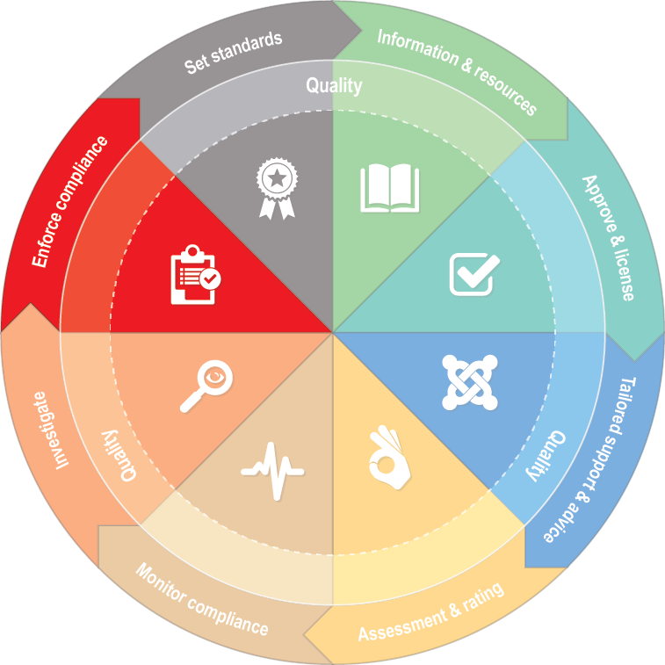
Enforce compliance
Enforcement means the use of influence, including through administrative and statutory methods, to compel an approved provider to operate an ECEC service in compliance with the NQF and Child Safe Standards – so that they ensure the safety, health and wellbeing of children in the service.
Enforcement action by the Regulatory Authority is taken for the purpose of ensuring that those providing ECEC services are ensuring the safety, health and wellbeing of children in the service.
Enforcement action can influence the attitude and behaviour of everyone with obligations under the National Law, National Regulations and Child Safe Standards, including someone that the Regulatory Authority has determined has breached their obligations, and has three key elements:
- to rectify or fix the non-compliance
- to apply a sanction (a penalty or punishment)
- to provide deterrence against future non-compliance (both specifically to those involved and also generally to others with the same obligations).
Under the National Law, certain information about some statutory sanctions used by the Regulatory Authority is permitted to be published. Publishing the information is to inform the public and users of services as well as to deter other ECEC services from non-compliance. The Regulatory Authority publishes enforcement actions on its website at www.vic.gov.au/enforcement-action-regulatory-authority on a regular basis.
How the Regulatory Authority enforces compliance
The Regulatory Authority takes an escalating approach to enforcement so that it can respond appropriately and proportionately to detected non-compliance, including with the Child Safe Standards. Rectified lower-order non-compliance is met with lower-order intervention, and increased intervention applies in line with increased seriousness, culpability, recidivism and apathy.
Authorised officers of the Regulatory Authority support ECEC services to rectify non-compliance as soon as it is identified. Tailored advice and support is nearly always successful and sufficient in ensuring ECEC services address minor, one-off non-compliances. However, even if rectified, enforcement action may still be appropriate in certain situations if they are sufficiently serious or risky to children’s safety, health and wellbeing.
The action the Regulatory Authority takes depends on a number of factors including:
- the service’s ability to comply with their obligation to ensure the safety, health and wellbeing of children
- the service’s compliance history and current compliance levels
- the risk mitigation strategies the service implemented to respond to the incident/issues
- the actual or potential risk posed by the incident or issues to the health, safety or wellbeing of children
- the willingness and ability of the service to rectify the behaviour or the environment that led to the incident or issues occurring
- public interest factors.
The Regulatory Authority assesses these factors to determine not only whether enforcement action is required but also the proportionality of that action. The Regulatory Authority addresses and deters non-compliance using various administrative activity as well as a range of statutory sanctions available under the National Law and on occasion, will prosecute the most serious non-compliance.
Administrative actions and statutory sanctions
Administrative actions that the Regulatory Authority utilises to influence compliance by an ECEC service include:
- additional monitoring of the service (see the Regulatory Authority’s Monitoring Compliance Policy for further information)
- attendance of the approved provider at a formal meeting
- a Warning Notice issued to the approved provider, and in some circumstances to an individual such as a staff member or educator.
The Regulatory Authority uses administrative actions where:
- there is a moderate-to-significant impact on the safety, health and wellbeing of children, or there is systemic and ongoing low-to-moderate non-compliance, and
- the service has taken action to address the non-compliance.
Statutory sanctions used by the Regulatory Authority to influence compliance by an ECEC service include:
- issuing compliance notices or directions
- amending a service or provider approval to impose limitations on their operation
- prohibiting an individual from being involved in an ECEC service
- taking emergency action to prevent an activity from continuing
- suspending or cancelling a service or provider approval.
Statutory sanctions escalate in severity and some are suited to particular non-compliance. The most serious statutory sanctions, such as suspensions, emergency actions, prohibitions and cancellations, are reserved for the most serious cases of non-compliance.
The table on the following page outlines the statutory sanctions available to the Regulatory Authority. These sanctions can also be applied in situations where the Regulatory Authority determines that the Child Safe Standards have not been complied with.

Statutory sanctions under the National Law | Description
Amendment of service approval by varying or imposing a condition  (section 55) | A written notice amending a service approval at any time without an application from the approved provider by:  - varying a condition of the service approval, or  - imposing a new condition on the service approval
Amendment of provider approval by varying or imposing a condition  (section 23) | A written notice amending a provider approval at any time without an application from the approved provider by:  - varying a condition of the provider approval, or  - imposing a new condition on the provider approval.
Reassessment of fitness and propriety (section 21) | Reassessment (at any time) of approved provider’s fitness and propriety to be involved with the provision of an education and care service. This includes:  - the reassessment of a person with management or control  - the assessment of an individual who becomes a person with management or control after the grant of provider approval.
Compliance direction  (section 176) | A written direction requiring an approved provider to take steps set out in the direction to comply with a specific provision of the National Regulations.
Compliance notice  (section 177) | A written notice requiring the approved provider to take the steps set out in the notice to comply with any provision of the National Law or National Regulations.
Suspension or cancellation of a supervisor certificate (section 123) | A written notice suspending or cancelling a supervisor certificate to prevent the person from being placed in charge of a service either temporarily (suspension) or permanently (cancellation). This includes a person who:  - is no longer fit and proper to supervise a service, and/or  - has failed to comply with a condition of their certificate or the National Law and National Regulations.
Notice to suspend education and care by family day care educator (section 178) | A written notice directing the approved provider to suspend a family day care educator if satisfied that:  - the approved provider or nominated supervisor is not complying with the National Law or National Regulations, or  - there is a risk to the safety, health or wellbeing of the children being educated by the family day care educator.
Emergency action notice (section 179) | A written notice directing the approved provider to take certain steps to remove or reduce an immediate risk to the safety, health or wellbeing of children being educated and cared for by the service.
Direction to exclude inappropriate persons from service premises  (section 171) | A direction to an approved provider, nominated supervisor and/or family day care educator to exclude an inappropriate person from a service premises).  An inappropriate person includes a person:  - who may pose a risk to the safety, health or wellbeing of any children being educated and cared for by the service, or  - whose behaviour or state of mind is such that it would be inappropriate for him or her to be on the premises.
Prohibition notice  (section 182) | A written notice given to a person prohibiting them from:  - providing education and care to children for a service  - being engaged as a supervisor, educator, family day care educator, contractor, staff member or a volunteer at an approved service  - carrying out any other activity relating to services.
Enforceable undertaking (sections 180 and 181) | A written undertaking from a person who has allegedly breached the National Law or National Regulations setting out what they will do or refrain from doing to comply with the National Law and National Regulations.
Suspension of service approval (section 70) | A written notice to the approved provider suspending a service approval for any of the reasons set out in section 70.
Suspension of provider approval (section 25) | A written notice to the approved provider suspending a service approval for any of the reasons set out in section 25.
Emergency removal of children (section 189) | Emergency removal of children by the Regulatory Authority where it considers on reasonable grounds that there is immediate danger to the safety, health or wellbeing of children being educate and cared for by the service.
Cancellation of service approval (section 77) | A written notice to the approved provider cancelling a service approval for any of the reasons set out in section 77.
Cancellation of provider approval (section 31) | A written notice to the approved provide cancelling a provider approval for any of the reasons set out in section 31.

Victorian children’s services

The Victorian Children’s legislation contains many similar statutory sanctions as those listed above. For further information or specific details about those sanctions, please visit the Regulatory Authority’s website, access the Children’s Services legislation online or contact the Regulatory Authority on 1300 307 415.

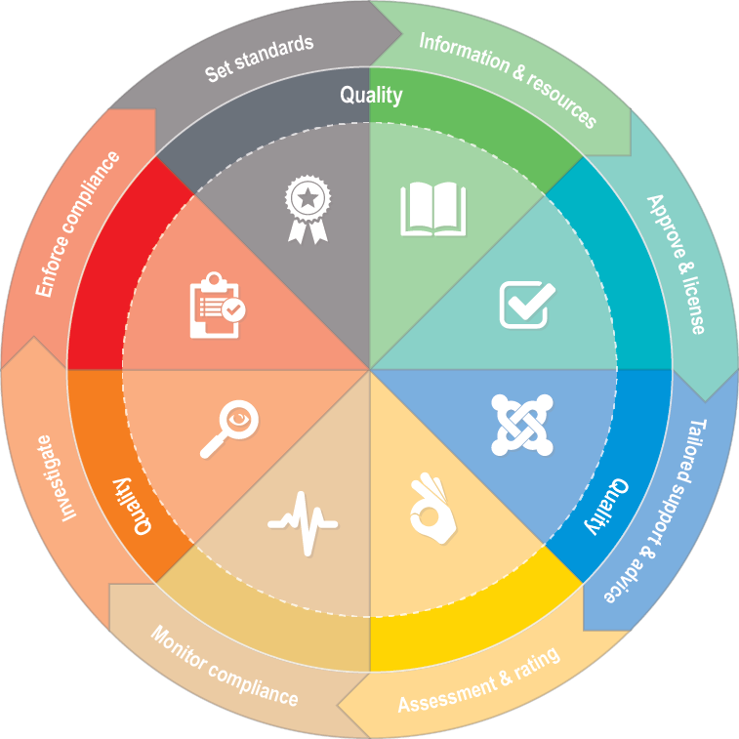
Continuous quality improvement
The purpose of continuous quality improvement is that children receive the best possible education and care that ensures their educational and developmental needs are met or exceeded.
Driving the provision of quality education and care is central to the Regulatory Authority’s role and objectives. Continuous quality improvement of ECEC services overlays and intersects with all aspects of the Regulatory Authority’s regulatory model.
The Regulatory Authority places substantial importance on fostering a culture of continuous quality improvement so that it may lead to better educational and developmental outcomes for children.
This starts at the point of approval, where the Regulatory Authority assesses the fitness and propriety of new applicants and their ability to:
- provide an ECEC service that meets developmental and educational needs of the children
- understand their obligations to assess and improve the quality of their service on an ongoing basis.
The quality of ECEC services is then specifically measured against detailed quality standards on a regular basis through the assessment and rating process. The Regulatory Authority also monitors ECEC services’ ongoing compliance with the NQF and Child Safe Standards throughout interactions with services, such as during compliance visits. Equally, tailored advice and support offered to ECEC services identifies and emphasises the need for quality improvement.
Continuous quality improvement is also driven by the Regulatory Authority by requiring and viewing an ECEC service’s Quality Improvement Plan (QIP) during assessment and rating and other monitoring activities. The QIP is a requirement of the NQF. It must contain particular information and must be reviewed regularly by the provider – at least annually.
All aspects of the Regulatory Authority’s regulatory model incorporate quality. This is entirely appropriate and necessary as the Regulatory Authority is regulating how education and care is provided to our next generations. The quality of this education and care is entwined with and regulated alongside the ability of providers to protect the safety, health and wellbeing of children in ECEC services.

Reviews, feedback and complaints

Statutory reviews
Decisions by the Regulatory Authority to impose statutory sanctions are subject to statutory review processes set out in the National Law. Assessment and rating decisions are subject to internal and external review procedures as established by the National Law. These legislative review rights and processes are set out in writing by the Regulatory Authority when they apply. Details can also be found in the National Law or on the Regulatory Authority’s and/or ACECQA’s website.
The Regulatory Authority treats review processes very seriously and ensures that required reviews are undertaken by a new decision maker and in line with any requirements such as timeframes, set out in the National Law. Those requesting a review will receive acknowledgement of receipt of their request and will be informed about the outcome of the review in writing.
Contact the Regulatory Authority on 1300 307 415 for more information about reviews.
Decisions made in a court or tribunal such as by a Judge or Magistrate in a prosecution, may also be reviewable through the court or tribunal’s appeal processes. Queries about review processes related to a decision made by a court or tribunal should be directed to the court or tribunal that made the decision.

Feedback
The Regulatory Authority welcomes feedback about its processes or practice including staff performance, and invites that information verbally or in writing directly to the staff member or their manager by:
- emailing quality.assessment.regulation@education.vic.gov.au
- calling the Regulatory Authority on 1300 307 415.

Complaints
About the safety, health and wellbeing of children
If you have concerns about the safety, health or wellbeing of children, or about the behaviours or practices of staff at an ECEC service, you can make a complaint to the Regulatory Authority. These types of complaints are an important aspect of the Regulatory Authority’s monitoring and detection process.
To make a complaint, write, email or telephone the regional office nearest you (details at: www.vic.gov.au/make-complaint-early-childhood-services-regulatory-authority).
About the Regulatory Authority – staff or actions
Anyone wishing to make a complaint about a Regulatory Authority staff member or their experience with, or decision by, the Regulatory Authority is encouraged to contact the staff member first to discuss their concerns. If this is unsuccessful in resolving the complaint, please contact the nearest regional office in the first instance and speak to the Area Manager (or ask for another contact if that is the person being complained about). Regional office contact details are available at www.vic.gov.au/quality-assessment-and-regulation-regional-office-contacts.
Complaint forms are also available from the Regulatory Authority website (www.vic.gov.au/make-complaint-early-childhood-services-regulatory-authority). Details can also be emailed or telephoned to quality.assessment.regulation@education.vic.gov.au
or 1300 307 415.
The Regulatory Authority is committed to responding to complaints effectively and requires all staff to be committed to effective dispute resolution. Our complaints procedure framework is available online.
If a person is not satisfied with the Regulatory Authority’s actions they can also contact the Victorian Ombudsman (www.ombudsman.vic.gov.au) or, in relation to privacy or an FOI decision, the National Education and Care Privacy Commissioner or National Education and Care FOI Commissioner (www.necsopic.edu.au).

Glossary
Term | Definition
Approved learning frameworks | The NQS is linked to national learning frameworks that recognise children learn from birth. Education and care services are required to base their educational program on an approved learning framework:  - Victorian Early Years Learning and Development Framework  - Belonging, Being and Becoming: the Early Years Learning Framework for Australia  - My Time, Our Place: Framework for School Age Care in Australia.
Approved provider | A person or corporate entity that holds a provider approval and is able to apply for a service approval under the National Law.
Australian Children’s Education & Care Quality Authority (ACECQA) | ACECQA is the independent national authority responsible for:  - overseeing the implementation of the NQF  - working with the state and territory regulatory authorities to implement and administer the NQF.
Children’s Services legislation | A term used in this document to describe the:  - Children’s Services Act 1996, and  - Children’s Services Regulations 2009.
Child Safe Standards | The Child Safe Standards require organisations involving children to have policies, procedures and practices to keep them safe. They are designed to ensure that organisations that work with children take steps to create a culture of child safety and protect children from all forms of abuse. From 1 January 2023, the Regulatory Authority oversees compliance with the Child Safe Standards in ECEC services as the integrated sector regulator under the Child Wellbeing and Safety Act 2005.
Secretary of the Department of Education and Training (the Department) | Victoria’s Regulatory Authority responsible for the approval and regulation of ECEC services operating in Victoria.
ECEC services | A term used in this document that refers to services in Victoria who provide approved education and care to children.
National Law | Education and Care Services National Law Act 2010
National Quality Framework (NQF) | The NQF includes the:  - Education and Care Services National Law Act 2010  - Education and Care Services National Regulations 2011  - National Quality Standard  - Approved learning frameworks.
National Quality Standard (NQS) | The NQS is part of the NQF and is the benchmark for quality education and care against which services are rated. The NQS consists of seven quality areas. Each quality area contains standards and elements against which ECEC services are assessed and rated. The quality areas are:  - Educational program and practice  - Children’s health and safety  - Physical environment  - Staffing arrangements  - Relationships with children  - Collaborative partnership with families and communities  - Leadership and service management  Visit www.acecqa.gov.au for full details of each of the quality areas and their applicable standards and elements.
National Regulations | Education and Care Services National Regulations 2011
Regulatory Authority | In Victoria, the Regulatory Authority for Early Childhood Education and Care (ECEC) Services, including of Child Safe Standards within those services, is the Secretary of the Department of Education (the department).

COAG, Investing in the early years – a national early childhood development strategy (2009). Available at http://apo.org.au/node/19168
Australian Children’s Education and Care Quality Authority (ACECQA). Available at: https://www.acecqa.gov.au/resources/research#ECSR
Section 271 of the National Law (and section 166 of the Children’s Services Act) sets out when this can occur.
Australian Children’s Education and Care Quality Authority (ACECQA) various research and reports available at: www.acecqa.gov.au/resources/research
For example see: Investing in the Early Years (2009) COAG – A National Early Childhood Development Strategy and other research available from ACECQA at: www.acecqa.gov.au/resources/research
Section 3 of the Education and Care Services National Law Act 2010
Section 3 of the Education and Care Services National Law Act 2010
Ayres, Ian and Braithwaite, John (1992) Responsive regulation: Transcending the deregulation debate Ayres and Braithwaite
In the case of services operating under the Children’s Services legislation it is the Children’s Services Act 1996 and the Children’s Services Regulations 2009 as well as the Child Safe Standards.
Information and resources are also developed in relation to the Children’s Services legislation for those services operating under that system.
Under the Children’s Services legislation, there are slight differences in this process and specific guidance is provided on the Regulatory Authority website.
Tailored support and advice does not extend to legal advice.
The Children’s Services legislation does not provide an assessment and rating process.

