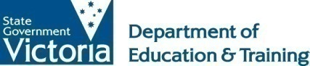 | Choosing a quality early childhood service:  Information for families

Introduction

As a parent or family member, you care about the safety, wellbeing and development of your children. That includes times when they are being educated and cared for by others.

Finding the right early childhood service to suit your child’s needs and those of your family is important. This guide explains what to look for in a quality early childhood service and what to do if you have any concerns that a service is not meeting its obligations.

Services for children are often subject to laws and regulations that prescribe how education and care must be provided to children. Generally the more formal types of care arrangements are regulated to ensure children are protected from harm and that their opportunities for learning and development are maximised. Parents and guardians often make informal arrangements for someone else to care for their children. These sorts of informal care arrangements generally do not need to be approved or licensed. The more formal arrangements do.

Contents
- What is a quality early childhood service?
- Visiting early childhood services.
- How can I be sure that a service is meeting the required standards?
- How will I know if a service is approved or licensed?
- When you’re not sure whether a particular service should be approved or licensed.
- Further information.

What is a quality education and care service?

Quality early childhood services are those that meet the educational and developmental needs of individual children, while at the same time providing for the needs of their families.

In Victoria, family day care services and centre-based services including kindergartens, long day care and outside school hours care services operate under the National Quality Framework (NQF) which includes the Education and Care Services National Law Act 2010 (National Law), the Education and Care Services National Regulations 2011 (National Regulations) and the National Quality Standard (NQS).

A small number of other services including occasional care services must meet the requirements of the Children’s Services Act 1996 (Children’s Services Act).

The National Quality Framework reflects what the international research says about quality education and care and requires that:

- The educational program and practice is stimulating, engaging and enhances children’s learning and development.
- Every child’s health and wellbeing is safeguarded and promoted.
- The physical environment is safe, suitable and provides a rich and diverse range of experiences.
- Staffing arrangements create a safe and predictable environment for children and support warm, respectful relationships.
- Relationships with children are responsive, respectful and promote children’s sense of security and belonging.
- Respectful, supportive relationships with families are developed and maintained.
- Effective leadership contributes to sustained quality relationships and environments that facilitate children’s learning and development.

Visiting early childhood services

Visiting the service is a great way to check whether you feel the service suits you and your child. It gives you the chance to see the service and observe the educators and children first hand. A visit also gives you the chance to ask questions.

When you visit, you may wish to focus on the room your child will be placed in upon enrolment.

On first entering a service or family day care residence you may notice a particular atmosphere, e.g. inviting/cold, relaxed/frantic, or happy/tense. You should expect educators to make you feel welcome and interact warmly with your child and with you.

Children who feel secure and content in a service will generally be engaged in their activities and relate freely and positively with educators and other children.

The service should be safe and comfortable – inside and outside. Children should have a choice of fun, interesting and challenging activities and choices for both quiet and active play.

Early childhood services need a service approval if they operate under the NQF or a licence if they operate under the Children’s Services Act.

This service approval/licence should be visible from the main entrance of the service. The approval/licence will be in the form of a certificate that shows the service approval/licence, provider approval/licensee approval, the name(s) of the nominated supervisor(s)/primary nominees and any waivers/exemptions that apply to the service. If the service has a kindergarten program funded through the Department of Education and Training (the Department) this notice should also be displayed.

Things to consider

- Do the educators make your child and you feel welcome?
- Are educators warm, responsive and respectful in their interactions with children?
- Are the children you see engaged in the educational program?
- Are the children supervised at all times? Are they supervised in a way that suits their age and development?
- Do educators interact positively with other educators and parents?
- Is the educational program run both inside and outside? Is there a balance of indoor and outdoor play?
- Is this a safe environment for children to play, learn and develop? Is the service clean and well maintained?
- Are there opportunities for children to play in groups and alone?
- Are there spaces for children to be involved in active, noisy play as well as space for quiet play?
- Is there enough equipment for the children at the service?
- Is important information displayed including the service approval/licence?

What questions should I ask when I visit?

Educators should be happy to talk to you about how they provide quality education and care for children.
As well, they will be happy to discuss the role of the National Quality Framework, including the requirements of relevant legislation and how they meet them.

You may like to ask:

- How does the program meet the different needs of each child? How will the service meet your child’s developmental needs and interests? This is an opportunity to outline any needs, interests and experiences particular to your child and family.
- How will the service meet my child’s additional needs? (If your child has any additional needs.)
- Which room/ group will my child be in (if accepted at the service)? How many children are in that room/group? How old are they? How many educators work with them?
- Will the same educators consistently care for my child?
- What qualifications do educators have? (Educators may be degree-qualified early childhood teachers, diploma-qualified educators or certificate III-qualified educators.)
- How will my child be assisted to settle into the service? What happens if my child becomes unwell, upset or unsettled?
- Can parents be involved? In what ways? Am I welcome to visit at any time of the day? Can I stay to share my child’s activities?
- What are the arrangements for providing food and drink for children? What are the sleeping arrangements for children?
- What are the arrangements for administering medication and the management of medical conditions (if your child has specific medical needs)?
- How will any concerns about my child be addressed?

How can I be sure that a service is meeting the required standards?

Services operating under the National Quality Framework (preschools/kindergartens, long day care, outside school hours care and family day care services) must meet the requirements of the National Quality Framework. In addition, the National Quality Framework also includes an assessment and rating system which assesses services against the National Quality Standard. Other services such as occasional care services must meet the requirements of the Children’s Services Act. These services are not assessed and rated against the National Quality Standard.

The Department of Education and Training

The Department is responsible for monitoring early childhood services and ensuring that they meet the requirements of the relevant legislation. The Department is also responsible for investigating notifications of incidents and complaints and undertaking the assessment and rating of services.

If it is identified that a service is operating in a way that places the safety, health and wellbeing of children at risk the Department will work with the service to resolve the relevant issues. The Department also publishes details of enforcement actions such as imposing conditions, cancellation of service or provider approval, issuing a compliance notice or prosecutions on the Quality Assessment and Regulation (QARD) section of the Department’s website at www.education.vic.gov.au/childhood/providers/regulation/Pages/enforcement.aspx

Making a complaint about an early childhood service
Parents and families are well placed to observe what is happening in early childhood services. If you have a concern that the health safety, and wellbeing of children may have been compromised, or if you believe the relevant legislation has been contravened at an early childhood service, you should make a complaint to the Quality Assessment and Regulation Division (QARD) at the relevant regional office of the Department.

Contact details are available at: Quality Assessment and Regulation: Regional Offices. Alternatively you may call 1300 307 415 or email licensed.childrens.services@edumail.vic.gov.au

Where relevant legislation may have been contravened, or there may be a risk to the safety, health, or wellbeing of children, QARD will investigate. This may include a visit to the service, talking with witnesses, and interviews with key people. More detailed information is available at: www.education.vic.gov.au/childhood/parents/childcare/Pages/concerns.aspx

Making a complaint about the Quality Assessment and Regulation Division

Anyone wishing to provide feedback or make a complaint about a QARD staff member or their experience with QARD is encouraged to contact their QARD regional office in the first instance. For more information and to view the relevant contact details see: Quality Assessment and Regulation: Regional Offices.

Services operating under the National Quality Framework

Assessment and rating of services

Education and care services are assessed and rated against the National Quality Standard. Following an assessment visit, services will receive one of the following overall ratings:

- Exceeding National Quality Standard
- Meeting National Quality Standard
- Working Towards National Quality Standard
- Significant Improvement Required
Services must meet each element of the 58 elements of the National Quality Standard and 18 standards in order to receive a rating of Meeting National Quality Standard. Services will receive a rating of working towards NQS if one or more elements are not met.

Services that achieve a rating of exceeding National Quality Standard may apply to the Australian Children’s Education and Care Quality Authority (ACECQA) to be considered for a rating of Excellent. The criteria for the Excellent rating is available from the ACECQA website www.acecqa.gov.au.

Individual quality areas or standards may be rated as exceeding the National Quality Standard, regardless of the overall service rating. Educators should be able to explain the areas that the service has performed well on, as well as priorities for continuous quality improvement.

Services that have been assessed and rated are required to display their overall rating and the rating for each quality area at the entrance of the service. You can search for services in your area that have been rated on the Starting Blocks website at: www.startingblocks.gov.au/find-child-care/

How does continuous improvement work?

Each service is required to develop a quality improvement plan that is reviewed at least annually and that identifies specific improvements for the service. Families of enrolled children may have opportunities to contribute to the quality improvement plan for an education and care service.

Following an assessment visit, services receive an assessment report, a rating against each of the seven quality areas and an overall rating. Assessment and rating reports provide information for services about their strengths and areas for improvement.

How continuous improvement works in education and care services

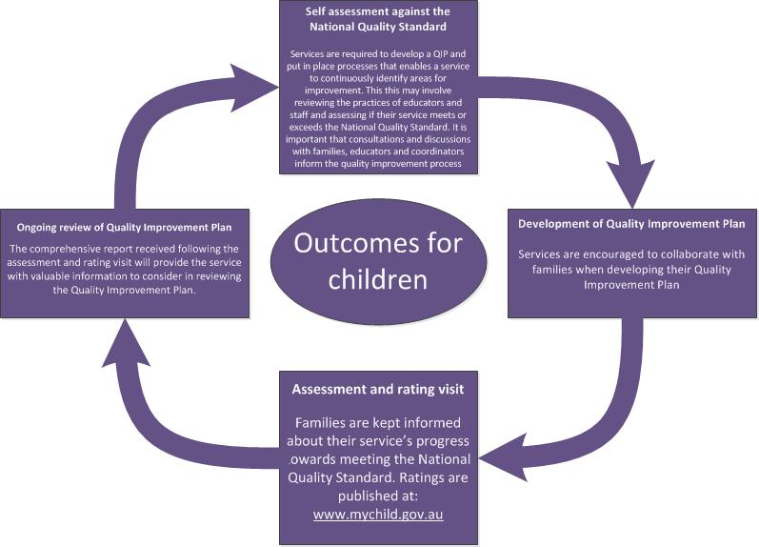

Services operating under the Children’s Services Act services

A number of services operate under the Children’s Services Act (including all limited hours and short term licensed services). A small number of other services that hold a standard licence including budget-based services not funded for Child Care Benefit, occasional care, early childhood intervention, mobile services, and several school holiday care programs.

These services must meet the requirements of the Victorian Children’s Services Act and the Victorian Children’s Services Regulations.

Victorian children’s services are monitored by the Department.

The Department also investigates incidents or complaints about a service.

How will I know if a service is approved or licensed?

You can be sure if a service is approved or licensed as these services are required to display certain information visible from the main entrance of the service.

For education and care services operating under the National Quality Framework, information on display will include:

- The service approval and provider approval the person who is responsible for the service that day (Centre-based services).
- The service rating (if the service has been assessed and rated, or if it has not been assessed and rated a notice of provisional rating).

For services operating under the Children’s Services Act, information on display will include:

- The licence including details of the licensee.
- The names of the representatives of the licensee, the primary nominee and nominees.

When you’re not sure whether a particular service should be approved or licensed

The legal requirements for early childhood services can sometimes seem confusing and it’s not always immediately clear whether or not a particular arrangement fits under the definition of an education and care service operating under the National Quality Framework or a service required to operate under the Children’s Services Act.

If you are not sure if a particular service is approved or licensed you can visit either the Starting Blocks website developed by the ACECQA at www.startingblocks.gov.au or the Register of education and care services operating under the National Quality Framework in Victoria that is available on the ACECQA website at: www.acecqa.gov.au.
The Register of Victorian children’s services operating under the Children’s Services Act is available on the Department website at: www.education.vic.gov.au/childhood/providers/regulation/Pages/vcsregister.aspx.

Alternatively you can contact the Department on 1300 307 415 or by email at: licensed.childrens.services@edumail.vic.gov.au.

Informal care arrangements

For additional information related to non-approved or unlicensed care, please visit the website of the Office of the Child Safety Commissioner at www.ocsc.vic.gov.au.

Further information

For services operating under the National Quality Framework or the Victorian Children’s Act

The Department of Education and Training, Quality Assessment and Regulation Division can be contacted on 1300 307 415 or by email at: licensed.childrens.services@edumail.vic.gov.au.

This does not apply to services regulated under the Children’s Services Act

