A GUIDE TO Digital signatures
Children’s Services Act 1996 and Children’s Services Regulations 2020
This guide is to support new applicants and existing approved providers and approved services to make an application or to notify the Regulatory Authority (the Department of Education and Training) under the Children’s Services Act 1996 and Children’s Services Regulations 2020.
Digital Signature IDs are not mandatory and only apply to Portable Document Format (PDF) versions of application and notification forms. You may choose to complete forms using Digital Signature IDs or print declaration pages, and if applicable, the prescribed payment page to apply handwritten signatures. If printing forms, signatories must sign all required areas (and initial any corrections) before the form is scanned and submitted to the Regulatory Authority. Forms are also available in Microsoft Word format. Word versions must be printed, completed, and a scanned copy submitted to the Regulatory Authority. Word versions do not have the digital signature capability.
The Regulatory Authority may only accept PDF versions of application and notification forms where:
- a clear and legible image of handwritten signatures are attached to Digital Signature IDs, OR
- the form has been completed, printed, and signatories have signed the form before being scanned for submission.
- Where PDF forms are used, and Digital Signature IDs are applied, forms may be completed and submitted electronically; PDF forms do not need to be printed unless handwritten signatures are used, or copies are required for your records.
Acrobat Reader
The use of Adobe Acrobat Reader will enable you to view, complete, and where digital signatures are used, sign, share for co-signing, and submit completed forms by email.
For more information on Adobe products, including downloading, installation, and usage, please visit their website at http://adobe.com/au/ or via the following links:
- to download Adobe Acrobat Reader DC, Adobe Acrobat Reader DC webpage
- to manage Digital IDs, https://helpx.adobe.com/au/acrobat/using/digital-ids.html
- for technical support and contact details, https://www.adobe.com/au/about-adobe/contact.html
Preparation for your digital signature ID
To complete your digital signature set-up, you will first need to:
- sign a blank white piece of paper with a black pen,
- take a clear and legible photograph of your handwritten signature with a smartphone camera or other electronic device,
- edit the image to crop out any excess white space around the signature (to reduce image size and increase signature visibility),
- send/transfer the photograph of your signature to your computer and save the image to your desktop or preferred folder,
  - if using Windows Explorer on a PC, go to your desktop or folder, right ‘click’ on the file/image, and select “Convert to Adobe PDF”,
  - if using Finder on a Mac, open the image in Preview, go to the File menu and select “Export as PDF…”
- save the photograph of your handwritten signature to your desktop or preferred folder as a .pdf format/file type.

Digital signature set-up
- Once Adobe Acrobat Reader DC is installed, open the program and go to edit and then preferences,
- Select signatures in the menu options located on the left side of the preferences dialogue box.
- Click on the more button next to the creation & appearance option that you can now see in the main preferences window to create you signature.
- Click new in the appearance section of the creation & appearance dialogue box.
- A dialogue box with the heading Configure Signature Appearance will open.
- Enter your name in the title field.
- Under Configure Graphic select Imported graphic then click file. Note: This graphic needs to be a .pdf file.
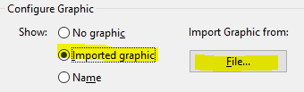
- Use the Select File dialogue box to select a picture of your signature and click okay.
- Referred to in the Preparation for Your Digital Signature ID section (above).
- Click okay to close the Configure Signature Appearance dialog box.
- Click okay again to close the Creation & Appearance dialog box and click okay to exit Preferences and finish setting up.
Signing your form
- Click on the field with a red flag at the top left corner when signing a form. e.g.
- A dialogue box with the heading Digital ID Configuration Required will appear with the question, ‘would you like to configure one now?’ Select Configure Digital .
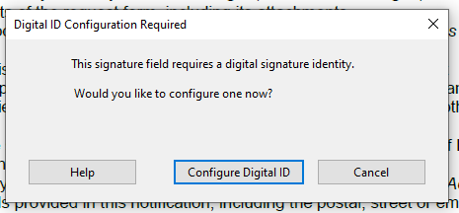
- Then click create a new Digital ID and click continue.
- Fill in your name, organisational unit and email address when prompted: Make sure that the country is Australia.
- You will be asked to enter your preferred password and click save.

- The Sign with a Digital ID dialog box will appear, with your new Digital ID showing and click continue.
- If the picture of your signature does not show where the red circle is (illustrated above), click on Appearance and select the name of the file you made earlier.
- Enter your password and click sign.
- Your Digital Signature ID should now display your signature with digital details within the form. Save the form before sharing for co-signing or submitting this form to the Regulatory Authority.
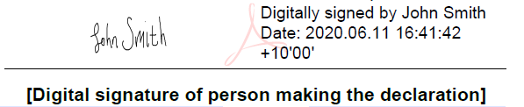

- A clear and legible image of handwritten signatures must be applied to all Digital Signature IDs - without this, your application or notification cannot be assessed.
- The department recommends that you destroy and securely dispose of the paper containing your handwritten signature, delete all electronic photographs of your signature, and to use a single user password-protected computer for storing and using your Digital Signature ID.

