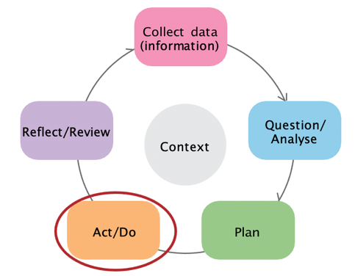

Stage 4: Collect monitoring data

This data literacy tip sheet outlines practical information and suggestions to help services collect data to monitor their SRF plan and activities. It aligns with the Act/Do
stage of the Early Years Planning Cycle.

Early Years Planning Cycle

Collecting data to monitor your SRF plan
Collecting monitoring data will help you to:
- check if your SRF plan is being implemented as intended.
- see if you are achieving your goals
- complete your SRF Mid-Year Review and End of Year Acquittal and Review.
- think about whether your SRF plan needs to be adapted and provide support for plan variations.
To collect monitoring data, refer to the indicators and measures of success in your SRF plan. You might collect secondary data and primary data to monitor your SRF.
Common primary data sources that will be useful for monitoring purposes include:
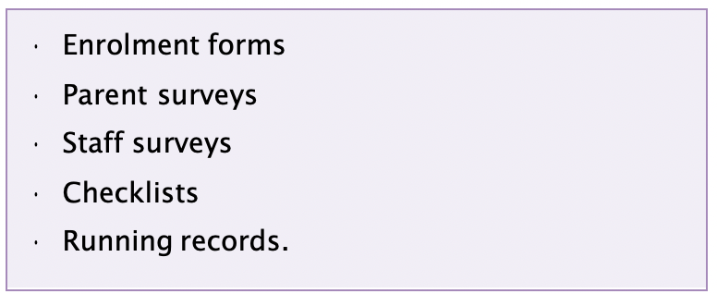
Simple data collection methods for collecting feedback from families could include:
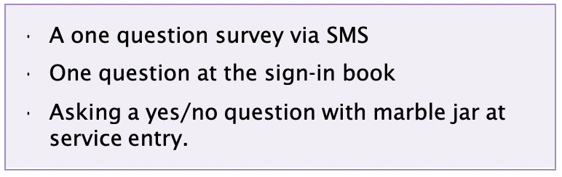

How do I embed the collection of monitoring data into practice?
Think about the sources of data you already collect and how these could be modified to collect monitoring data for SRF activities. Some typical sources include:
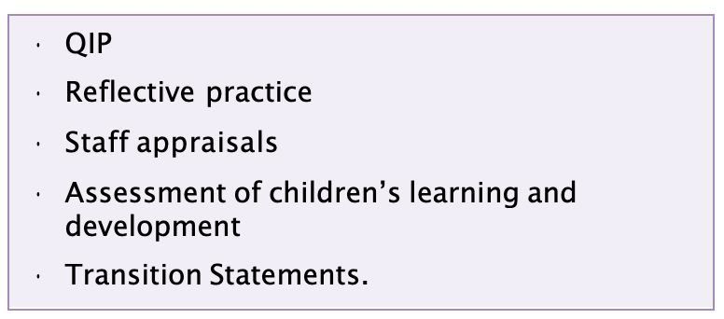

How can I strengthen my data collection for monitoring purposes?
- Think about the data you collect regularly and how you can embed the collection of monitoring data into your existing practice.
- Collect a range of monitoring data that helps you to:
  - understand whether your plan is being implemented as intended
  - understand whether the SRF activities have led to outcomes for the service, staff, children, and families.
- Set a calendar reminder to help you remember to organise and collate the monitoring data on a regular basis.
- Remember to store data securely and make it non-identifiable where possible.

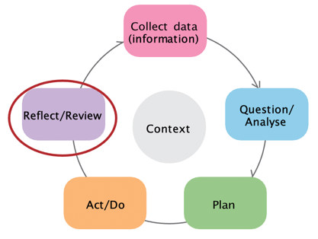

Stage 5: Review progress

This data literacy tip sheet outlines practical information and suggestions to help services review the progress of their SRF plan. It aligns with the Reflect/review stage of the Early Years Planning Cycle.

Early Years Planning Cycle

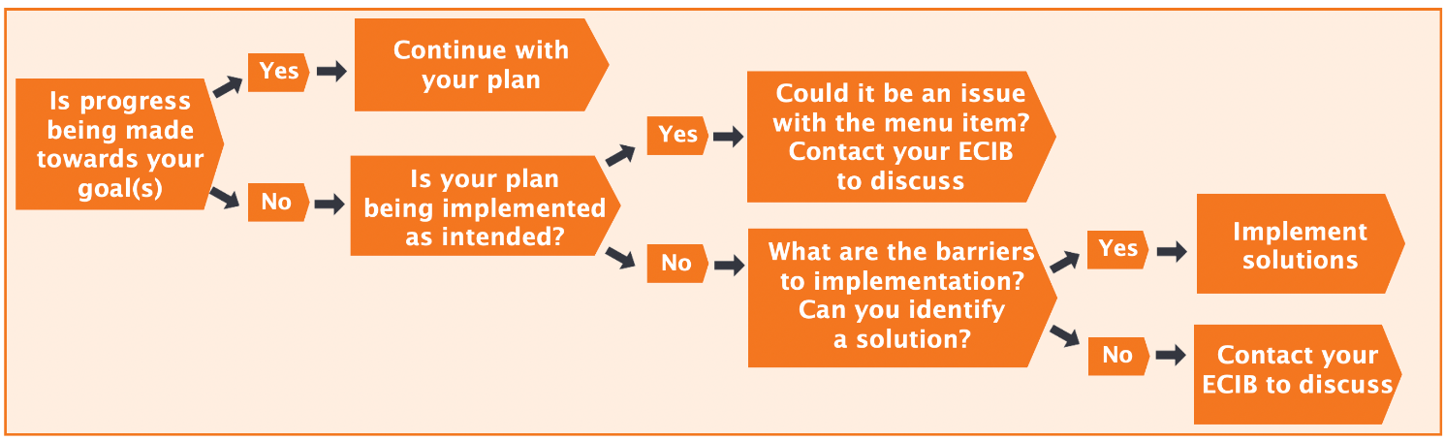

Figure 1: Decision making flowchart to determine if you are making progress towards your goals and if your
SRF plan needs adapting

Working out what the monitoring data is telling you
Reviewing your monitoring data on a regular basis enables you to understand:
- whether you’re implementing menu items as intended
- whether you’re making progress towards your goal. This information then enables you to make changes or adjustments to your SRF plan if necessary.
When making sense of your monitoring data, refer to your SRF plan and ask yourself:
- Are we implementing our SRF activities as we intended?
- Are we making progress towards the goals we set ourselves?

Ask your colleagues to help you review your monitoring data and identify if you need to adapt your SRF plan. This will allow you to share perspectives, ask questions of each other and support each other’s learning in this area.

Working out whether your SRF plan needs adapting
The decision-making flowchart in Figure 1 is a process you can use to determine whether your SRF plan needs adapting. Adapting your SRF plan means modifying it based on what you have learnt. Adaptation may not be necessary if your indicators and measures of success indicate good progress. If your measures indicate an issue, this presents an opportunity to change or adapt what you’re doing.
Reviewing your SRF plan at the end of the year
At the end of the year, you will work out the outcomes of your SRF plan to understand whether the SRF activities have led to outcomes for the service, staff, children, and families. You can also reflect on what you’ve learnt through your SRF activities. This review process will help you to complete your End of Year Acquittal and Review and inform your SRF planning for the following year.

