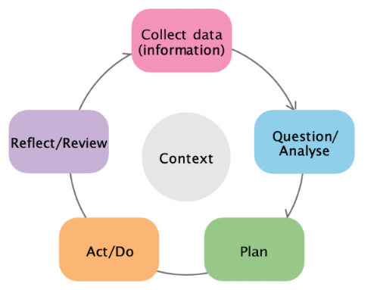

Using data effectively in your SRF plan

The five stages of using data to improve the impact of SRF are outlined below. The five stages align with the Early Years Planning Cycle stages. Further information on each stage is provided in the SRF data literacy tip sheets.
Early Years Planning Cycle

- Collect data
Collect a range of data to provide a complete picture of the recurrent learning and development needs of children and families that attend your service. | - Develop questions to help work out what data you need.  - Collect community/child level, service level and educator level data. | - Look at existing community data such as AEDC to identify community needs and issues.  - Think about the data your service already collects such as enrolment data. | - Collect new data to understand families concerns and priorities.  - Build on the data and reflections from your previous SRF plan and end of year review.
- Question/Analyse data
Make sense of your data and summarise key findings to provide a clear picture of the  issues and needs of your service at a community/child, service, and educator level. | - Start by trying to make sense of individual pieces of data.  - Look for patterns or trends in quantitative data. What is happening over time? | - Look for key themes in qualitative data.  - Explain to others what you think the data is indicating in clear, simple terms. | - Create a team. Making sense of combined data findings is best done as group.  - Use what you’ve found from the data to select your SRF priority area(s).
- Plan to implement
Ensure your SRF plan addresses the areas of need identified by your data findings. | - Select menu items that address the identified needs of your service.  - Make sure your goals are S.M.A.R.T. | - Develop indicators and measures of success to monitor your SRF plan. | - Identify data sources for your indicators and measures of success.
- Collect monitoring data
Collect and collate monitoring data regularly to monitor the progress of your SRF plan. | - What is implementation telling you? | - What are your reflections?  - What are your findings? | - Use your monitoring data to support your mid-year and end of year review.
- Review progress
Review progress to help you understand whether your SRF plan is being implemented as intended and whether you are achieving your goals. | - What progress are you making against your SRF plan?  - What outcomes you have achieved? | - What is not working?  - Does any part of your SRF plan need to change, and how? | - What would you like to extend on in your next SRF plan?

