How to create a spreadsheet to upload multiple enrolments for a single service
Quick Reference Guide

A service provider is required to provide details of all children enrolled and attending a funded kindergarten program for children in the year before school via the Kindergarten Information Management system (KIM).
KIM allows you to add multiple enrolments for a single service by uploading a spreadsheet that you have prepared in advance.
In order to add multiple enrolments successfully, it is important that the enrolments spreadsheet is formatted correctly and then saved as a .csv file. This Quick Reference Guide provides instructions for preparing your enrolments spread sheet.

Download the .csv template
- From the KIM home page, click the relevant service.
- Click the Enrolments tab.
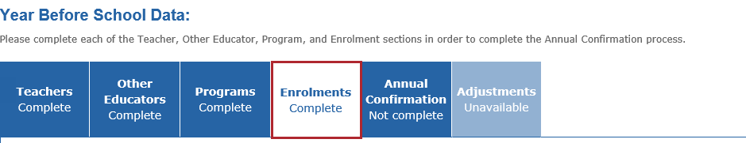
- Click Upload Multiple Enrolments +.
- Click CSV Template.
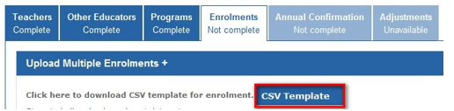
When you have completed the following steps and are ready to upload your spreadsheet, it is important that you follow the instructions in the Quick Reference Guide: How to add, edit or remove an enrolment in the year before school.
- Complete and save the .csv spreadsheet to your computer.

Below provides details of all columns in the spreadsheet.
Column order
Ensure that the enrolments .csv spreadsheet you have opened and will use contains the following column headings and formatting in this specific order.
Note: Do not include any commas, apostrophes or special characters in your data such as: @, *, $. Hyphens (-) are accepted. See Appendix 1 of this document for more information.
- ServiceName: must be exactly the same as the service name in KIM
- GivenName: UPPER or lower case or Mixed case. Can include a hyphen but not an apostrophe (‘)
- FamilyName: UPPER or lower case or Mixed case. Can include a hyphen but not an apostrophe (‘)
- Sex: use a capital M, F or O only
- DOB: Date of Birth must be DD/MM/YYYY format only e.g. 26/01/2010
- AddressUnitNumber: Child’s unit number. Or leave blank if none.
- AddressStreetNumber: The child’s street number.
- AddressStreetName: The child’s street name. Can include a hyphen but not an apostrophe (‘)
- AddressStreetType: must be all capital letters (see page 6 – Valid Street Types)
- AddressSuburb: The child’s suburb.
- AddressState: must be all capital letters e.g. VIC
- DateCommenced: The date the child commenced the funded kindergarten program in the current calendar year. DD/MM/YYYY format only e.g. 28/01/2015
- AdultAEducation – highest level of primary/secondary education (e.g. Year 10 or equivalent, Year 9 or equivalent) that parent/guardian A (Primary Carer) has achieved. If the person has never attended school, select Year 9 or below.
- AdultAQualification – highest qualification that parent/guardian A (Primary Carer) has achieved (e.g. no non-school qualification, bachelor degree. If the person has not completed a qualification post school, select ‘No non-school qualification’. Qualifications completed overseas are recognised.
- AdultAOccupation – Code of occupation group of Parent/Guardian A’s (Primary Carer) main job. If the person is not currently in paid work but has had a job in the last 12 months, or has retired in the last 21 months, please use their last occupation to select from the occupation group list. If the person has not been in paid work in the last 12 months, select N. For information about the occupation group codes see Appendix 4 – Parental Occupation Codes.
- AdultBEducation – as above. Leave blank if no second parent/guardian.
- AdultBQualification – as above. Leave blank if no second parent/guardian.
- AdultBOccupation – as above. Leave blank if no second parent/guardian.
Note: Ensure there are no SPACES before the first character or after the last character in any cell of the CSV file. Spaces between words are allowed.

Formatting examples

Correct Formatting
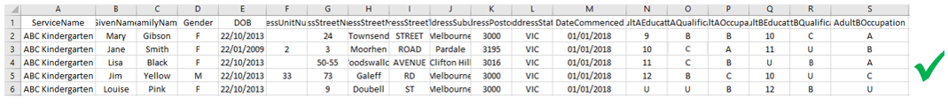
Note: The above images provide a basic example of how to complete the spreadsheet, ensure you have completed the spreadsheet based the enrolment circumstances.

Incorrect Formatting
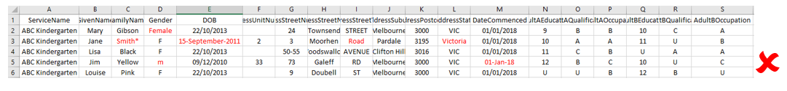

Document Format and save
Once you have completed the spreadsheet and formatted the cells correctly, the document must be saved in .csv format in order to upload it to KIM.
To save the document in .csv format follow these instructions:
- With the spreadsheet open, select File, then Save As.
Result: The File Save menu pops up.
- Select the relevant location in your computer to save the file.
- For Microsoft Office users, click Save as type dropdown list and select CSV (Comma delimited), then click Save.
Note: For Mac users, click Save as type dropdown list and select Windows Comma Separated (.csv), then click Save.

Appendix 1 – Mandatory Fields
Note:
- Apostrophes (‘) must not be entered in any field
- Do not enter future commencement dates
- Do not include spaces before the first or after the last character in each cell
- Do not enter Apostrophes or symbols in the cells e.g: ‘ “ @ $ % =
- Hyphens and spaces between names is permitted e.g. Mary-Louise
- Ensure all dates are formatted DD/MM/YYYY e.g. 16/01/2019
- Ensure Sex, AddressStreetType and AddressState are ALL UPPERCASE
If you are unable to upload the .csv file, please contact the HELP desk for assistance Phone: 1800 614 810 Email: HELP.helpdesk@edumail.vic.gov.au

Column | Mandatory | Type | Values / Format | Example | Description
ServiceName | Y | Text | UPPER or lower case or Mixed or hyphen | Appletree Kinder  APPLETREE KINDER  Apple-tree kinder | The name of the service attended by the child  NOTE: This must be an exact match of the service name in KIM
GivenName | Y | Text | UPPER or lower case or Mixed or hyphenated | Mary  Mary-Jo  Mary Anne | Child’s First Name
FamilyName | Y | Text | UPPER or lower case or Mixed or hyphenated  ‘-‘ or space only | Smith  Smith-Hart  Smith Hart | Child’s Last Name
Sex | Y | Text | M or F (UPPERCASE only) | M for Male  F for Female  O for Other | Child’s Sex
DOB | Y | Date | dd/mm/yyyy | 23/02/2010 | Child’s DOB
AddressUnitNumber | N | Text | Blank if not required | Blank  2  A  2A | Child’s Address Unit Number
AddressStreetNumber | Y | Text | Numbers , letters | 1  1A  10-12 | Child’s Address Street Number
AddressStreetName | Y | Text | UPPER or lower case or Mixed or hyphenated | Alexandra Park  ALEXANDRA PARK  Alexandra-Park | Child’s Address Street Name
AddressStreetType | Y | Text | UPPER only - refer Appendix 2 for valid street types | STREET  Street types must exactly match the valid street types in Appendix 2 | Child’s Address Street Type
AddressSuburb | Y | Text | UPPER or lower case or Mixed or hyphenated | Northcote or Box Hill  NORTHCOTE or BOX HILL  Northcote or Box-Hill | Child’s Address Suburb
AddressPostCode | Y | Number | Must be 4 numbers only | 3182 | Child’s Address Postcode
AddressState | Y | Text | State code | VIC, NSW, QLD, SA, WA, ACT, NT, TAS | Child’s Address State
DateCommenced | Y | Date | dd/mm/yyyy | 28/01/2015 | The date the child commenced at this service
AdultAEducation | Y | Number or text | 9, 10, 11, 12, U | 9 = Year 9 or equivalent or below  10 = Year 10 or equivalent  11 = Year 11 or equivalent  12 = Year 12 or equivalent  U = Did not provide a response | The highest year of primary or secondary school the Adult A (Primary Carer) has completed
AdultAQualification | Y | Text | N, C, D, B, U | N = No non-school qualification  C = Certificate I to IV (including trade certificate)  D = Advanced diploma / Diploma  B = Bachelor degree or above  U = Did not provide a response | The highest qualification level the Adult A (Primary Carer) has completed
AdultAOccupation | Y | Text | A, B, C, D, N, U | A = Code A occupation  B = Code B occupation  C = Code C occupation  D = Code D occupation  N = Person has not been in paid work in the last 12 months  H = Person has not been in paid work for the last 12 months because the person cares for their own children full time  U = Did not provide a response | The occupation group of Adult A (Primary Carer)
AdultBEducation | N | Text | 9, 10, 11, 12, U | 9 = Year 9 or equivalent or below  10 = Year 10 or equivalent  11 = Year 11 or equivalent  12 = Year 12 or equivalent  U = Did not provide a response | The highest year of primary or secondary school the Adult B has completed
AdultBQualification | N | Text | N, C, D, B, U | N = No non-school qualification  C = Certificate I to IV (including trade certificate)  D = Advanced diploma / Diploma  B = Bachelor degree or above  U = Did not provide a response | The highest qualification level the Adult B has completed
AdultBOccupation | N | Text | A, B, C, D, N, U | A = Code A occupation  B = Code B occupation  C = Code C occupation  D = Code D occupation  N = Person has not been in paid work in the last 12 months  H = Person has not been in paid work for the last 12 months because the person cares for their own children full time  U = Did not provide a response | The occupation group of Adult B

Appendix 2 – Valid Street Types
Street Type | Street Type | Street Type | Street Type | Street Type | Street Type
ACCESS | CLOSE (CL) | FAIRWAY | LANE (LA) | QUADRANT | TERRACE (TCE)
ALLEY | COMMON | FIRETRAIL | LINE | QUAY | THROUGHWAY (THROWAY)
APPROACH | CONCOURSE | FOLLOW | LANEWAY | QUAYS | TOLLWAY
ARCADE | COPSE | FORD | LINK | RAMBLE | TOP
ARTERY | CORNER | FORMATION | LOOKOUT | ROAD (RD) | TOR
AVENUE (AVE) | CORSO | FREEWAY | LOOP | REACH | TRACK
BANK | COURSE | FRONT | LOWER | RESERVE | TRAIL
BASIN | COURT | FRONTAGE | MALL | REST | TURN
BAY | COURTYARD | GAP | MEAD | RETREAT | UNDERPASS
BEACH | COVE | GARDEN | MEANDER | RETURN | VALE
BEND | CRESCENT (CRES) | GARDENS | MEWS | RIDE | VALLEY
BUILDING (BLDG) | CREST | GATE | MOTORWAY | RIDGE | VIEW
BOULEVARD (BLVD) | CRIEF | GATES | NOOK | RING | VISTA
BOARDWALK | CROSS | GATEWAY | OUTLOOK | RISE | WALK
BOWL | CROSSING | GLADE | OVERPASS | RISING | WALKWAY
BRACE | CULDESAC | GLEN | PROPERTY (P) | ROADWAY | WAY
BRAE | CURVE | GRANGE | PARK | ROTARY | WHARF
BREAK | DALE | GREEN | PARKLANDS | ROUND | WYND
BRIDGE | DEVIATION | GROUND | PARKWAY | ROUTE
BROADWAY | DIP | GROVE | PASS | ROW
BROOK | DOWNS | GROVET | PATH | RUN
BROW | DRIVE (DR) | HAVEN | PATHWAY | SERVICEWAY (SERWAY)
BYPASS | DRIVEWAY | HEATH | PARADE (PDE) | SIDING
CANAL | EASEMENT | HEIGHTS | PIER | SLOPE
CAUSEWAY | EDGE | HILL | PLACE (PL) | SPUR
CENTRE | ELBOW | HUB | PLAZA | SQUARE
CENTREWAY | END | HIGHWAY (HWY) | POCKET | STEPS
CHASE | ENTRANCE | INTERCHANGE (INTER) | POINT | STRAND
CIRCLE | ESPLANADE | ISLAND | PORT | STREET (ST)
CIRCLET | ESTATE | JUNCTION | PROMENADE | STRIP
CIRCUIT | EXPRESSWAY (EXPWAY) | KEY | PURSUIT | SUBWAY
CIRCUS | EXTENSION | KNOLL | QUAD | TARN

