About program details
You are required to provide information about the kindergarten program offered at the service you operate via the Kindergarten Information Management (KIM) system.
Please ensure that you have added your qualified early childhood teachers prior to entering the program details (refer to the Quick Reference Guide: How to Add, Edit, or Remove a Teacher for more information).

Provide program details
- In the service Home page, click on the Programs tab.
- Click the Edit button under the text “This service currently delivers the kindergarten program as:”
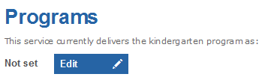
Result: the Programs Offered screen will display.
- Select whether the kindergarten program is delivered using; a sessional model; integrated into a long day care program; or, using both sessional groups AND integrated in a long day care program.
Hover your mouse over the blue question marks for more information.
If you select Using a sessional model, you will be required to indicate:
- whether the service uses a rotational model to deliver the kindergarten program, and
- whether the service offers;
  - a kindergarten program for four year olds only
  - a kindergarten program for four year olds and a separate kindergarten program for three year olds, or
  - a combined kindergarten program for three and four year olds.
If the service offers a separate or combined program for three year olds, you will be required to indicate whether the program for three year old children is planned and delivered by an early childhood teacher.
If you select Integrated into a Long Day Care program (LDC), you will be required to enter the number of weeks per year that the kindergarten program operates at the service. You must also indicate whether you have a program for three year old children that is planned and delivered by an early childhood teacher holding an approved qualification.
If you select Both sessional groups AND integrated in a LDC program, you will be required to provide all of the above information.
- Click Save
Result: a group will display under the Programs tab. The program type will display dependent on your selection in step 3. If you selected that the kindergarten program is delivered using both a sessional model and integrated into long day care, two groups will display – Integrated and Sessional:
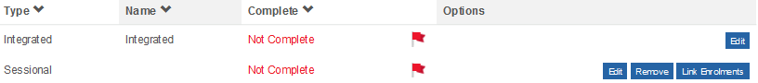
- To enter the required information for each group, click the Edit button.

Sessional Model
- If you indicated that your program is delivered using a sessional model, you are required to enter:
- The name of the group
- The hours the group operates per day. The total hours for the week must equal a minimum of 15 hours
- The fee charged for the program prior to the application of the kindergarten fee subsidy and the fee period (select term, daily, hourly or weekly).
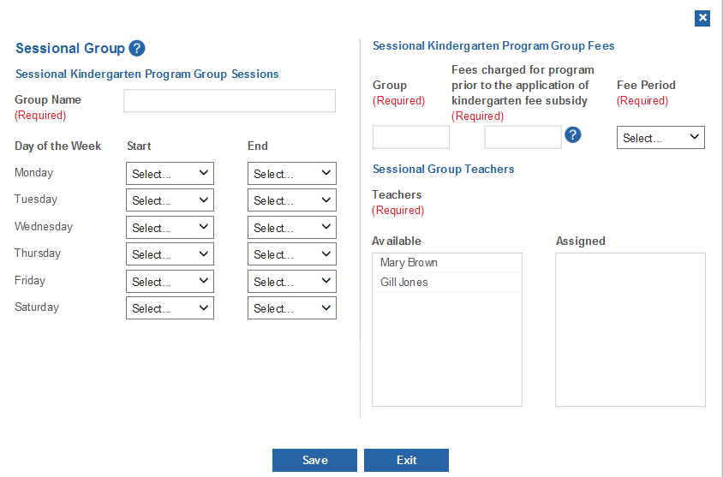
- If you also indicated that the service uses a rotational model, you are required to add and select the rooms in which each kindergarten session is delivered.
If you only use one room for all your sessions, please name it "Kindergarten Room", then select this room for all the sessions. If you have more than one room you will need to add multiple rooms and use the unique room names that you are familiar with.
To add a room:
- Click Add+
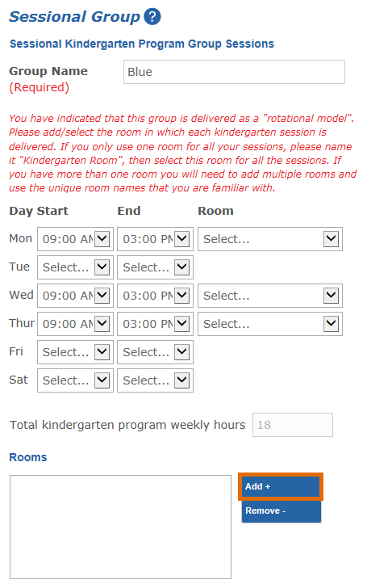
Result: A window will display asking for the Room Name.
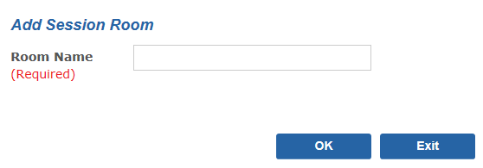
- Enter the Room Name and click OK.
Result: The room name will display under Rooms.
- Add more rooms if required and then use the drop-down list to select the room for each kindergarten session.
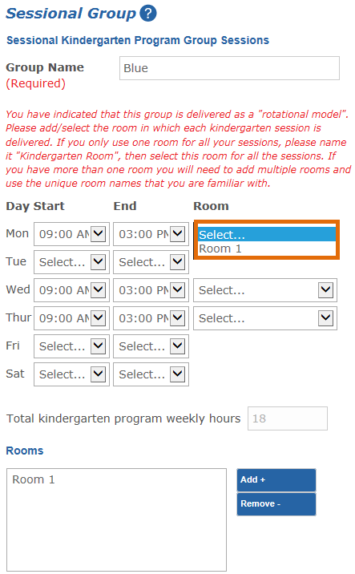
- You must have already entered your qualified early childhood teacher(s) under the Teacher tab, to be able to link each teacher to a group. If you have not entered your teacher(s), you will need to do this prior to completing the Program tab.
In the box titled Available click on the name of the teacher who is planning and delivering this particular group.
Result: the teacher will now display in the Assigned box.
For example, to assign Mary Brown to this group, click on the name Mary Brown in the Available box.
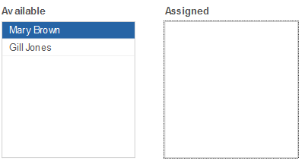
Mary Brown will automatically display in the Assigned group.
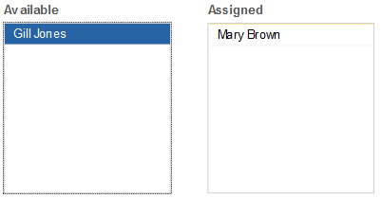
If you have assigned a teacher by mistake, click on the teacher’s name in the Assigned box. The teacher will now display in the Available box.
- Click Save.
Result: If all required information has been entered, the group will display with the status Complete.
- To add another sessional group, click the Add Sessional Group + button.

Integrated into Long Day Care
- If you indicated that your program is integrated into a long day care program, you are required to enter the start and finish time for each day that the teacher(s) works.
Note: The teacher name is pre-populated with the teacher(s) you added under the Teachers tab. If you have not added any teachers, you will need to do this before you enter the program details. 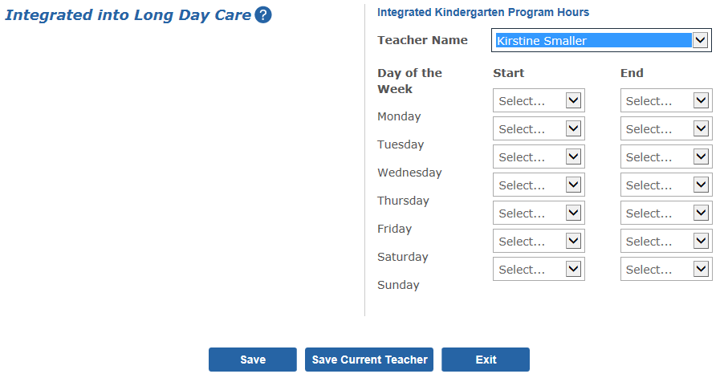
- If there is more than one teacher, click Save Current Teacher after entering the first teacher’s program hours.
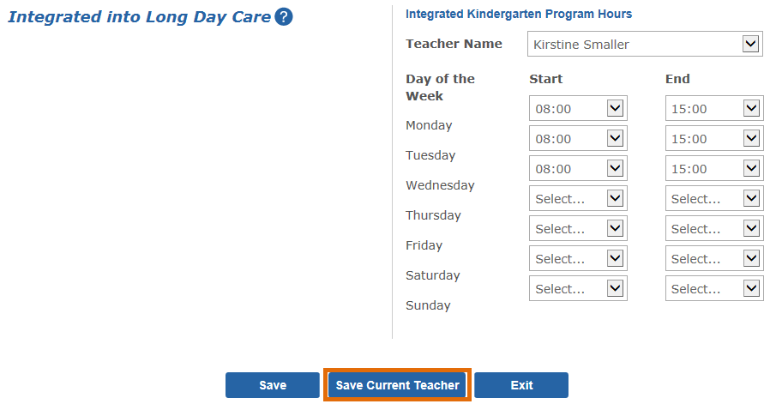
- Select the next teacher from the drop-down list and enter their program hours.
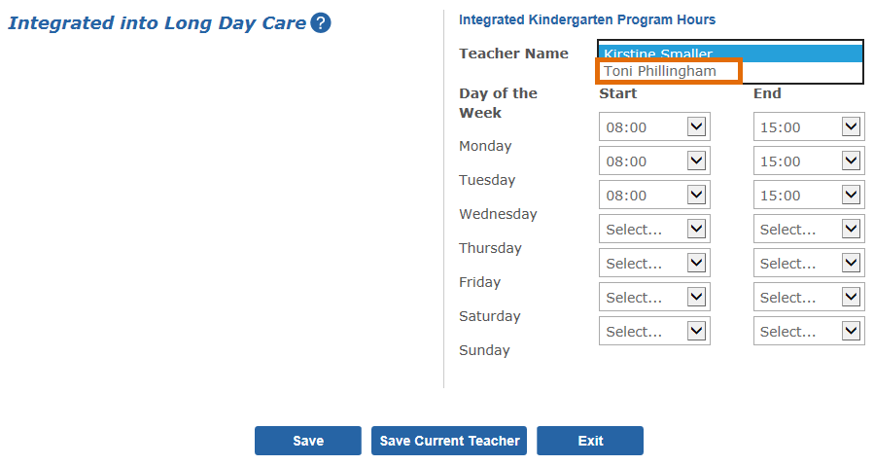
- When all teacher shifts have been entered, click Save.
Result: the group status will display as Complete.

Update program details
- Click the Edit button next to the group you want to edit.
- Edit details as required
- Click Save.

Remove a (sessional) group
- Click the Remove button next to the group you wish to remove.
- A message will display verifying the name of the group being removed.
- Click Remove.

