- On your KIM home page, click on the Edit/Apply button for the corresponding service. If you are unable to select this option, there is a pending application for the service that needs to be completed or approved. Check your Saved and Submitted applications under Application Status in the main menu.
Tip!
You can also access this form by clicking the Update button under the service’s contact details on the service’s home page.

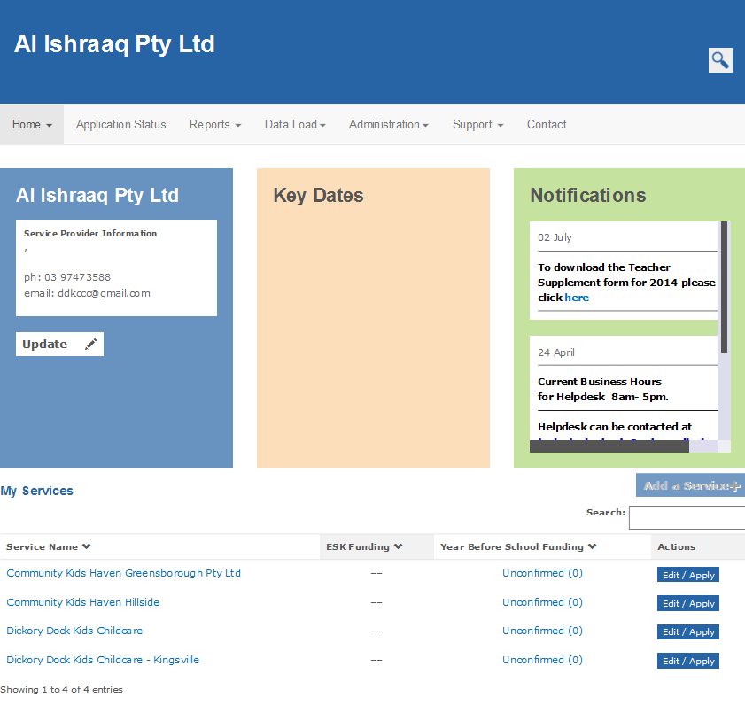
- Select Edit this Service
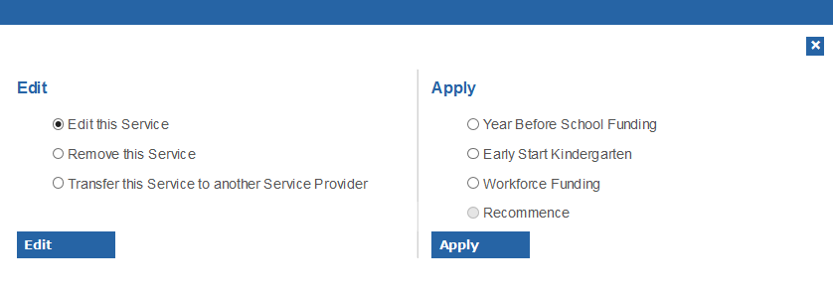
- Click Edit
- Check the service address and emergency contact details that are provided in the form and update as required. Please note that you are not able to edit the Service Name. If the name is incorrect, please contact your Department regional office.
- To select the LGA Code, click Select LGA.
Two options are presented:
VMAS Suggested Addresses: the system will attempt to match the address you entered with an LGA code. If it can match the address you entered, select the address to auto-populate the LGA code. If the system cannot find a matching address, it will display ‘No Matching Addresses’. You will then need to select the second option LGA Codes.
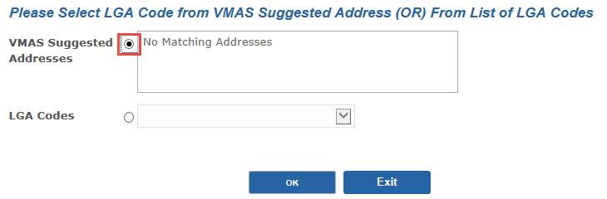
LGA Codes: Manually select the LGA from the drop-down list. Type the first couple of letters of the LGA name to quickly navigate through the list. Then select the relevant LGA Code (e.g. Melbourne (C) 24600).
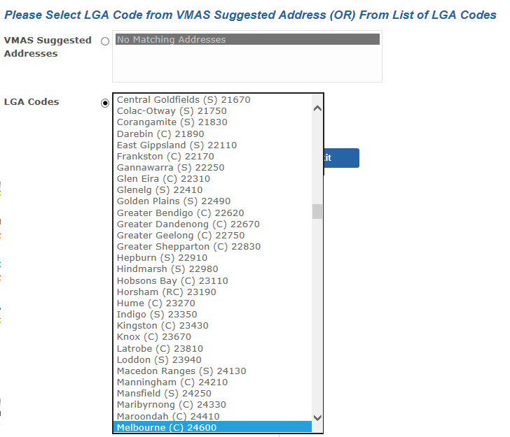
- Click OK
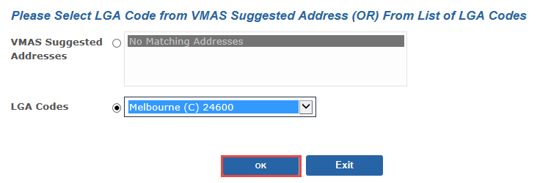
Result: The LGA Code populates the LGA field in the address screen.
- When all details on the page are complete and correct, click Next.
- Update the service’s current National Quality Framework rating if required.
- Update the service’s programs or activities offered at the service location if required.
- Click Submit.
Result: the form is submitted for approval by the Department and will display in the Application Status menu, under the Submitted tab until it is approved.

