About KIM
The Kindergarten Information Management system (KIM) is used to request funding from and provide information to the Department of Education and Training (the Department) about your organisation and the service(s) it operates.
You can use KIM to:
- update service or service provider details (please note that KIM is separate from NQA ITS and the Funded Agency Channel so please remember to update these systems simultaneously)
- add and adjust enrolments in the funded kindergarten program in the year before school
- add and update workforce information
- add and update the funded kindergarten program details
- complete the two mandatory data collection processes (annual confirmation of data and kindergarten census)
- apply for supplementary funding

KIM Support
Help Desk
For KIM technical support call the Health and Early Learning Practitioners Helpdesk on 1800 614 810 or email: HELP.Helpdesk@edumail.vic.gov.au

Quick Reference Guides
Visit the Support menu on your KIM home page or the KIM page of the Department of Education and Training website to download Quick Reference Guides to help you to access and navigate KIM: http://www.education.vic.gov.au/childhood/providers/funding/Pages/kinderim.aspx

Access KIM
To access KIM, you need a registered eduPass account.
Organisation Administrators can see the Quick Reference Guide: How Organisation Administrators Add a User.
Users can see the Quick Reference Guide: How to Register for eduPass and Access KIM.

- Open your internet browser, e.g. Internet Explorer.
- Access KIM at https://kim.eduweb.vic.gov.au
Result: KIM login screen displays.
- Type your UserID (which starts with ‘EC’) and eduPass password into the UserID and Password fields, then press Enter.
Result: KIM – Acceptable Use Policy screen displays.
- Read the Acceptable Use Policy and then press Continue.
Result: the KIM service provider Home screen displays.
- To log out, click the user name at the top right corner of the screen.
- Click Sign Out.

Service Provider Home page
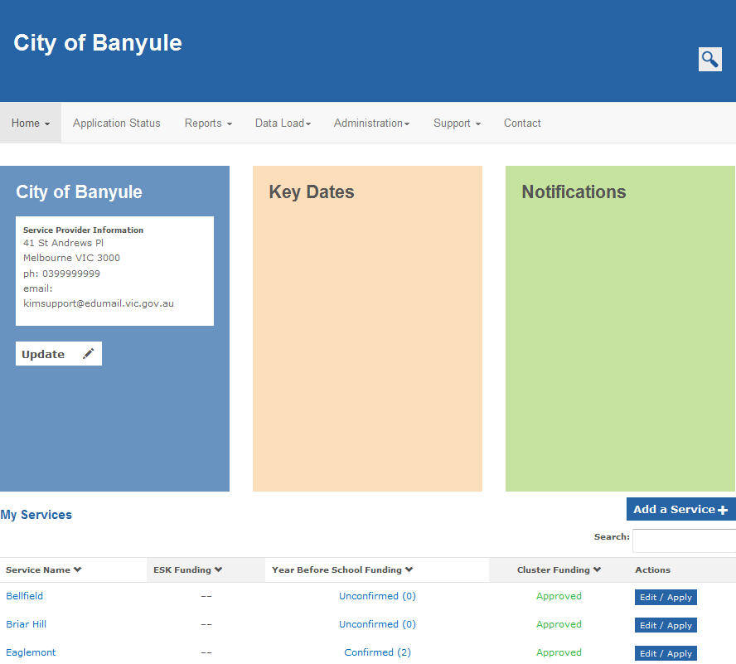

Main menu
Use the main menu displayed on the top of the screen to navigate KIM. It contains the following areas:
- Home – will take you back to your Home page
- Application Status – use to access saved forms and to view the status of submitted applications
- Reports – currently not in use
- Data Load – data upload for multiple services
- Administration – only visible to service providers that have enabled customised access
- Support – training guides and kindergarten funding resources
- Contact – contact information for the Health and Early Learning Practitioners Helpdesk and DET regional offices

Service Home page – Year before School
Click on Edit / Apply to edit information about the service, apply for funding for the service or to navigate to the ESK page
Click on the service name to navigate to the Service Home page for children in the year before school
Click Add a Service to apply to add an additional service location for kindergarten funding
Displays a list of the service provider’s services and a summary of ESK, per capita and cluster funding per service
Columns can be sorted by clicking on the ˅ symbol next to the column header
Important dates and notifications are communicated to service providers via these windows

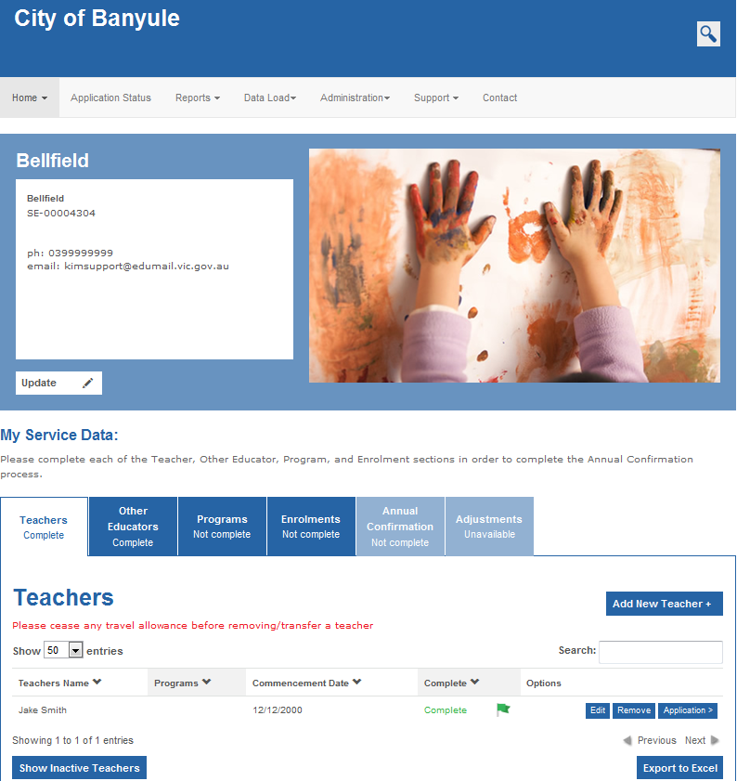
Service Home page – Early Start Kindergarten (ESK)
Use the action buttons next to a particular entry to quickly and easily update information or apply for funding
A full extract of data entered can be exported to Excel
Use this Search function to search for particular entries.
Click on a tab to view, add or update information related to the funded kindergarten program. When the required information is entered for each teacher, other educator, the program and enrolments, the corresponding tab displays with the status Complete and the Annual Confirmation tab is enabled. If more information is required, the tab will display as Not Complete.
The Service Home page is used to enter and confirm the core data (teachers, other educators, program and enrolments) relevant to the funded kindergarten program in the year before school.
After the annual confirmation process is complete, the data must be kept up-to-date to ensure funding eligibility requirements continue to be met and the funding amount is correct.

Use this Search function to search for applications submitted by a service.
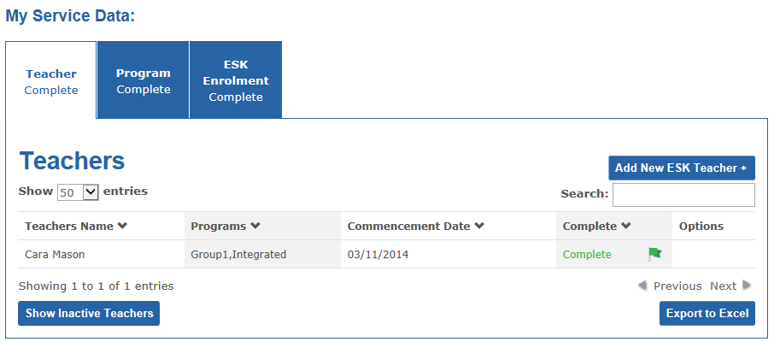
Click on a tab to view, add or update information related to the ESK program. When the required information is entered for each teacher, the program and enrolments, the corresponding tab displays with the status Complete. If more information is required, the tab will display as Not Complete.
The ESK page is accessed by clicking the Edit/Apply button next to the relevant service on the Service Provider Home page and selecting Early Start Kindergarten.
The ESK page is used to enter the teachers, program and enrolments for the ESK program.
Data must be kept up-to-date to ensure funding eligibility requirements continue to be met and the funding amount is correct.

A full extract of data entered can be exported to Excel
Use this Search function to search for particular entries.
Use this Search function to search for applications submitted by a service.

Application Status
The Application Status menu item gives you access to a variety of forms and funding applications.

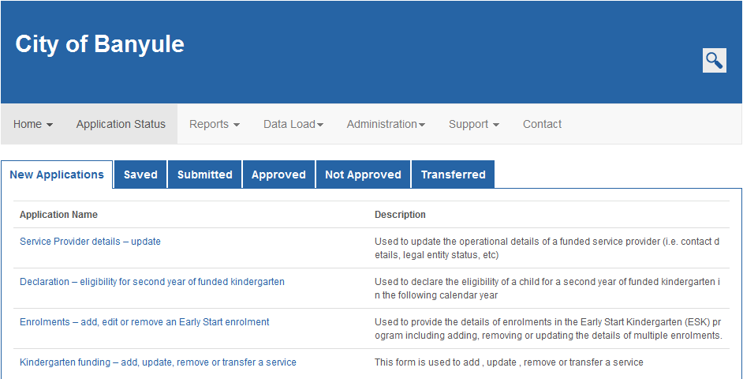
New Applications – this menu item is currently not in use
Saved – list of applications that have been started and saved but not yet submitted.
Submitted – list of submitted applications waiting for Department processing.
Pending Service Provider Approval – this tab will only display if user access is set so that all submitted applications must be reviewed and approved by the service provider.
Approved – list of approved applications.
Not Approved – list of not approved applications.
Transferred – only displays applications where a service is being transferred from another funded service provider to your organisation.

Applications in the Submitted, Approved and Not Approved tabs are read-only and cannot be edited.
Submit a new application from the New Applications tab to update previously submitted information.

