What is a user role?
A user role provides a user with a set of permissions in the system so they can perform specific functions in KIM.

KIM User roles
There are a number of user roles in KIM and each user role has different permissions. The KIM User Roles are described below.

Service User role
A Service User can:
- complete and submit service level core data including; Teachers, Other Educators, Programs, Enrolments, Annual Confirmation, Adjustments and Annual Census.

Organisation User (Org User) role
An Organisation User can:
- complete and submit for all service level core data in the organisation including; Teachers, Other Educators, Programs, Enrolments, Annual Confirmation, Adjustments and Annual Census
- complete and submit funding application forms
- add, update, remove or transfer a service.

Super User role
A Super User can:
- complete and submit all service level core data in the organisation including; Teachers, Other Educators, Programs, Enrolments, Annual Confirmation, Adjustments and Annual Census
- complete and submit funding application forms
- add, update, remove or transfer a service
- perform bulk data uploads
- if two-step approval is set up for their Organisation, review and submit funding application forms.

Organisation Administration (Org Admin) role
Note: the Org Admin role in KIM is different from the in eduPass.
An Org Admin can:
- complete and submit for all service level core data in the organisation including; Teachers, Other Educators, Programs, Enrolments, Annual Confirmation, Adjustments and Annual Census
- complete and submit funding application forms
- add, update, remove or transfer a service
- perform bulk data uploads
- if two-step approval is set up for their Organisation, review and submit funding application forms.
- allocate user roles to other users within their organisation.

Customising User Access
Important Information:
- Only the Org Admin role can view and update user roles.
- Before KIM access is provided, users must be registered in eduPass (see the Quick Reference Guide: How to Register for eduPass and Access KIM).

What user access can be customised and who can customise it?
The person who has the Org Admin role can manage their organisation’s user access. This means that the Org Admin can ensure each user (i.e. each Kindergarten teacher) has the right level of access to perform appropriate actions in KIM that is relevant to their role.

How do I customise user access?
From the Service Provider Home screen:
- Click Administration and then select User Management in the drop-down list.
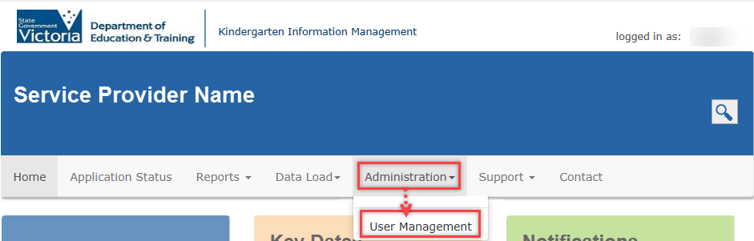
- In the User Search field start typing the User’s name and it will appear in the drop-down list.
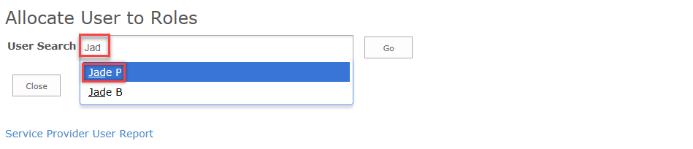
- Click the correct user record and click Go.
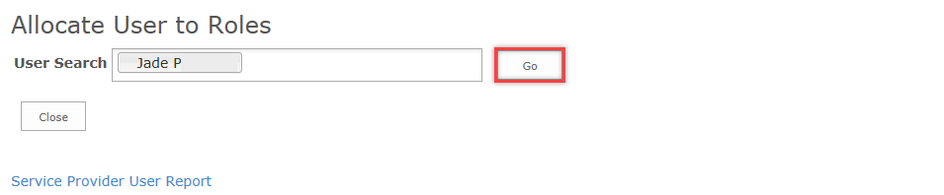

Update Service Data access
- Beside the correct user record, click Assign Access.
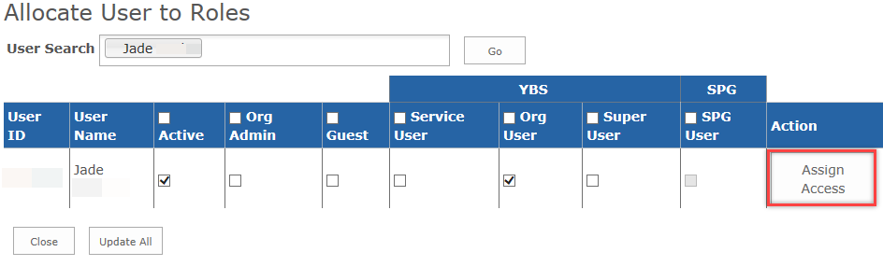
The Configure User Access pop-up window displays.
- To assign service data access for a service or multiple services, tick the corresponding checkboxes in the All Data column.
- Click Update Service.
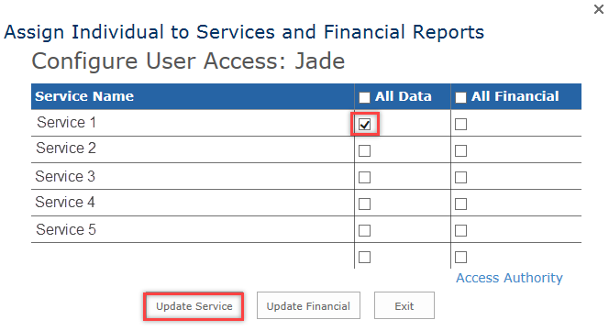
- Click Exit to return to the Allocate User to Roles screen.

Update User Role
- To update the user role, select the checkbox in the relevant role column.
- Click Update All.
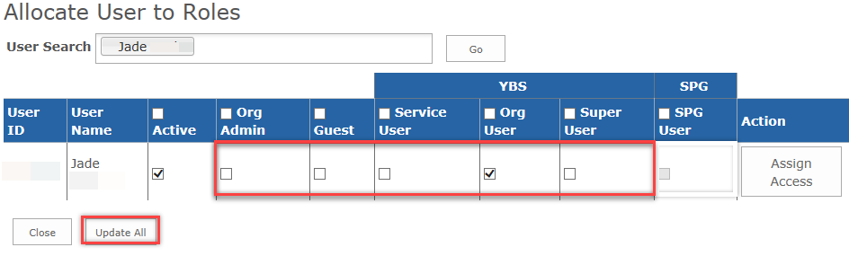

Activate or Deactivate a user
- From the Allocate User to Roles screen, once the user record displays, check the Active column:
  - If the checkbox is ticked, the User is active.
  - If the checkbox is unticked, the User is deactivated.
You can update the user’s active/de-active status by updating the Active checkbox accordingly.
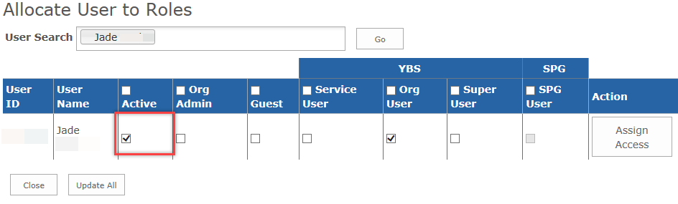
- Once complete, click Update All.

Delete a user
- To delete a user contact the HELP Helpdesk on 1800 614 810 or help.helpdesk@edumail.vic.gov.au and request assistance.

Approval types
There are two types of approvals:
- One step approval; this is the default option and all users can submit data and funding application forms for the Department’s approval.
- Two step approval; completed funding application forms are directed to the service provider’s authorised person, usually the Super User or the Org Admin, for review and approval prior to submission to the Department.

When do I customise the approval process?
For service providers that are large with multiple services, the two step approval process adds an additional step to ensure information submitted for approval to the Department is checked and by their authorised person.
All service providers receive the one step approval setup by default. For two step approval to be added to your organisation, the Org Admin must contact the HELP Helpdesk and request to change from one step approval to the two step approval, this will then be reviewed and the Org Admin will be advised of an outcome.

