To access the Kindergarten Information Management (KIM) system, users need a registered eduPass account (see the Quick Reference Guide: How to Register for eduPass and Access KIM).
Each service provider has one person designated as an Organisation Administrator (OA) who is responsible for inviting other users from their organisation to register for and activate eduPass accounts.

If you do not know who has been designated as the OA for your organisation, call the Help Desk on 1800 614 810.

This Quick Reference Guide describes how the OA:
- invites users to register for and activate an eduPass account
- gives users access to KIM
- extends, reinstates or removes user access to KIM.

eduPass invitation
OAs will receive an automatic email from the Department of Education and Training. The sender’s address will be ‘no-reply@edumail.vic.gov.au’ and the subject title will be [Your Service Provider Name] has invited you to access an eduPass application.

Follow the instructions in the Quick Reference Guide: How to Register for eduPass and Access KIM. You are then able to invite other users to register for eduPass accounts, using the instructions below.

Invite a user
- Access eduPass at https://edupass.education.vic.gov.au/community/portal
Result: the eduPass log in screen displays.
- Enter your eduPass UserID and password, which were provided by email to all designated OAs, and then press Log In.
Result: the Welcome to eduPass screen displays.
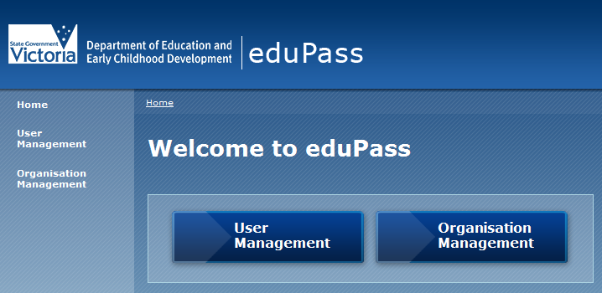
- Click Organisation Management.
Result: the My Organisation screen displays
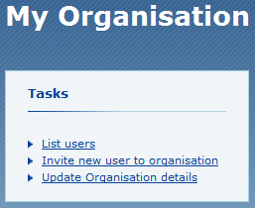
- Click the Invite new user to organisation link.
Result: the Invite user screen displays.
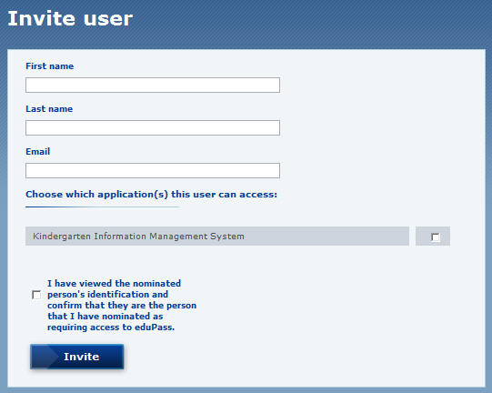
- Complete the nominated user’s name and email details.
- Check the box to select the application Kindergarten Information Management System.
- Check the box to confirm that I have viewed the nominated person’s identification..., and then click Invite.
Result: eduPass sends an email invitation to the nominated user. The invitation will show as a ‘Pending Invite’ in the Organisation Invitations table in the My Organisation screen. The nominated user can then register for and activate an eduPass account.

Extend or reinstate user access
- In the My Organisation screen, click List users.
Result: the My Application Users screen displays with a table of users.
- In the table of users, click Edit next to the user requiring activation/extension.
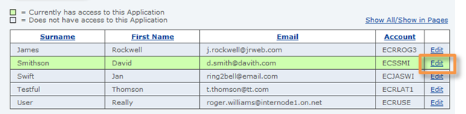
Result: the User Details screen displays.
- Review the user’s personal details, and if required, click Modify to make changes to their details.
- In the User access granted by this organisation section, click Change next to Kindergarten Information Management System.
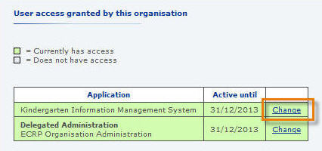
Result: the Approve Access screen displays.

- In the Approve access until field, type a new access end date that is no later than the end of the current year, and then click Approve.
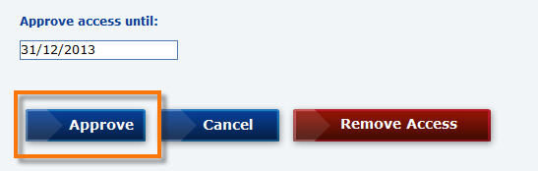
Result: the Confirm access section displays.
- Click Confirm.
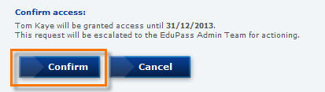
Result: user access is extended or reinstated.

Remove user access
- Repeat Extend or reinstate user access steps 1–4.
- In the Approve Access section, click Remove Access.
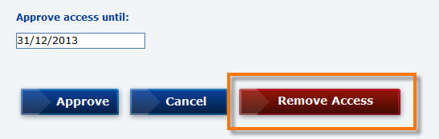
Result: the Confirm Access section displays.
- Click Confirm.
Result: user access is removed.

