How to declare eligibility for a second year of funded kindergarten
Quick Reference Guide

About the declaration of eligibility for a second year of funded kindergarten
The declaration is used to inform the Department of the eligibility of a child for a second year of funded kindergarten. The teacher, in consultation with the child’s parents, must have assessed the child’s eligibility for a second year of funded kindergarten using the process detailed in the Kindergarten Funding Guide and completed the necessary documentation (Term Three Plan for Learning and Development and Second Year Discussion).
The declaration should be completed in KIM by the child’s kindergarten teacher in consultation with, and with the consent of, the child’s parents/guardians from the end of term 3 of their first year of funded kindergarten. The declaration can be submitted in KIM up to mid-November in the child’s first year of funded kindergarten.
Please ensure that the child’s teacher is entered in KIM prior to submitting the declaration. For instructions on adding a teacher, refer to the Quick Reference Guide: How to add, edit or remove a teacher.

declare eligibility for a second year of funded kindergarten
- From the KIM service provider home page, click on the Service Name under My Services.
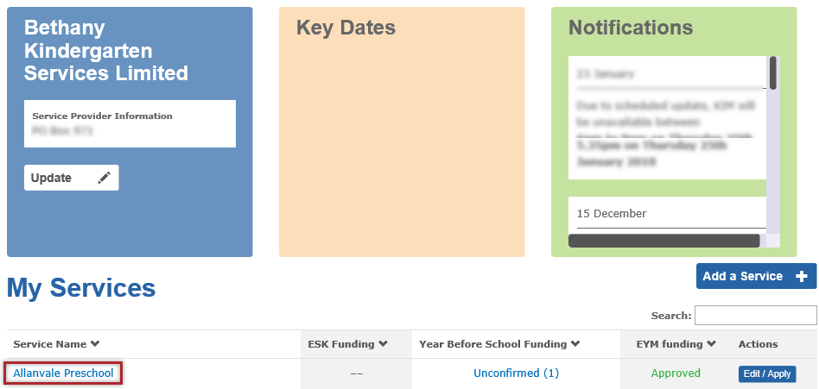
- Click Enrolments.
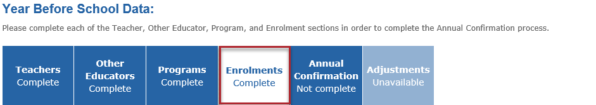

- Click Edit next to the child that you are declaring eligibility.
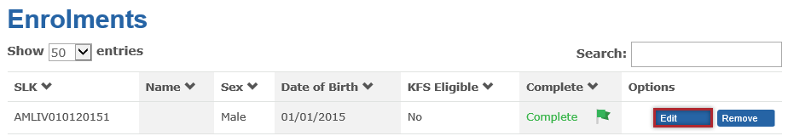
Result: The selected child details window opens.
- Click Next at the bottom of the screen.
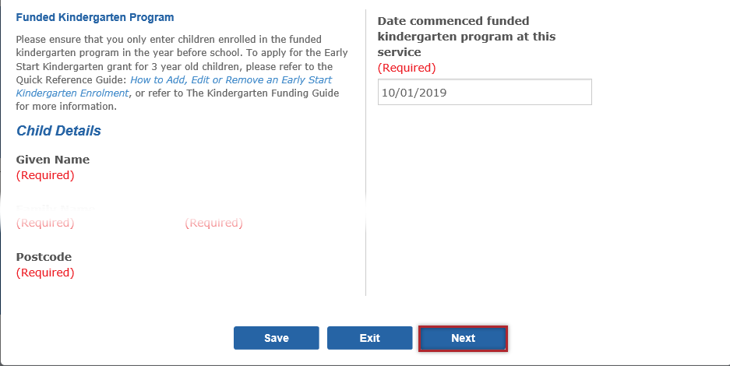

- Click Next again to go to the next screen.
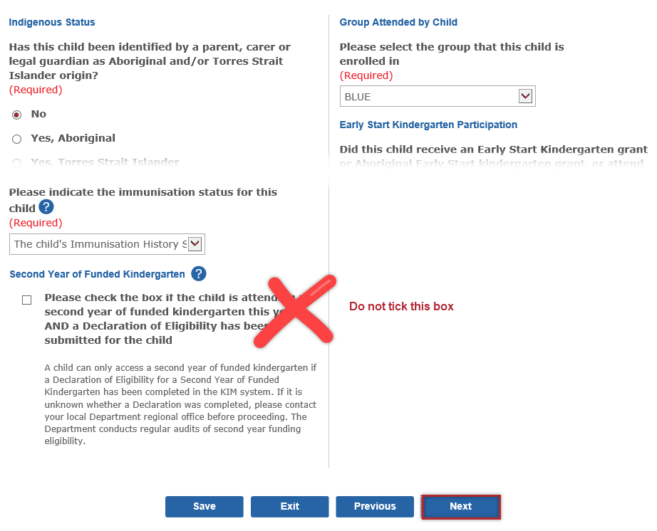
Note: DO NOT check the tick box under the heading Second Year of Kindergarten. This box should only be checked if the child is currently enrolled and attending a second year of funded kindergarten.

- Click Next.
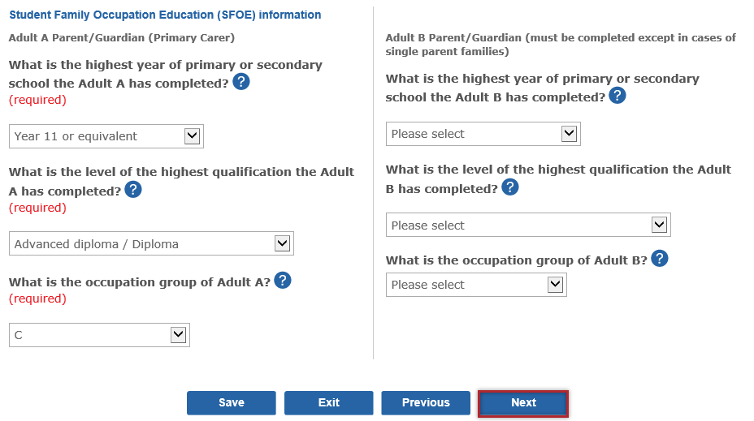
- When the section Eligibility and funding for a second year of funded kindergarten displays, click the tick box to declare the child is eligible for a second year of funded kindergarten.
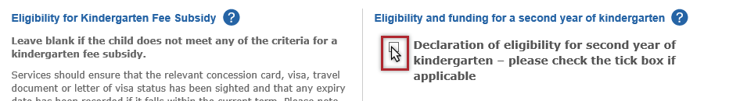
- Select the teacher who assessed the child from the drop-down list.
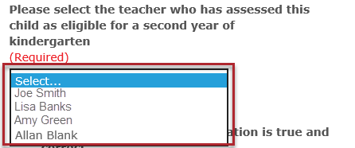
Mary Smith
James Brown

- Select at least two areas in which the child has displayed behaviour consistent with a delay in learning and development.
- Click Save. The KIM system will record the child as eligible to attend a second year of funded kindergarten in the next enrolment year. 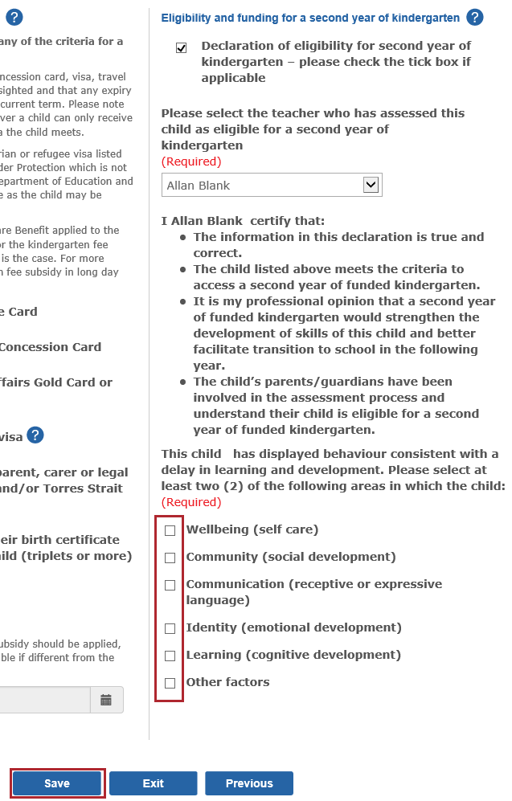
Note: The selected teacher does not have to submit the declaration in KIM. It may be submitted by another KIM user authorised by the service provider on the teacher’s behalf.

How to print a declaration of eligibility for a second year of funded kindergarten
- Under the Enrolments tab, click Edit next to the child record that has been declared eligible for a second year of funded kindergarten.
- To print the first page of the child record, press the Print Screen/PrtScrn key on your keyboard.
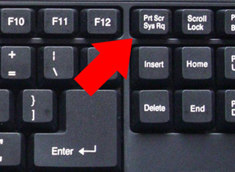
- Open a new blank Word document.
- Click the Paste symbol on the far left of the top menu bar.
Result: A copy of the first page of the child record will paste into the Word document.
- Go back to KIM and click Next to navigate to the second page of the child record.
- Press the PrtScrn key on your keyboard.
- Go back to the Word document.
- Click the Paste symbol.
Result: A copy of the second page of the child record will paste into the Word document.
- Repeat steps 5-8 to capture the third page of the child record.
- Print the Word document.
Tip: Most computers have a Snipping Tool which allows you to capture images on your computer.
To open the Snipping Tool:
- First make sure that you open the page that you want to print in KIM. Then click on the Search icon at the bottom left of your computer screen.
- In the Search box, type Snipping Tool. If your computer has the Snipping Tool program, it will display in the search results. Click the Snipping Tool icon.
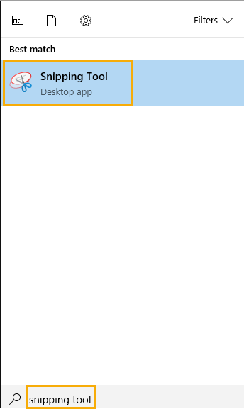
Result: The Snipping Tool program opens.

- Click New.
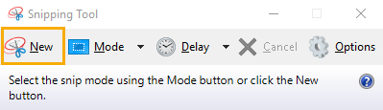
- Click and drag the cursor around the area you want to capture.
Result: You can now save (and then print) the image.

